The Mash
The mash is the process that converts the starches in the malted barley into fermentable sugars. At the Carolina Brewery, they start by crushing the malted barley between rollers to break up the kernel.
There is a fine tradeoff in the rolling process: the more the kernel is broken up, the more sugars can be extracted from the grains; but if it is broken up too much, the husk that surrounds the kernel may get broken down, which can cause a stuck mash. If the kernel is broken up just enough, then when the mash is finished, the whole husks form a filter bed that captures any solids from the liquid; but if the husks are broken down too much, they clog up and don't let the liquid through -- a stuck mash.
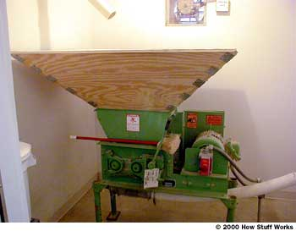
Photo courtesy Carolina Brewing Company
Grain mill
Next, the crushed grains pass through a feed pipe into the mash-lauter-tun. This insulated vessel has a device called a hydrator, which sprays heated water onto the grains as they enter. This eliminates any dry spots in the mash -- dry spots mean wasted sugars. The wet grains stay in the mash-lauter-tun for an hour. Since the vessel is insulated, the temperature stays at around 150 F (65 C).
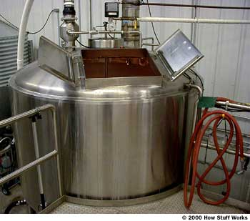
Photo courtesy Carolina Brewing Company
The mash-lauter-tun
The purpose of the mash is to convert the starches in the malted barley into fermentable sugars to be used in the next step of the brewing process. Starches are strings of many glucose molecules chained together -- these chains must be broken down into chains of only two or three glucose molecules before they can be fermented. We learned earlier that the malted barley contains enzymes, which can convert the starches.
There are two different types of enzymes in the malted barley: alpha-amylase and beta-amylase. The alpha enzymes break up the long chains of starches by splitting them in half. The beta enzymes break down the starches by chopping them off a couple at a time from the ends of the chain. Only if these two enzymes work together can the conversion be accomplished in a reasonable amount of time. There is a catch though: The alpha enzymes are most active at 149 to 153 F (65 to 67 C), and the beta enzymes are most active at 126 to 144 F (52 to 62 C). So the temperature and duration of the mash must be carefully controlled to get a good conversion.
The last steps needed to complete the mash are lautering and sparging. The liquid is drained from the bottom of the mash-lauter-tun and then recirculated to the top so that it is filtered through the husks of the spent grains. Additional heated water is then poured over the grains -- a process called sparging -- to make sure all of the sugars are removed.
The mash is an amazing process. Before the mash starts, the grains don't taste at all sweet, but the liquid that is drained off from the grains at the end of the mash is very sweet and sticky. This liquid, which now contains mostly fermentable sugars, goes on to the boil.
The Wort
The next step in the beer brewing process is called the boil. At the end of the boil we will have a finished wort (pronounced wert).
To start, the liquid from the mash is put into a huge brew kettle. The one used at the Carolina Brewery holds more than 600 gallons (2,270 L). It is a steam jacketed brew kettle. This kettle has double walls with a gap between them through which steam is circulated. This provides very even heating, since both the bottom and the sides are heated. The temperature is raised until the liquid comes to a vigorous rolling boil, and it is held there for 90 minutes.
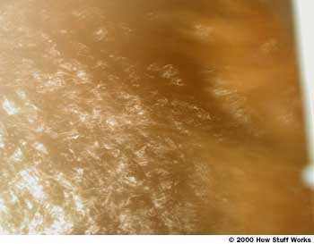
Photo courtesy Carolina Brewing Company
A boiling wort
At the beginning of the boil, hops are added. These are called the boiling hops, and their job is to add bitterness to the beer. The acids that produce bitterness in the beer are not easy to extract from the hops, which is why they need to be boiled for up to 90 minutes. The oils that produce the hop flavor and aroma are very volatile and evaporate quickly, so the boiling hops only contribute bitterness to the beer -- the flavor and aroma are added later.
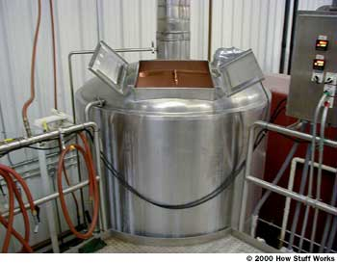
Photo courtesy Carolina Brewing Company
Brew kettle
Depending on what type of beer is being brewed, more hops may be added near the end of the boil -- these are called finishing hops. Generally, hops that are added about 15 minutes before the end contribute flavor to the beer. Hops added just a few minutes before the end contribute aroma to the beer. The oils in the hops that give the beer a distinctive hop smell are the most volatile, so these hops really just need to steep in the hot wort for a few minutes, like tea leaves, to extract the oils. Some of the beers brewed at the Carolina Brewery get finishing hops added at three different times. In order for each batch of beer to taste the same, exactly the same amount of the same type of hops must be added at exactly the same time during each boil.
Separating the Solids
Before the wort can go on to the next step, all of the solids must be separated from the liquid. This is done in a very neat way. The wort is pumped from the kettle, and forced back into the kettle through a jet nozzle. This flow of liquid causes a whirlpool to form; and if you've ever stirred tea leaves in a cup, you know that they move to the center of the whirlpool. When this whirlpool forms in the brew kettle, all of the hops and other solids move to the center. The pump is then turned off, and over the next 20 minutes the whirlpool gradually stops and the solids settle to the bottom, forming a fairly solid cone.
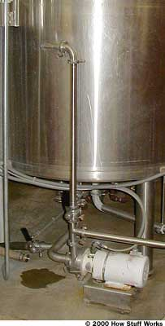
Photo courtesy Carolina Brewing Company
The whirlpool pump that swirls the beer
When the wort is drained, the solids stay in the kettle. Next, the wort must be cooled down to the proper temperature for the yeast. This is done in a liquid-to-liquid heat exchanger. The wort is circulated through one set of tubes while chilled water is circulated through another set. The tubes with hot wort running through them transfer heat to the tubes holding the chilled water.
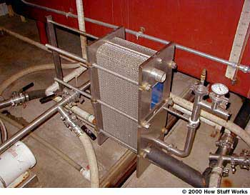
Photo courtesy Carolina Brewing Company
Heat exchanger
The cooling water is chilled first, so that the volume of water that is required to cool down one entire batch of wort is about equal to the volume of wort. The cooling water ends up at a temperature of about 170 F (76 C), and is stored in an insulated tank and used to brew the next batch of beer. This way both the water and the heat energy are saved.
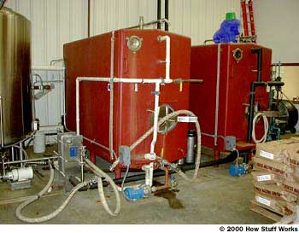
Photo courtesy Carolina Brewing Company
Hot and cold water storage tanks
It is important to cool the wort quickly so that the yeast can be added right away and fermentation can begin. This reduces the chance of contamination by stray yeasts floating around in the air.

Fermentation, Bottling and Homebrewing
Fermentation is the process by which yeast converts the glucose in the wort to ethyl alcohol and carbon dioxide gas -- giving the beer both its alcohol content and its carbonation. To begin the fermentation process, the cooled wort is transferred into a fermentation vessel to which the yeast has already been added. If the beer being made is an ale, the wort will be maintained at a constant temperature of 68 F (20 C) for about two weeks. If the beer is a lager, the temperature will be maintained at 48 F (9 C) for about six weeks. Since fermentation produces a substantial amount of heat, the tanks must be cooled constantly to maintain the proper temperature.  These fermentation tanks hold more than 2,400 gallons (9,085 L), which means that it takes four batches of wort to fill one tank. Since fermentation takes at least two weeks, the capacity of the brewery is limited by how many tanks they have.  When the wort is first added to the yeast, the specific gravity of the mixture is measured. Later, the specific gravity may be measured again to determine how much alcohol is in the beer, and to know when to stop the fermentation. Click here for more details on measuring the amount of alcohol in beer.  The fermenter is sealed off from the air except for a long narrow vent pipe, which allows carbon dioxide to escape from the fermenter. Since there is a constant flow of CO2 through the pipe, outside air is prevented from entering the fermenter, which reduces the threat of contamination by stray yeasts.  When fermentation is nearly complete, most of the yeast will settle to the bottom of the fermenter. The bottom of the fermenter is cone shaped, which makes it easy to capture and remove the yeast, which is saved and used in the next batch of beer. The yeast can be reused a number of times before it needs to be replaced. It is replaced when it has mutated and produces a different taste -- remember, commercial brewing is all about consistency.  While fermentation is still happening, and when the specific gravity has reached a predetermined level, the carbon dioxide vent tube is capped. Now the vessel is sealed; so as fermentation continues, pressure builds as CO2 continues to be produced. This is how the beer gets most of its carbonation, and the rest will be added manually later in the process. From this point on, the beer will remain under pressure (except for a short time during bottling).  When fermentation has finished, the beer is cooled to about 32 F (0 C). This helps the remaining yeast settle to the bottom of the fermenter, along with other undesirable proteins that come out of solution at this lower temperature.  Now that most of the solids have settled to the bottom, the beer is slowly pumped from the fermenter and filtered to remove any remaining solids. From the filter, the beer goes into another tank, called a bright beer tank. This is its last stop before bottling or kegging. Here, the level of carbon dioxide is adjusted by bubbling a little extra CO2 into the beer through a porous stone.  Bottling and Kegging  The most important thing about the bottling and kegging process is to keep the beer from being contaminated by stray yeasts, and to keep oxygen away from the beer. These are the main things that can reduce the shelf-life of beer.  The ways that the beer is transferred into bottles and kegs is pretty similar; but bottling has a few extra steps, so we'll talk about bottling.  The bottling line at the Carolina Brewery can fill up to 100 12-oz (355 ml) bottles of beer every minute. To start the process, the empty bottles are loaded onto the bottling line, where they are first rinsed with a chlorine solution, and then blasted with CO2 to remove the solution.  Next, the bottles enter a turret-like mechanism that can hold 12 bottles at once. Each bottle rides around the turret once. During its ride, the bottle is purged with CO2 several times before it is filled. The bottles are pressurized with CO2 so that when the beer is forced into the bottles under pressure it doesn't foam up too much. After the beer has been added to the bottles, the pressure is slowly relieved until the beer is at ambient pressure. As each filled bottle leaves the turret, an empty one takes its place.  Next comes the capping machine -- but now there is a little bit of air space at the top of the bottle that needs to be purged. To do this, the bottle is passed under a very narrow, high-pressure jet of water that hits the beer, causing it to foam up and drive the air out of the bottle. The cap is then applied before any air can re-enter the bottle.  After the cap is applied, the outside of the bottle is rinsed to remove any beer that may have foamed out during the process.  Surprisingly, the most difficult part of the bottling process is applying the label to the bottle. Getting a label to stick to a cold wet beer bottle is no easy trick.  The labels are fed into the labeling machine, which has a spinning device that rolls glue onto the labels and then sticks them to the bottles as they pass by. If all goes well, the label will be properly positioned, smooth and well-adhered.  A special inkjet printer squirts the date onto the label as it moves past the print head. The date the beer was bottled and also a "best before" date (three months after the bottling date) are printed on the label. | Related Content:  - Explanations:  - How Alcohol Works  - How do brewers measure the alcohol in beer?  - How does the widget in a beer can work?  - Opinions:  In what ways do you evaluate superior beer?  Post your response now.  - Prices:  - Marty Nachel - Homebrewing for Dummies  - Stacy Tibbetts et al - Basic Homebrewing: All the Skills And Tools You Need to Get Started  - Lee W. Janson - Brew Chem 101: The Basics of Homebrewing Chemistry
  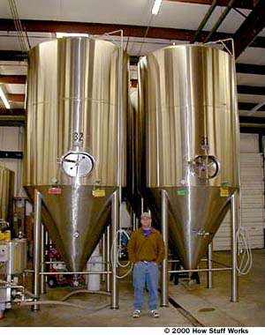
  Photo courtesy Carolina Brewing Company
  Fermentation tanks
  How Yeast Makes Alcohol
  and Carbon Dioxide
  When the yeast first hits the wort, concentrations of glucose (C6H12O6) are very high, so through diffusion, glucose enters the yeast (in fact, it keeps entering the yeast as long as there is glucose in the solution). As each glucose molecule enters the yeast, it is broken down in a 10-step process called glycolysis. The product of glycolysis is two three-carbon sugars, called pyruvates, and some ATP (adenosine triphosphate), which supplies energy to the yeast and allows it to multiply. The two pyruvates are then converted by the yeast into carbon dioxide (CO2) and ethanol (CH3CH2OH, which is the alcohol in beer). The overall reaction is:
  C₆H₁₂O₆ => 2(CH₃CH₂OH) + 2(CO₂)
  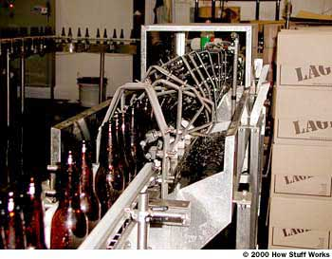
  Photo courtesy Carolina Brewing Company
  Bottle rinse -- this section of track inverts the bottles, rinses them with a cleaning solution, dries them with CO2 and then flips them back over.
  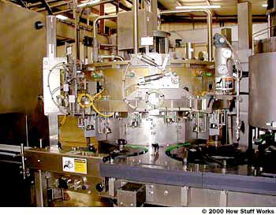
  Photo courtesy Carolina Brewing Company
  Bottle filling station
  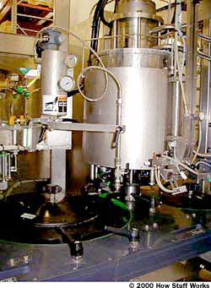
  Photo courtesy Carolina Brewing Company
  Bottle capping machine
  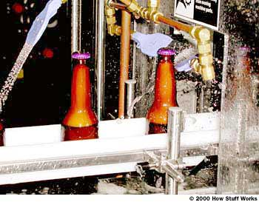
  Photo courtesy Carolina Brewing Company
  Bottle rinsing -- note the foam in the bottle
  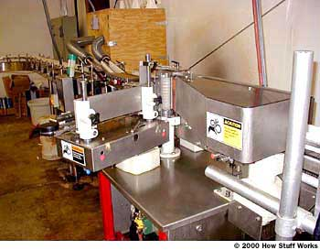
  Photo courtesy Carolina Brewing Company
  Labeling machine
  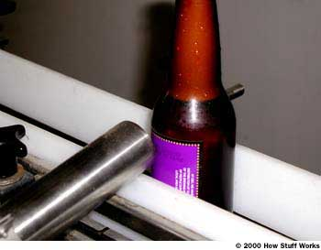
  Photo courtesy Carolina Brewing Company
  Label printer

Hops
The hops used to make beer are the flower of the hop vine, which is a member of the hemp family (Cannabaceae). Hops are closely related to another member of the hemp family that you may have heard of -- cannabis, or marijuana, although hops do not have the psychoactive effects associated with marijuana.
Hops contain acids, which give beer its bitterness, as well as oils that give beer some of its flavor and aroma. Adding hops to beer also inhibits the formation of certain bacteria that can spoil the beer.
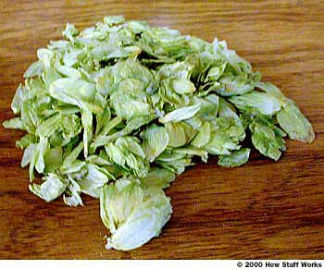
Photo courtesy Carolina Brewing Company
Hops
There are many different kinds of hops, each of which gives a different taste, aroma and amount of bitterness to the beer it is used in. In the United States, hops are grown mainly in Washington state. Hops are also grown in Germany, Southern England and Australia.
Yeast
Yeast is the single-celled micro-organism that is responsible for creating the alcohol and carbon dioxide found in beer. There are many different kinds of yeasts used to make beer; and just as the yeast in a sourdough starter gives sourdough bread its distinctive flavor, different types of beer yeast help to give beer its various tastes.
There are two main categories of beer yeast: ale yeast and lager yeast. Ale yeast is top fermenting, meaning it rises near the surface of the beer during fermentation, and typically prefers to ferment at temperatures around 70 F (21 C). Lager yeasts are bottom fermenting. They ferment more slowly and prefer colder temperatures, around 50 F (10 C).

How Beer is Made
2. Malt
Barley is used to make brewers' malt. At the malting companies, barley is soaked, germinated (sprouted), then dried and/or kilned/roasted to arrest further growth. During the period of controlled growth in the malting plant, specific barley enzymes are released to break down the membranes of the starch cells that make up most of the kernel. But these are internal changes only; apart from a slight change in colour, the external characteristics remain essentially unchanged. When the malt leaves a malting plant, it still looks like barley.
In the brewery, the malt is screened and crushed rather than ground to flour in order to keep the husks as whole as possible. This process not only prevents the extraction of undesirable materials from the husks but also allows them to act as a filter bed for separation of the liquid extract formed during mashing.
3. Mashing
Malt is added to heated, purified water and, through a carefully controlled time and temperature process, the malt enzymes break down the starch to sugar and the complex proteins of the malt to simpler nitrogen compounds. Mashing takes place in a large, round tank called a "mash mixer" or "mash tun" and requires careful temperature control. At this point, depending on the type of beer desired, the malt is supplemented by starch from other cereals such as corn, wheat or rice.
4. Lautering
The mash is transferred to a straining (or lautering) vessel which is usually cylindrical with a slotted false bottom two to five centimetres above the true bottom. The liquid extract drains through the false bottom and is run off to the brew kettle. This extract, a sugar solution, is called "wort" but it is not yet beer. Water is "sparged" (or sprayed) though the grains to wash out as much of the extract as possible. The "spent grains" are removed and sold as cattle feed.
5. Boiling and Hopping
The brew kettle, a huge cauldron holding from 70 to 1,000 hectolitres and made of shiny copper or stainless steel, is probably the most striking sight in a brewery. It is fitted with coils or a jacketed bottom for steam heating and is designed to boil the wort under carefully-controlled conditions. Boiling, which usually lasts about two hours, serves to concentrate the wort to a desired specific gravity, to sterilize it and to obtain the desired extract from the hops. The hop resins contribute flavour, aroma and bitterness to the brew. Once the hops have flavoured the brew, they are removed. When applicable, highly-fermentable syrup may be added to the kettle. Undesirable protein substances that have survived the journey from the mash mixer are coagulated, leaving the wort clear.
6. Hop Separation and Cooling
After the beer has taken on the flavour of the hops, the wort then proceeds to the "hot wort tank". It is then cooled, usually in a simple-looking apparatus called a "plate cooler". As the wort and a coolant flow past each other on opposite sides of stainless steel plates, the temperature of the wort drops from boiling to about 10 to 15.5 °C, a drop of more than 65.6 °C, in a few seconds.
7. Fermentation
The wort is then moved to the fermenting vessels and yeast, the guarded central mystery of ancient brewer's art, is added. It is the yeast, which is a living, single-cell fungi, that breaks down the sugar in the wort to carbon dioxide and alcohol. It also adds many beer-flavouring components. There are many kinds of yeasts, but those used in making beer belong to the genus saccharomyces. The brewer uses two species of this genus. One yeast type, which rises to the top of the liquid at the completion of the fermentation process, is used in brewing ale and stout. The other, which drops to the bottom of the brewing vessel, is used in brewing lager.
In all modern breweries, elaborate precautions are taken to ensure that the yeast remains pure and unchanged. Through the use of pure yeast culture plants, a particular beer flavour can be maintained year after year. During fermentation, which lasts about seven to 10 days, the yeast may multiply six-fold and in the open-tank fermenters used for brewing ale, a creamy, frothy head may be seen on top of the brew. When the fermentation is complete, the yeast is removed. Now, for the first time ,the liquid is called beer.
8. Cellars
For one to three weeks, the beer is stored cold and then filtered once or twice before it is ready for bottling or "racking" into kegs.
9. Packaging
In the bottle shop of a brewery, returned empty bottles go through washers in which they receive a thorough cleaning. After washing, the bottles are inspected electronically and visually and pass on to the rotary filler. Some of these machines can fill up to 1,200 bottles per minute. A "crowning" machine, integrated with the filler, places caps on the bottles. The filled bottles may then pass through a "tunnel pasteurizer" (often 23 metres from end to end and able to hold 15,000 bottles) where the temperature of the beer is raised about 60 °C. for a sufficient length of time to provide biological stability, then cooled to room temperature.
Emerging from the pasteurizer, the bottles are inspected, labelled, placed in boxes, stacked on pallets and carried by lift truck to the warehousing areas to await shipment. Also in the bottle shop may be the canning lines, where beer is packaged in cans for shipment. Packaged beer may be heat-pasteurized or micro-filtered, providing a shelf-life of up to six months when properly stored. Draught beer, since it is normally sold and consumed within a few weeks, may not go through this process. The draught beer is placed in sterilized kegs ready for shipment.

