ENTERPRISE ERP SYSTEM
Complete System Documentation
─────────────────────────────────────
Date: June 26, 2026
Version: 2.0 Enterprise Edition

Overview
This document provides a comprehensive technical and functional description of the Enterprise ERP platform. All screenshots were captured live from the running application using an automated browser tool, authenticated as an Administrator for full system visibility.
The system is built on a React (Vite) frontend with a Node.js/Express/MySQL backend, featuring real-time updates via Socket.IO, role-based access control, and a modular design supporting multiple business verticals.

Module Summary

# | Module | Route | Primary Role
1 | Dashboard | / | Admin
2 | Manager Portal | /manager | Manager
3 | Inventory | /inventory | Inventory, Admin
4 | Sales POS | /sales | Cashier, Sales
5 | Sales History | /sales/history | Admin, Manager
6 | Revenue Analytics | /revenue | Admin, Manager
7 | HR Module | /hr | HR, Admin
8 | Employees | /employees | HR, Admin
9 | Attendance | /attendance | HR, Admin
10 | Shift Audit | /shift-audit | Manager, Admin
11 | Leave Management | /leaves | HR, Admin, All
12 | Payroll | /payroll | HR, Admin
13 | Pharmacy | /pharmacy | Pharmacist, Admin
14 | Suppliers | /suppliers | Admin, Manager
15 | Customers CRM | /customers | Sales, Admin
16 | Expenses | /expenses | Admin, Manager
17 | Users & Access | /users | Admin only
18 | EOD Report | /eod | Admin, Manager
19 | Delivery Dispatch | /delivery | Admin, Manager

1. Dashboard
Route: /
Primary Role: Admin
Purpose: Central command center providing live KPIs and system-wide visibility
The Dashboard is the first screen presented to administrators after login. It aggregates data from across all modules into a single, at-a-glance view.

Key Features
• Live KPI tiles: Today's revenue, transactions, and active staff count
• Quick-access navigation shortcuts to all major ERP modules
• Recent activity feed showing the latest system events
• System-wide alerts and low-stock / expiry notifications
• Role-aware layout — content adapts based on logged-in user's role
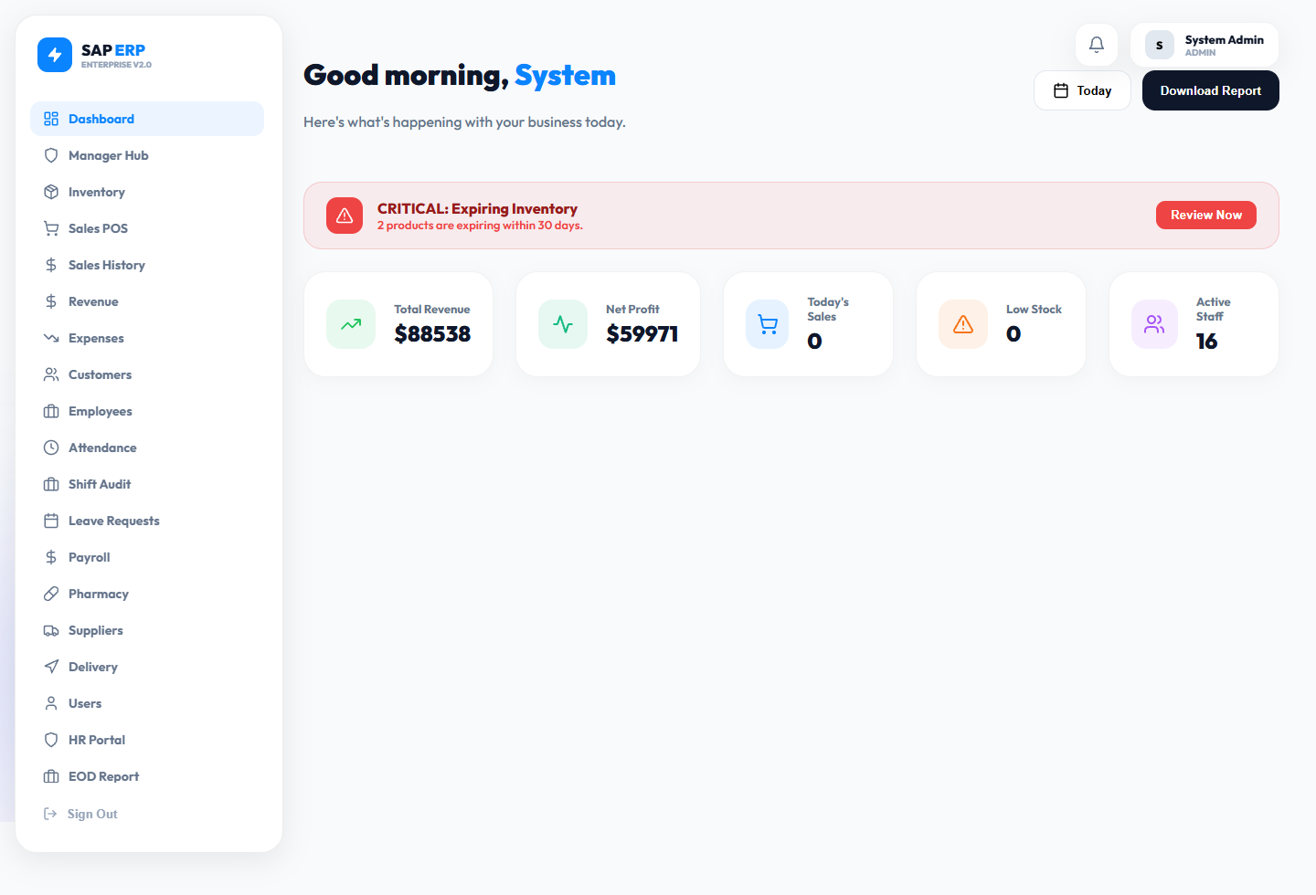

2. Manager Portal
Route: /manager
Primary Role: Manager, Admin
Purpose: Operational control center for middle management oversight

Key Features
• Approve or reject employee leave requests with comments
• Review and sign off on shift handover reports
• Monitor real-time floor activity and operational status
• View departmental performance summaries and alerts
• Access to critical operational metrics without full admin rights
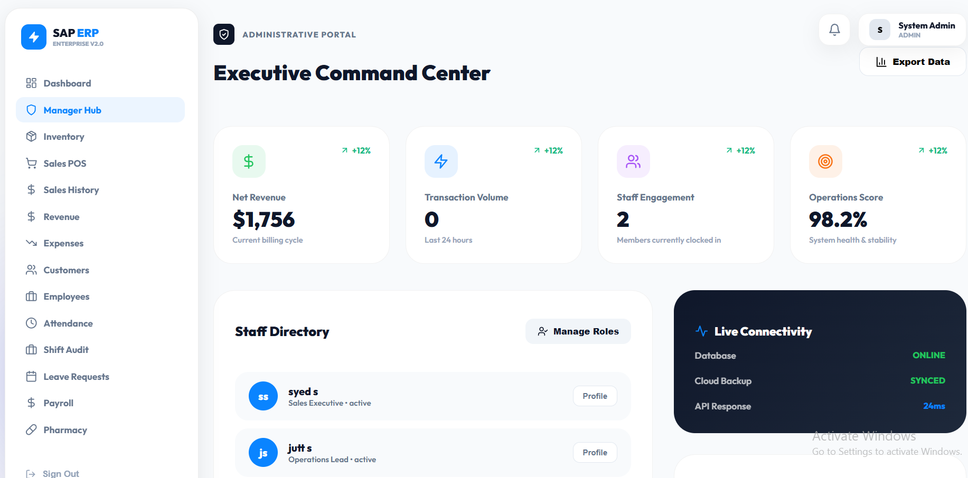

3. Inventory Management
Route: /inventory
Primary Role: Inventory Manager, Admin
Purpose: Full product and stock lifecycle management

Key Features
• Add, edit, and delete products with SKU, price, category, and stock levels
• Low-stock alerts with configurable reorder threshold
• Stock adjustment history tracking purchases, sales, and write-offs
• Category-based filtering (Construction, Pharmacy, General, etc.)
• Supplier linkage per product for quick reordering
• Barcode-ready product codes for POS integration

4. Sales POS Terminal
Route: /sales
Primary Role: Cashier, Sales
Purpose: Fast, intuitive Point-of-Sale terminal for processing transactions

Key Features
• Product search and barcode-ready item lookup
• Live shopping cart with real-time quantity and price updates
• Customer selection and linking for loyalty point tracking
• Apply percentage or fixed-amount discounts
• Multiple payment methods: Cash and Card
• Auto-generated receipts with invoice printing support
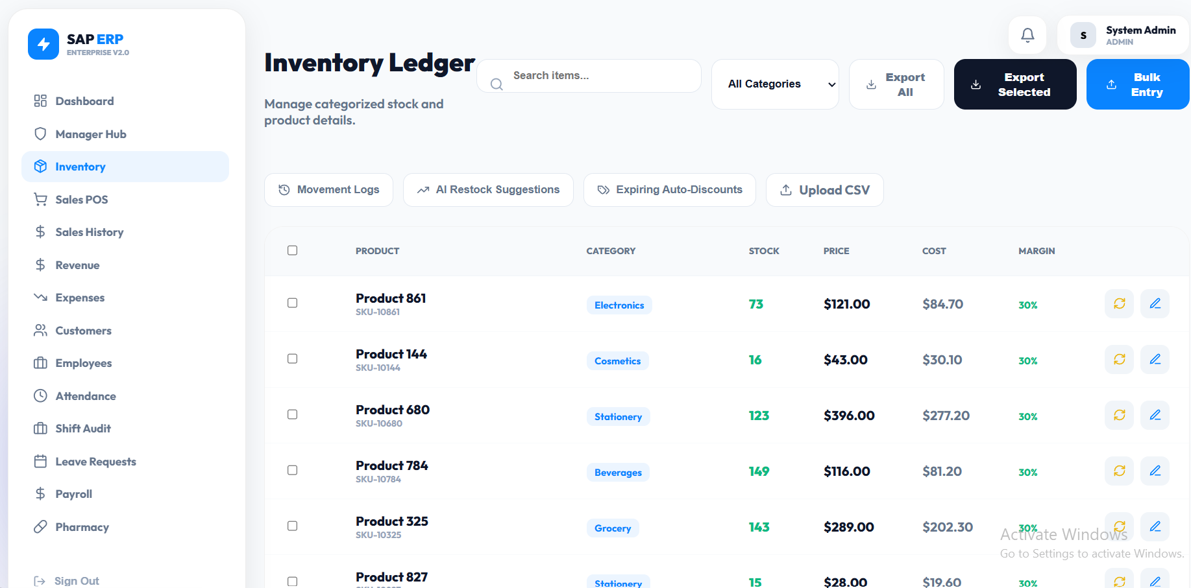
• Inventory stock auto-decremented on successful sale
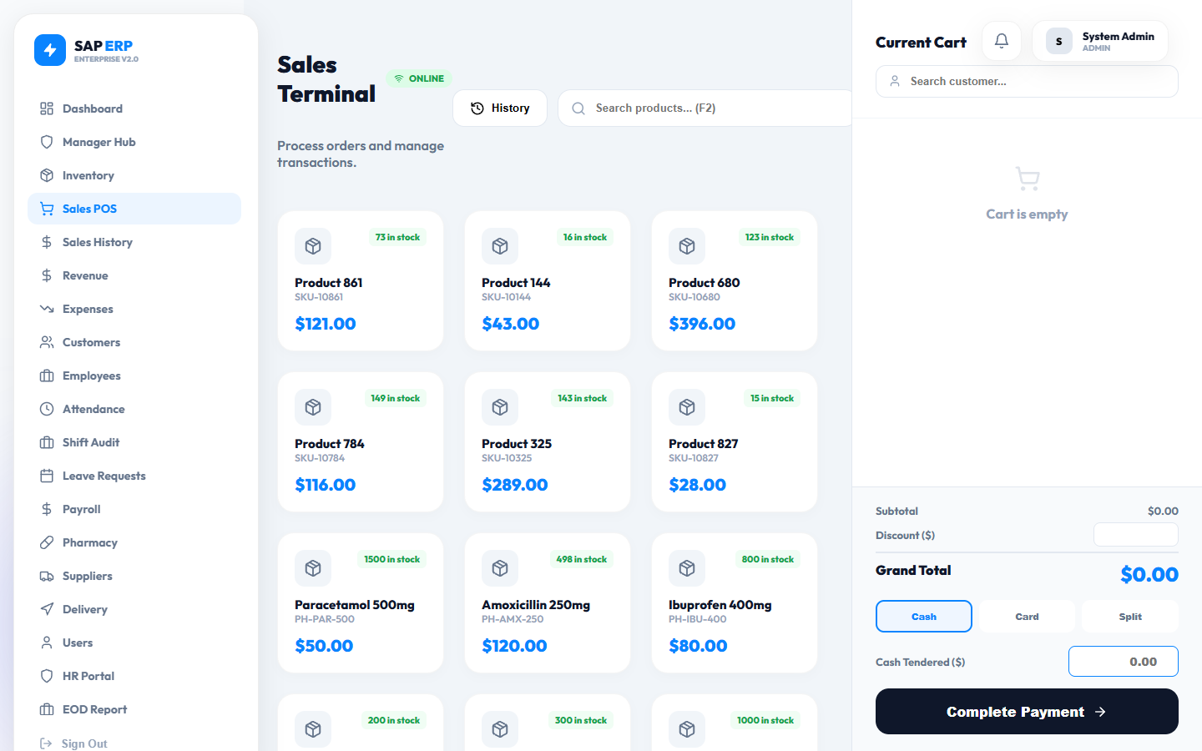

5. Sales History
Route: /sales/history
Primary Role: Admin, Manager
Purpose: Complete transactional audit trail for all processed sales

Key Features
• Browse all past sales with timestamps, amounts, and cashier information
• View full receipt breakdown for any historical transaction
• Process refunds and returns with reason logging
• Filter by date range, cashier, payment type, or amount
• Export transaction data to CSV for accounting purposes
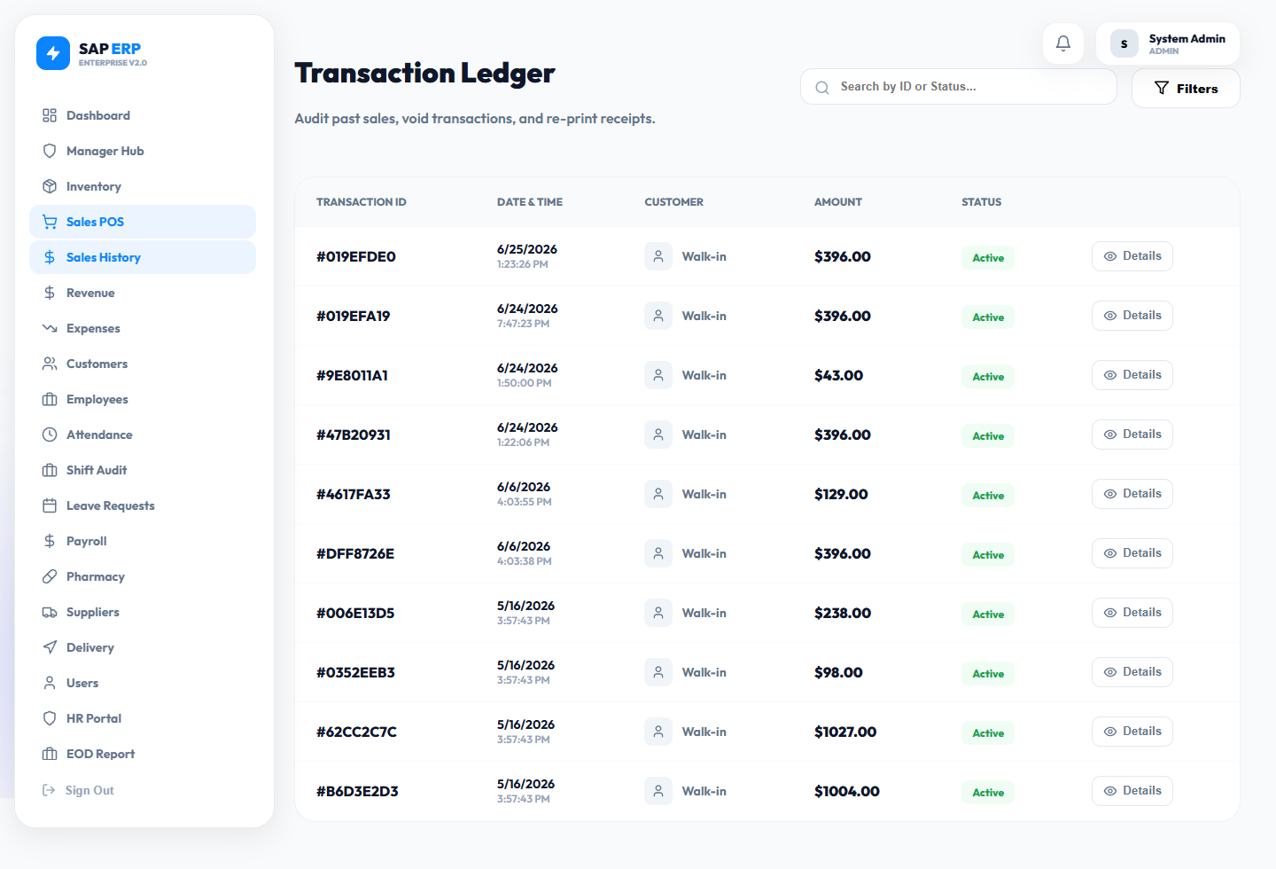

6. Revenue Analytics
Route: /revenue
Primary Role: Admin, Manager
Purpose: Financial intelligence and income trend analysis

Key Features
• Gross revenue vs. net profit trend charts with daily/weekly/monthly views
• Top-selling products and categories ranked by revenue contribution
• Revenue breakdown by cashier, terminal, or time period
• Expense deduction summary for accurate Profit & Loss calculation
• Visual charts for quick identification of performance patterns
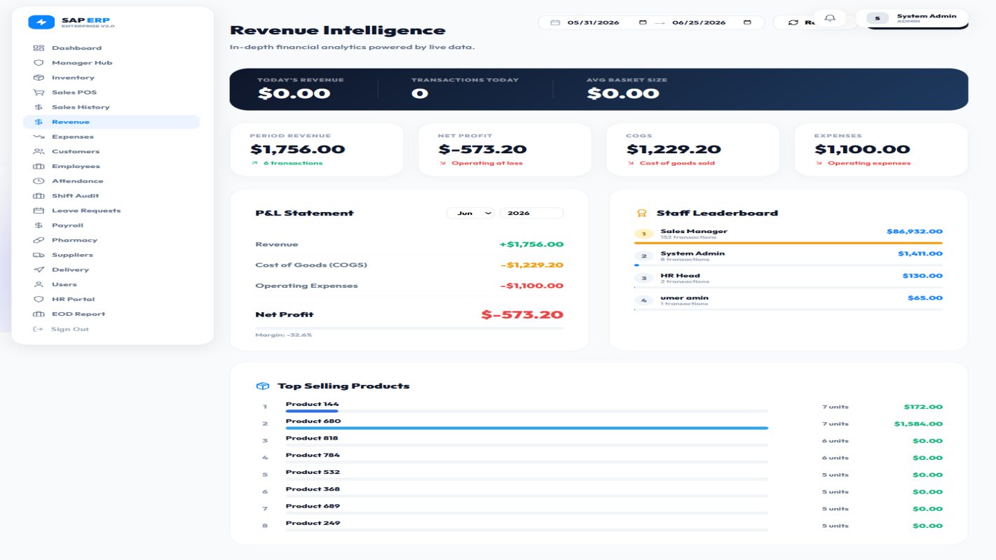

7. HR Module
Route: /hr
Primary Role: HR, Admin
Purpose: Human resources administration and workforce policy management

Key Features
• Headcount overview by department and role
• Onboarding checklists and document tracking per new hire
• Leave policy configuration and enforcement
• Staff performance and contract status overview
• Centralized HR communications and announcements
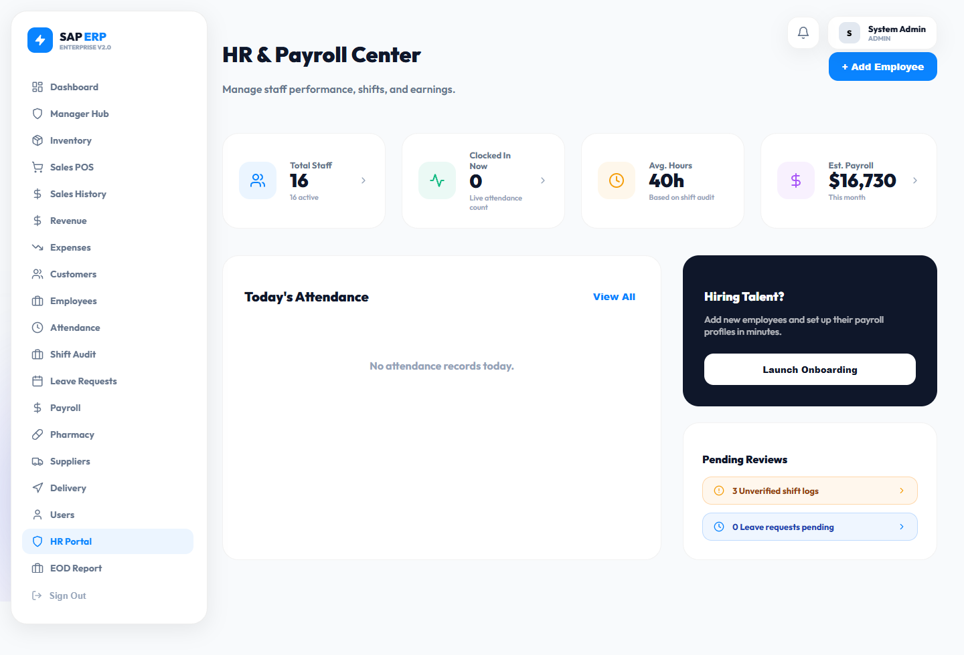

8. Employees Directory
Route: /employees
Primary Role: HR, Admin
Purpose: Centralized database of all staff members and their profiles

Key Features
• Full employee profiles: name, role, department, join date, salary, contact
• Search and filter by role, department, or employment status
• Edit employee details including salary, designation, and contact info
• View attendance and leave history directly from employee profile
• Activate or deactivate staff accounts for system access
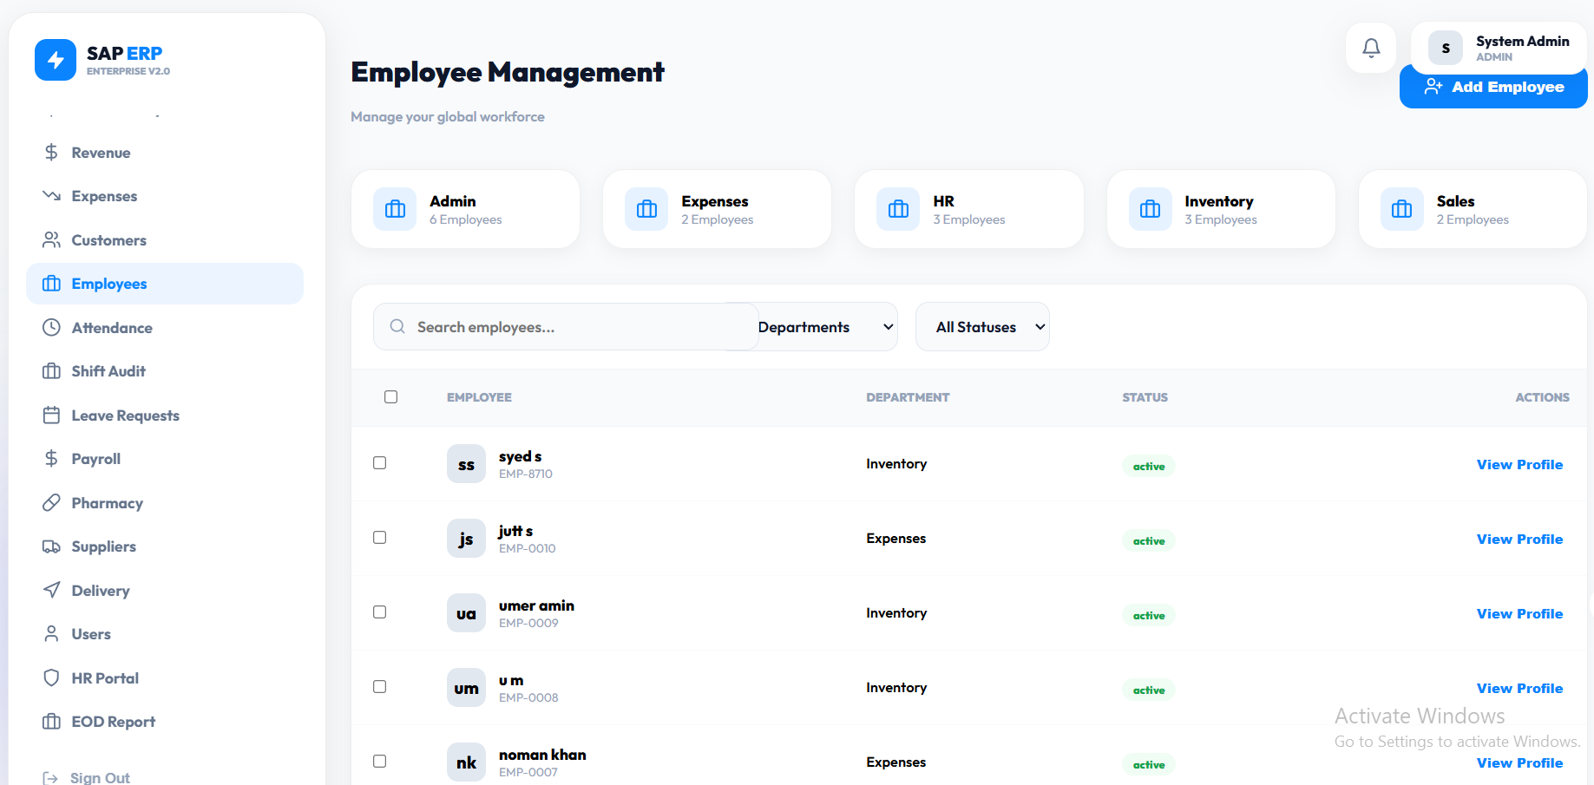

9. Attendance Tracking
Route: /attendance
Primary Role: HR, Admin
Purpose: Daily presence monitoring and timesheet management

Key Features
• Real-time clock-in and clock-out log entries
• Late arrival, early departure, and absence tracking
• Automatic calculation of worked hours per shift
• Overtime detection and automatic flagging
• Monthly attendance summary reports per employee
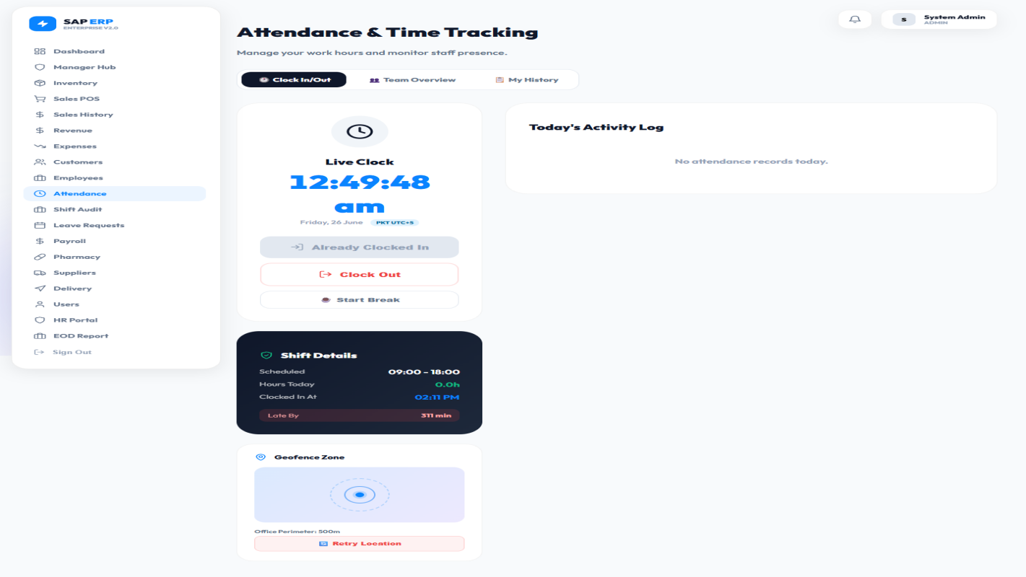

10. Shift Audit
Route: /shift-audit
Primary Role: Manager, Admin
Purpose: Cash drawer reconciliation and shift handover verification

Key Features
• Opening and closing cash balance logging at the start/end of each shift
• Variance detection comparing actual vs. expected cash in drawer
• Complete sales summary per shift for accountability
• Supervisor digital sign-off workflow
• Discrepancy investigation notes and resolution tracking
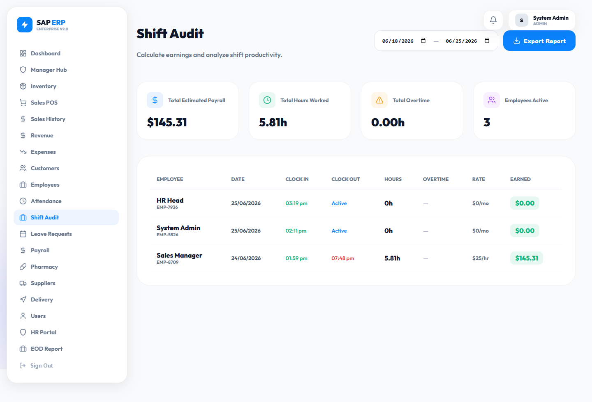

11. Leave Management
Route: /leaves
Primary Role: All employees (request), HR/Admin (approve)
Purpose: Structured leave request and approval workflow

Key Features
• Employees submit leave requests specifying type (Annual, Sick, Casual) and dates
• Manager/HR approval or rejection with optional comments
• Leave balance tracking per employee updated in real-time
• Calendar view of approved leaves for scheduling and capacity planning
• Automatic payroll impact: approved leaves deducted or marked accordingly
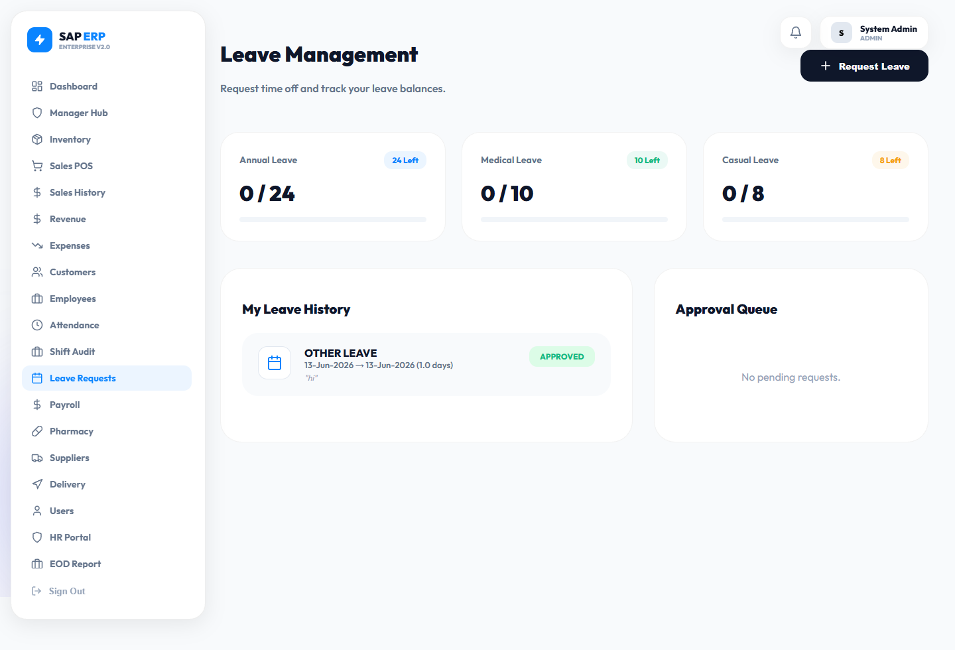

12. Payroll System
Route: /payroll
Primary Role: HR, Admin
Purpose: Automated salary computation and payslip generation

Key Features
• Salary calculation automatically based on attendance and leave records
• Deductions: Absences, salary advances, and performance penalties
• Additions: Overtime pay, performance bonuses, and allowances
• Payslip generation and PDF download per employee per month
• Payroll run history with approval workflow
• Bank transfer details management for direct deposit
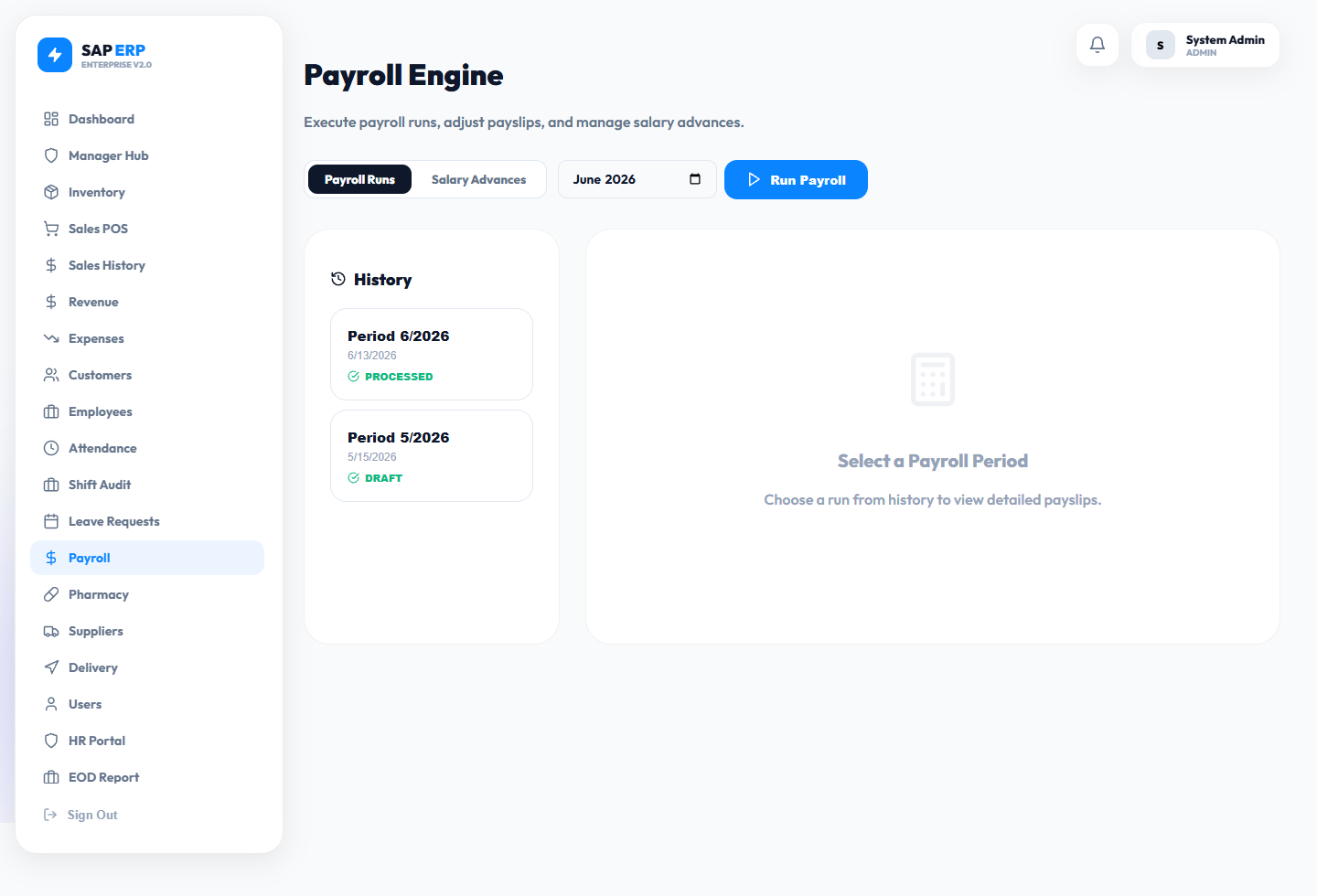

13. Pharmacy Module
Route: /pharmacy
Primary Role: Pharmacist, Admin
Purpose: Medical inventory and regulatory compliance management

Key Features
• Drug inventory with batch numbers, expiry dates, and supplier information
• Tiered expiry alerts: 30-day and 7-day warning levels
• Controlled substance log with strict quantity and dispensing tracking
• Prescription management: create, verify, and dispense workflows
• Batch recall workflow for recalled or contaminated stock
• Regulatory compliance reporting for audits
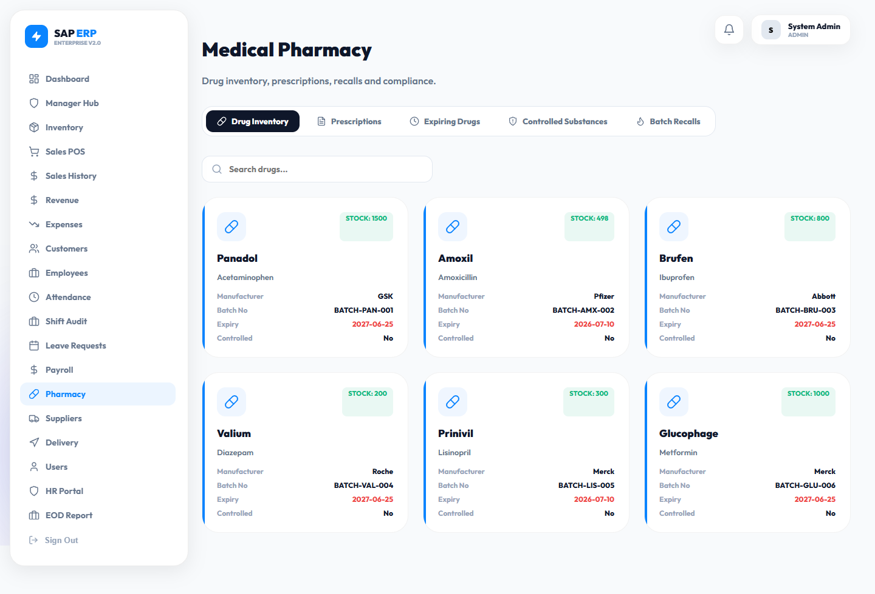

14. Suppliers
Route: /suppliers
Primary Role: Admin, Manager
Purpose: Vendor relationship and procurement management

Key Features
• Supplier directory with contact information, categories, and payment terms
• Purchase order (PO) creation and real-time tracking
• Goods Received Notes (GRN) logging for inventory reconciliation
• Supplier performance ratings and on-time delivery metrics
• Invoice and payment history per vendor for financial reconciliation
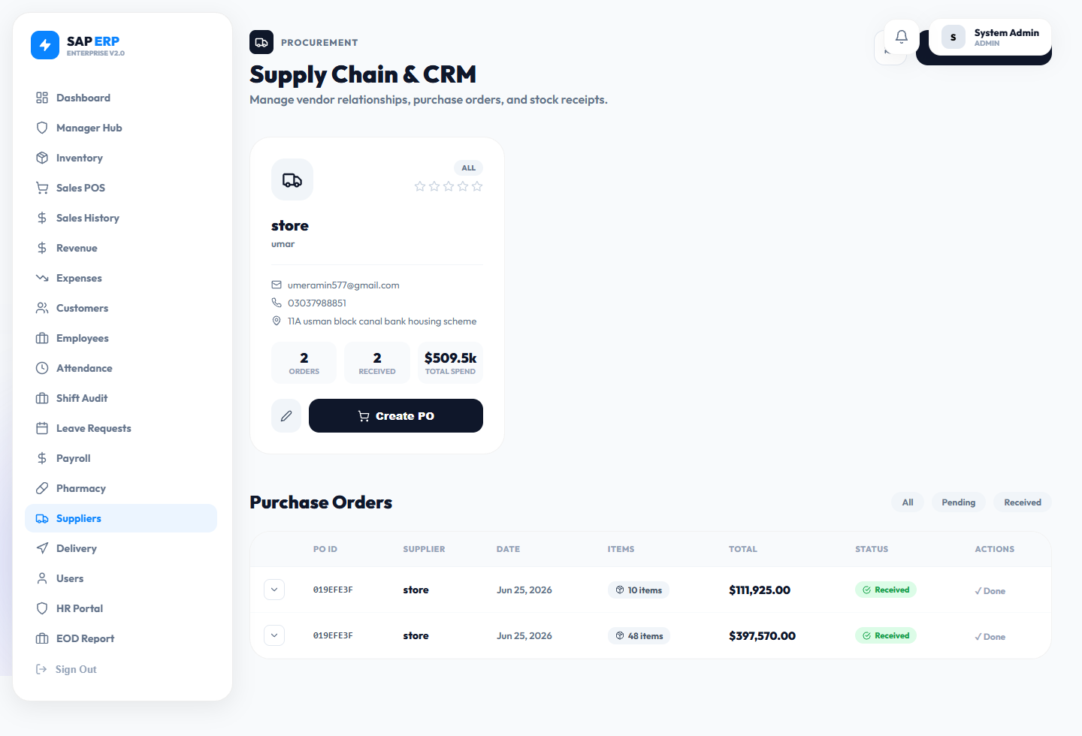

15. Customers CRM
Route: /customers
Primary Role: Sales, Admin
Purpose: Client relationship management for retail and B2B customers

Key Features
• Customer profiles with contact details and complete purchase history
• Loyalty point balance tracking and redemption at POS
• Total spending and visit frequency analytics
• Add, edit, and delete customer records
• Direct linking of customers to sales transactions during checkout
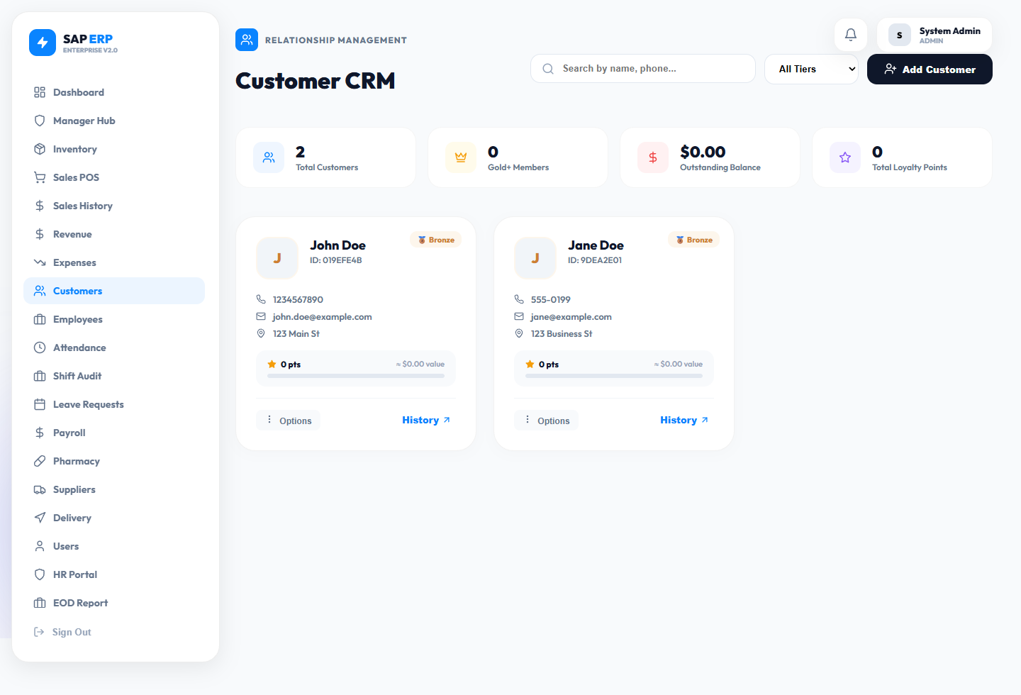

16. Expenses
Route: /expenses
Primary Role: Admin, Manager
Purpose: Operational cost logging for accurate net profit calculation

Key Features
• Log daily business expenses by category (Utilities, Supplies, Maintenance, etc.)
• Attach descriptive notes and receipt references to each entry
• Monthly expense summaries with category breakdowns
• Integrated into EOD and Revenue reports for full P&L calculation
• Expense approval workflow for management oversight and budget control
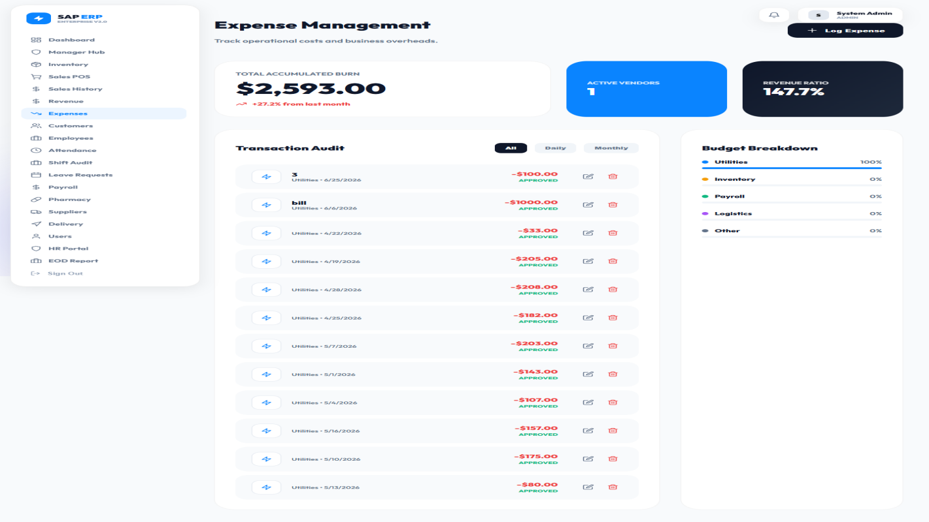

17. Users & Access Control
Route: /users
Primary Role: Admin only
Purpose: System-level user account and permission management

Key Features
• Create new user accounts with role assignment
• Available roles: Admin, Manager, HR, Sales, Cashier, Pharmacist, Inventory
• Password management: set and reset capabilities
• Activate and deactivate accounts without permanent deletion
• Role-Based Access Control (RBAC) — each role sees only permitted modules
• Login audit trail for security monitoring
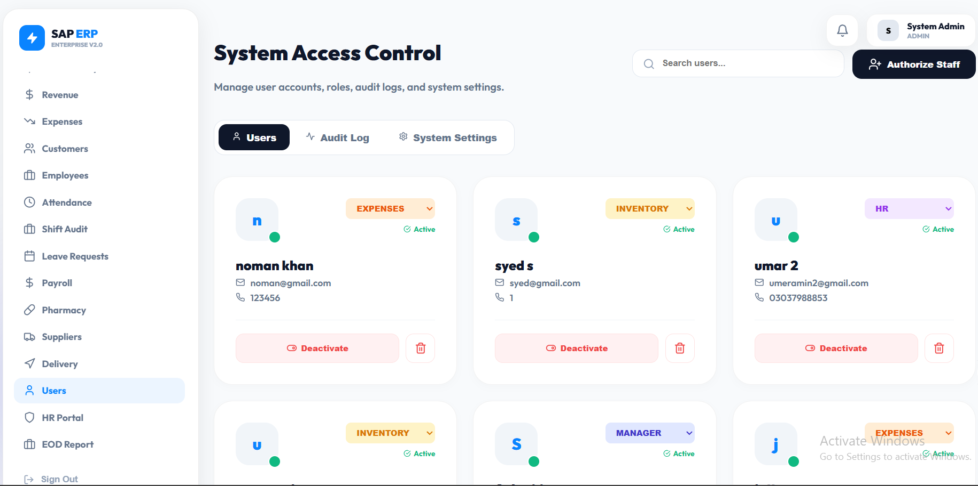

18. End-of-Day (EOD) Report
Route: /eod
Primary Role: Admin, Manager
Purpose: Daily financial reconciliation and cash management report

Key Features
• Daily sales total vs. expected cash in drawer comparison
• Expense deductions for accurate net revenue calculation
• Shift-by-shift breakdown showing each cashier's contribution
• Discrepancy flagging with investigation workflow
• Exportable PDF report for accountant and auditor review
• Historical EOD report archive for trend analysis
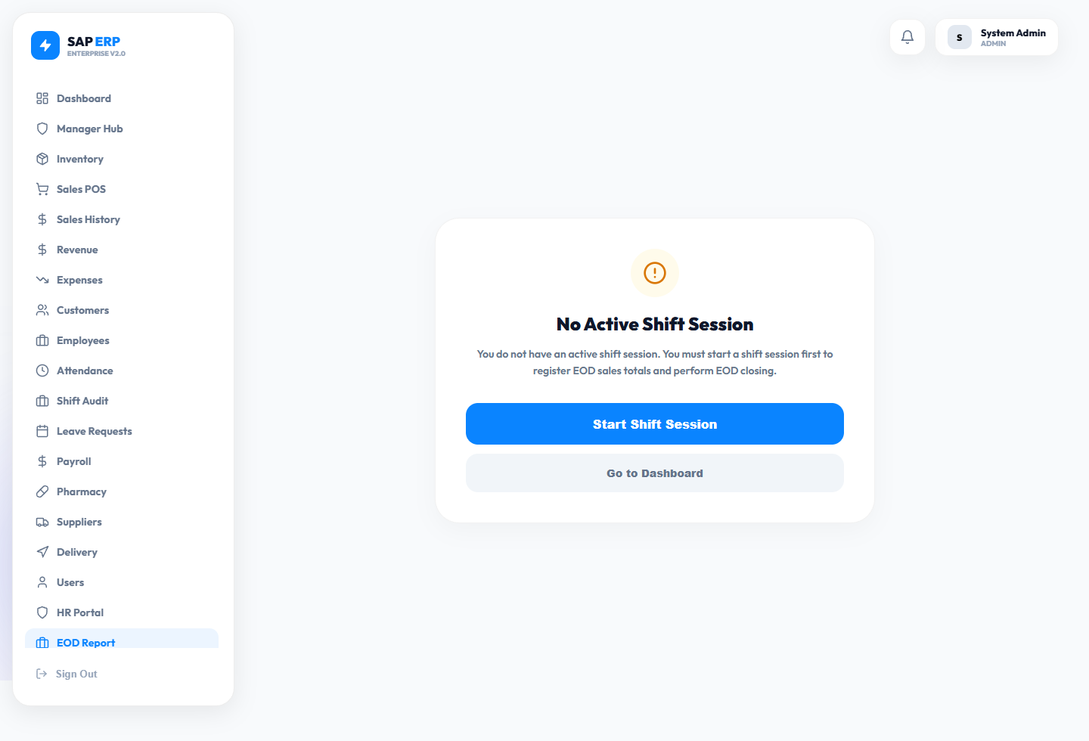

19. Delivery Dispatch
Route: /delivery
Primary Role: Admin, Manager
Purpose: Logistics and last-mile delivery management

Key Features
• Create delivery orders with customer address, items, and priority level
• Assign deliveries to available drivers from a central dispatch board
• Real-time status tracking: Pending → Assigned → In Transit → Delivered
• Priority levels: Standard, High, Express for SLA management
• Delivery history and on-time performance metrics per driver
• Customer notification integration for delivery updates
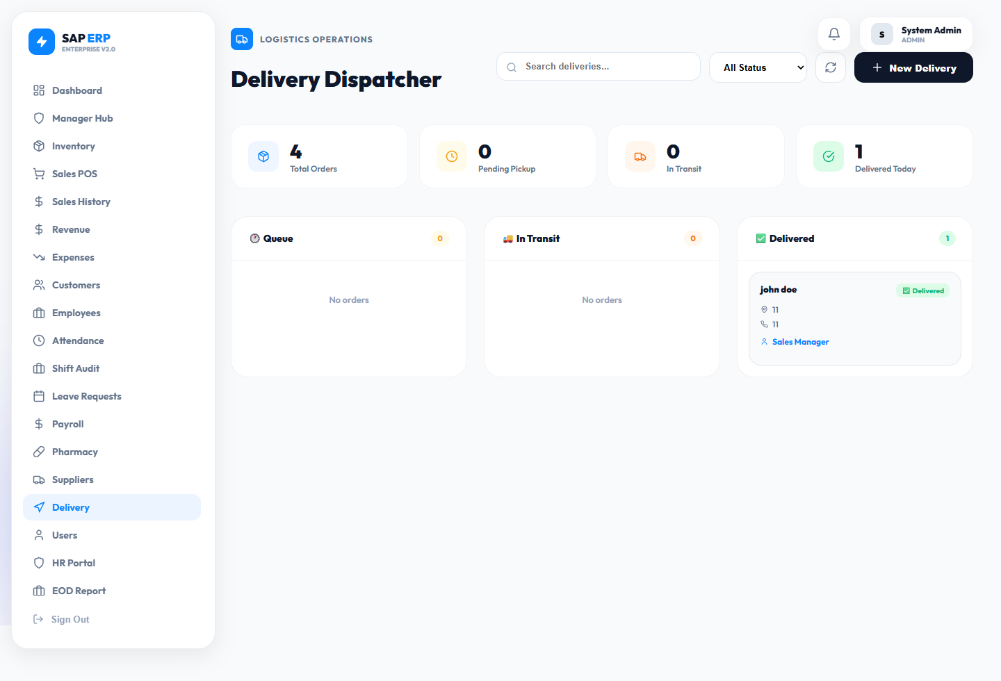

Enterprise ERP v2.0 — Confidential Documentation — June 2026

