DATA PREPARATION AND HANDLING FINAL PROJECT
Group Members:
- Arvind Neelakantan (161021191)
- Parth Manish Shah (130344203)
- Rahil Wajidali Ansari (129983201)
Dataset selected: Online Retail II Dataset.
Link: https://archive.ics.uci.edu/ml/datasets/Online+Retail+II#
Dataset Description:
The dataset contains real online retail transaction data set of a UK-based, registered, non-store online retail.
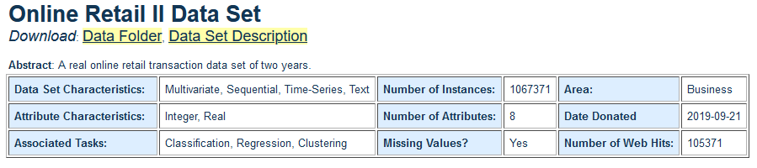
Attribute Information:
Variable Name | Description
InvoiceNo | Invoice number. Nominal. A 6-digit integral number uniquely assigned to each transaction. If this code starts with the letter 'c', it indicates a cancellation.
StockCode | Product (item) code. Nominal. A 5-digit integral number uniquely assigned to each distinct product.
Description | Product (item) name. Nominal.
Quantity | The quantities of each product (item) per transaction. Numeric.
InvoiceDate | Invoice date and time. Numeric. The day and time when a transaction was generated.
UnitPrice | Unit price. Numeric. Product price per unit in sterling (£).
CustomerID | Customer number. Nominal. A 5-digit integral number uniquely assigned to each customer.
Country | Country name. Nominal. The name of the country where a customer resides.

Preliminary Observations of the Dataset:
- Missing values:
- Country – represented as ‘Unspecified’.
- CustomerID – represented as blank.
- Description – represented as blank.

- Outliers:
- Price – Negative values
- Quantity – Negative values
- Errors in categorical variables:
- Invoice – Supposed to be a numerical column, but it contains non-numerical data for cancelled invoices (starts with the letter c). We could convert it to numerical and create a new sub category flag for cancelled invoices.
- StockCode – Supposed to be a numerical column, but it contains non-numerical data like ‘POST’ , ‘GIFT’ , ‘TEST001’ etc.

