**

## Submission by:

## **Arvind Neelakantan**

## **Rahil Ansari**

## **Parth Manish Shah**

## **Etim Emmanuel Ebam**

## Subject**- BAN140 Introduction to Data Visualization**

## Professor **– Jemisa Sadiku**

## Date **– 2 April 2021**

Course Project – **Milestone 4**

# Course Project Milestone 4

## Introduction to the Dataset Used:

* Movies and TV Shows streamed on Netflix since the year 2007 to Jan 2021. Downloaded from Kaggle (<https://www.kaggle.com/shivamb/netflix-shows?select=netflix_titles.csv> )
* Dataset consists of more than **7700** rows and **12** distinct columns with attributes such as – **Titles, Cast, Country, Director, Release year, etc.**

## Analytical Questions this report Answers:

* Movies / Tv Shows Available on Netflix Over the Years
* Country-wise Overall Top 10 Content
* Content Added in 2020 by Country
* Content Releases per month over the years
* Most Popular Genres Available on Netflix
* Top Content Ratings Available on Netflix

## Our Intended Audience:

**Netflix Top Management**

* Our analysis is meant for the **top management** at **Netflix Inc.** which includes Netflix’s **Marketing heads, Content creation** **heads** and **CEO, Reed Hastings**.
* We will try to analyze various key insights that might help Netflix in making profitable decisions.

# OUR ANALYSIS

## Movies / Tv Shows Available on Netflix Over the Years

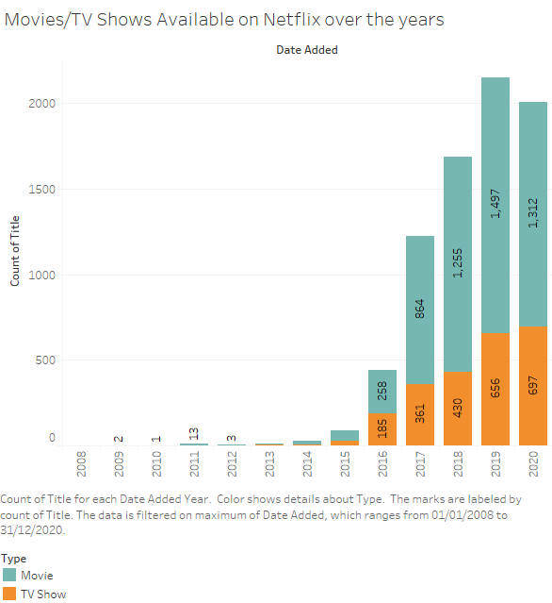

**Percentage of Movies vs Tv Shows.**

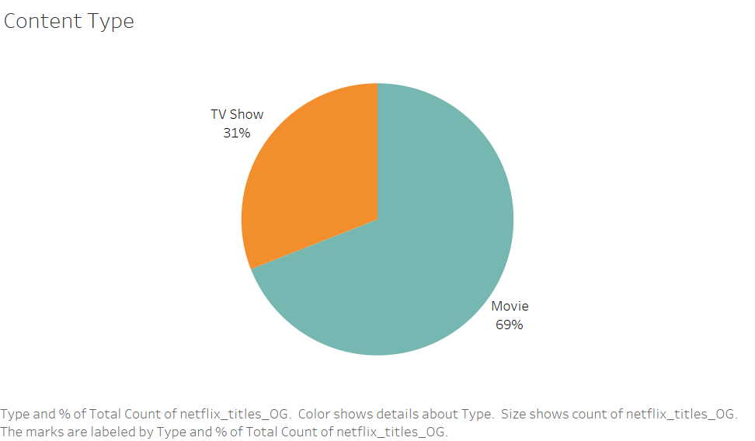

* First chart depicts the number of movies and tv shows added to Netflix yearly from 2007 to 2020. While second chart describes the ratio of movie vs tv shows i.e. **Movies – 69 %, Tv Shows – 31 %** out of the entire library.
* The **year 2015** saw a **considerable rise** in the number of content added. That is because Netflix started producing its own content in 2013, first show being House of Cards.
* Thereafter**,** the yearly addition of new movies and tv shows to the Netflix library saw an **exponential growth**.
* We see a **slight decrease** in the trend in **2020** because of the **Covid-19 Pandemic.**

### OUR RECOMMENDATION:

* It is obvious that because of the pandemic the **market for streaming services have changed**, a lot of people will stay at home and would naturally have an urge to watch interesting content.
* Netflix will have to develop a strategy where it can serve the appetite of users all over the world while also making better decisions about which kind of content to produce/upload.
* Additionally, because **people will have more time on their hand** while being at home, they will rather be interested in watching entertaining TV series over Movies which are much shorter in length.
* So, it would be recommended to Netflix to **equally focus on production of TV shows as much as movies**.

## Country-wise Overall Top 10 Content

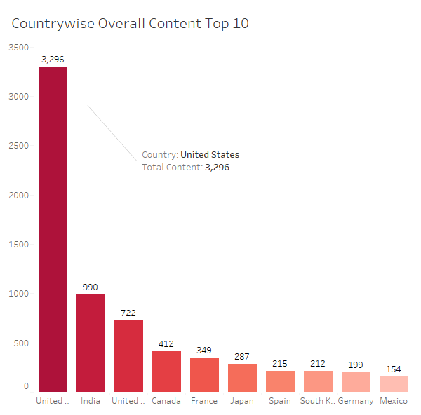

* Viewing the chart, it is apparent that the **largest producer** of content on Netflix is the **USA**  with 3296 movies and shows, followed by **India** with 990. The obvious reason is that two largest content production communities, Hollywood and Bollywood are in USA and India.

### OUR RECOMMENDATION:

* As said earlier Netflix needs to adapt to the new norm that Covid Pandemic has brought. They need to **produce more content in high return areas**, meaning that they will have to play by their strength.
* Using historical data, Netflix can produce the type of content that people have liked in recent past and then go ahead with producing in that genre. For example, **comedy movies and Documentary formats** have seen a rise in viewership. So, Netflix could focus here, take lesser risks as the new market is not totally understood.

## Content Added in 2020 by Country

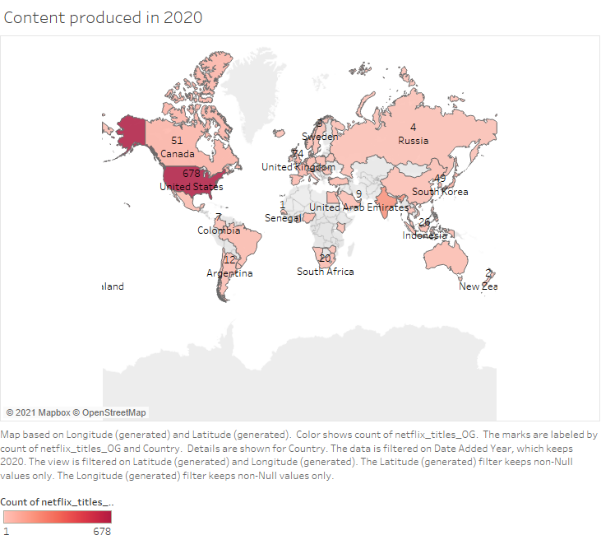

* The “**Map Chart”** depicts the amount of content added to Netflix in 2020 by different countries.
* From the map chart, we can see that **USA, India, UK and Canada** are the largest content producers in 2020.
* The spread of content also shows the rising popularity of Netflix worldwide. However, there are still some countries like in Africa and Asia which have no Netflix presence.

### OUR RECOMMENDATIONS:

* Since USA, India, UK and Canada are the major consumers of content, Netflix needs to increase the speed and frequency of content addition in these countries to leverage the growing audiences.
* They can also focus on producing exclusive original content in large consumer countries like India and USA and also emerging content producers like South Korea, whose K-Dramas and movies are rapidly gaining popularity worldwide, to maximise their returns.

## Content Releases per month over the years

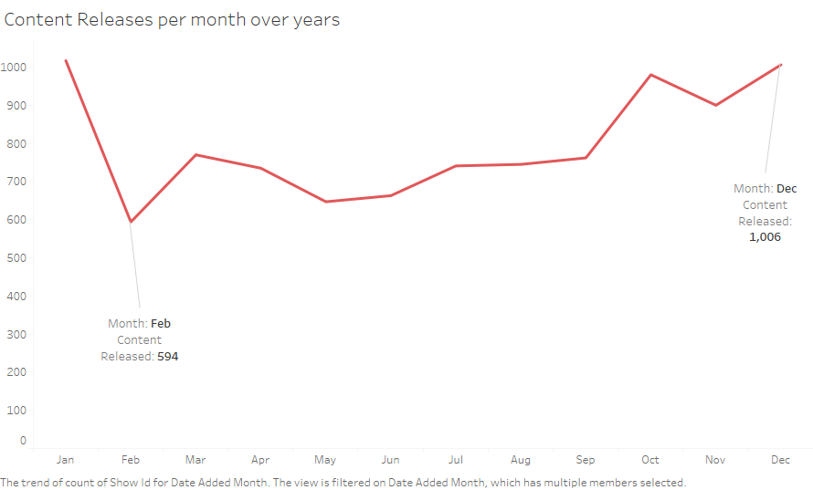

* We have also created a **“Line graph”** to analyze the frequency of new titles addition for each month.
* Looking at the Line graph we can infer that **most** of the content is added in **December & January**.
* The major reason for titles addition in these months may be because December and January are holiday seasons.
* It is also observed that **February** is the month with the **least** amount of content addition. The lower number may be due to the people losing interest after watching a lot of content in the preceding holiday season.

### OUR RECOMMENDATIONS:

* Netflix should focus on adding new and different content during the holiday season to cater to a varied range of audiences.
* They should also consider adding more content in the summer of 2021, as there are restrictions imposed worldwide forcing most people to stay at home due to the ongoing COVID-19 pandemic.
* This can help Netflix to considerably increase its viewership as well as number of subscribers.

## Most Popular Genres Available on Netflix

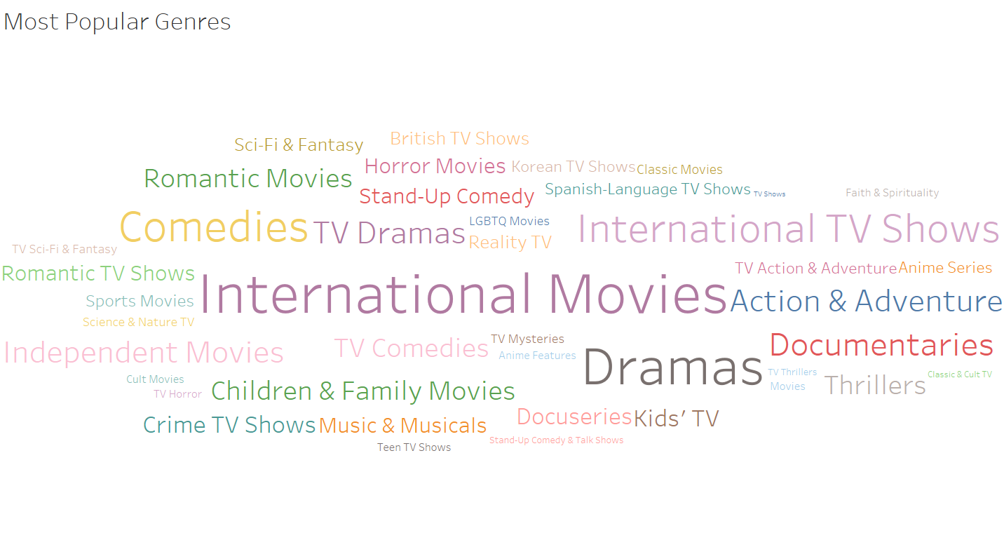

* We have used a **“word cloud”** to show the most popular genres that are available on Netflix.
* There are lot of popular genres available on Netflix. But we will be discussing the Top 5.
* The top 5 Netflix Genres:

1. International Movies / TV Shows
2. Dramas
3. Comedies
4. Action & Adventure
5. Children & Family Movies

* We can see from the word cloud that the most popular genre in Netflix is “International Movies / TV Shows.
* International Movies / TV Shows are the movies / tv shows that are produced outside of the USA.
* Other popular genres include:
* Romantic movies / tv shows
* Horror
* Anime Series
* LGBTQ movies / Tv shows

### OUR RECOMMENDATIONS:

#### Anime Series:

* **“ANIME”** is a style of Japanese Film and television animation, which are made for both **Adults & Children.**
* This genre was only popular in Japan.
* But in recent years the popularity of Anime has grown immensely and people around the world watch it.
* **Netflix should take this opportunity and start producing Netflix Original Anime’s as it will grow their viewership all over the world.**

#### LGBTQ Movies / Tv shows:

* With the LGBTQ community growing every day, and communities all over the world accepting them graciously, Netflix should start producing or streaming more content that has LGBTQ characters, cast, stories etc.
* This allows them to connect with such audiences and eventually is a great idea for developing this genre.

It should be noted that there are now several competitors like Amazon Prime, BBC, Hulu, etc. in the online streaming industry challenging Netflix on all fronts. Therefore, Netflix has pledged more thank $2 Billion to produce content in not only several genres but several languages. Netflix’s strength comes from its company culture which believes in taking right decisions and always following the instincts. Therefore, executives need to follow the cultural values as aim at telling stories through cinema that resonates with people of the community they are providing service to.

## Top Content Ratings Available on Netflix

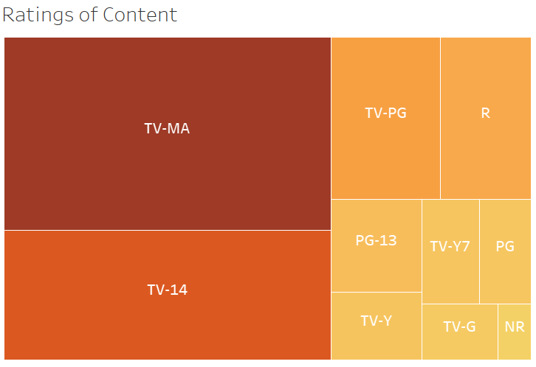

* We have used a **“Tree Map”** to show the most popular and widely available ratings for the content available on Netflix.
* **RATINGS** – This is the certification given to the movies / tv shows so that one can identify which age group the movies / tv shows are meant for.
* **We can identify the Top 5 ratings from the tree map. They are:**

1. **TV-MA:** This content is intended to be viewed by mature/adult audiences and may be suitable for children under 17.
2. **TV-14**: This program may be unsuitable for children under the age of 14
3. **TV-PG**: This program contains material that parents may find unsuitable for younger children. Parental guidance is recommended.
4. **R:** Restricted – Under 17 requires accompanying parent or adult guardian.
5. **PG 13**: Parents are strongly cautioned; some material may be inappropriate for children under 13.

* From this tree map we can see that most of the content available on Netflix is meant for mature audiences or adults.
* By comparison, the content available for other age groups and kids is pretty low.

### OUR RECOMMENDATIONS:

* Our recommendation would be that Netflix maintain a fair balance between different types of content, that can be enjoyed by all age groups.
* This will help them reach different audiences of different age groups effectively.
* So, alongside producing content for mature audiences, Netflix should also focus on producing content that can enjoyed by younger audiences as well.

# References

Thea Sokolowski (n.d.). How data drives decision-making at Netflix. Retrieved from <https://outsideinsight.com/insights/data-drives-decision-making-netflix/>

Kasey Moore (Feb 9, 2021). What Movie & TV Genres Perform Well in the Netflix Top 10s? Retrieved from <https://www.whats-on-netflix.com/news/what-movie-tv-genres-perform-well-in-the-netflix-top-10s/>

Brian Lloyd (2016). 11 Suggestions For Netflix To Make It Better For Everyone. Retrieved from <https://entertainment.ie/tv/tv-news/11-suggestions-for-netflix-to-make-it-better-for-everyone-211501/>

Jemisa Sadiku (2021). Lecture Slides. For analytical charts and design principles.