**ImageJ plugin for analysis of porous scaffolds used in tissue engineering**

Morteza Haeri 1

1. Center for Biomaterials, University of Connecticut Health Center, Farmington, CT, USA.

**Abstract**

ND is an image processing plugin that can be used to calculate the average size and distance between particles and their closest neighbors in many-particle systems. It is written in Java and implemented in ImageJ, the open source Java-based software developed by National Institute of Health (NIH). ND is particularly useful in analysis of porous synthetic and natural constructs (known as scaffolds) that are commonly used in the field of regenerative medicine and tissue engineering. Architecture of these scaffolds including pore size and density significantly affects the behavior and fate of cells cultured on them. ND adds to the built-in functionalities of ImageJ to provide a fast and user-friendly method to better characterize the porosity of these scaffolds.

**Keywords**

ImageJ, porosity characterization, scaffold, nearest neighbor distance

1. **Overview**

*Introduction*

ND is an ImageJ plugin that was developed to calculate the average size and distance between pores and their nearest neighbors in a porous scaffold by using images of the scaffold as input. The architecture of the porous scaffolds including pore size distribution and density dramatically affects their interaction with biological cells and mechanical properties of the scaffold [1-5]. Therefore, characterization of fabricated scaffolds using microscopy techniques and subsequent processing of the images is an essential step in correlating a specific cell-scaffold response with an effective scaffold design. Although ImageJ is taking center stage as a reliable open source and user-friendly tool for image processing in the biomedical field, image analysis is done either manually or by using propriety software associated with microscope companies or other commercial software whenever specialized plugins for ImageJ are not available. ND is an example of a specialized plugin that builds upon the built-in functionalities of ImageJ, and contributes to the collective efforts to enrich its library of available plugins and advances its versatility in image processing.

The main usage of the ND plugin is to analyze the wall thickness and average spacing of particles/pores/tubules located randomly in a sample. The plugin uses an image of the sample as input and outputs a result table listing the average distance of each particle from its neighbors, nearest neighbor distance, and the average wall thickness of its neighbors. The number of neighbors to be accounted for in calculating the averages is set by the user.

*Implementation/Architecture*

The plugin was written in Java, using the ImageJ built-in Java compiler.

*Installation*

To install the plugin, ImageJ must be installed first. ImageJ can be downloaded from

http://rsbweb.nih.gov/ij. Variants like Fiji (http://fiji.sc/) may also be used.

ND\_.java file should be downloaded to the plugins folder of the ImageJ installation.

The ND\_.java file should be compiled for the first time using Plugins -> Compile and Run …. .

On restarting ImageJ, the plugin will appear under the menu Plugins. Alternatively, the already compiled file (ND\_.class) can be downloaded and placed in the Plugin folder of ImageJ installation. Prior to running the ND plugin, an image should be opened first and the Results table must have records including centroid coordinates of the particles that need to be analyzed. (Centroid and Fit ellipse must be checked under Analyze͢͢͢͢͢͢ -> Set Measurements). The user may run Analyze -> Analyze Particles built-in Plugin to generate a Results table needed by the ND Plugin. Messages will be displayed in case any of the above conditions are not met and users will be directed on how to proceed.

*Algorithm*

In a close packed configuration of particles/fibers having a circular cross section in 2D space there are 6 immediate neighbors surrounding each particle. In randomly packed systems, coordination number depends on the visual perception and can be lower or higher. Estimation of particle spacing of a particle with its neighboring particles is performed as follows:

1. The centroid coordinates of each particle (X,Y) is derived from the result table of the built-in Analyse Particles plugin.
2. A circle is fit on each particle with the center (X,Y) and radius r.
3. The spacing (wall thickness) between a pair of particles (d) is calculated as: 

*r1*

*d*

*r2*

.

.

1. The distances of each particle with all the other particles is stored in an array and sorted.
2. Depending on the coordination number of interest, average of the distances is calculated.
3. Results are shown in a new result table, which contain the distance of the closest neighbor to each particle, the average wall thickness, and the average distance of the closest neighbors.

*Quality Control*

Functional testing, load testing and end-to-end testing were carried out in Microsoft Windows 7- 64 bit. The ND Plugin functions as expected and results were manually verified.

*Example of Use*

*Measurement of tubule/fiber diameter and their spacing in tubular scaffolds or fiber reinforced composites*

The main usage of the ND plugin is to analyze the size and spacing of particles/pores/tubules located randomly in a sample. While the size of particles can be estimated using the built-in “Analyze Particle” plugin in ImageJ, the spacing between the features cannot be estimated. Fig. 1 shows an example of a tubular scaffold used in tissue engineering, which was analyzed using ND plugin. ND provides this ability for the user to calculate the spacing between each particle/pore and its n closest neighbors with n being the coordination number of interest (Fig. 2). Additionally, the histogram of the average distances of the closest neighbors provides a quantitative measure of how uniformly the feature of interest is spatially distributed. Initially, preliminary steps need to be taken for the plugin to do its function. These steps are as follows:

1. Open the image (File -> Open)
2. Threshold the image to make the feature of interest evident (Image -> Adjust -> Threshold)
3. Run the built-in Analyze Particles ( Analyze -> Analyze Particles)
4. Run the ND plugin (Plugins -> ND)

The result table which outputs the average distance between tubules, the average wall thickness, and the distance of the closest neighbor distance for each tubule is shown in Fig. 2.

D:\Users\Morteza\Documents\papers\Journal of open research software\test run files\tubular p(EMA-co-HEA) scaffold_scale bar.tifD:\Users\Morteza\Documents\papers\Journal of open research software\test run files\Drawing of tubular p(EMA-co-HEA) scaffold_outlined.tif

Fig. 1: Scanning electron micrograph of a tubular scaffold used in tissue engineering (left) and its segmentation after using built-in Analyze Particles ImageJ plugin (right).

**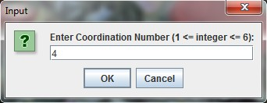**

**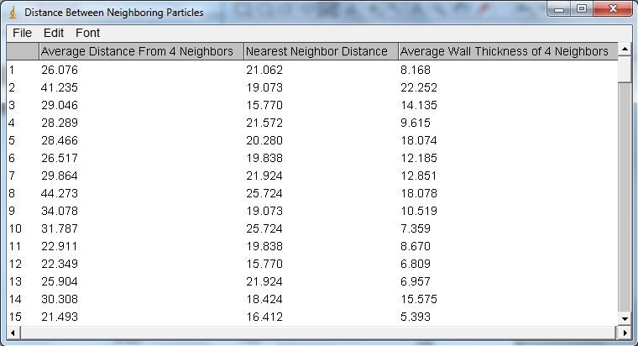**

Fig. 2: ND plugin running. Input window to take the coordination number of interest to the user (top) and the generated result table listing the average distance of each particle from its neighbors, nearest neighbor distance, and the average wall thickness of its neighbors (bottom).

**(2) Availability**

*Operating system*

ImageJ runs and is used on different versions of Unix, Mac OS X, and Windows.

*Programming Language*

Java

*Additional system requirements*

None at runtime

*Dependencies*

At runtime, the plugin requires ImageJ to be running

*List of contributors*

Morteza Haeri

Archive

*Code Repository Name*

Github

*Persistent Identifier*

<https://github.com/sedmorteza/ND/blob/master/ND_.java>

*Identifier*

https://github.com/sedmorteza/ND.git

*Publisher*

Morteza Haeri

*License*

GNU General Public License version 3

*Date published*

2013-09-24

1. **Reuse Potential**

*Measurement of pore size distribution and fiber thickness in electro-spun fiber mats*

Alternatively, in electro-spun fiber mats, ND can be used to estimate the average pore size as well as the average fiber size and distribution.

*Detection of co-localization*

A common measure used in biology is object-based co-localization (OBC). In OBC, the nearest neighbor distances (NND) from one point pattern to the other is plotted as a histogram and then a threshold distance is set (typically, the `diffraction-limited resolution' of ~ 200 nm), so that all points with a NND less than the threshold is considered `co-localized. ND plugin can easily be modified to provide this functionality.

**References**

1. **Scott JB, Afshari M, Kotek R, Saul JM**. 2011 The promotion of axon extension in vitro using polymer-templated fibrin scaffolds. Biomaterials, **32**(21): 4830-4839. DOI: <http://dx.doi.org/10.1016/j.biomaterials.2011.03.037>.
2. **Martínez-Ramos C, Vallés-Lluch A, Verdugo JM, Ribelles JL, Barcia Albacar JA, Orts AB, Soria López JM, Pradas MM**. 2012 Channeled scaffolds implanted in adult rat brain. Journal of Biomedical Materials Research A, **100**(12): 3276-3286. DOI: <http://dx.doi.org/10.1002/jbm.a.34273>.
3. **Oh S, Brammer KS, Li YS, Teng D, Engler AJ, Chien S, Jin S**. 2009 Stem cell fate dictated solely by altered nanotube dimension. Proceedings of National Academy of Sciences, **106**(7): 2130-2135. DOI: <http://dx.doi.org/10.1073/pnas.0813200106> .
4. **Karageorgiou V, Kaplan D.** 2005 Porosity of 3D biomaterial scaffolds and osteogenesis. Biomaterials, **26**(27): 5474-91. DOI: <http://dx.doi.org/10.1016/j.biomaterials.2005.02.002>.
5. **Peng-Yuan W, Lauren RC, Helmut T, Wei-Bor T, Nicolas HV**. 2013 High-throughput characterisation of osteogenic differentiation of human mesenchymal stem cells using pore size gradients on porous alumina. Biomaterials Science, **1**(9): 924-932. DOI: <http://dx.doi.org/10.1039/C3BM60026B>