ISM 6225

Distributed Information Systems

Assignment 4 – Stock Picking

ProjectGroup 22

RAHIL SHAIK

AAYUSH KUMAR

1. **Github repository link**

[**https://github.com/rahilshaik/2018_Fall_Assignment4_ActiveCloudSite**](https://github.com/rahilshaik/2018_Fall_Assignment4_ActiveCloudSite)

1. **Program result screen shots**

**Top Stocks**

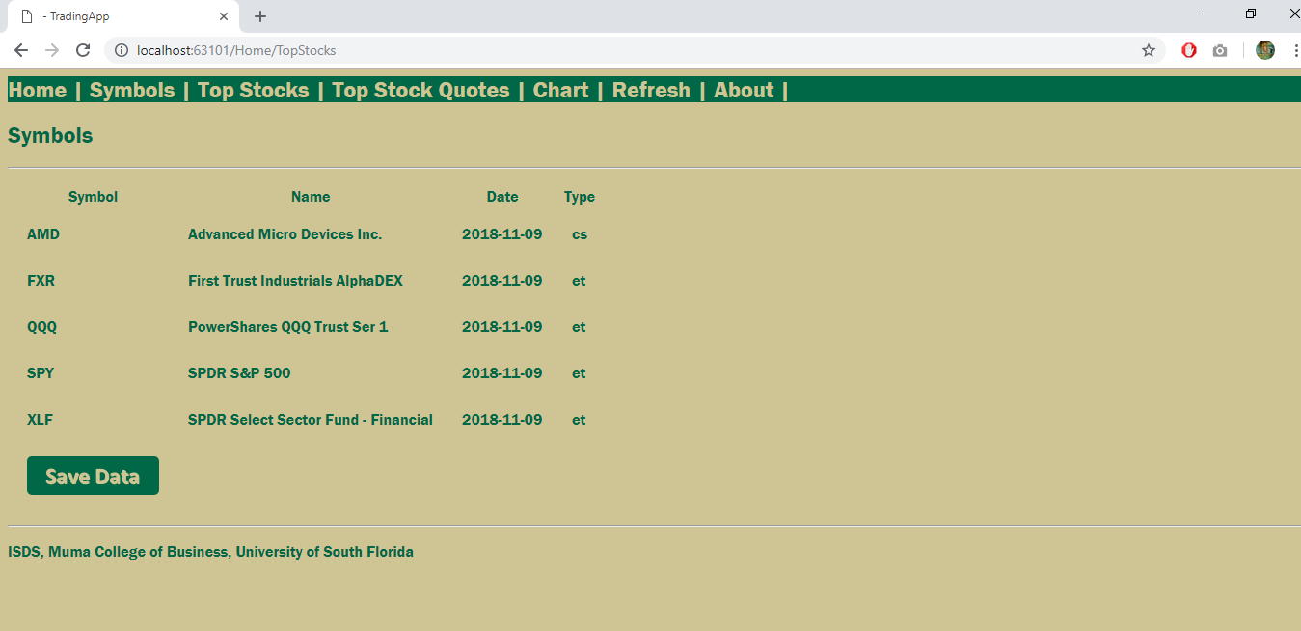

**Top Stock Quotes**

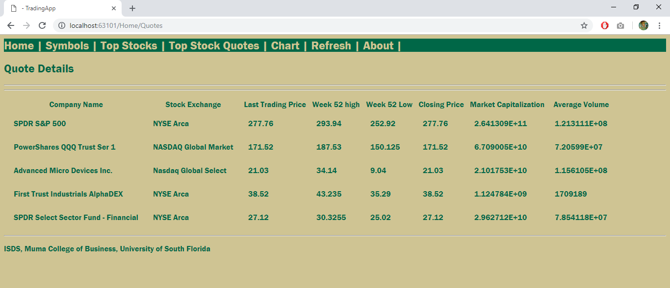

**Self-Reflection and Stock Picking Strategy Description:**

