ISM 6225

Distributed Information Systems

Assignment 2 – Object oriented Programming Introduction

ProjectGroup 22

RAHIL SHAIK

AAYUSH KUMAR

1. **Github repository link**

**https://github.com/rahilshaik/Assignment_LinkedList**

**https://github.com/Aayush963/Assignment_LinkedList**

1. **Program result screen shots**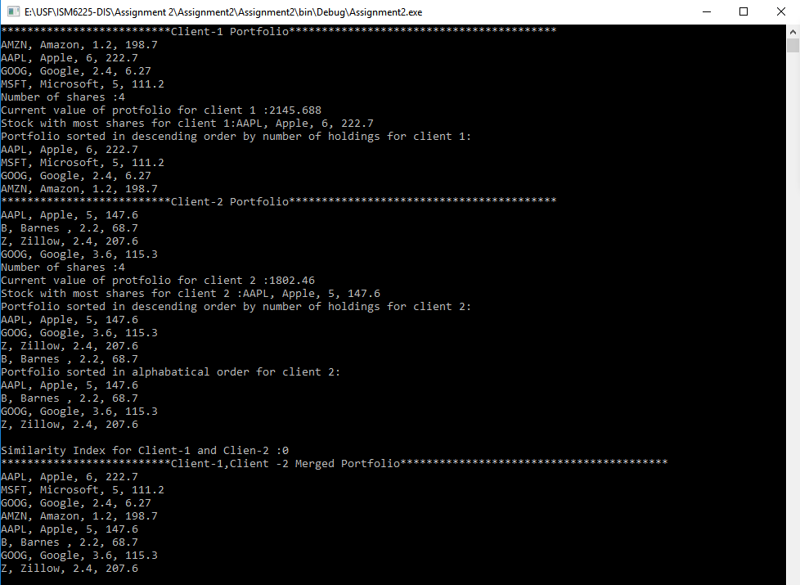
2. **Git Commits by user**

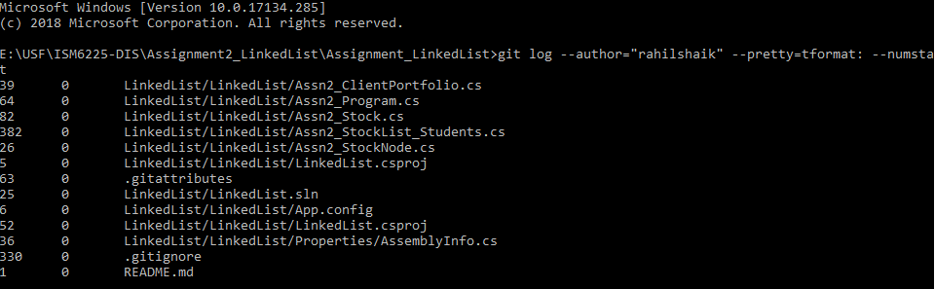

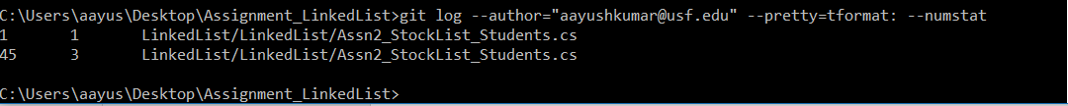

**Self-Reflection:**

**Rahil Shaik**

1. I have spent for a total of 12 hours on this assignment for our respective tasks to implement.
2. I have implemented **SortByValue**, **SortByName**, **MergeList**, **Similarity** methods.
3. In this process, I have learnt how the linked lists function and ways to access any object in linked list and iterate them. Also, we got an opportunity to work on override method to make object. Equals method work for value equality feature which is required for this assignment.
4. I have learnt using Git Hub to create the repository and check in the code into the repository.
5. Also, I have used online VSO to create a private repository (**https://rahilshaik.visualstudio.com/_git/Assignment2**) and created separate branches to work on our respective tasks. Once the code is done, we have merged those changes from respective branches to master branch to avoid conflicts.
6. As a suggestion, it would be very much useful if we get a chance to work on constructors, Inheritance and abstract methods which are required in the software development projects.
7. We have not covered anything about interfaces, Overloading concepts in the current assignment. Hence, it would be useful If we also work on them as they are frequently used in the development process irrespective of language.

**Aayush Kumar**

1. I’ve spent 15 hours to complete my assigned methods
2. I have implemented **MostShares**, **Length**, **Value**, **Print** methods.
3. I became familiar in accessing objects, methods from other classes. I learnt about linked lists and approach to traverse through the linked list.
4. I became familiar in using Git Hub and check in the code to the repository.
5. It would be useful if we become familiar with OOPS concepts in C# and implement abstract methods, interfaces.