Assignment:

1)Modify the GitHub workflow to add a new stage to deploy into Prod s3 after Non-prod S3 sync,but execute the stage only after an approval

Automation workflow operates from a developer's local machine all the way to production.1.
Terraform Workflow
Below is the 3 step foundational Terraform command cycle:
- terraform init: Initializes working directory by downloading required provider plugins (like AWS) and setting up your backend state configuration.
- terraform plan: Generates an execution preview comparing desired configuration against the actual state in AWS and lists out exactly what resources will be created, modified, or destroyed.
- terraform apply: Executes the approved plan,

2. Terraform Development Lifecycle (Branching & Promotion)
To maintain high stability and prevent unauthorized changes, AWS follow a strict branching and promotion strategy through GitHub:
- Feature Branching: Code is pushed to main branch and then to the feature branch.
- Local Validation: code is tested locally inside the respective environment folder (environments/non-prod or environments/prod), running init and plan to verify changes.
- Pull Request & Automated Quality Gates: Open a Pull Request (PR) is opened against the main branch. Automated CI/CD pipeline triggers quality checks, security scans (SAST/SCA), and validation.
- Code Review & Merge: Once peer-reviewed and approved, PR is merged automatically into main triggering the deployment pipeline to apply the infrastructure changes.

3. Executing Terraform Across Environments (Best Practices)
Managing multiple environments safely requires a structured directory layout and automated pipelines to eliminate human error:
- Directory Isolation: We separate environments into distinct folders (e.g., environments/non-prod and environments/prod) using modular architecture (modules/). This guarantees that experimental changes in non-production environments never bleed into production.
- State Management: Each environment maintains its own isolated remote state file backend to prevent state lock conflicts and corruption.(Terraform.tfvars)
- Automated CI/CD Execution: Rather than running apply locally on our laptops, production and non-production deployments are fully automated through our GitHub Actions CI/CD pipeline.
- Approval Gates: For production deployments, our pipeline enforces strict manual approval gates. Post manual review and approval ,Terraform modifies production infrastructure.
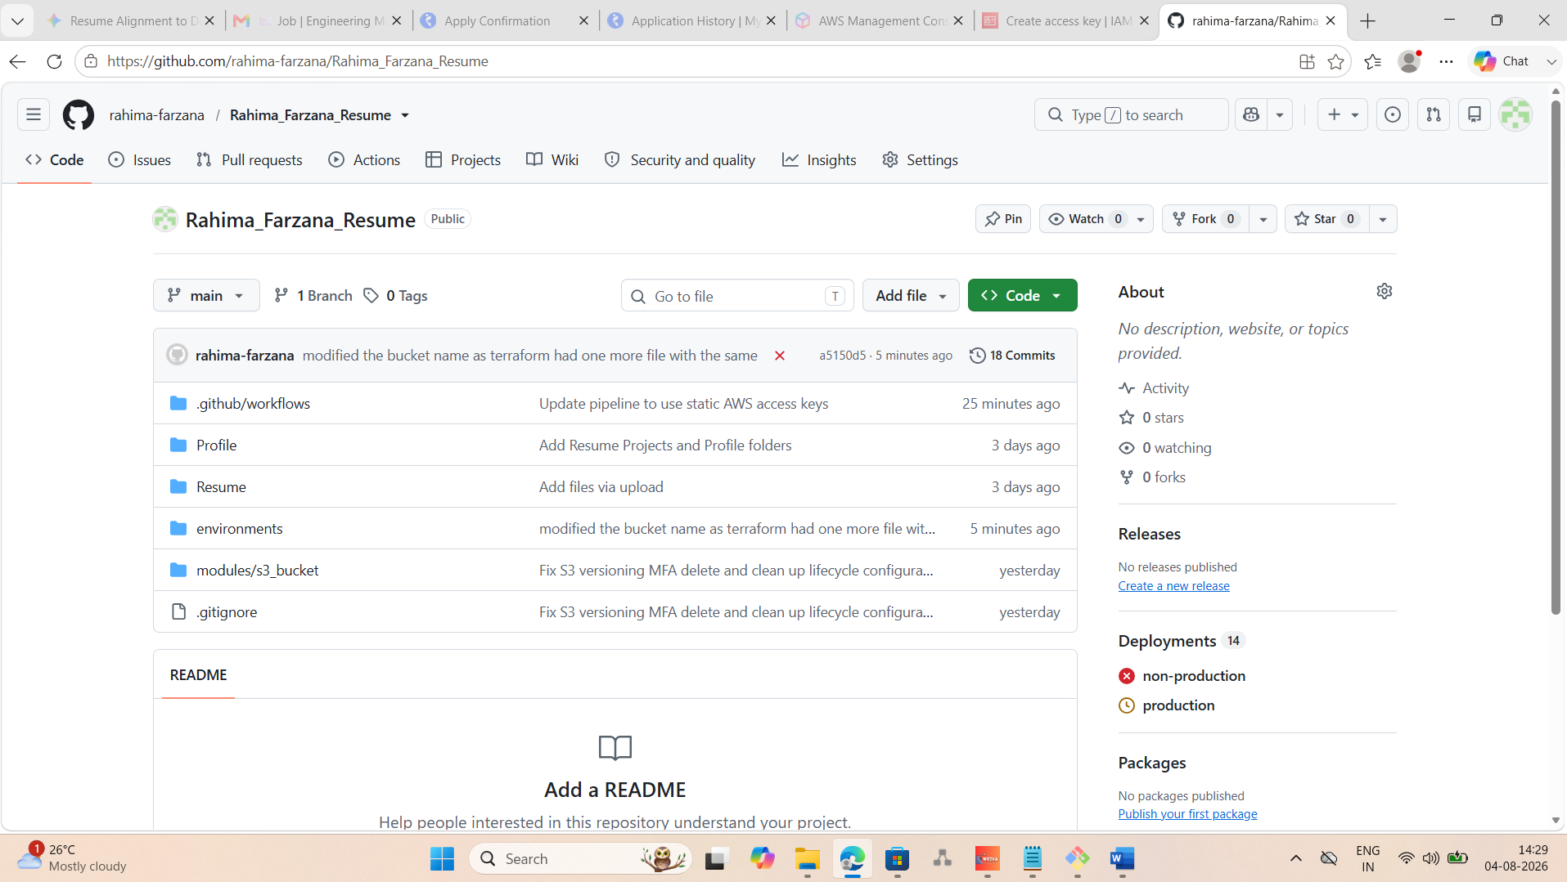

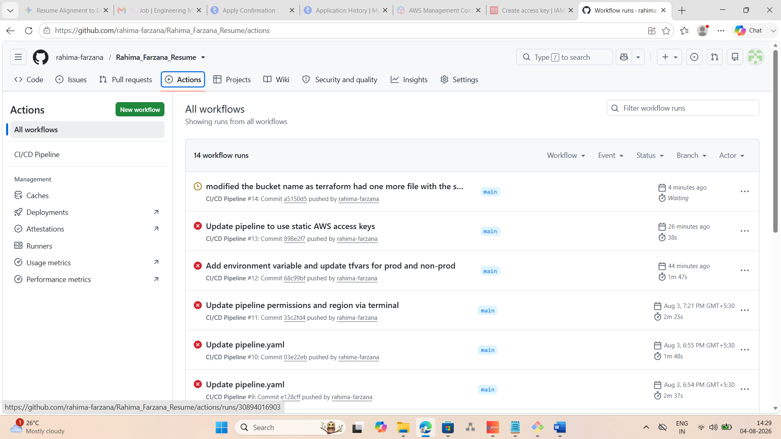

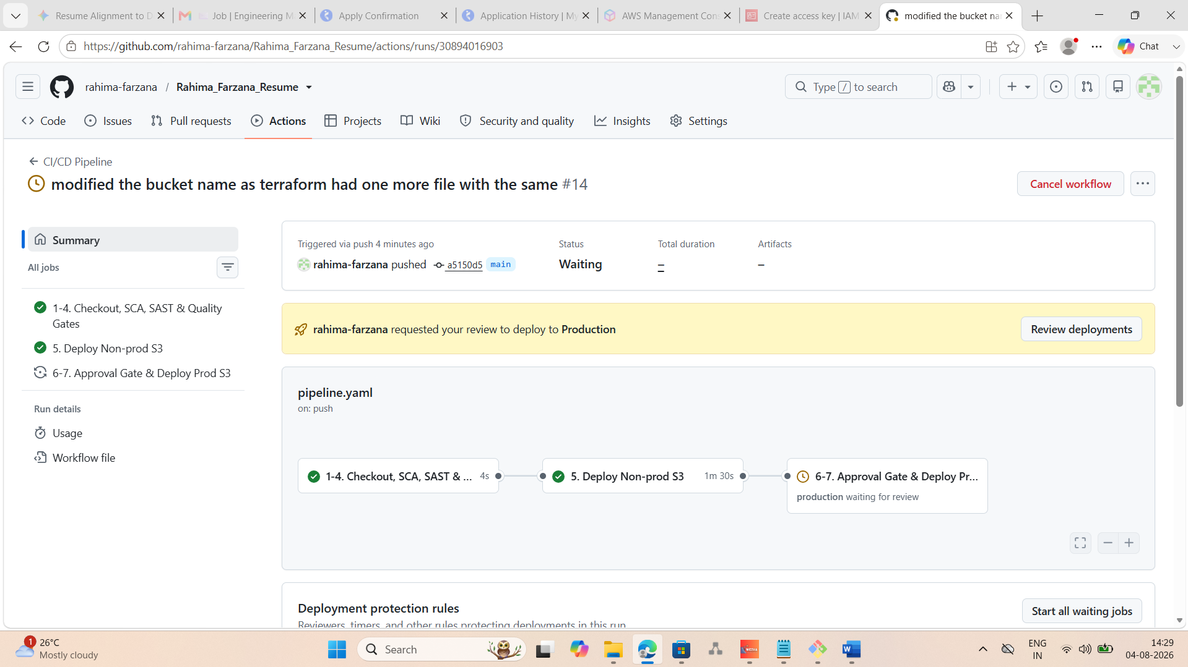

Below screenshot shows the approval process where senior engineer reviews the code and then approves to push the code to production environment.
