 | SIMATS ENGINEERING  Department of Computer Science and Engineering
CSA15 Cloud Computing and Big Data Analytics
CO3 AT2 - Capstone Cloud Access and Service Integration Case Study Student Template
Course Code | CSA1512 | Course Title | Cloud Computing and Big Data Analytics
Assessment | CO3 AT2 - Capstone Cloud Access and Service Integration Case Study | Submission Type | Individual digital case-study document
Faculty | Dr C. Rajesh Babu | Employee ID | SSETSCS415
Mode | Case study / capstone design reasoning | Submission | GitHub repository link through Google Classroom

How This Template Works
Read each case, connect it to the technical ideas learned in CO3 AT1, and then extend the design to your own capstone product. The answer must show cloud access, APIs, storage, serverless/event flow and edge/fog/cloud reasoning. Do not upload passwords, private keys, API tokens or sensitive personal data.

Student and Capstone Details
Student Name | RAHIMA BANU N
Register Number | 192525009
Class / Slot | Slot B
Capstone Title | CareRoute Cloud Ambulance Dispatch Optimizer Using ETA and Severity Analytics
CO3 AT1 Evidence Link | https://github.com/rahimabanu2108-blip/CSA1512_CLOUD_COMPUTING_ASSESSMENTS.git
GitHub Repository Link | https://github.com/rahimabanu2108-blip/CSA1512_CLOUD_COMPUTING_ASSESSMENTS.git
Submission Date | 14-Aug-2026

Case 1: Cloud-Native Backend and Web API Architecture
Scenario
A food delivery company wants to deploy a cloud-native backend with web APIs, browser/mobile clients and shared cloud storage for receipts and delivery images. Design the architecture and explain the role of each component.

A. Case Architecture Diagram
.
Browser//mobile client
Autntication service

Rest api gateway

Cloud Backend/Serverless Functions

Database
Object Storage
Notification Service

SMA/App alert servity data documents
ETA
Ambulance

B. Component Role Explanation
• Browser/Mobile Client – sends ambulance request and displays live status.
• Authentication – verifies the user before API access.
• REST API – provides secure endpoints for request, ambulance, ETA and status operations.
• Backend/Serverless Logic – validates requests, calculates priority/ETA and triggers events.
• Database – stores users, incidents, ambulance status, severity and ETA records.
• Object Storage – stores reports, documents and images.
• Notification Service – sends dispatch/status notifications.
• Logs & Monitoring – records errors, API activity and system health.

C. Capstone Extension: user-to-cloud workflow for your product
1. User opens the CareRoute web/mobile application.
2. User signs in and sends an emergency/ambulance request.
3. HTTPS request reaches the REST API.
4. Authentication is checked.
5. Backend reads incident severity and available ambulance data from the database.
6. ETA/priority logic selects a suitable ambulance.
7. Assignment is stored in the cloud database.
8. Notification event is triggered for the ambulance/user.
9. The client receives the response and displays ambulance status and ETA.
10. Logs and monitoring record the transaction.

Case 2: Storage and Serverless Upload Workflow
Scenario
A media startup must decide between SAN-backed storage, object storage and serverless processing for upload workflows. Recommend a deployment model and justify it.
Data / Event | Best Storage | Serverless Action | Reason
Patient/incident metadata | Cloud database | Validate and store record | Structured, frequently queried data.
Ambulance/location update | Cloud database | Update status and ETA | Small frequent updates need fast access.
Reports/documents/images | Object/blob storage | Trigger file validation/metadata extraction | Scalable and cost-effective for files.
New dispatch event | Object/database event source | Serverless function sends notification and updates dispatch state | Event-driven processing avoids always-on servers.

A. Storage and Serverless Recommendation
Storage and serverless recommendation:
Use cloud database storage for structured CareRoute records and object/blob storage for reports or images. Use serverless functions for event-driven processing such as file validation, dispatch-state updates and notifications.

B. Failure Handling and Cost/Performance Explanation
Failure handling:
• Retry temporary serverless failures.
• Use validation before writing records.
• Keep event processing idempotent so the same event does not create duplicate dispatches.
• Log failed events for monitoring and later review.
• Use database backups and object-storage versioning where available.
Cost/performance:
Object storage is better than SAN-style storage for large files because it scales easily. Serverless is suitable for irregular event-driven workloads because compute runs when triggered. A managed cloud database is suitable for structured, frequently accessed operational data.

C. Capstone Extension: one upload/event workflow
Capstone upload/event workflow:
Ambulance/report image upload
↓
Cloud Object Storage
↓ upload event
Serverless Function
↓
Validate file + create metadata
↓
Cloud Database
↓
Notification / API response
↓
CareRoute Web/Mobile Client
This keeps file storage separate from application data and uses serverless processing only when an upload event occurs.

Case 3: Edge, Fog and Cloud Placement
Scenario
A smart-city platform needs low-latency decision-making near sensors while still using the cloud for analytics. Decide what runs at edge, fog and cloud.
Task | Layer | Latency Need | Data Volume | Reason
Emergency alert filtering | Edge | Very low | Low | Immediate local filtering reduces response delay.
Traffic/ambulance status aggregation | Fog | Low | Medium | Fog layer combines nearby device data before cloud upload.
ETA and severity analytics | Cloud | Moderate | High | Cloud has scalable compute and historical data for analytics.
Long-term reports and dashboards | Cloud | High | High | Historical storage and analytics benefit from centralized cloud resources.

A. Edge/Fog/Cloud Architecture Explanation
Edge/Fog/Cloud architecture:
Ambulance GPS / Mobile Sensors
↓
EDGE
local filtering + immediate alert check
↓
FOG
nearby aggregation + temporary processing
↓
CLOUD
REST API + database + serverless + analytics
↓
ETA / severity results + dashboards
↓
Browser / Mobile Client
Reason: time-critical decisions stay close to the source, while large-scale analytics and storage remain in the cloud.

B. Capstone Extension or Direct Cloud Access Justification
Capstone cloud-access justification:
CareRoute needs secure direct cloud access through HTTPS REST APIs for user and ambulance applications. The API provides one controlled entry point and authentication before backend operations. Structured operational data is stored in a managed cloud database, while reports/images can use object storage. Serverless functions handle event-driven tasks such as notifications and status updates. Edge/fog processing can reduce latency for immediate sensor or location filtering, while the cloud performs historical ETA and severity analytics.

Final Capstone Cloud Access Architecture
☐ Show Browser/Mobile Client.
☐ Show hosted frontend or app access path.
☐ Show REST API endpoint and authentication check.
☐ Show backend/serverless logic.
☐ Show database, object/blob storage, logs and monitoring.
☐ Label the arrows: request, response, upload, event, notification or monitoring signal.

Final Diagram and Explanation
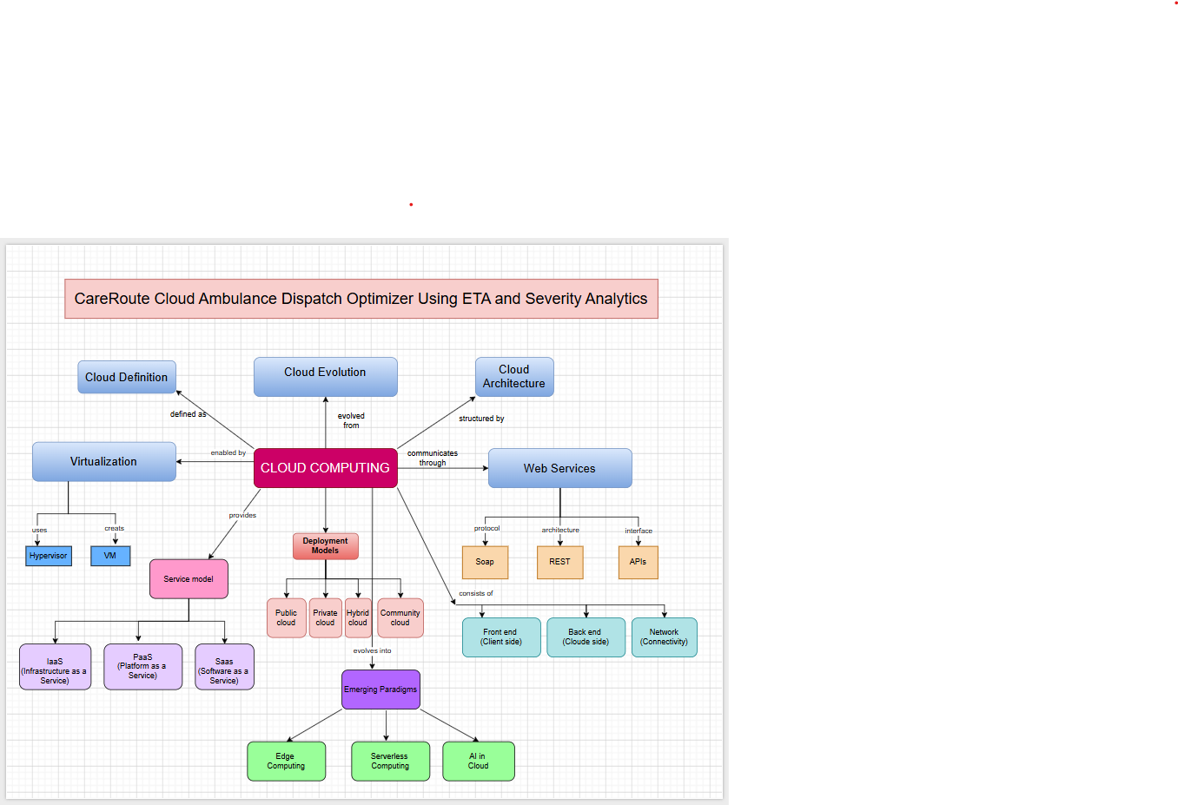

Submission Checklist
☐ Template completed in DOCX format.
☐ Diagrams pasted clearly in the document.
☐ GitHub repository contains DOCX/PDF, diagrams and README.
☐ Google Classroom submission contains GitHub link.
☐ Sensitive credentials are not visible anywhere.

Student Assurance
Declaration
I confirm that this case-study answer, cloud access design, diagrams and capstone extensions were prepared individually by me for the stated capstone title.
Student Signature: RAHIMA BANU N Date: 14-Aug-2026

