CSA1512 CLOUD COMPUTING AND BIG DATA ANALYTICS
NAME: RAHIMA BANU N SLOT:B
REG NO:192525009 FACULTY NAME: Dr Rajesh Babu C
EXPERIMENT 1:
OVERVIEW:
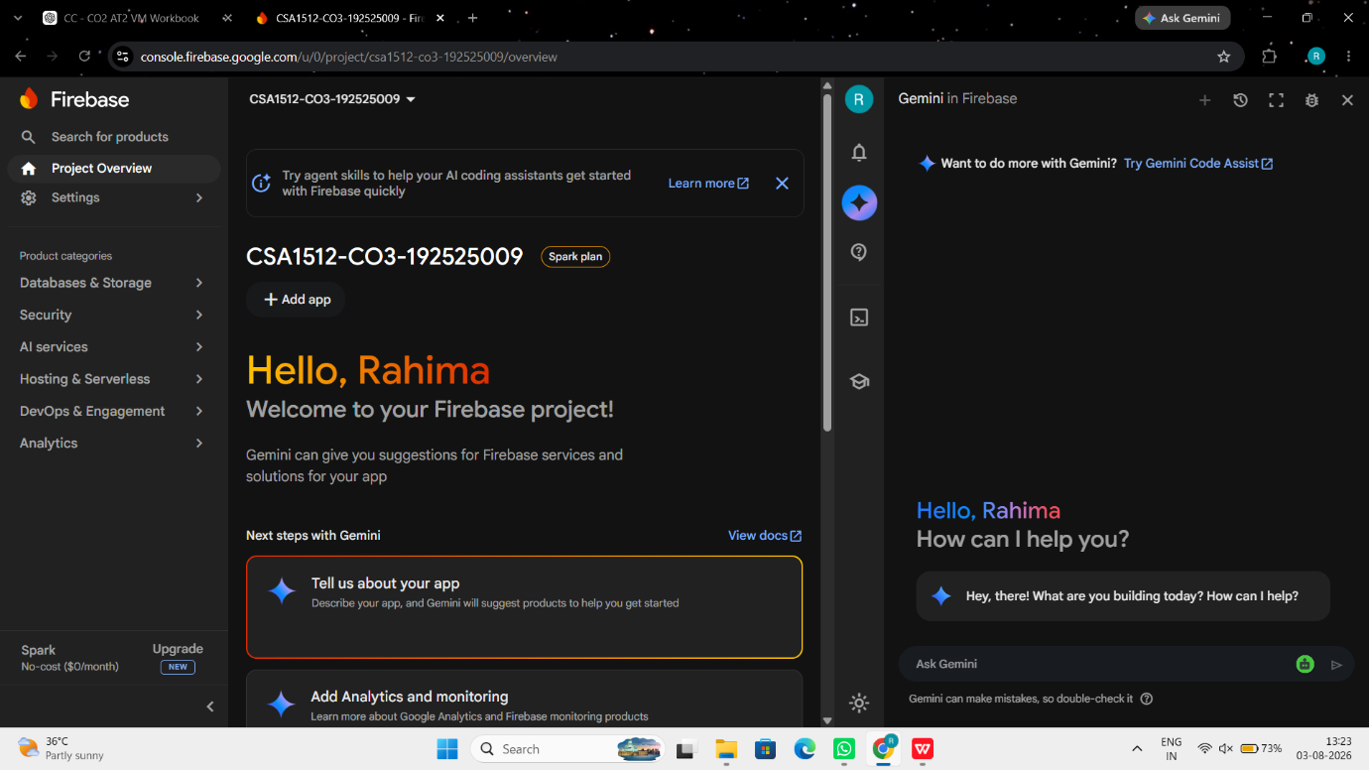
STORAGE:
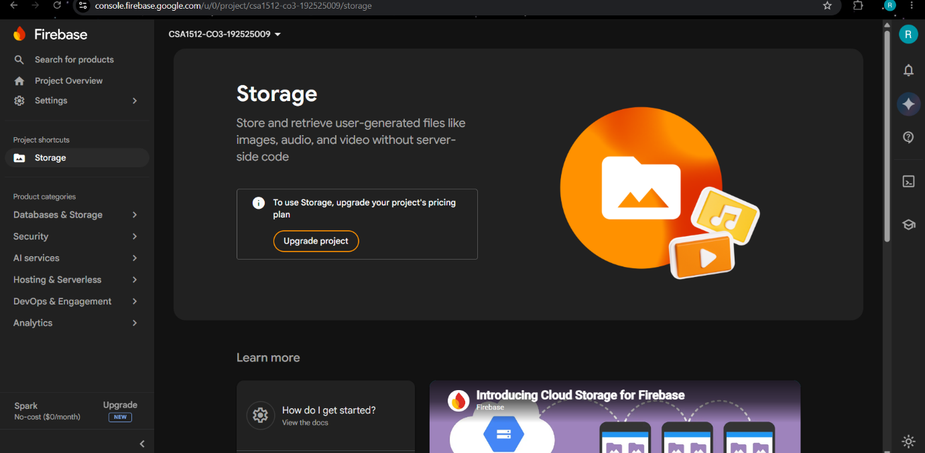

DIAGRAM:
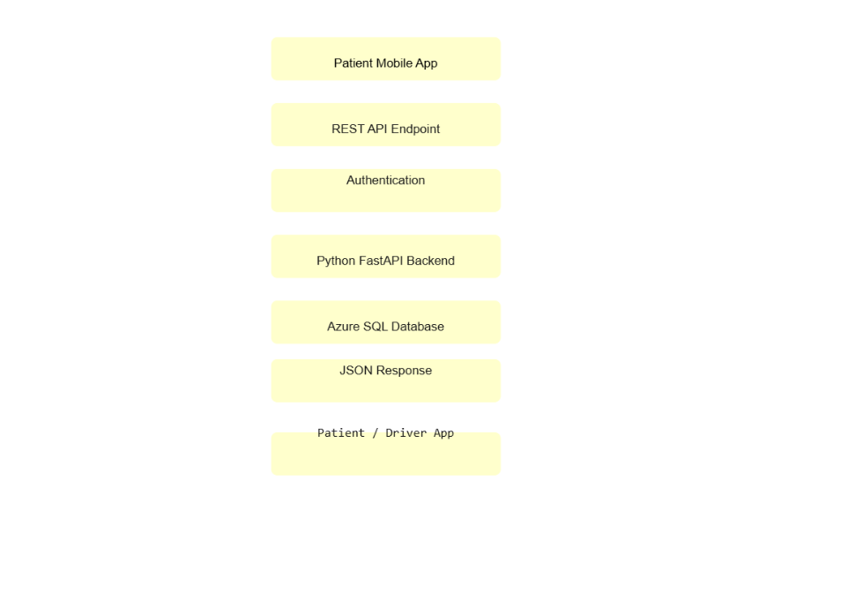
EXPERIMENT 2:
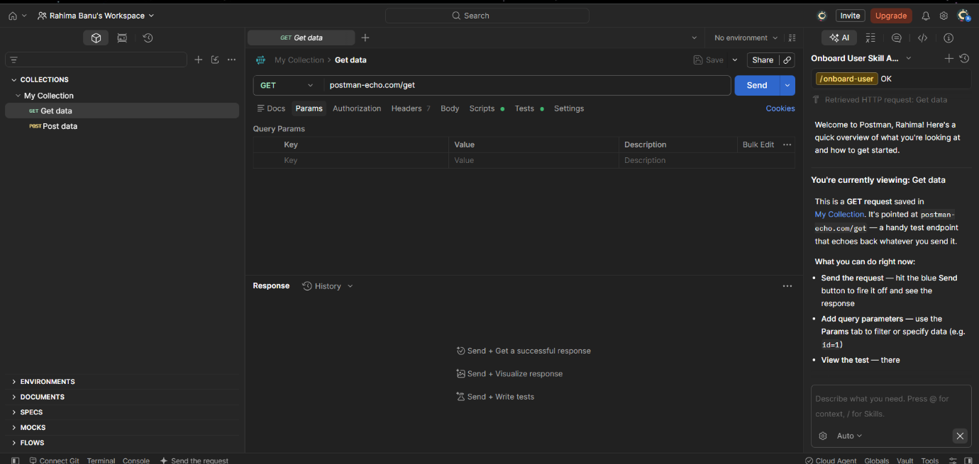
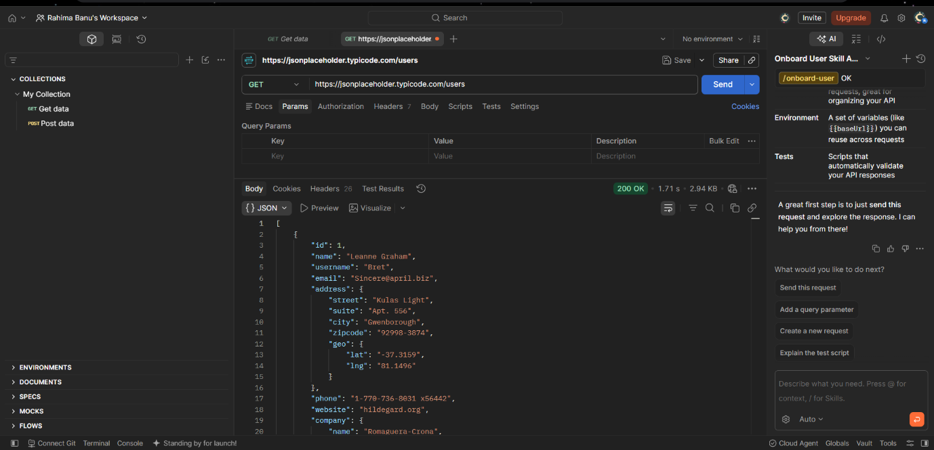
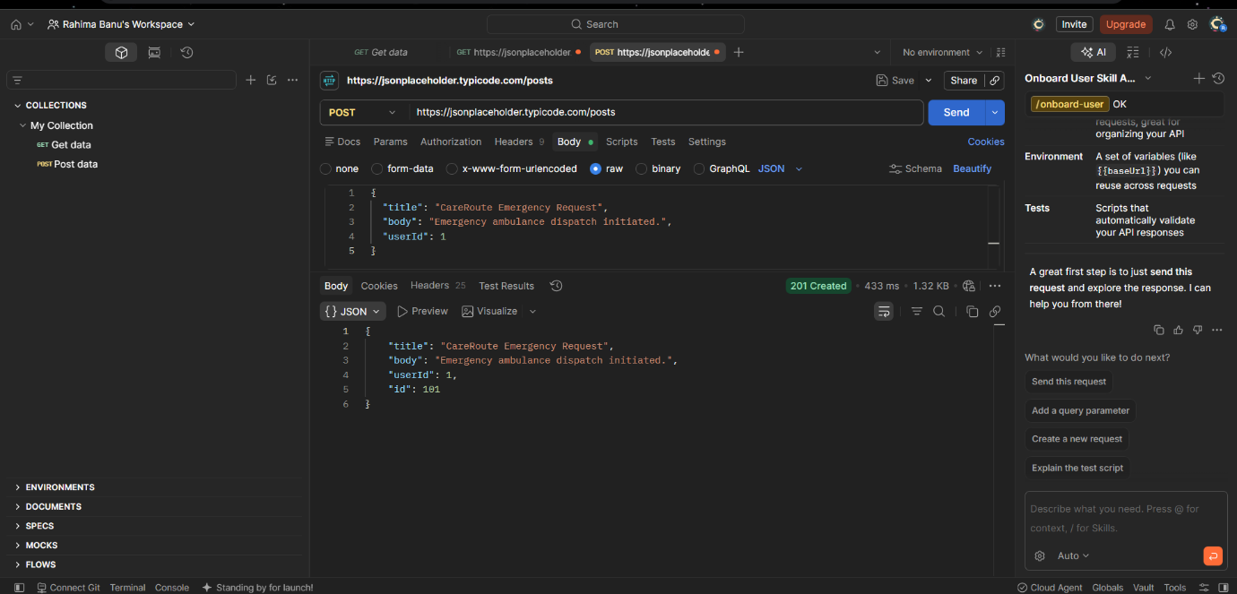
DIAGRAM:
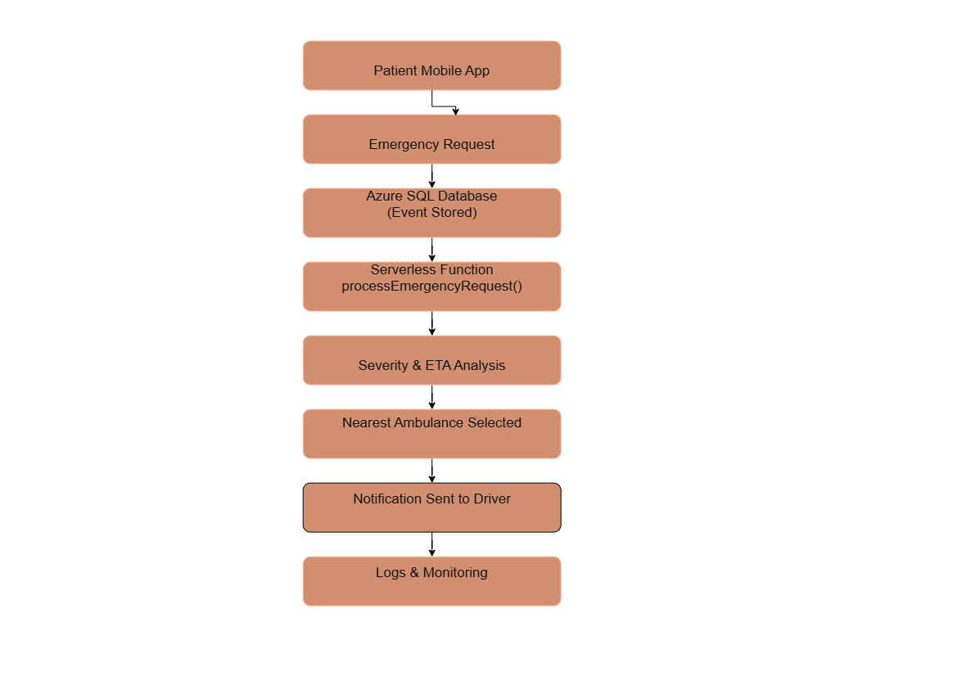

EXPERIMENT 3:
DIAGRAM:
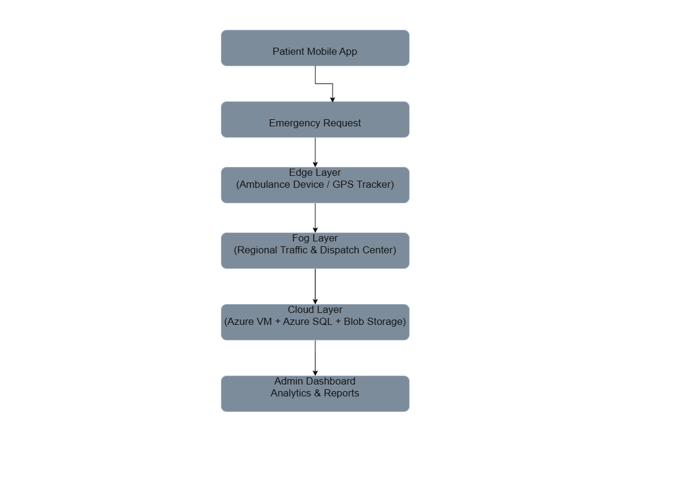
EXPERIMENT 4:
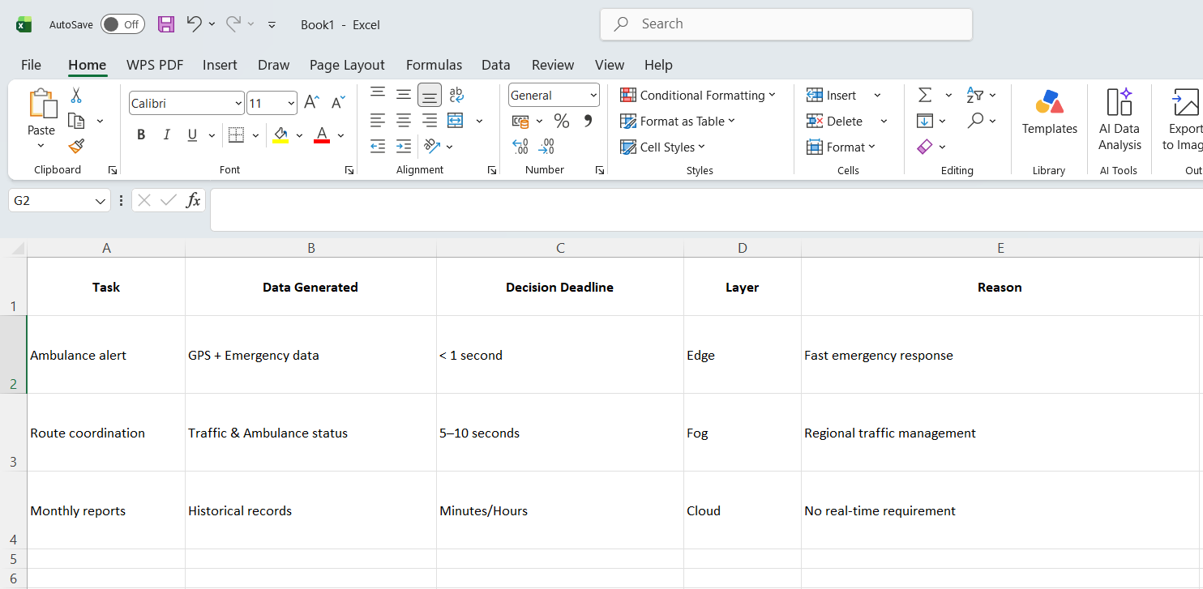

EXPERIMENT 5:
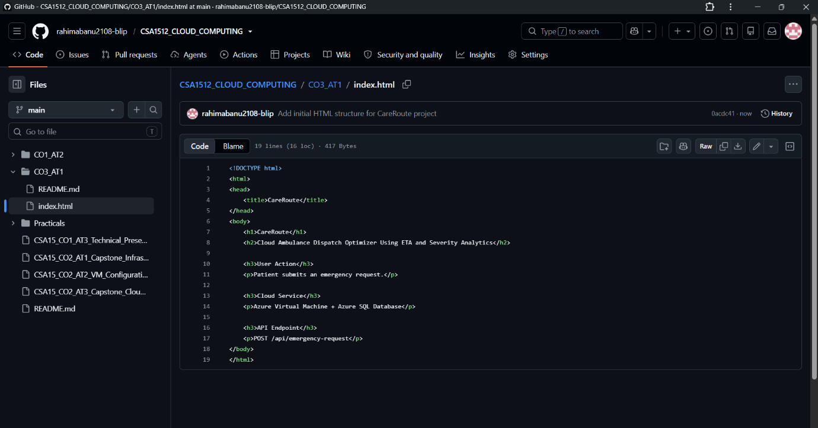
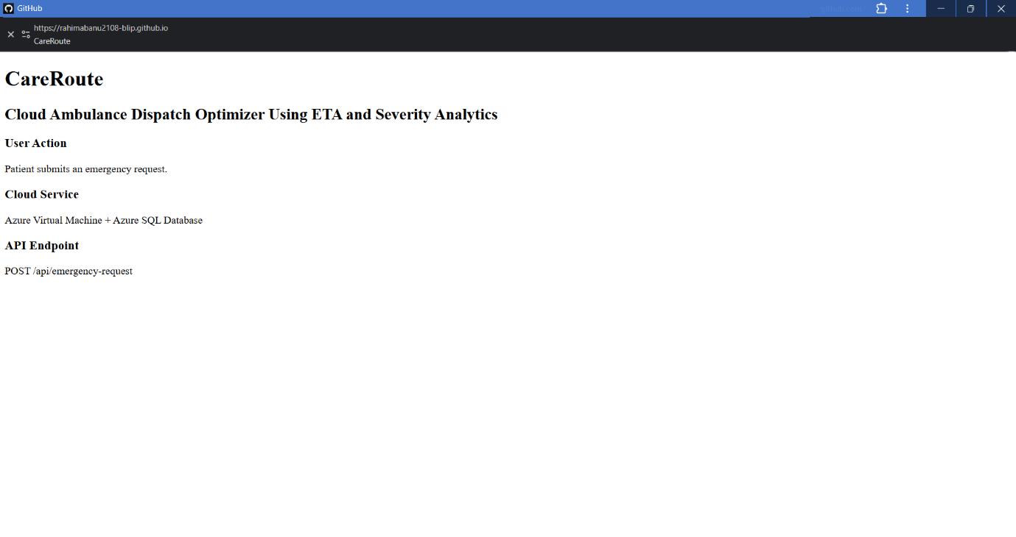
DIAGRAM:

