 | SIMATS ENGINEERING  Department of Computer Science and Engineering
CSA15 Cloud Computing and Big Data Analytics
CO4 AT2 - Big Data Industry Problem Solving Guided Tool Workbook
Course Code | CSA15 | Slot | B
Assessment | CO4 AT2 | Bloom Level | BL4 - Analyze
Faculty | Dr C. Rajesh Babu | Employee ID | SSETSCS415
Mode | Individual guided tool-based workbook | Submission | GitHub repository link through Google Classroom
End Evidence | Workbook + screenshots + diagrams + dashboard/mockup | Marks | 30

Student Details
Student Name | RAHIMA BANU N | Register Number | 192525009
Class / Section |  | Slot | B
Selected Scenario | Healthcare Emergency Analytics | Submission Date | 24-08-2026
GitHub Link | https://github.com/rahimabanu2108-blip/CSA1512_CLOUD_COMPUTING_ASSESSMENTS.git | Google Classroom Status

Workbook Purpose
What this workbook does
This workbook guides students to use real software tools and official technical references to derive a big-data industry solution. Students should learn from the tool, observe patterns, record evidence and then write their own technical explanation.
- Do not copy full text from websites or AI tools.
- Use official references to justify architecture, processing and security decisions.
- Screenshots are evidence; explanations are the actual assessment answer.

Scenario Bank
Instruction
Faculty may assign one scenario or ask students to complete more than one. If no specific scenario is assigned, select one scenario and complete all tool-guided sections for that scenario.
No. | Scenario | Data Context
1 | Healthcare Emergency Analytics | Emergency department data, ambulance updates, bed availability, alerts and treatment delays.
2 | E-Commerce Customer Behavior Intelligence | Clickstream events, cart abandonment, payment failure, campaign traffic and recommendation impact.
3 | Smart Agriculture Advisory Platform | Weather, soil sensors, crop advisories, pest reports, market prices and farmer app interactions.
4 | Cybersecurity Threat Monitoring | Authentication logs, firewall alerts, API access logs, failed login attempts and suspicious network events.
5 | Public Transport Demand Analytics | Ticketing data, bus GPS, passenger count, route delay, peak-hour demand and crowding alerts.

Selected Scenario and Reason
I selected Healthcare Emergency Analytics because it closely matches the CareRoute capstone, which manages ambulance requests, ambulance availability, emergency severity, ETA updates and hospital handoff. Big-data analytics can combine these data sources to support faster ambulance dispatch and better emergency resource management.

Guided Tool Module 1: Use Cloud Architecture Centers
Purpose: Use official cloud architecture references to identify suitable ingestion, storage, processing, analytics and security components for the selected scenario.
No. | Perform |  | Observe / Decide |  | Record in Workbook
1 | Open AWS Architecture Center, Azure Architecture Center and Google Cloud Architecture Center in three browser tabs. |  | You are not copying a full architecture. You are learning common cloud patterns and service categories. |  | Paste the three page titles or URLs.
2 | Search each site using terms from your scenario, such as healthcare analytics, streaming analytics, data lake, retail analytics, IoT analytics or security monitoring. |  | Notice which patterns repeatedly appear: ingestion, data lake, warehouse, processing, ML/analytics, visualization and security. |  | Record at least one useful reference from each cloud provider.
3 | Identify the services/components mentioned in the reference diagrams. |  | Separate service category from vendor-specific service name. Example: object storage is the category; Amazon S3/Azure Blob Storage/Cloud Storage are service examples. |  | Complete the tool-category table.
4 | Compare the three references. |  | Choose the most suitable architecture pattern for your scenario and explain why. |  | Write a short justification.
5 | Draw your own provider-neutral architecture in draw.io. |  | Your diagram must show data sources -> ingestion -> storage -> processing -> analytics/dashboard -> users, with security controls. |  | Paste the diagram screenshot/link.
Cloud Provider |  | Reference Page / URL |  | Useful Pattern Found |  | Useful Service Categories
AWS |  | AWS Architecture Center |  | Data ingestion → storage → analytics |  | Ingestion, object storage, processing, analytics, security
Azure |  | Azure Architecture Center |  | Data ingestion → data lake → analytics |  | Ingestion, data lake, processing, analytics, security
Google Cloud |  | Google Cloud Architecture Center |  | Data ingestion → storage → processing → analytics |  | Ingestion, storage, processing, analytics, visualization

Cloud Architecture Justification
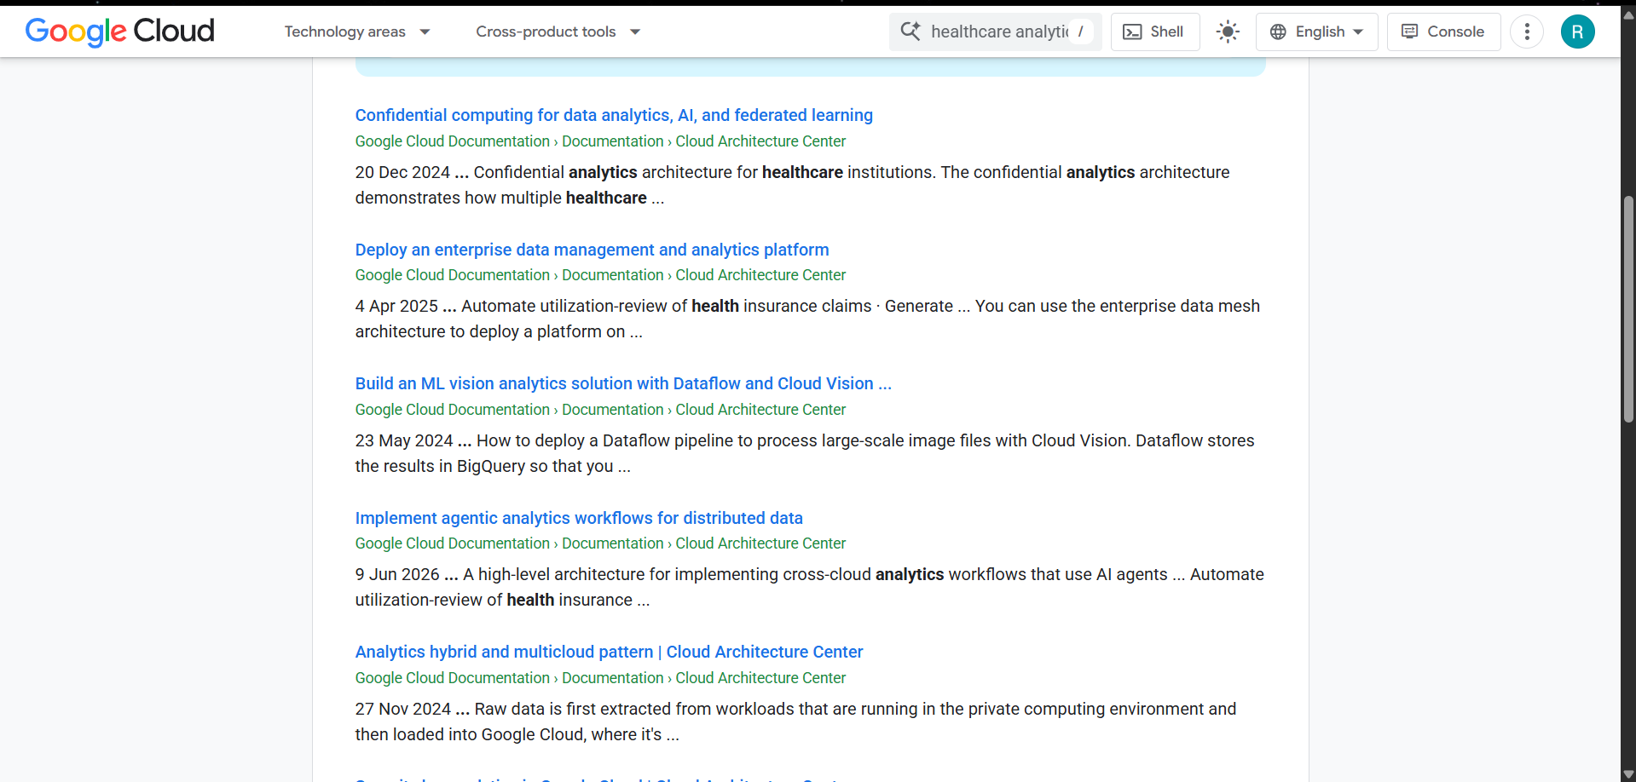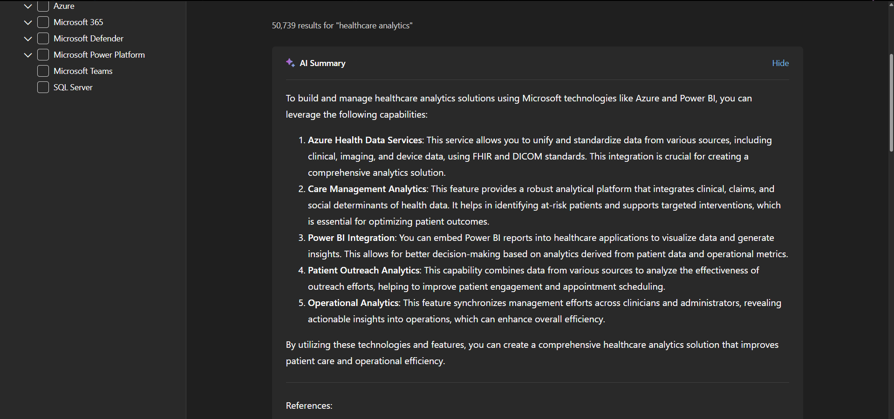

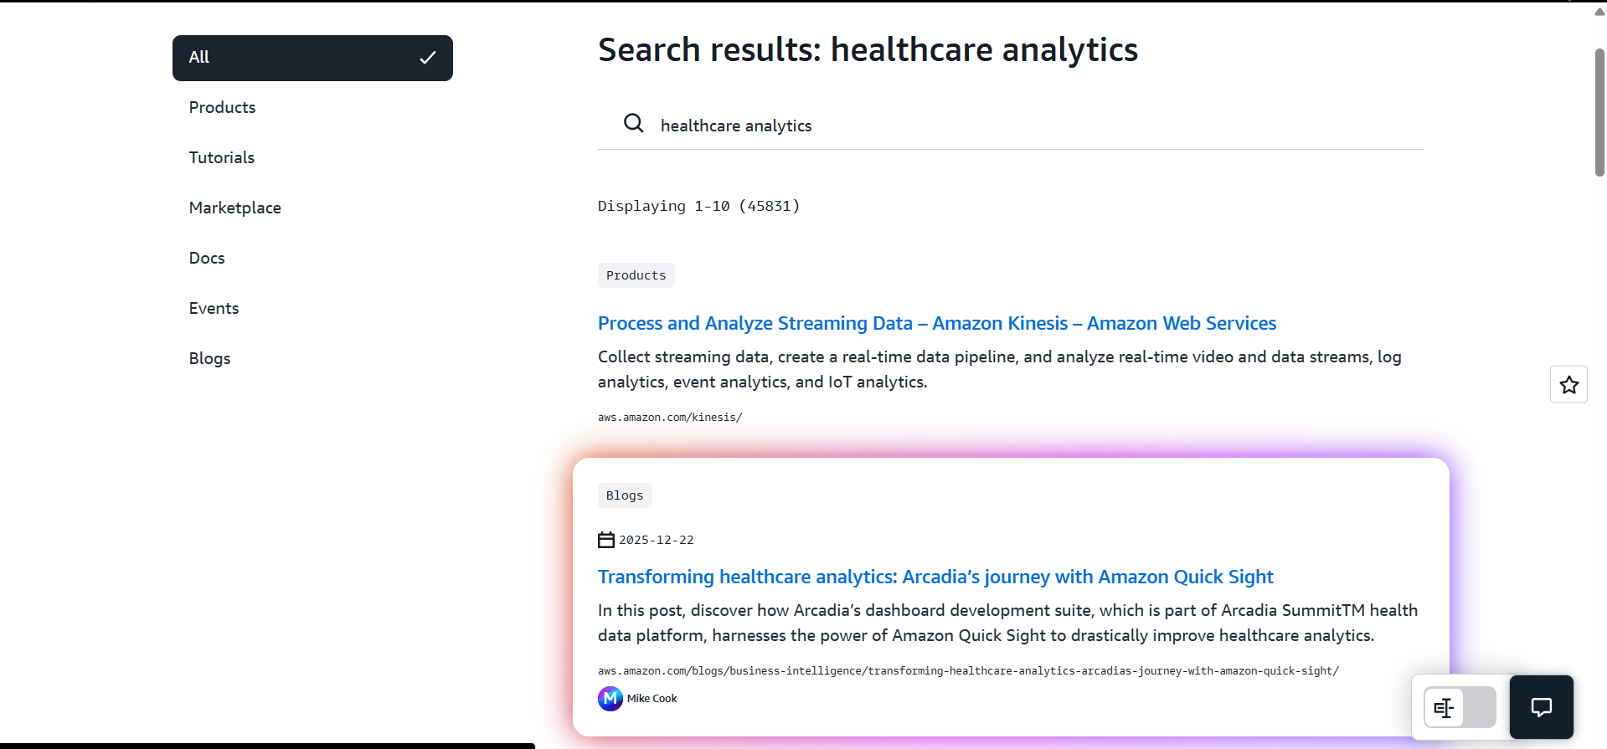

Architecture Diagram Evidence
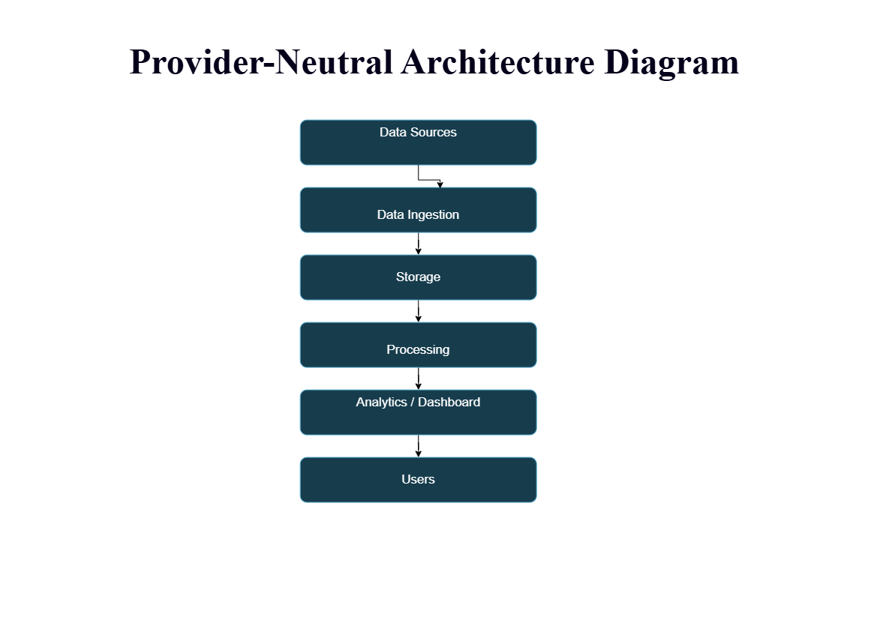

Guided Tool Module 2: Use Hadoop and Spark Documentation
Purpose: Decide whether your problem needs batch processing, streaming processing or hybrid processing by reading official Hadoop/Spark documentation.
No. | Perform |  | Observe / Decide |  | Record in Workbook
1 | Open the Apache Hadoop MapReduce tutorial. |  | MapReduce is suitable when large stored data can be processed in batches, such as daily logs or historical transactions. |  | Write one sentence on what mapper and reducer mean.
2 | Open the Apache Spark Structured Streaming guide. |  | Structured Streaming is suitable when new events continuously arrive, such as sensors, clickstream, live alerts or location updates. |  | Write one sentence on what streaming source, processing and sink mean.
3 | Classify your scenario data into batch data and streaming data. |  | Historical records normally become batch data; live sensor/log/API updates normally become streaming data. |  | Complete the batch-vs-stream table.
4 | Choose one processing approach for your scenario: Hadoop/MapReduce, Spark batch, Spark streaming or hybrid. |  | The decision must match the data velocity and decision urgency. |  | Write your processing decision.
5 | Prepare a simple pseudo-flow, not full code. |  | Example: Mapper reads log line -> emits hour, count. Reducer sums counts. Dashboard shows peak hour. |  | Write pseudo-flow or paste diagram.
Data Item |  | Batch / Streaming |  | Why |  | Suggested Framework
Historical ambulance records |  | Batch |  | Historical data is processed periodically |  | Hadoop/MapReduce
Historical emergency records |  | Batch |  | Used for past-data analysis |  | Hadoop/MapReduce
Live ambulance GPS |  | Streaming |  | Updates arrive continuously |  | Spark Streaming
Emergency requests |  | Streaming |  | Requires immediate processing |  | Spark Streaming
Ambulance availability |  | Streaming |  | Status changes continuously |  | Spark Streaming
Hospital availability |  | Streaming |  | Current status is needed for dispatch |  | Spark Streaming

Processing Framework Decision
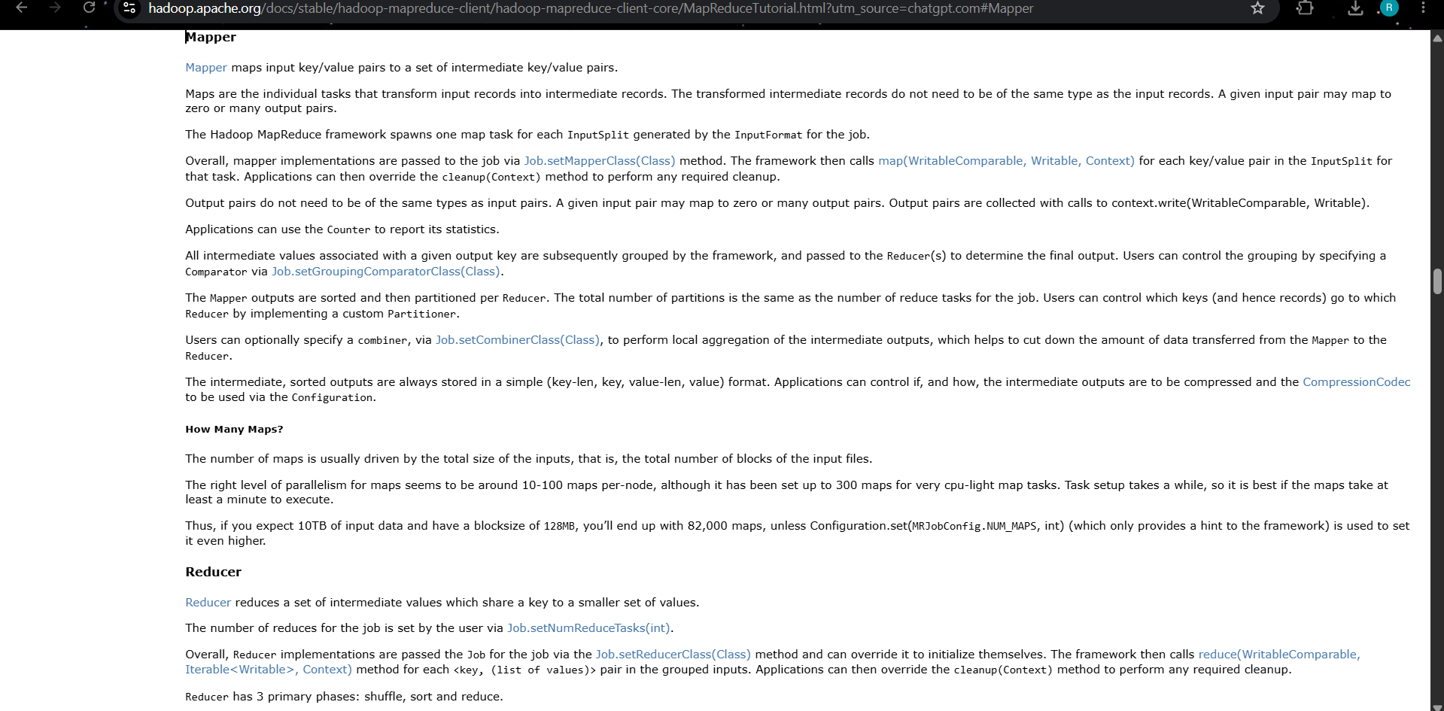

MapReduce / Spark Pseudo-Flow
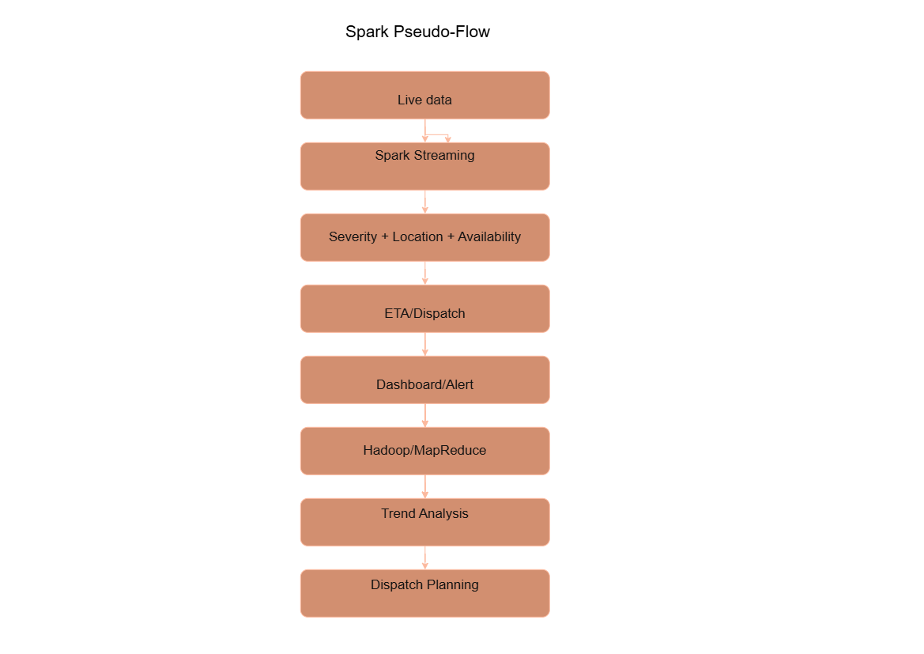

Guided Tool Module 3: Threat Modeling with OWASP Threat Dragon / Microsoft Tool
Purpose: Identify privacy and security risks in the big-data solution before proposing controls.
Tool Choice
Use OWASP Threat Dragon if you need a web/desktop cross-platform threat modeling tool. Use Microsoft Threat Modeling Tool when a Windows system is available. The required evidence is the threat model diagram and threat-control table.
No. | Perform |  | Observe / Decide |  | Record in Workbook
1 | Open OWASP Threat Dragon or Microsoft Threat Modeling Tool. |  | A threat model is a security diagram that shows components, data flows, trust boundaries and possible threats. |  | Write which tool you used.
2 | Create a new threat model named with your scenario. |  | Use a clear title such as CO4_AT2_Healthcare_Emergency_Analytics. |  | Paste model name.
3 | Add external entities. |  | External entities are users/systems outside your platform: patient, customer, sensor, payment gateway, bus GPS device, public API. |  | List at least two external entities.
4 | Add processes and data stores. |  | Processes transform data; data stores hold data. Example: ingestion API, stream processor, data lake, warehouse, dashboard. |  | List processes and stores.
5 | Draw data flows and trust boundaries. |  | Trust boundaries mark where security assumptions change: public internet to cloud, app to API, processing layer to storage. |  | Paste screenshot of DFD.
6 | Identify threats using STRIDE thinking. |  | Spoofing, Tampering, Repudiation, Information Disclosure, Denial of Service and Elevation of Privilege help structure risks. |  | Complete the threat table.
7 | Write mitigations. |  | Controls may include authentication, authorization, encryption, masking, audit logs, rate limits, backup and monitoring. |  | Map every threat to one control.
Component / Data Flow |  | Threat |  | Impact |  | Mitigation
Emergency Request API |  | Unauthorized access |  | False or unauthorized emergency requests |  | Authentication and authorization
Ambulance GPS Data |  | Information Disclosure |  | Sensitive location data may be exposed |  | Encryption
Dispatch Data |  | Tampering |  | Incorrect ambulance assignment |  | Access control and audit logs
Emergency API |  | Denial of Service |  | Emergency requests may be delayed |  | Rate limiting and monitoring
Emergency Request API |  | Unauthorized access |  | False or unauthorized emergency requests |  | Authentication and authorization

Threat Model Diagram Evidence
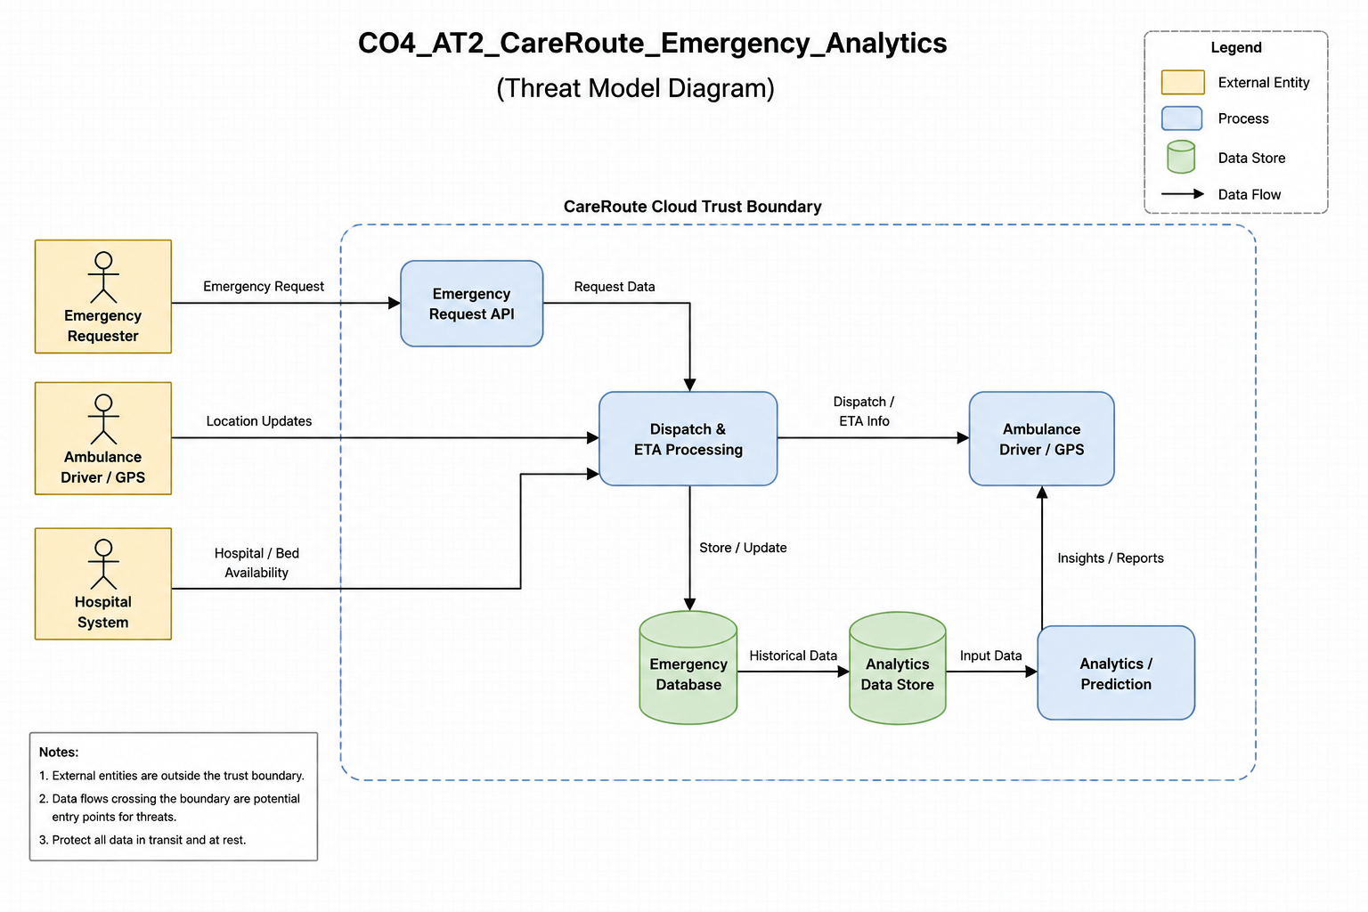

Guided Tool Module 4: Dashboard or Analytics Output Mockup
Purpose: Show how raw big data becomes useful decisions through a dashboard, alert, forecast, recommendation or report.
Beginner-Friendly Choice
Use any one: Power BI, Looker Studio, Tableau Public or Canva. If login/install is difficult, Canva dashboard mockup is acceptable. If data connection is possible, Power BI/Looker Studio/Tableau Public is stronger.
No. | Perform |  | Observe / Decide |  |  | Record in Workbook
1 | Prepare a small sample dataset in Excel or Google Sheets with 10-20 rows. |  | Columns should match your scenario. Example: timestamp, user/location, event type, value, status, risk level. |  |  | Paste column names.
2 | Choose the dashboard tool. |  | Power BI/Tableau/Looker are analytics tools; Canva is acceptable for visual mockup when live data connection is blocked. |  |  | Write chosen tool and reason.
3 | Import or recreate the sample data. |  | In Power BI/Looker/Tableau, connect data. In Canva, manually create charts from sample values. |  |  | Paste screenshot of data/chart setup.
4 | Create at least three visual elements. |  | Use KPI card, bar chart, line chart, table, map, alert count or pie/donut chart as appropriate. |  |  | List the visuals.
5 | Add decision labels. |  | A dashboard is useful only if it supports a decision: allocate beds, detect fraud, reroute buses, restock products, warn farmers. |  |  | Write decision supported by each visual.
6 | Export/share screenshot. |  | Paste the final dashboard screenshot or public/report link if available. |  |  | Paste evidence.
Visual Element |  | Metric Shown |  |  | Decision Supported
KPI Cards |  | Active ambulances, ETA, emergency cases |  |  | Monitor current emergency situation
Severity Bar Chart |  | Number of cases by severity |  |  | Prioritize critical cases
ETA Line Chart |  | Ambulance ETA over time |  |  | Select faster dispatch options
Hospital Table |  | Available beds |  |  | Decide suitable hospital destination
KPI Cards |  | Active ambulances, ETA, emergency cases |  |  | Monitor current emergency situation
Visual Element |  | Metric Shown |  | Decision Supported
KPI Card |  | Active ambulances / Average ETA |  | Monitor emergency response
Bar Chart |  | Cases by severity |  | Prioritize critical cases
Line Chart |  | ETA over time |  | Identify delays and choose faster dispatch
Hospital Table |  | Available beds |  | Select suitable hospital

Dashboard / Analytics Output Evidence
The CareRoute dashboard provides a centralized view of emergency requests, available ambulances, ambulance locations, patient severity, assigned drivers, estimated arrival time (ETA), and dispatch status. It helps dispatchers monitor emergencies in real time and make faster ambulance assignment decisions.

Final CO4 AT2 Solution Sections
Final Assembly
After completing the guided tool modules, combine the evidence into the final solution. The final answer must show technical reasoning, not only screenshots.

1. Problem Understanding
What to include: Identify stakeholders, decisions required, data produced, expected analytics output and urgency.

Student Response
CareRoute involves patients/requesters, ambulance drivers, dispatchers and hospitals. The main decisions are which ambulance should be assigned, which emergency should be prioritized, the estimated arrival time and which hospital should receive the patient. The system produces emergency details, ambulance location and availability, severity level, ETA and hospital capacity data. Analytics helps dispatchers make faster and better emergency-response decisions.

2. 5Vs Mapping
What to include: Map Volume, Velocity, Variety, Veracity and Value using scenario evidence.

Student Response
Volume: Large number of emergency requests, ambulance location updates and hospital records.
Velocity: Ambulance locations, ETA and emergency status are updated continuously in real time.
Variety: Patient details, severity data, GPS/location data, ambulance status and hospital information.
Veracity: Data must be accurate and reliable because incorrect information can affect emergency decisions.
Value: Analytics helps reduce ambulance response time, prioritize critical cases and improve hospital selection.

3. Big Data Architecture
What to include: Paste final draw.io architecture showing sources, ingestion, storage, processing, analytics/security and users.

Student Response
Data Sources: Patient/Requester, Ambulance Driver, GPS/Location Data, Hospital Data
↓
Data Ingestion: REST APIs, Real-Time Data Updates
↓
Cloud Data Storage: Firebase Realtime Database, Emergency Records, Ambulance Records, Hospital Records
↓
Data Processing: Data Cleaning, Severity Processing, ETA Calculation, Ambulance Matching
↓
Analytics/ML: Severity Analytics, ETA Prediction, Priority Ranking
↓
Dashboard & Alerts: Dispatcher Dashboard, Emergency Alerts, Live Map, KPI Reports
↓
Users: Dispatcher, Ambulance Driver, Hospital, Patient/Requester
Security & Privacy: Authentication, Role-Based Access Control, Data Encryption, Audit Logs

4. Data Flow Pipeline
What to include: Explain how raw data moves, gets cleaned, stored, processed and converted into dashboard/alert/decision.

Student Response
Emergency and ambulance data is collected through the application and APIs. The raw data is validated and cleaned before being stored in the cloud database. Processing combines emergency severity, ambulance availability, location and ETA information. The analytics layer identifies priority cases and suitable ambulances. The processed results are displayed on the dashboard and used to support dispatch decisions and alerts.

5. Tool and Technology Justification
What to include: Use cloud architecture references and Hadoop/Spark documentation to justify chosen tools.

Student Response
Firebase/Cloud Database: Provides scalable cloud storage and real-time data updates.
Python/FastAPI: Handles backend APIs, data processing and dispatch logic.
Google Maps API: Provides location and route information for ETA estimation.
Power BI: Provides interactive dashboards and analytics visualizations.
Apache Spark: Can be used for processing large volumes of emergency and location data efficiently.

6. Security and Privacy Strategy
What to include: Use threat model output to explain threats and controls.

Student Response
CareRoute uses role-based authentication so patients, drivers and dispatchers can access only the information required for their roles. Data should be encrypted during transmission and storage. Access controls protect patient and emergency information. Audit logs can record important system activities. Regular validation and monitoring help detect unauthorized access and incorrect data.

7. Challenges and Solutions
What to include: Write at least four big-data implementation challenges and one practical solution for each.

Student Response
High-volume real-time data: Use scalable cloud storage and distributed processing.
Incorrect or incomplete emergency data: Apply data validation and cleaning before processing.
Real-time location and ETA updates: Use real-time databases and location APIs.
Security and privacy risks: Implement authentication, role-based access control and encryption.
Network or system failure: Use cloud backup, error handling and monitoring mechanisms.

8. Business Outcome
What to include: State measurable outcome: faster decision, reduced fraud, lower waiting time, improved prediction, lower downtime or better user experience.

Student Response
CareRoute helps reduce ambulance response and waiting time by using real-time ambulance availability, location, severity and ETA analytics. It enables dispatchers to prioritize critical emergencies, assign suitable ambulances faster and select hospitals based on capacity. This improves emergency response efficiency and provides better patient service.

Rubric
Criteria | Marks | Evaluation Focus | Evidence
Problem and 5Vs analysis | 6 | Scenario-specific analysis and correct big-data reasoning | Workbook tables
Architecture and data flow | 6 | Correct pipeline, cloud components and flow clarity | draw.io diagram
Processing framework decision | 5 | Batch/streaming/hybrid justification using Hadoop/Spark concepts | Decision table
Security and privacy | 5 | Threat model, risks and controls | Threat model table/screenshot
Dashboard/output design | 4 | Useful decision-oriented analytics output | Dashboard/mockup
Clarity and submission quality | 4 | Organized, original, complete evidence | GitHub/GCR

Submission Checklist
- Student details and selected scenario are filled.
- Cloud architecture references are recorded.
- Hadoop/Spark processing decision is completed.
- Threat model diagram/table is included.
- Dashboard/mockup screenshot or link is included.
- Final solution sections are completed.
- DOCX/PDF and supporting files are uploaded to GitHub.
- GitHub repository link is submitted through Google Classroom.

Official Reference Links
AWS Architecture Center: https://aws.amazon.com/architecture/
Azure Architecture Center: https://learn.microsoft.com/en-us/azure/architecture/
Google Cloud Architecture Center: https://docs.cloud.google.com/architecture
Apache Hadoop MapReduce Tutorial: https://hadoop.apache.org/docs/stable/hadoop-mapreduce-client/hadoop-mapreduce-client-core/MapReduceTutorial.html
Apache Spark Structured Streaming: https://spark.apache.org/docs/latest/streaming/index.html
Microsoft Threat Modeling Tool releases: https://learn.microsoft.com/en-us/azure/security/develop/threat-modeling-tool-releases
OWASP Threat Dragon: https://owasp.org/www-project-threat-dragon/
Power BI documentation: https://learn.microsoft.com/en-us/power-bi/
Looker Studio create report: https://docs.cloud.google.com/data-studio/create-a-report
Tableau Public: https://www.tableau.com/community/public
Canva Charts: https://www.canva.com/help/charts/

