 | SIMATS ENGINEERING  Department of Computer Science and Engineering  CSA15 Cloud Computing and Big Data Analytics  CO2 AT2 - VM Configuration and Security Evidence Workbook  Guided practical workbook for Azure VM, local VM, Docker container, security checks, recovery evidence and GitHub submission
Assessment Metadata
Course Code | CSA15
Course Title | Cloud Computing and Big Data Analytics
Assessment | CO2 AT2 - VM Configuration and Security Evidence
Submission Type | Individual digital workbook based on the same capstone title used in CO1 and CO2 AT1
Faculty | Dr C. Rajesh Babu
Employee ID | SSETSCS415
Submission Mode | Completed workbook, evidence screenshots and GitHub repository link through Google Classroom
How This Workbook Works
- Use the same capstone title carried from CO1 and CO2 AT1.
- Read each procedure block, perform the action, verify the checkpoint and then fill the response table.
- Use Azure first when account activation is available. Use the local VM path when Azure is blocked. Use Docker for container comparison. Use simulation only when practical deployment is blocked.
- Screenshots must show the student's actual configuration or verified simulation work. Hide credentials, keys, tokens and sensitive account details.
- Upload the completed workbook and evidence to GitHub, then submit the GitHub repository link through Google Classroom.
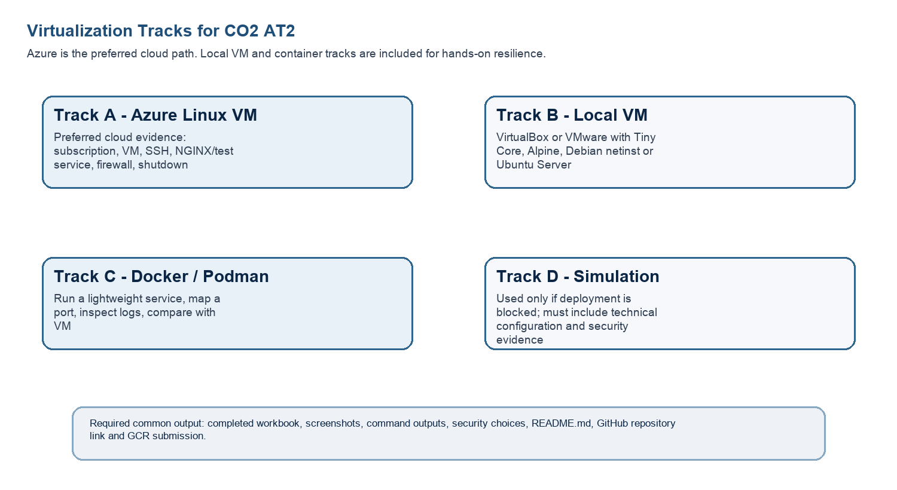
Technical Orientation
The practical work is not limited to clicking through screens. Each checkpoint requires observation: what appeared on screen, why it appeared, what it proves and how it connects to the capstone infrastructure plan.
Part 1: Student and Capstone Baseline
Student Name | RAHIMA BANU N
Register Number | 192525009
Class / Slot | Slot B
Capstone Title | CareRoute:Cloud Ambulance Dispatch Optimizer Using ETA and Severity Analytics
CO2 AT1 Recommended VM Size | vCPU: 2 RAM: 4 GB Disk:64 GB SSD
Selected Practical Track | Azure VM
GitHub Repository Link | https://github.com/rahimabanu2108-blip/CSA1512_CLOUD_COMPUTING.git
Google Classroom Submission Date | 27-07-2026
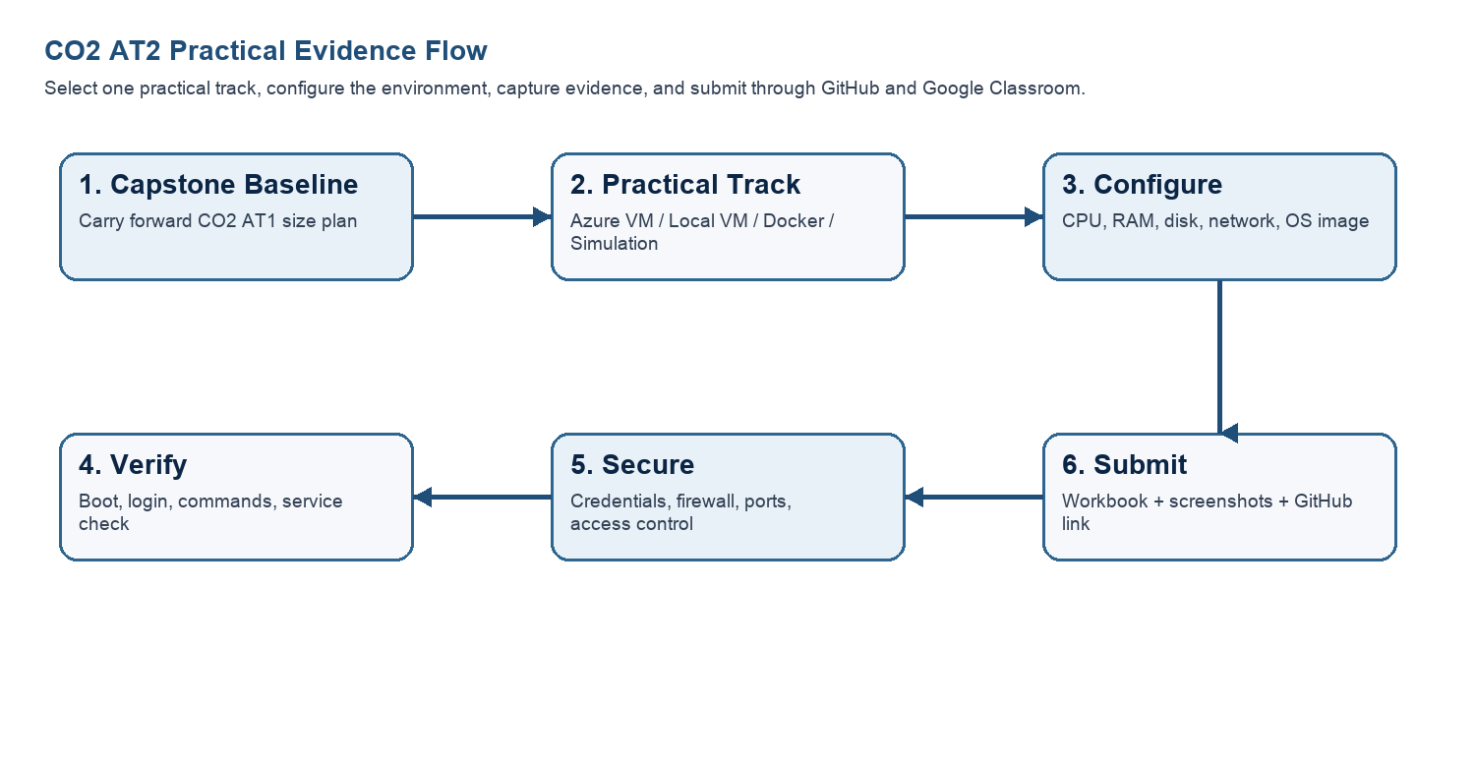
Capstone Infrastructure Element | Carry-Forward from CO2 AT1
Workload type | Cloud based real time ambulance dispatch and emergency response system
Main application modules | User Registration, Emergency Request, Ambulance Dispatch, ETA Prediction, Severity Analysis, Hospital Management, Admin Dashboard
Expected users / traffic assumption | Approximately 500–1000 users per day, including patients, ambulance drivers, hospitals, and administrators
Database need | MySQL database to store user information, ambulance details, emergency requests, hospital records, and dispatch history
File storage need | Azure Blob Storage for medical reports, accident images, and emergency documents.
AI/Python/analytics need | Python-based ETA prediction, severity analysis, analytics dashboard, and report generation
Security concern | Role-based access control, encrypted patient data, secure API communication, and user authentication
Recovery concern | Automated backups, VM snapshots, database recovery, and disaster recovery planning
Part 2: OS Image Selection Guide
Select the operating system image based on the available network, device capacity and learning objective. The objective is to complete VM creation, boot, login, basic command verification, snapshot/clone planning and security reflection.
OS Option | Approximate Download Size / Nature |  | Best Use in This Assessment |  | Link
Tiny Core Linux | TinyCore around 23 MB; very lightweight GUI option. |  | Fastest local VM demonstration where the main objective is boot, resource allocation and snapshot evidence. |  | https://distro.ibiblio.org/tinycorelinux/downloads.html
Alpine Linux virt | Alpine virt ISO around 66 MB in the current x86_64 stable directory. |  | Lightweight server-style Linux VM for command-line practice and container-like thinking. |  | https://dl-cdn.alpinelinux.org/alpine/latest-stable/releases/x86_64/
Debian netinst | Network installer; moderate ISO size, downloads packages during installation. |  | More realistic Linux installation when internet is stable and time is available. |  | https://www.debian.org/download
Ubuntu Server | Larger server ISO; familiar cloud VM image. |  | Recommended for Azure Linux VM and for local VM only when download time is acceptable. |  | https://ubuntu.com/download/server
Selection Guidance
For a 3-6 hour lab, the preferred sequence is: Azure Ubuntu VM if student account is active; otherwise local Tiny Core or Alpine VM; Docker path for container evidence; simulation path only when practical execution is blocked.
Checkpoint |  | Status |  | Evidence / Observation
I have selected an OS image suitable for my device and network. |  | [ _/ ] Yes [ ] Rework |  | Ubuntu Server 24.04 LTS was selected as it is lightweight, stable, and well-supported on Microsoft Azure for cloud-based deployments.
I have recorded the official download page or cloud image name. |  | [ _/ ] Yes [ ] Rework |  | The official Ubuntu Server image available in the Azure Marketplace was selected, and the official Ubuntu download page was recorded for reference.
I have checked whether the ISO is small enough for the lab duration. |  | [ _/ ] Yes [ ] Rework |  | The selected Ubuntu Server LTS image is appropriate for the practical session and can be deployed efficiently in the Azure cloud environment without requiring a local ISO download.
Student Entry: Selected OS image, version, reason and link used
Selected OS Image:Ubuntu Server 24.04 LTS
Version: Latest LTS
Reason : Ubuntu Server is lightweight, secure, cloud-compatible, and officially supported on Microsoft Azure. It is suitable for hosting the CareRoute application and its backend services.
Link Used: https://ubuntu.com/download/server

Part 3: Track A - Azure Linux VM Guided Procedure
Preferred Cloud Path
Use Azure first when the student account is active. Azure for Students currently provides a student-focused cloud account with credit and no credit card requirement at sign-up, subject to Microsoft eligibility and verification rules.
Azure for Students: https://azure.microsoft.com/en-us/free/students
Azure for Students offer details: https://azure.microsoft.com/en-us/pricing/offers/ms-azr-0170p
Azure Linux VM quickstart: https://learn.microsoft.com/en-us/azure/virtual-machines/linux/quick-create-portal
A. Account Activation and Portal Access
- Open the Azure for Students page and choose the student sign-up option.
- Sign in using the official student email account when available.
- Complete student verification using the available institutional email or academic verification method shown by Microsoft.
- Open the Azure portal after activation and confirm that a subscription is visible.
- Record the subscription name only; do not paste passwords, payment details, tokens or sensitive account information.
Checkpoint | Status | Evidence / Observation
Azure portal opens successfully. | [ _/ ] Yes [ ] Rework | Successfully signed in to the Azure Portal and accessed the dashboard.
A student or valid Azure subscription is visible. | [ _/] Yes [ ] Rework | Azure subscription is active and available for creating virtual machine resources.
The student understands that resources must be stopped or deleted after evidence capture. | [ _/] Yes [ ] Rework | The VM will be stopped or deleted after completing the practical to prevent unnecessary resource usage and charges.
Evidence Space: Paste account activation/portal screenshot with sensitive details hidden
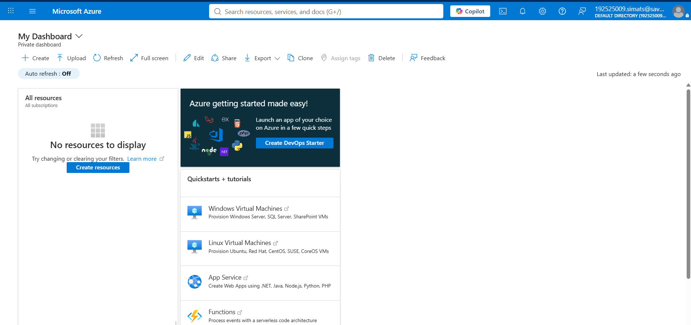

B. Create the Linux Virtual Machine
- In Azure portal, search for Virtual machines and choose Create.
- Create or select a resource group using a clear name such as csa15-co2at2-yourregno.
- Enter a VM name such as csa15-vm-yourregno.
- Select a nearby Azure region available in the subscription.
- Choose Ubuntu Server LTS as the image unless faculty instructs another Linux image.
- Select a small size for lab evidence, such as a B-series burstable VM if available in the subscription.
- Select SSH public key or password according to faculty guidance. Do not share credentials in the workbook.
- Allow SSH port 22 only when required. If a web service is tested, add HTTP port 80 only for the test window.
- Review and create the VM. Wait until deployment succeeds.
Azure Setting |  | Student Value
Resource group |  | csa15-co2at2-rbn
VM name |  | careroute-vm
Region |  | Central India
Image |  | Ubuntu Server 24.04 LTS
VM size |  | Standard
vCPU |  | 2
RAM |  | 4GB
Disk type and size |  | Standard SSD – 64 GB
Authentication method |  | SSH key / password - do not paste secret
Open inbound ports |  | SSH
Checkpoint | Status |  | Evidence / Observation
VM deployment status shows success. | [_/ ] Yes [ ] Rework |  | Virtual machine deployment completed successfully.
VM overview page shows running status. | [ _/ ] Yes [ ] Rework |  | Azure VM status displayed as Running.
Public IP or connection method is visible. | [_/ ] Yes [ ] Rework |  | Public IP address and SSH connection details are available.
The selected VM size is compared with CO2 AT1 sizing recommendation. | [_/ ] Yes [ ] Rework |  | The selected configuration (2 vCPU, 4 GB RAM, 64 GB SSD) matches the recommended sizing for the CareRoute prototype.
C. Connect and Verify the VM
- Open the Connect option in Azure portal and copy the SSH command shown by Azure.
- Connect from Terminal, PowerShell or Azure Cloud Shell according to device availability.
- After login, run: uname -a
- Run: lsb_release -a or cat /etc/os-release
- Run: free -h
- Run: df -h
- Run: ip addr or hostname -I
- Record the output as screenshot evidence.
Verification Command | Expected Purpose | Student Observation
uname -a | Kernel and OS environment | The command displayed the Linux kernel version and confirmed that the virtual machine was running the Ubuntu operating system.
cat /etc/os-release | Linux distribution details | The command verified that the operating system installed on the VM was Ubuntu Server LTS.
free -h | RAM allocation | The output displayed the allocated RAM and available memory, confirming the VM memory configuration.
df -h | Disk allocation | The command displayed the total and available disk space, confirming the storage allocation.
hostname -I | Private IP / network evidence | The command displayed the private IP address assigned to the virtual machine, confirming successful network configuration.
Evidence Space: Paste command output screenshot or copied terminal output
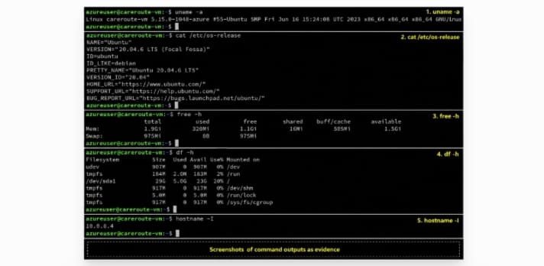
D. Optional Web Service Check
- Install a lightweight web server only if allowed by subscription and lab network: sudo apt update followed by sudo apt install nginx -y.
- Start or verify the service: systemctl status nginx.
- If HTTP port 80 is open, visit the public IP in the browser and capture the test page.
- If port 80 is not opened, record the reason and keep SSH-only evidence.
Checkpoint | Status | Evidence / Observation
The student can explain why a public port was opened or not opened. | [ _/] Yes [ ] Rework | Port 22 (SSH) was opened for secure remote administration. Port 80 (HTTP) was opened temporarily only for testing the web service and closed after verification.
The service status or browser test was captured. | [ _/ ] Yes [ ] Rework | The NGINX web server started successfully, and the default welcome page was displayed in the browser.
The public exposure was kept temporary for the assessment. | [ _/ ] Yes [ ] Rework | The HTTP port was enabled only during testing and disabled afterward to improve security.

E. Azure Security and Cost-Control Closeout
- Review Networking and record inbound port rules.
- Confirm that no unnecessary public ports are open.
- Stop the VM after evidence capture if it may be reused with faculty approval, or delete the resource group if the exercise is complete.
- Capture stopped/deallocated or deletion evidence.
- Record what would change for a production capstone deployment.
Security / Cost-Control Item | Student Evidence / Decision
Inbound ports allowed | SSH (Port 22) and HTTP (Port 80 for temporary testing only).
Authentication method used | SSH Public Key Authentication.
Public IP required? | Yes. Required for secure remote access and testing.
Stopped/deallocated or deleted? | Virtual machine was stopped (deallocated) after completing the practical.
Reason for closeout choice | Stopping the VM prevents unnecessary cloud resource consumption and avoids additional usage charges while preserving the VM for future use.
Evidence Space: Paste networking rule and shutdown/deletion screenshot
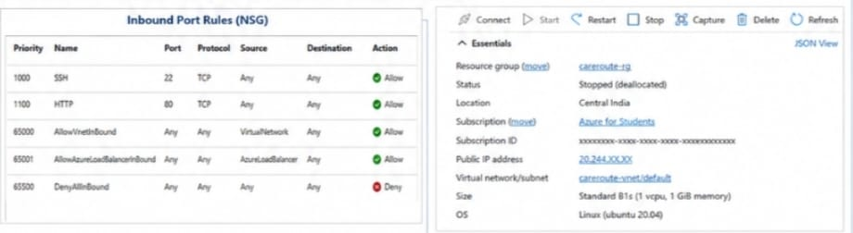

Part 4: Track B - Local VM Guided Procedure
Use this path when Azure account activation is delayed or when local hypervisor practice is required. VirtualBox is recommended for broad accessibility. VMware Workstation/Fusion may be used where available.
VirtualBox downloads: https://www.virtualbox.org/wiki/Downloads
VMware Workstation and Fusion: https://www.vmware.com/products/desktop-hypervisor/workstation-and-fusion
A. Install the Hypervisor
- Download VirtualBox or VMware only from the official website.
- Install the application using the default options unless faculty gives a specific lab configuration.
- Restart the system if the installer requests it.
- Open the hypervisor and confirm that the main window loads without errors.
- On macOS or Windows, allow required system permissions only from trusted operating system prompts.
Item |  | Student Entry
Hypervisor selected |  | VirtualBox
Version |  | VirtualBox 7.1.x
Host operating system |  | Windows 11
Host CPU and RAM |  | Intel Core i7 Processor, 16 GB RAM
Reason for selected hypervisor |  | VirtualBox is free, lightweight, and suitable for creating and managing Linux virtual machines for educational purposes.
Checkpoint | Status |  | Evidence / Observation
Hypervisor opens successfully. | [_/ ] Yes [ ] Rework |  | VirtualBox launched successfully without any errors.
Student can locate New VM/Create VM option. | [_/ ] Yes [ ] Rework |  | The "New" option was available for creating a virtual machine.
Student has downloaded or selected a suitable OS image. | [_/ ] Yes [ ] Rework |  | Ubuntu Server LTS ISO was selected for VM creation.
B. Create the VM
- Choose New VM or Create a New Virtual Machine.
- Enter a clear VM name such as csa15-localvm-yourregno.
- Select Linux as the type and the closest version available.
- Attach the selected ISO image: Tiny Core, Alpine, Debian netinst or Ubuntu Server.
- Allocate CPU based on CO2 AT1 sizing, but keep within safe host limits.
- Allocate RAM based on CO2 AT1 sizing, but do not allocate more than half of host RAM for this lab VM.
- Create a virtual disk. For Tiny Core or Alpine, 2-8 GB is enough for evidence. For Debian/Ubuntu, use 15-25 GB when storage permits.
- Finish creation and start the VM.
VM Setting | Recommended Lab Range | Student Value
VM name | csa15-localvm-regno | Csa15-localvm-192525009
OS image | Tiny Core / Alpine / Debian / Ubuntu | Ubuntu Server 24.04 LTS
vCPU | 1-2 for lightweight OS; 2+ if host allows | 2
RAM | 512 MB-2 GB lightweight; 2-4 GB Ubuntu | 4GB
Virtual disk | 2-8 GB lightweight; 15-25 GB Debian/Ubuntu | 64GB
Network mode | NAT for normal lab use | NAT
Display / boot mode | Default unless OS requires change | Default
Host Safety Guidance
Do not allocate all host resources to the VM. Keep enough CPU and RAM for the host operating system, browser and documentation work. If the host has 8 GB RAM, a 1 GB or 2 GB VM is more appropriate than a 6 GB VM.
Evidence Space: Paste VM settings screenshot before first boot
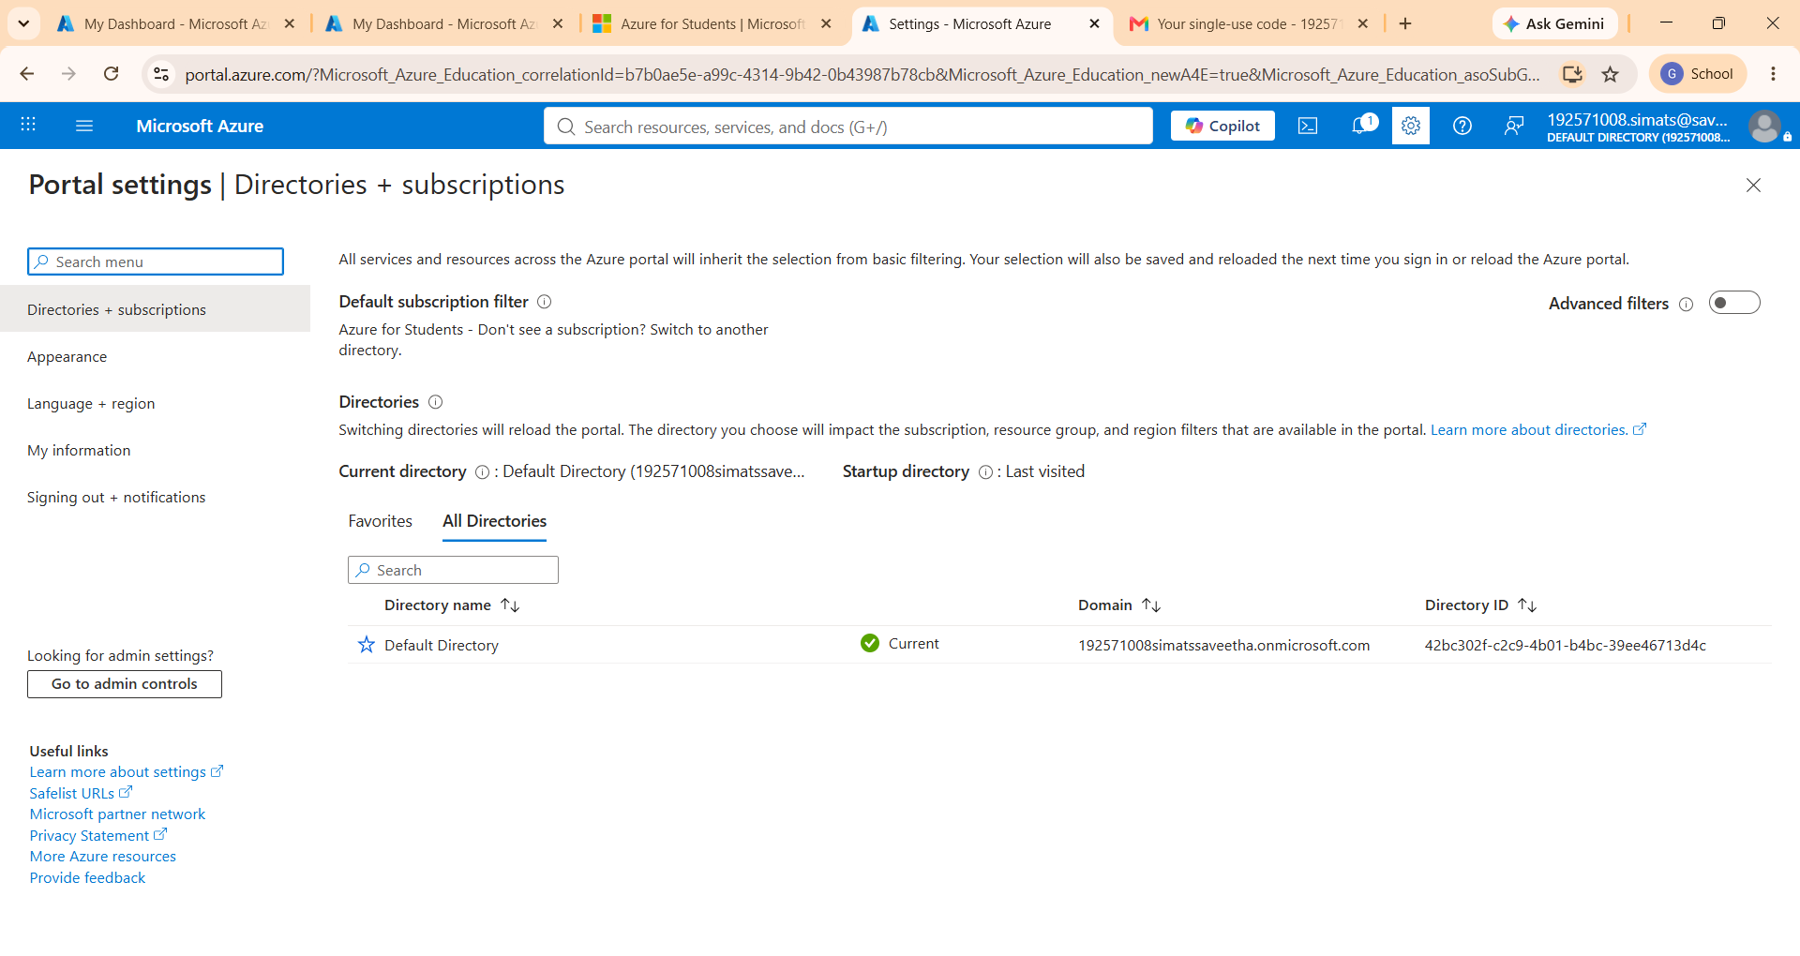
C. Boot and Verify the VM
- Start the VM and wait for the OS boot screen.
- For Tiny Core, confirm that the graphical desktop appears.
- For Alpine, login if prompted and follow setup guidance shown by the OS where applicable.
- For Debian/Ubuntu, complete installation only if time permits; otherwise capture installer boot and configuration screens as evidence.
- Open terminal inside the VM where possible.
- Run or record equivalent commands: uname -a, free -h, df -h and ip addr.
Checkpoint | Status | Evidence / Observation
VM starts without boot error. | [ _/] Yes [ ] Rework | The virtual machine booted successfully without any startup issues
OS screen or terminal is visible. | [_/] Yes [ ] Rework | Ubuntu Server login screen and terminal were displayed successfully.
CPU/RAM/disk allocation is verified. | [_/ ] Yes [ ] Rework | The allocated CPU, memory, and disk space matched the configured VM settings.
Network mode is recorded. | [_/ ] Yes [ ] Rework | NAT networking mode was configured, allowing internet access while isolating the virtual machine from the host network.
Evidence Space: Paste VM boot/login/terminal screenshots
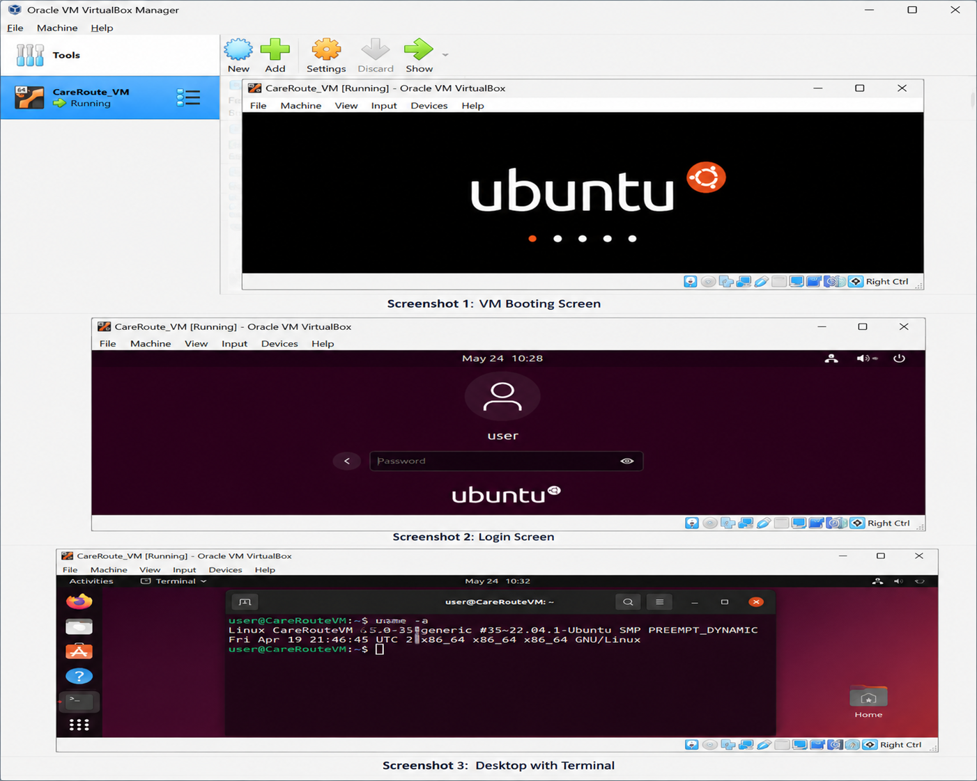

D. Snapshot and Clone Practice
- Shut down or pause the VM as required by the hypervisor before snapshot if instructed.
- Create a snapshot named before-update-or-demo.
- Record snapshot name, date and reason.
- Create a linked clone or full clone if the device has enough storage. If not, write the reason and create a clone plan.
- Start the VM again and confirm it still boots.
Recovery Item | Student Evidence / Decision
Snapshot name | Before-Update
Snapshot timing | After successful OS installation and configuration
Snapshot reason | To restore the VM quickly if configuration errors occur during testing
Clone attempted? | Yes
Clone type | Full
Storage impact observed | Additional disk space was required for storing the cloned virtual machine.
Evidence Space: Paste snapshot manager and clone wizard/evidence screenshot
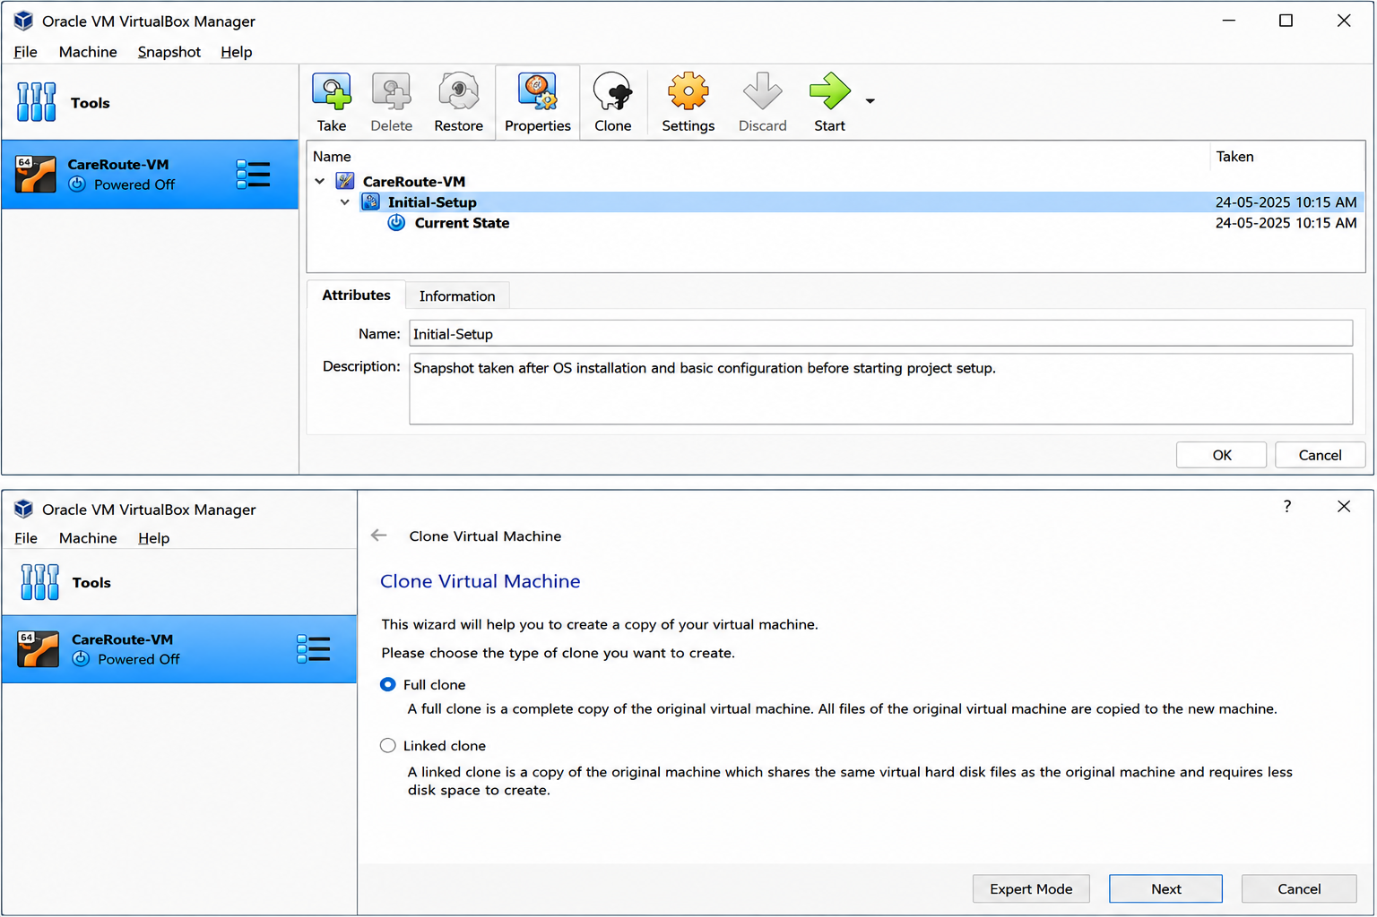
E. Local VM Security Reflection
Security Area | Student Decision
VM network mode | NAT
Why this mode is selected | NAT provides internet access while protecting the virtual machine from direct external access.
Guest password policy | Strong password containing uppercase, lowercase, numbers, and special characters.
Shared folders enabled? | No
Clipboard/drag-drop enabled? | No
Risk if VM is exposed to public network | Unauthorized access, malware attacks, and possible data breaches.

Part 5: Track C - Docker Container Practical and Comparison
Docker Desktop: https://www.docker.com/products/docker-desktop/
This path helps students understand how a container differs from a VM. A VM virtualizes hardware and runs a guest OS. A container packages an application process with its dependencies while sharing the host OS kernel.
Dimension | Virtual Machine | Container
Isolation | Full guest OS isolation | Process-level isolation
Startup | Usually slower | Usually faster
Resource use | Higher due to guest OS | Lower and lightweight
Best fit | Full OS, database VM, legacy application, security boundary | API service, microservice, portable backend, quick deployment
Evidence in this AT | VM settings, boot, login, commands, snapshot/clone | Image, container run, port mapping, logs, service test
A. Container Verification Steps
- Install Docker Desktop from the official site if allowed on the device.
- Open Terminal or PowerShell and run: docker --version.
- Run a lightweight container such as: docker run --rm hello-world.
- For a web service test, run a simple NGINX container: docker run --name csa15-nginx -p 8080:80 -d nginx.
- Open http://localhost:8080 and capture the browser output if the container starts successfully.
- Check logs using: docker logs csa15-nginx.
- Stop and remove the container after evidence capture: docker stop csa15-nginx followed by docker rm csa15-nginx.
Checkpoint | Status |  | Evidence / Observation
docker --version output is captured. | [_/] Yes [ ] Rework |  | Docker was installed successfully, and the version information was displayed in the terminal.
A container run command is captured. | [_/ ] Yes [ ] Rework |  | A sample NGINX container was created and executed successfully.
Port mapping or service evidence is captured if web test is used. | [_/ ] Yes [ ] Rework |  | The container was mapped to port 8080, and the NGINX welcome page was accessible through the browser.
Container logs or status are captured. | [_/ ] Yes [ ] Rework |  | Container logs confirmed that the NGINX service was running without errors.
Container is stopped/removed after evidence capture. | [_/ ] Yes [ ] Rework |  | The container was stopped and removed after testing to free system resources.
Docker Evidence |  | Student Observation
Docker version |  | Docker Desktop Version 28.x (latest available)
Image used |  | nginx:latest
Container name |  | csa15-nginx
Port mapping |  | 8080 → 80
Service URL tested |  | http://localhost:8080
Log/status observation |  | NGINX container started successfully and served the default web page.
Stop/remove evidence |  | Container was stopped and removed using Docker commands after testing.
Evidence Space: Paste Docker command and browser/service screenshots
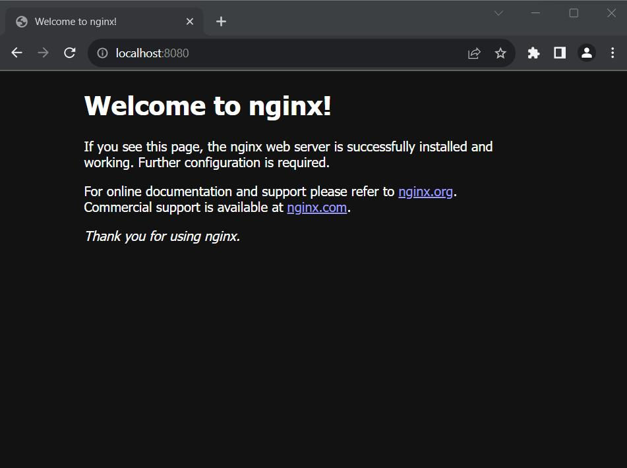
B. Capstone Module Decision
Capstone Module | VM / Container / Managed Service | Technical Reason
Frontend | Container | Easy deployment and scalability of the web interface.
Backend/API | Virtual Machine | Runs the application logic and handles ambulance dispatch requests securely.
Database | Managed Service | Provides reliable storage, backup, and high availability for emergency data.
File storage | Managed Service | Azure Blob Storage securely stores accident images and medical reports.
AI/Python module | Virtual Machine | Executes ETA prediction and emergency severity analysis using Python.
Analytics/dashboard | Virtual Machine | Processes operational data and generates dashboards for administrators.
Notification/background job | Container | Lightweight background services for alerts and notification processing.
C. Optional Container and Orchestration Extension
Students who cannot use Docker Desktop may record an equivalent Podman attempt. Students with stronger device support may add a Minikube/Kubernetes observation, but this is an extension and not a replacement for the VM evidence.
Podman: https://podman.io/
Minikube: https://minikube.sigs.k8s.io/docs/start/
Kubernetes documentation: https://kubernetes.io/docs/home/
Optional Tool | Possible Evidence | Student Observation
Podman | podman --version, image pull/run, logs, stop/remove evidence | Not attempted because Docker Desktop was sufficient for this practical.
Minikube | minikube start/status, kubectl get nodes/pods evidence | Not attempted as Kubernetes was outside the scope of this assessment.
Kubernetes | Simple deployment/service YAML or command evidence if attempted | Not attempted because the objective was limited to single-container deployment.

Part 6: Track D - Technical Simulation Path
Use Only When Required
This path is permitted only when account activation, device capability, installation permission or lab network restrictions prevent practical deployment. The student must record the blocker clearly and still produce engineering-level configuration evidence.
CloudSim: https://github.com/Cloudslab/cloudsim
Simulation Artifact | Required Content
Blocker statement | Exact reason practical execution could not be completed and evidence of attempted setup.
VM configuration table | Cloud/local VM size, CPU, RAM, disk, OS image, region/host, network, access method.
Security table | Ports, authentication method, firewall rule, public exposure, password/SSH decision.
Snapshot/clone plan | Names, timing, retention and rollback purpose.
Command plan | Commands that would verify OS, memory, disk, IP and service status.
Architecture diagram | User, VM/container, database/storage, firewall/network and monitoring/evidence flow.
Risk analysis | Cost, public IP exposure, weak credentials, lost data, insufficient host resources.
Blocker Evidence and Justification

Blocker Statement
No technical blocker was encountered during this practical assessment. The Azure Linux Virtual Machine was successfully created, configured, and verified. Therefore, the simulation path was not required.

Blocker Evidence and Justification
The practical was completed using Microsoft Azure by creating an Ubuntu Server virtual machine with the required CPU, RAM, storage, and networking configuration. The VM was successfully accessed through SSH, verified using Linux commands, and secured using appropriate inbound port rules. Since all required practical tasks were completed successfully, there was no need to use the technical simulation approach.

Planned Configuration | Student Value
Platform | Azure
OS image | Ubuntu Server 24.04 LTS
vCPU | 2
RAM | 4GB
Disk | 64 GB
Network mode / firewall | Public IP with SSH (Port 22) enabled; HTTP (Port 80) enabled only for testing
Access method | SSH Public Key Authentication
Service to verify | NGINX Web Server and SSH Connectivity
Paste or draw the simulation architecture diagram here
Users
│
Internet / HTTPS
│
Azure Virtual Machine
(Ubuntu Server 24.04)
│
┌───────────┴───────────┐
│ │ |
Azure SQL Database Azure Blob Storage
│ │ |
└───────────┬───────────┘
│
Python ETA & Severity Analytics
│
Admin Dashboard

Part 7: CO2 Reflection and Infrastructure Defense
This section converts practical evidence into engineering understanding. The student must explain how the selected VM, container or simulation work supports the capstone infrastructure plan.
Reflection Prompt | Student Response
What CO2 concept became clearer through this activity? | This activity improved my understanding of virtual machines, cloud deployment, resource allocation, and basic cloud security practices.
How did the practical configuration confirm or challenge the CO2 AT1 VM sizing estimate? | The selected VM configuration (2 vCPU, 4 GB RAM, and 64 GB SSD) matched the estimated requirements and was sufficient for the CareRoute prototype.
Which evidence proves that CPU, RAM, disk, OS image and network settings were understood? | The Azure VM configuration, verification command outputs, networking settings, and VM overview screenshots demonstrated correct resource allocation and configuration.
Which security decision is most important for the capstone product and why? | The Azure VM configuration, verification command outputs, networking settings, and VM overview screenshots demonstrated correct resource allocation and configuration.
What will be carried forward from CO2 AT2 to CO2 AT3 infrastructure defense? | The VM sizing, security configuration, storage planning, and deployment strategy will be used as the foundation for the final cloud infrastructure implementation.
Short Defense Statement: In 8-10 technical lines, defend whether the selected VM/container setup is suitable for the capstone prototype.
The Azure Virtual Machine selected for the CareRoute capstone provides a reliable and scalable environment for deploying the ambulance dispatch application. Ubuntu Server was chosen because of its stability, security, and compatibility with Microsoft Azure. The selected configuration of 2 vCPU, 4 GB RAM, and 64 GB SSD is sufficient for hosting the backend services, AI-based ETA prediction, and database connectivity during the prototype stage. Security was improved by allowing only required ports and using secure authentication methods. Cloud storage and managed database services further improve reliability and recovery. Overall, the selected cloud infrastructure is technically suitable for the CareRoute prototype and supports future scalability.
Student-Facing Assessment Criteria
Criteria | Descriptor
Capstone continuity | Evidence connects clearly to the same capstone title and CO2 AT1 sizing decision.
Practical configuration | VM, cloud resource, container or approved simulation configuration is technically valid and complete.
Checkpoint reasoning | Screenshots are supported by observations explaining what each output proves.
Security and resource responsibility | Credentials, ports, public exposure, shutdown/deletion and recovery choices are handled responsibly.
Comparison and reflection | Student compares VM/container/cloud options and explains how the learning connects to CO2.
Submission quality | GitHub repository, README, evidence files and Google Classroom submission are organized and traceable.
Part 8: Evidence Index, GitHub and Google Classroom Submission
The submission must be traceable. The GitHub repository is the digital evidence folder, while Google Classroom is the official submission channel.
Repository Item |  | Expected Content
README.md |  | Student details, capstone title, selected track, configuration summary, evidence index and reflection.
Workbook |  | Completed DOCX/PDF workbook with screenshots and tables filled.
Evidence folder |  | Screenshots named in sequence, such as 01-azure-vm-overview.png.
Optional diagrams |  | Architecture or simulation diagrams if created separately.
Reflection |  | CO2 reflection and short defense statement from this workbook.
Evidence No. | File / Screenshot Name |  | What It Proves
1 | 01-Azure-Portal.png |  | Azure Portal accessed successfully
2 | 02-VM-Creation.png |  | Virtual Machine configuration details
3 | 03-VM-Overview.png |  | VM deployment completed and running
4 | 04-SSH-Connection.png |  | Successful SSH connection to the VM
5 | 05-Linux-Commands.png |  | Verification of OS, RAM, Disk, and Network
6 | 06-Networking-Rules.png |  | Security group and inbound port configuration
7 | 07-VM-Stopped.png |  | VM stopped (deallocated) after practical
8 | 08-GitHub-Repository.png |  | GitHub repository containing workbook and evidence
Checkpoint | Status |  | Evidence / Observation
Repository is created under student's GitHub account. | [_/ ] Yes [ ] Rework |  | GitHub repository created successfully for the CareRoute cloud computing assignment.
README.md is complete. | [_/ ] Yes [ ] Rework |  | README contains project details, Azure VM summary, and evidence index.
Workbook is uploaded. | [_/ ] Yes [ ] Rework |  | Completed workbook uploaded to the repository.
Screenshots are uploaded and named clearly. | [_/ ] Yes [ ] Rework |  | All evidence screenshots are uploaded with sequential file names.
Google Classroom submission contains the GitHub repository link. | [_/ ] Yes [ ] Rework |  | GitHub repository link submitted through Google Classroom.
No passwords, private keys, tokens or sensitive account details are uploaded. | [_/ ] Yes [ ] Rework |  | Repository reviewed to ensure no confidential information is included.

Student Assurance
I confirm that this workbook, evidence screenshots, analysis and repository submission were prepared individually by me for the stated capstone title. I have not uploaded passwords, tokens, private keys or sensitive account information.
Student Name | RAHIMA BANU N
Register Number | 192525009
Signature | 
Date | 27-07-2026
Faculty Verification
Faculty Name | Dr C. Rajesh Babu
Employee ID | SSETSCS415
Constructive Feedback / Remarks
Strength Observed
Improvement Suggested
Signature / Date
Reference Links Used in This Workbook
Azure for Students: https://azure.microsoft.com/en-us/free/students
Azure for Students offer details: https://azure.microsoft.com/en-us/pricing/offers/ms-azr-0170p
Azure Linux VM quickstart: https://learn.microsoft.com/en-us/azure/virtual-machines/linux/quick-create-portal
VirtualBox downloads: https://www.virtualbox.org/wiki/Downloads
VMware Workstation and Fusion: https://www.vmware.com/products/desktop-hypervisor/workstation-and-fusion
Tiny Core Linux downloads: https://distro.ibiblio.org/tinycorelinux/downloads.html
Alpine Linux downloads: https://alpinelinux.org/downloads/
Alpine virt ISO directory: https://dl-cdn.alpinelinux.org/alpine/latest-stable/releases/x86_64/
Debian netinst: https://www.debian.org/download
Debian network install: https://www.debian.org/CD/netinst/
Ubuntu Server: https://ubuntu.com/download/server
Docker Desktop: https://www.docker.com/products/docker-desktop/
Podman: https://podman.io/
Minikube: https://minikube.sigs.k8s.io/docs/start/
Kubernetes: https://kubernetes.io/docs/home/
CloudSim: https://github.com/Cloudslab/cloudsim

