
CSA15 Cloud Computing and Big Data Analytics
CO1 AT2 - Digital Concept Map and Service Model Matrix
Individual Student Submission Template

Student and Faculty Details
Student Name | RAHIMA BANU N | Register Number | 192525009
Class / Section | A | Slot | B
Course Code | CSA1512 | Course Title | Cloud Computing & Data Analytics
Capstone Title | CareRoute Cloud Ambulance Dispatch Optimizer Using ETA and Severity Analytics
Submission Date | 13-07-2026
Faculty Name | Dr Rajesh Babu C | Employee ID
Department | AI & ML

Assessment Brief
Course Outcome | CO1 - Explain the evolution, architecture, characteristics, service models, and emerging paradigms of cloud computing.
Assessment Type | Individual concept mapping, service-model responsibility analysis, and capstone-cloud interpretation.
Assessment Focus | Each map must show key nodes, link labels, relationship meaning, and a logical hierarchy. The response must connect cloud fundamentals to the student's own perception of the capstone title.
Submission Mode | Editable DOCX + exported diagram evidence + GitHub repository link submitted in Google Classroom.
Permitted Tools | draw.io / diagrams.net, Lucidchart, Miro, Canva, PowerPoint, Google Drawings, or equivalent diagramming tool.
Individual Rule | Every student must submit their own concept map, matrix, capstone-cloud mapping, and reflection. The capstone title may be shared by a team, but the assessment answer must not be common.
Total Marks | 100 marks

Code of Conduct and Student Assurance
Academic Integrity Statement
This assessment must be completed individually. Students may discuss the capstone domain with their team, but the concept map, service model matrix, explanations, GitHub evidence, and reflection submitted here must be individually prepared.
Student Assurance | I confirm that this submission represents my own understanding of CO1 concepts and my individual interpretation of the selected capstone title.
Tool Use | I have used digital tools only for diagram preparation, organization, and presentation. I have not copied another student's diagram, matrix, or explanation.
Evidence | I have uploaded the required files to my GitHub repository and submitted the repository link / evidence link through Google Classroom.
Student Signature
Date | 13-07-2026

Procedure for Preparing the Digital Concept Map
Use the following procedure to prepare the diagram and upload evidence. Students who already know another diagramming tool may use it, but the exported evidence and source file must still be submitted.
- Open https://app.diagrams.net/ or the desktop version of draw.io / diagrams.net.
- Choose Device, Google Drive, or OneDrive as the save location according to availability.
- Create a blank diagram and name the file as CSA15_CO1_AT2_RegisterNumber_Concept_Map.drawio.
- Place the capstone title at the center or as a clearly visible anchor node.
- Add major cloud nodes: cloud definition, cloud evolution, cloud architecture, service models, deployment models, virtualization, web services, SOAP, REST, APIs, elasticity, scalability, resource pooling, measured service, and emerging paradigms.
- Connect nodes with labeled arrows such as uses, depends on, enables, scales through, communicates through, belongs to, supports, provides, consumes, or controls.
- Use colors meaningfully: one color for service models, one for cloud characteristics, one for API/web-service concepts, and one for capstone-specific elements.
- Export the final diagram as PNG or PDF. Keep the editable .drawio source file also.
- Paste the exported diagram image or screenshot in this DOCX under Task 1.
- Upload the DOCX, exported PNG/PDF, and .drawio file to GitHub, then submit the GitHub link in Google Classroom.

GitHub Submission Procedure
Step | Required Action | Expected Evidence
1 | Create or use your individual GitHub account. | GitHub profile link.
2 | Create a repository named CSA15-CO-Assessments-RegisterNumber or use the repository instructed by faculty. | Repository URL.
3 | Create a folder named CO1_AT2 inside the repository. | Folder visible in repository.
4 | Upload this completed DOCX, exported diagram PNG/PDF, and editable .drawio source file. | At least three evidence files uploaded.
5 | Add a short README.md explaining the capstone title and files submitted. | README visible in the AT2 folder.
6 | Submit the GitHub folder link in Google Classroom. | GCR submission with repository/folder link.

Assessment Questions and Student Response Sections
Important
The capstone project may be developed by a team, but every response below must be written from the individual student's own perspective. Do not submit a common team answer.

Task 1 - Digital Cloud Concept Map
Create one integrated digital concept map for CO1. The map must show key nodes, link labels, relationship meaning, and a logical hierarchy. It must also connect the concepts to your selected capstone title from your individual perspective.
Mandatory Concept Group | Minimum Concepts / Nodes to Include
Cloud Fundamentals | Definition, characteristics, benefits, limitations, on-demand access, measured service.
Cloud Evolution and Drivers | Hardware evolution, internet software evolution, distributed systems, cost economics, mobility, remote access, big data growth.
Architecture and Deployment | Front-end, back-end, network layer, data center, management software, public/private/hybrid/community cloud.
Service Models and Responsibility | IaaS, PaaS, SaaS, XaaS, provider responsibility, user responsibility, shared responsibility.
Virtualization and Web/API Layer | Virtual machine, hypervisor, abstraction, resource pooling, multi-tenancy, web services, SOAP, REST, API request/response.
Capstone Connection | Your capstone users, app/module, cloud backend, database/storage, dashboard/analytics, scalability and elasticity idea.
Paste exported concept map image / screenshot here. Resize neatly within this white space.
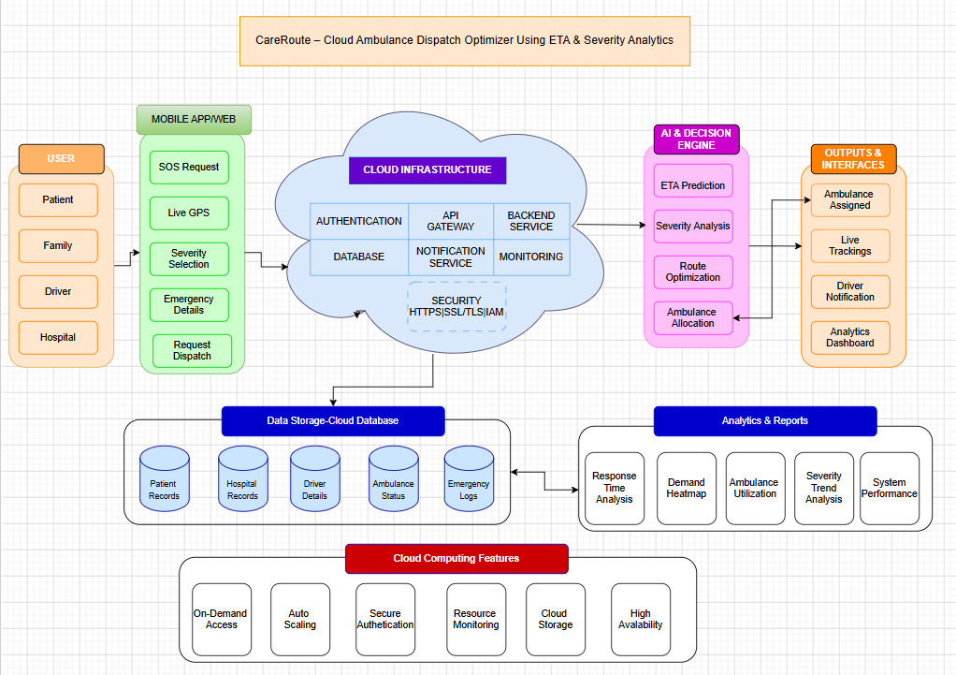
Brief explanation of your concept map: explain the most important nodes, link labels, hierarchy, and capstone connection.
The concept map illustrates the workflow of CareRoute Cloud Ambulance Dispatch Optimizer Using ETA and Severity Analytics. It begins with Users who send an emergency request through the mobile app or web portal. The request is processed using Cloud Services and the AI Decision Engine, which analyzes severity, calculates ETA, and assigns the nearest ambulance. The Cloud Database stores all emergency and ambulance information, while the Outputs provide live tracking, notifications, ETA updates, and analytics. The hierarchy shows the complete flow from emergency request to ambulance dispatch, highlighting the integration of cloud computing and AI in the capstone project.

Task 2 - Service Model Matrix
Complete the matrices by making technical decisions for your capstone project. Select only the rows that are relevant to your capstone design. If a row is not used, write a short technical reason instead of leaving it blank.
Your answer should show how responsibility shifts between cloud provider and student development team, and how the chosen services support the capstone workflow, API design, storage, security, scalability, and evidence submission.

Task 2A - Service Model Responsibility Matrix
Service Model | Capstone Role / Module | Provider Responsibility | Student Responsibility | Evidence to Submit
IaaS | Cloud Storage & Virtual Servers | Provides virtual machines, storage, and networking infrastructure | Configure servers, deploy application, manage storage | Cloud architecture diagram
PaaS | Backend Application & API | Provides runtime environment, database connectivity, deployment platform | Develop backend logic, REST APIs, ETA calculation, ambulance dispatch logic | Backend/API screenshots or code
SaaS | Authentication & Notifications | Provides ready-to-use authentication and notification services | Configure user roles, login, and notification settings | Login page and notification screenshots
XaaS / Specialized Service | Maps & ETA Service | Provides GPS, maps, route calculation, and ETA services | Integrate Maps API and display live ambulance tracking | Map integration screenshots

Task 2B - Capstone Cloud Service Decision Matrix
Cloud Layer / Function | Selected Tool or Service | Data / Resource Handled | API or Integration Path | Security / Scaling Note
Client access and UI | Flutter Mobile App / Web Portal | Emergency requests, GPS location | REST API | HTTPS communication
API / backend logic | Node.js / Express | Dispatch logic, ETA calculation | REST API | Auto Scaling
Authentication and identity | Firebase Authentication | User login and identity | Firebase SDK | JWT & Role-Based Access
Database / structured records | MongoDB Atlas | Patients, ambulances, hospitals, requests | MongoDB API | Cloud Backup & Encryption
File / object storage | Firebase Storage | Medical documents, reports | Firebase Storage API | Secure Cloud Storage
Monitoring / logs / usage metrics | Firebase Analytics / Cloud Monitoring | Performance logs, API usage | Monitoring Dashboard | Real-time monitoring
Analytics / reporting output | Power BI / Dashboard | Response time, ETA accuracy, emergency reports | Database Integration | Read-only analytics access
Technical justification: Explain why the selected cloud service pattern fits your capstone project's users, data, API flow, scalability, and security needs.
The selected cloud service pattern is suitable for CareRoute because it provides a secure, scalable, and reliable platform for emergency ambulance dispatch. Cloud-based authentication protects user accounts, while the backend processes emergency requests, severity analysis, and ETA calculations efficiently. The cloud database stores patient, ambulance, and hospital information securely, and cloud storage manages emergency-related documents. APIs connect the mobile application, backend, maps, and notification services, enabling real-time communication. Auto scaling and monitoring ensure the system remains responsive during high emergency demand, making the solution efficient, secure, and highly available.

Task 3 - Capstone Cloud Flow Mapping
Study the sample architecture-flow template below. Redraw it in draw.io / diagrams.net using your own capstone architecture. Replace every generic label with your actual user role, screen, API endpoint, backend logic, cloud storage, analytics output, security control, and scalability or elasticity decision.
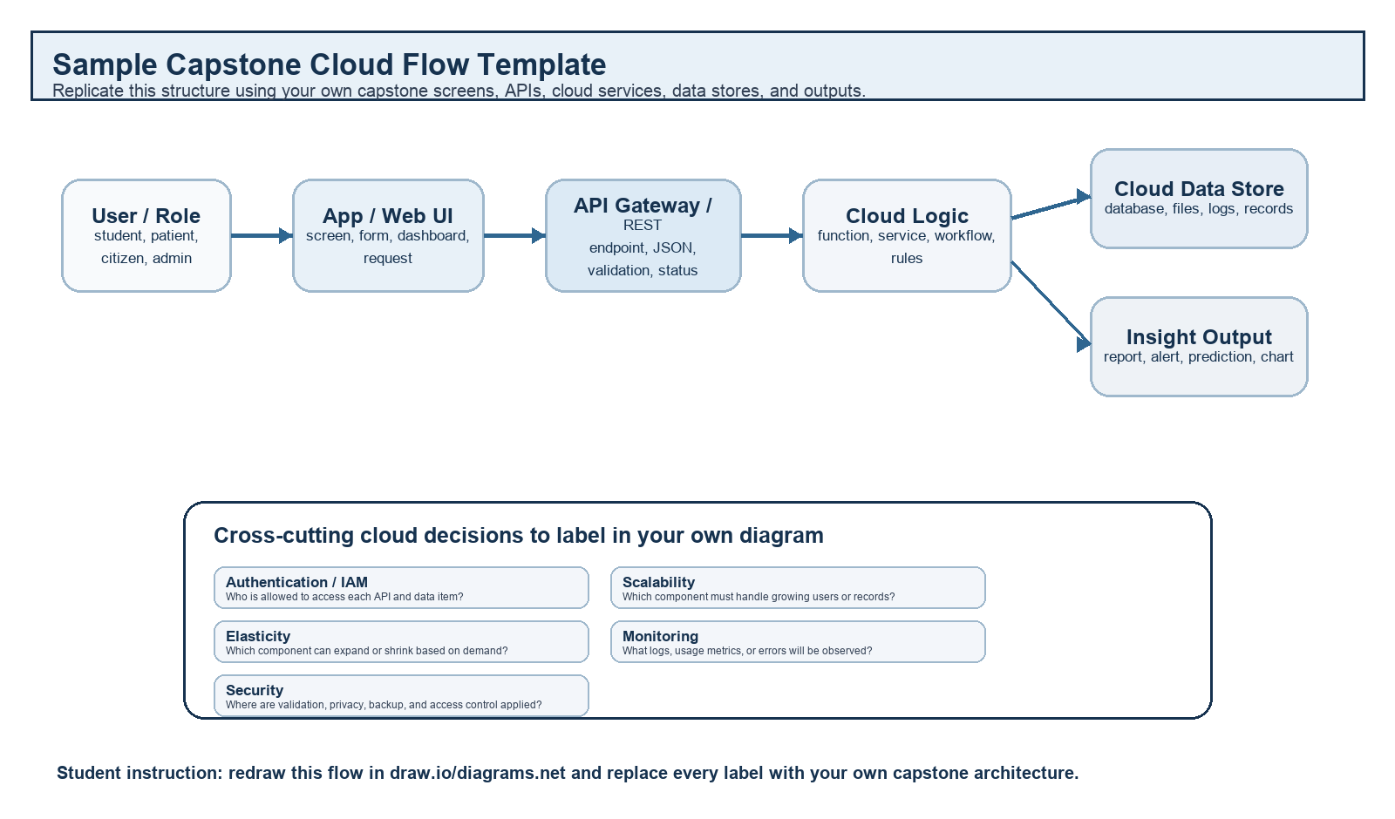
Student Drawing Requirement
Do not copy the sample as it is. Use it as a layout model, then create your own capstone-specific flow diagram with meaningful labels, arrows, data movement, API names, and cloud service choices.
Flow Component | Student Entry
User role and action | Patient/Family submits an emergency ambulance request through the mobile app or web portal.
Frontend / app screen | Emergency Request Screen (SOS button, GPS location, patient details, severity level).
API endpoint and method | POST /api/requestAmbulance
Backend processing rule | Verify user, analyze emergency severity, calculate ETA, identify the nearest available ambulance, and dispatch the request.
Cloud database / storage operation | Store patient details, ambulance status, GPS location, hospital information, and emergency request logs in the cloud database.
Response, alert, report, or dashboard output | Display ambulance assignment and ETA, notify the driver and hospital, provide live tracking, and update the admin dashboard with emergency reports.
Security, scalability, and elasticity labels added in diagram | Security: HTTPS/TLS, JWT Authentication • Scalability: Load Balancer • Elasticity: Auto Scaling
Paste your redrawn capstone cloud-flow diagram here.

Verify Users

Show Live Tracking
Cloud
Database
Analyse Senerity
Cloud
API
Mobile App/
Web
Patient/
Family

Find Ambulance nearby

Brief explanation: explain one complete request-response path from user action to cloud response.nation (Request–Response Path)
A patient or family member submits an emergency request through the CareRoute mobile app by entering their location and emergency severity. The request is securely sent via a POST API to the cloud backend, where the system authenticates the user, analyzes the severity, calculates the ETA, and identifies the nearest available ambulance. The cloud database stores the request details, and the system dispatches the ambulance while sending notifications to the driver and hospital. Finally, the user receives the ambulance details, live tracking, and estimated arrival time (ETA) through the application.

Task 4 - Individual Reflection
Answer the following from your own perspective. Avoid team-common wording.
1. What is the strongest cloud concept represented in your capstone project?
The strongest cloud concept represented in my capstone project is cloud-based real-time emergency service management. CareRoute uses cloud computing to receive emergency requests, authenticate users, process ambulance dispatch, calculate ETA, and store patient and ambulance information in a centralized database. Cloud services enable secure communication, high availability, and real-time data sharing among patients, ambulance drivers, hospitals, and administrators. This ensures faster response times and reliable emergency management.
2. Where will elasticity or scalability become important in your capstone product?

Elasticity and scalability become important when multiple emergency requests are generated simultaneously, such as during natural disasters, accidents, or peak traffic hours. The cloud infrastructure can automatically allocate additional computing resources to process more requests without affecting system performance. As the number of users, hospitals, and ambulances increases, the application can scale efficiently while maintaining fast response times and uninterrupted service.

3. Which API or web-service idea is most relevant to your project and why?

The most relevant web service for my project is the Google Maps API. It provides real-time GPS tracking, route optimization, distance calculation, and estimated time of arrival (ETA). These features help the system identify the nearest available ambulance and guide the driver through the fastest route to the patient's location. The API also enables live ambulance tracking, improving coordination between patients, drivers, and hospitals.

4. What did you personally understand better after preparing this concept map and matrix?

After preparing the concept map and responsibility matrix, I developed a better understanding of how different cloud service models (IaaS, PaaS, SaaS, and XaaS) work together in a real-world application. I also learned how cloud databases, APIs, authentication services, monitoring tools, and AI-based analytics are integrated to build a secure, scalable, and efficient emergency response system. This activity helped me visualize the complete workflow from user request to cloud processing and final service delivery.

Evaluation Rubric - 100 Marks
Criteria | Marks | Expected Standard
Concept identification | 20 | Major CO1 concepts are accurately identified: cloud fundamentals, characteristics, evolution, service models, deployment models, virtualization, web services, SOAP/REST, APIs, elasticity, and scalability.
Relationship mapping | 20 | Links between concepts are accurate, meaningful, and labeled. The map should explain how concepts depend on, enable, consume, provide, scale, or control one another.
Hierarchy and organization | 15 | Concepts are arranged in a logical hierarchy with clear grouping, readable flow, and no disconnected keyword clusters.
Technical relevance | 15 | The map strongly reflects cloud course content and avoids decorative or generic non-technical content.
Service model matrix | 15 | IaaS, PaaS, SaaS, and XaaS are compared with provider responsibility, user responsibility, examples, capstone usage, and risks or limitations.
Capstone alignment and individual reflection | 10 | The student's own capstone interpretation is visible in the concept map, flow mapping, justification, and reflection. Team-common answers are avoided.
Visual clarity and digital evidence | 5 | Diagram is neat, readable, exported properly, and supported with GitHub evidence including source and exported files.

Faculty Evaluation Record
Evaluator Name |  | Marks Awarded
Observation |  | Signature

