
CSA15 - CLOUD COMPUTING AND BIG DATA ANALYTICS
TEAM ASSIGNMENT RESPONSE TEMPLATE
Field | Student Entry
Slot | B
Assignment Title | Cloud-Ready Smart Campus Service Platform: API Implementation, Workload Sizing and Virtualized Deployment
Team Number
Date of Submission | 01-09-26
GitHub Repository | https://github.com/rahimabanu2108-blip/CSA15_CO1_CO2_Assignment_Student_Response.git

Team Members
S.No. | Register Number | Team Member | Owned Module / Responsibility
1 | 192525009 | Rahima Banu N | REST API development, SQLite database, request creation/retrieval, status update and input validation.
2 | 192571008 | Gokulapriya B | Workload Analytics and Predictive Alerts, Docker deployment, testing and GitHub documentation.

1. Problem Interpretation and Team Innovation
Problem Interpretation
Our team interprets the problem as developing a cloud-ready Smart Campus Service Request and Incident Response Platform that enables students and staff to report campus service issues digitally. The system should allow users to submit requests with details such as category, location, description, and priority, while authorized staff can retrieve requests and update their status. The platform should use persistent storage, REST APIs, secure access, and container-based deployment to provide a reliable and scalable solution. Our team also focuses on workload analytics and predictive alerts to identify increasing service demand and support better resource allocation.

Approved Team Innovation
Name: Predictive Workload Alerts and Analytics
Purpose: To analyze service requests based on priority, category, and status and identify increasing workload levels.
Users: Campus administrators and authorized service staff.
Measurable Value: Provides workload counts and alerts when the number of pending or high-priority requests crosses a defined threshold, helping staff allocate resources more effectively.

Requirement / Constraint | Type | Priority | Acceptance Evidence
Users shall create service requests with category, location, description and priority. | Functional | Must | Postman POST request with successful response
Users shall retrieve a specific service request using its ID. | Functional | Must | Postman GET /requests/1 response
Authorized staff shall update the status of a service request. | Functional | Must | Postman PUT request showing updated status
The system shall list and filter stored service requests. | Functional | Must | Postman GET /requests response

2. Architecture, API and Pseudocode
Architecture Diagram
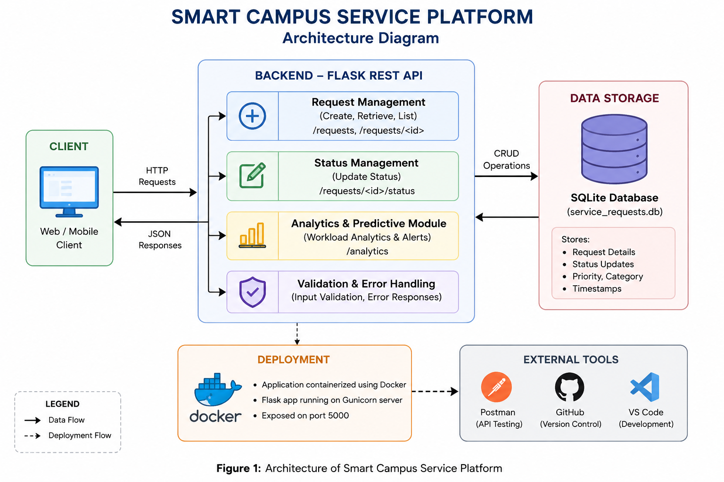

Method | Route | Purpose | Input / Output | Status Codes
POST | /requests | Create a new service request | Input: category, location, description, priority. Output: created request with ID. | 201, 400
GET | /requests | Retrieve all service requests | Input: optional filters. Output: list of requests. | 200, 400
GET | /requests/<id> | Retrieve a specific service request | Input: request ID. Output: request details. | 200, 404
PUT | /requests/<id>/status | Update the status of a request | Input: status. Output: updated request. | 200, 400, 404

Pseudocode
BEGIN

1. Start Smart Campus Service Platform

2. Receive service request from user

3. Read category, location, description and priority

4. Validate all required input fields
IF input is invalid
Return error message
ELSE
Continue

5. Store the service request in the database
Set status = "Pending"

6. Generate a unique request ID

7. Return successful response with request details

8. When staff requests data
Retrieve service requests from database
Display request details

9. When authorized staff updates a request
Validate new status
Update status in database
Return updated request

10. Perform workload analytics
Count total requests
Count pending and high-priority requests
Analyze workload level

11. IF workload exceeds the defined threshold
Generate workload alert
Recommend additional resource allocation
ELSE
Display normal workload status

12. End

3. Infrastructure Sizing and Deployment Decision
Engineering Result | Formula / Method | Substitution | Final Value | Justification
Daily active users | Registered users × DAU % | 3,000 × 25% | 750 users/day | 25% of registered users are assumed to be active daily.
Peak active users | DAU × Peak active share | 750 × 20% | 150 users | 20% of DAU are assumed to be active during peak time.
Peak requests/second | Peak users × actions/min × peak factor ÷ 60 | 150 × 1.5 × 2 ÷ 60 | 7.5 requests/sec | Applies the given API activity rate and peak factor.
Required vCPU | (Peak requests/sec × CPU time/request) ÷ target utilization | (7.5 × 0.1) ÷ 0.65 | 1.15 vCPU → 2 vCPU | Round up to a practical 2-vCPU deployment.
Required RAM | Engineering allocation for application + database + OS | Practical deployment allocation | 4 GB RAM | Provides sufficient memory for the Flask application, database and OS.
Required storage | Business data + evidence + logs + DB overhead | Calculated from assignment workload assumptions | At least 10 GB | Provides capacity for business data, evidence uploads, logs and overhead.
Growth headroom | Base capacity × 25% | 2 vCPU × 25% | 0.5 vCPU headroom | Meets the assignment requirement of at least 25% growth headroom.

Selected Deployment Environment
Docker Container on a Linux-based environment
Docker is selected because it provides a lightweight, portable and isolated environment for deploying the Flask-based Smart Campus Service Platform. It packages the application, dependencies and runtime together, making deployment consistent across different systems. It also supports easy scaling and is compatible with cloud deployment. The containerized application can be tested locally using Docker Desktop and demonstrated using docker ps. The assignment allows Docker as an approved containerized deployment environment.

Security and Recovery Controls
Authentication: Users are authenticated before accessing protected services.
Roles: Role-based access control is used to allow authorized staff to update service requests.
Input Validation: Required fields, priority values, status values and request IDs are validated to prevent invalid input.
Secrets: Passwords, API keys and other sensitive configuration values are stored securely using environment variables rather than hard-coded in the source code.
Backup: The SQLite database is backed up periodically to preserve service request data.
Rollback: Previous application versions and database backups are maintained so the system can be restored if a deployment or update fails.

4. Implementation and Source Code
Module | Technology | Owner | Repository Path | Execution Evidence
REST API / Backend | Python, Flask | Rahima Banu N | /app.py | Flask server running in terminal
Database | SQLite | Rahima Banu N | /campus.db | Stored request data
API Testing | Postman | Rahima Banu N | /tests/ | POST, GET and PUT responses
Input Validation & Security | Flask, Python | Rahima Banu N | /app.py | 400 Bad Request for invalid input

Source Code in Selectable Text
from flask import Flask, request, jsonify
import sqlite3
from datetime import datetime

app = Flask(__name__)
DB = "campus.db"

def db():
con = sqlite3.connect(DB)
con.row_factory = sqlite3.Row
return con

@app.route("/")
def home():
return jsonify({"message": "Smart Campus Platform", "status": "Running"})

@app.route("/requests", methods=["POST"])
def create():
data = request.get_json()

required = ["category", "location", "description", "priority"]
if not data or any(x not in data or not data[x] for x in required):
return jsonify({"error": "All fields are required"}), 400

con = db()
cur = con.execute("""
INSERT INTO requests
(category, location, description, priority, status, created_at)
VALUES (?, ?, ?, ?, ?, ?)
""", (
data["category"], data["location"],
data["description"], data["priority"],
"Pending", datetime.now().isoformat()
))
con.commit()
con.close()

return jsonify({"message": "Request created", "request_id": cur.lastrowid}), 201

@app.route("/requests", methods=["GET"])
def get_all():
con = db()
rows = con.execute("SELECT * FROM requests").fetchall()
con.close()
return jsonify([dict(row) for row in rows])

@app.route("/requests/<int:id>", methods=["GET"])
def get_one(id):
con = db()
row = con.execute("SELECT * FROM requests WHERE id=?", (id,)).fetchone()
con.close()

if not row:
return jsonify({"error": "Request not found"}), 404

return jsonify(dict(row))

@app.route("/requests/<int:id>/status", methods=["PUT"])
def update(id):
data = request.get_json()

if not data or "status" not in data:
return jsonify({"error": "Status is required"}), 400

con = db()
con.execute(
"UPDATE requests SET status=? WHERE id=?",
(data["status"], id)
)
con.commit()
con.close()

return jsonify({"message": "Status updated"})

@app.route("/analytics")
def analytics():
con = db()

total = con.execute("SELECT COUNT(*) FROM requests").fetchone()[0]
pending = con.execute(
"SELECT COUNT(*) FROM requests WHERE status='Pending'"
).fetchone()[0]
high = con.execute(
"SELECT COUNT(*) FROM requests WHERE priority IN ('High','Emergency')"
).fetchone()[0]

con.close()

level = "HIGH" if pending >= 5 or high >= 3 else "NORMAL"

return jsonify({
"total_requests": total,
"pending_requests": pending,
"high_priority": high,
"workload": level
})

def init_db():
con = db()
con.execute("""
CREATE TABLE IF NOT EXISTS requests (
id INTEGER PRIMARY KEY AUTOINCREMENT,
category TEXT,
location TEXT,
description TEXT,
priority TEXT,
status TEXT,
created_at TEXT
)
""")
con.commit()
con.close()

if __name__ == "__main__":
init_db()
app.run(host="0.0.0.0", port=5000)

5. Results, Testing and Validation
Test / Requirement | Input or Condition | Expected Result | Observed Result | Evidence
Create request | Valid request details | Request created successfully | Passed | SS2
Retrieve request | Valid request ID | Request details displayed | Passed | SS3
List requests | GET all requests | All stored requests displayed | Passed | SS4
Update status | Status = Resolved | Status updated successfully | Passed | SS5

Result Evidence
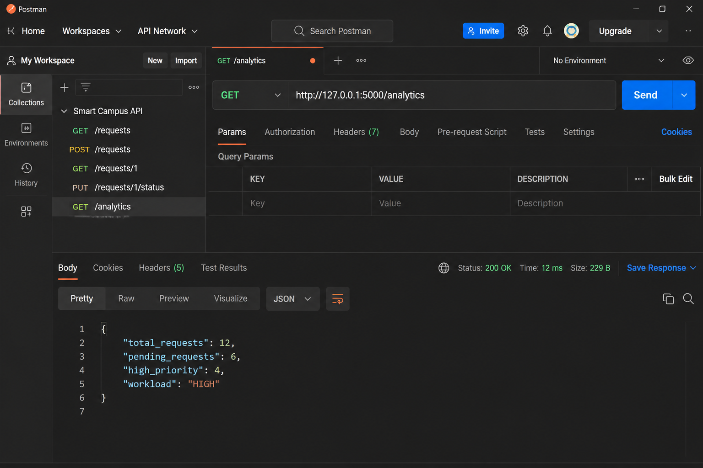

Engineering Conclusion
The implemented Smart Campus Service Request Platform successfully demonstrates request creation, retrieval, status updating, input validation, persistent storage, workload analytics and Docker-based deployment. Testing through Postman and Docker provides evidence that the main functional requirements are achieved. The main limitations are the use of a lightweight SQLite database and a basic workload-alert mechanism. For production deployment, the system can be improved using a scalable cloud database, stronger authentication and authorization, automated backups, monitoring, load balancing and more advanced predictive analytics.

6. GitHub and Submission Record
Evidence | Repository Path / URL | Verified
Source code | https://github.com/rahimabanu2108-blip/CSA15_CO1_CO2_Assignment_Student_Response.git | [Yes]
README and setup | https://github.com/rahimabanu2108-blip/CSA15_CO1_CO2_Assignment_Student_Response.git | [Yes]
Architecture source | https://github.com/rahimabanu2108-blip/CSA15_CO1_CO2_Assignment_Student_Response.git | [Yes]
Tests and screenshots | https://github.com/rahimabanu2108-blip/CSA15_CO1_CO2_Assignment_Student_Response.git | [Yes]
Contribution evidence | https://github.com/rahimabanu2108-blip/CSA15_CO1_CO2_Assignment_Student_Response.git | [Yes]

References and Tool Disclosure
References: CSA15 – Cloud Computing and Big Data Analytics Assignment Problem Statement and Team Assignment Response Template. Flask documentation and Python documentation were referred to for implementation guidance.
Tools Used: Python, Flask, SQLite, Postman, Docker, VS Code and GitHub. AI-assisted tools were used for coding guidance, debugging support and documentation preparation. The generated code and outputs were manually reviewed, executed and verified through API testing and Docker deployment.

