My Thesis documentation

what’s Version Control Systems?
Version control systems (VCS) are software tools that enable developers to track and manage changes to code, documents, or any other digital assets over time. They play a crucial role in software development, ensuring that code changes are properly documented, reversible, and collaborative.
A VCS stores the history of changes made to files, allowing developers to revert to previous versions if needed. This can be particularly useful when bugs or errors arise, enabling developers to quickly restore the codebase to a working state.
VCSs also facilitate collaboration among developers by providing a shared repository where changes can be synchronized. This allows multiple developers to work on the same project simultaneously without interfering with each other's work. VCSs also track the contributions of each developer, ensuring that everyone's work is properly credited.

Centralized VCS?
In a Centralized VCS, all changes are made to a single, central repository. This repository is typically stored on a server, and developers need to connect to the server to make changes. This can be a disadvantage if the server is down, or if there is a network outage. However, CVCS is relatively easy to set up and use, and it is often the best choice for smaller projects.

Distributed VCS
In a Distributed VCS, each developer has a complete copy of the repository. This allows developers to work offline, and it also makes the system more resilient to server outages. DVCS is more complex to set up and use than CVCS, but it is often the best choice for larger projects or projects with multiple teams.

CVCS vs DVCS
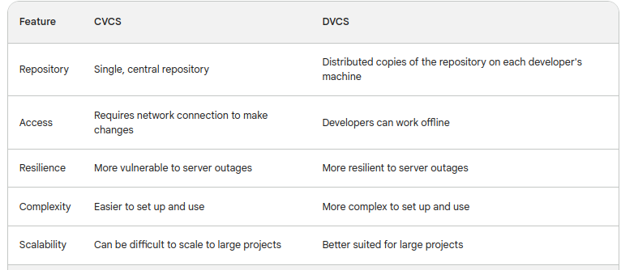

What is Git?
Git is a distributed version control system (VCS) for tracking changes in source code. It was originally created by Linus Torvalds in 2005 for the development of the Linux kernel. Git is a powerful and versatile tool that has been adopted by a wide range of organizations and individuals, and it is now the most widely used VCS in the world.

History of Git
The development of Git began in 2005 when Linus Torvalds, the creator of Linux, found himself in a dispute with the maintainers of BitKeeper, the VCS he was using to manage the Linux kernel. Torvalds was not happy with BitKeeper's licensing terms and decided to create his own VCS.
Torvalds initially developed Git in just five days, and it quickly became the preferred VCS for the development of the Linux kernel. Git's popularity soon spread beyond the Linux community, and it is now used by a wide range of organizations and individuals for managing source code for a variety of projects.

Types of Git Repositories
There are two main types of Git repositories: local and remote.
Local repositories store all of the files and history of your project on your local machine. This is the most common type of repository, and it is the one that you will typically use when you are working on your project locally.
Remote repositories store a copy of your project's history on a server. This allows you to share your project with others, and it also allows you to back up your project in case your local repository is lost or corrupted.

Git Installation Steps
- Installing Git:
  - sudo apt install git
  - git –version #check its installed version.
- Git Config:
  - git config –global user.name amin # set a user name for git
  - git config –global user.email aminudinr837@gmail.com # set an email for git
  - git config –global -l #check the config has been done on git.
- Creating Repository and managing it:
  - sudo mkdir lumi # creates a folder by the name of lumi
  - cd lumi #changed the directory to lumi.
  - sudo git init # makes the folder as repository that will be controlled by git.
- Create a file and adding it to git:
  - cd lumi
  - sudo touch amin.txt #creates a file named amin.
  - Sudo git add amin.txt # amin file is added to git and it will be tracking.
  - Sudo git commit -m ‘add first file’ # it will commit the file and tracks the changes into amin file.
  - Sudo git log #show your commited and the date it has been changed by whom.
- Make some changes into amin.txt file:
  - sudo vim amin.txt #open amin file
  - add the first line to this file #this message will be inserted into amin file.
  - Press Esc key then :wq #close the file and save it.
  - Sudo git diff File-Name #show the changes have been made in this file.
  - Sudo git add . #commits all changed files in this folder
  - sudo git commit #accepts the changes made into files.
- Commit changes as parts you want:
  - sudo git add File-name -p/--patch #it will let you commit parts of the file you want to be commited.
- Showing changes into each commit:
  - sudo git log #tell you a history of commited
  - sudo git log –oneline # list you all commits line by line.
  - Sudo git log –oneline –name-only -n 5 #list you all commits with corresponded files.
  - Sudo git show Commit_ID #show you the details of changes in each commit
- How to restore deleted files from git folder?
  - Sudo checkout File-Name #restore deleted file.
  - Sudo checkout Commit_ID – File-Name #restore each commit you want to restore from deleted file.
- How to restore a file from staged step into working directory step?
  - Sudo git reset HEAD File-Name #restore selected file from staged to working directory stage.
  - Sudo git checkout Commit_ID – File-Name #restore the file into specific commit
- How to reset previous commits and start from a specific commit again?
  - Sudo git reset HEAD~Number-Of-Commits_You_want_to_Come_Back #reset previous commits and start again from commit you selected.
  - Sudo git reset HEAD~2 –hard #it will remove other commits and files which has been created after this commit and go to two previous commit.
  - Sudo git reset HEAD~2 –soft #it won’t remove other commits and files which has been created after this commit and go to two previous commit.
- Creating Branches in Git:
  - sudo git branch Brand-Name # it will create a branch for you
  - git branch #show you all created branches and your current active branch.
  - Sudo git checkout Branch-Name #switch between git branches.
  - Git log –oneline #show all commits in each branch you are.
  - Git log –oineline –all #show all commits in all branches.
  - Git log –oneline –all –graph #show a graph of commits has been created in all branches.
- Combining Two or more branches:
  - sudo git merge Branch-Name Branch-Name #combine these two branches together.
- Pushing your local repository into github account
  - Go your github account and create a repository and name it the same as your local repository.
  - Go to your github account Setting, Developer mode, Generate PAT key/Token to use it instead of your password account during pushing repository.
  - Sudo git remote add origin Link-of-your-repository-on-github #connect your local repository to your github repository.
  - Sudo git push -u origin master #it will push your local repository to github and you can see the changes into it.
- Pulling remote repository into local repository
  - make some changes on your remote repository, for example creating a file or directory or any other changes.
  - Create a PAT (Personal Access Token) in your github account as mentioned in pushing step, if you didn’t create PAT in pushing step.
  - Sudo git remote add Repository-Name (origin) Link-of-your-repository-on-github #connect your local repository to your github repository. The origin parameter specifies the name of the remote repository. The default remote repository is named origin, but you can change the name if you have multiple remote repositories.
  - Sudo pull origin master #it will pull and merge all changes have been done in remote repository into your local repository. The master parameter specifies the name of the branch that you want to pull from. This is typically the main branch of your repository.

Important Shortcuts in Linux
- Clt+6 #enable selection
- Alt+\ #go to beginning of first line
- Alt+/ #go to the end of last line
- Clt+K #cut the selected lines
- Clt+U #undo cut lines

