1.CREATE A TABLE MANUAL OR

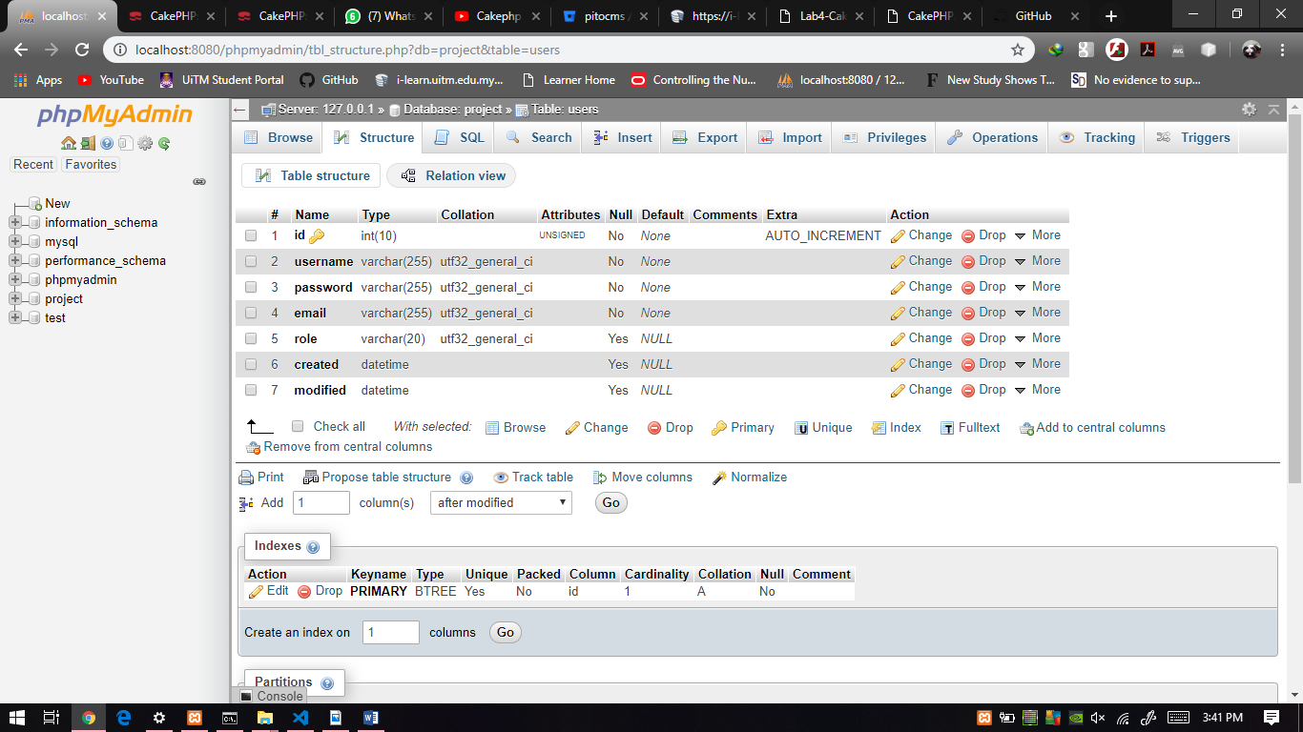

2.CREATE A TABLE WITH SQL COMMAND

|  |
| --- |
| CREATE TABLE users (  id INT(10) UNSIGNED NOT NULL AUTO_INCREMENT PRIMARY KEY,  username VARCHAR(255) NOT NULL,  password VARCHAR(255) NOT NULL,  email VARCHAR(255) NOT NULL,  role VARCHAR(20),  created DATETIME,  modified DATETIME  ) ENGINE=InnoDB DEFAULT CHARSET=utf32; |

3.OPEN CMD & RUN COMMAND

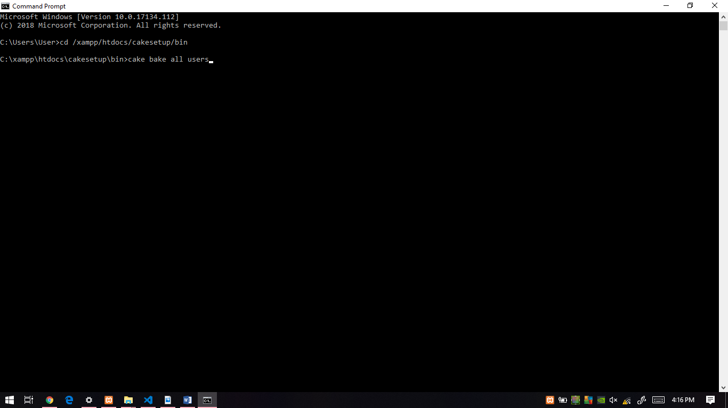 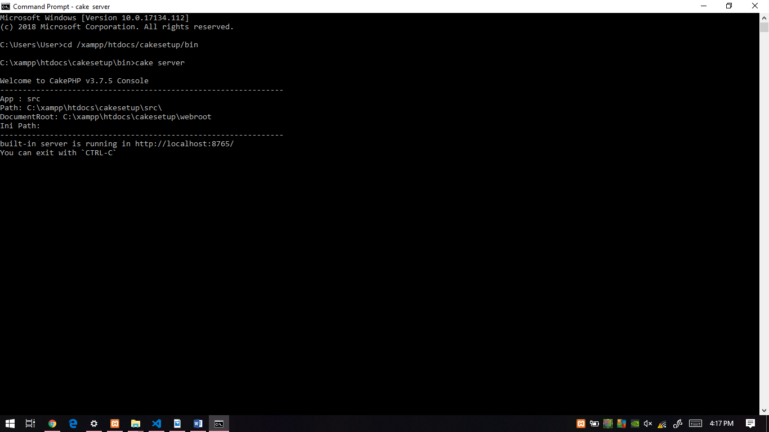

4.OPEN BROWSER & RUN <http://localhost:8765/users>

5.CREATE NEW USER & SUBMIT

