Playwright_POM_CLI — Assignment Report
Nov 11, 2026 · Rahim Mondol

Project overview
A Playwright + JavaScript Page Object Model framework testing the login on Sauce Demo (https://www.saucedemo.com), run from the CLI with npm run test:login and driven by data/users.json (1 success case, 2 error cases).
Page objects | pages/LoginPage.js (username, password, login button, error message; login(), getErrorMessage()), pages/InventoryPage.js (title + product list; isLoaded())
Test | tests/login.spec.js loops over data/users.json and creates one test per entry
npm script | "test:login": "playwright test tests/login.spec.js --project=chromium"
GitHub repo | https://github.com/rahimmondol123/Playwright_POM_CLI

Folder structure
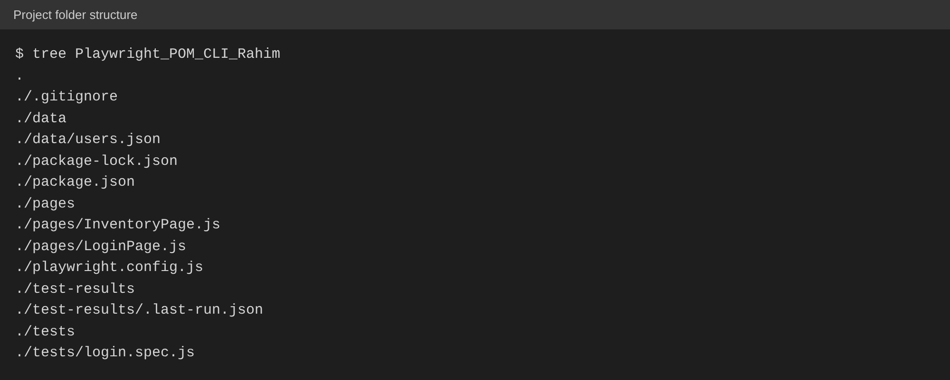

CLI run: npm run test:login
All 3 data-driven cases passed: standard_user / secret_sauce logged in (success), while locked_out_user / secret_sauce and standard_user / wrong_password showed an error message (2 errors).
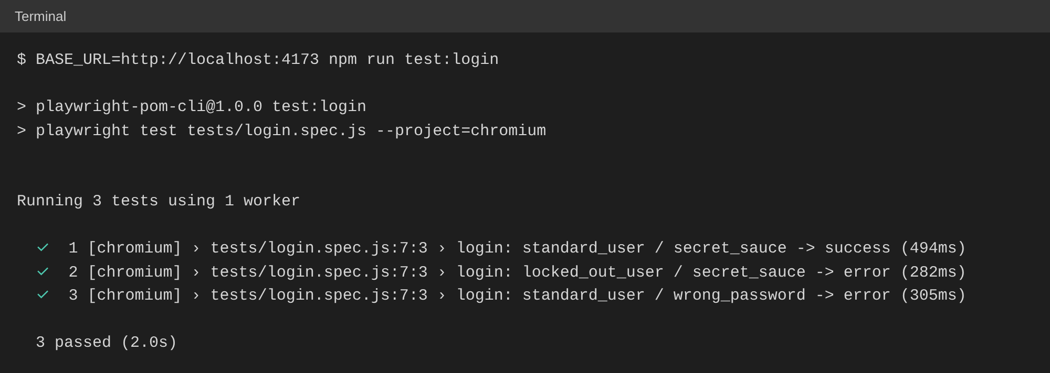

What Claude got right and what I adjusted
Claude generated the setup commands, both page object classes, the npm script and the data-driven loop correctly on its own. The parts that needed adjusting were that Sauce Demo marks its elements with data-test attributes (e.g. data-test="error", data-test="title"), so I set testIdAttribute: 'data-test' in playwright.config.js for the getByTestId() locators to match, and I made isLoaded() and getErrorMessage() wait for their element (waitFor) so they do not return false or an empty string before the page has finished loading.

