Freight Rate Prediction Report
Model: linear regression (NumPy least squares). Notebook: freight_rate.ipynb.

Approach to train / validation split
Labeled development data covers January 1 through October 31, 2025 (48,000 loads). The required scoring file is November–December 2025. Because the real task is to predict later dates, I did not use a random split.
I sorted the cleaned training rows by date and used a time-based 80/20 cut. The cutoff date is 2025-08-31. Rows on or before that date are the fit set (38,477 loads, January–August). Rows after that date are the hold-out check (9,523 loads, September–October).
A random mix would put later-season loads into training and leak information that would not be available when scoring November and December. The time split matches how the model is used in production.

How the hold-out set was scored
I fit linear regression only on the earlier slice, then predicted posted_rate on the later slice. Error metrics on that later period:
- MAE: $147.69 (typical dollar miss)
- RMSE: $640.01 (larger because a few long-haul loads have very high rates)
After that check, I refit on all 48,000 cleaned training rows and used that final model for validation_predictions.csv and the December chart. The MAE/RMSE above are from the time hold-out, not from the final submission file.
The line is easy to read: about $1.85 per mile, plus equipment (Reefer higher than Dry Van) and a small weekday term. Distance is the main signal (correlation with posted_rate about 0.91).

December 2025 predicted load rate
This chart is produced by the provided score.py after it validates both output files. The lane is fixed: Lexington to Fort Wayne, 360 miles, Dry Van, 32,000 lb. Only the date changes.
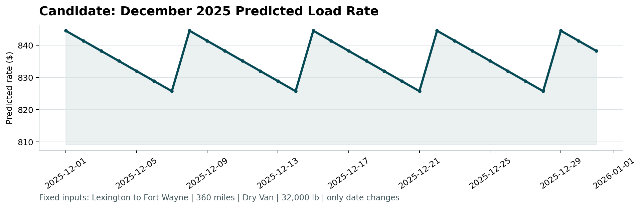
Figure: Candidate December 2025 predicted load rate (score.py).
The weekly up-and-down pattern is the weekday feature. Monday rates are a few dollars higher than Sunday. Distance, equipment, and weight do not change on this chart.

