Weather-Aware Truck Routing
Technical documentation for the Spotter Full Stack Developer assessment
Item | Details
Author | Abdul Rahim
Date | November 10, 2026
Live app | https://weather-truck-routing-phi.vercel.app
Repository | https://github.com/rahimxai/weather-truck-routing
Walkthrough | Loom video (link included with the submission)
Stack | React 19, TypeScript, Vite, MapLibre GL, deck.gl · Django 5.2, Django REST Framework · TomTom, Open-Meteo, OpenFreeMap · Vercel

1. Summary
The app helps a truck driver choose the safest route based on weather, load weight and travel time. The driver enters an origin, a destination, a departure time and a load weight. The app gets three truck routes from TomTom, places weather checkpoints every 10, 25 or 50 miles along each one, reads the forecast for the time the truck will actually reach each checkpoint, scores the risk with the assessment's thresholds and load rules, and recommends a route with a written reason.
Everything is shown on one map: routes colored by risk, checkpoint details, ranked route cards, and a weather heatmap along the trip corridor with a 0–48 hour slider that shows where each truck would be at every hour.
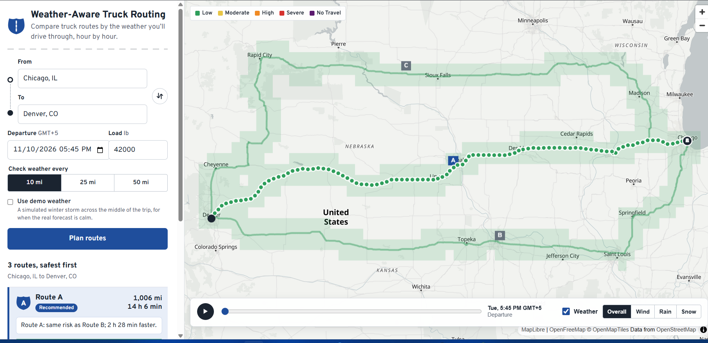
Figure 1. The live app planning Chicago, IL to Denver, CO: three truck routes, checkpoints at 10-mile spacing, the corridor heatmap and the 48-hour slider.

2. Requirements coverage
Every requirement in the assessment brief, how it is met, and where to find it in the code.
Requirement | How it is met | Code
Origin, destination, departure date/time, load weight | Trip form with place autocomplete (TomTom search), a departure picker in the driver's time zone limited to the 7-day forecast range, and load in lb (0–80,000). | TripForm.tsx, PlaceAutocomplete.tsx
3 route options from a routing API | TomTom Calculate Route in truck mode with the load in kg, live traffic and 2 alternatives. If fewer come back, extra routes are forced through side points and near-duplicates dropped; if there are still fewer than 3, the app says so. | adapters/tomtom.py, domain/alternatives.py
Weather every 10/25/50 mi at the truck's ETA | Checkpoints at mile 0, every interval and the destination. ETAs come from TomTom's travel time along the route; the forecast is interpolated to that exact time. | domain/checkpoints.py, domain/forecast.py
Risk from the provided rules | The thresholds and load rules exactly as specified; the level is the worst of wind, rain and snow, with a reason. | domain/risk.py
Recommend the best route (risk and time) | Ranked by No Travel, Severe and High miles, then average risk, then travel time, with an explanation of why the winner won. | domain/recommend.py
Routes, checkpoints, risk, ETAs and summaries on a map | Risk-colored route segments, clickable checkpoints with highway, ETA and weather, ranked route cards with the highways and states crossed, miles per level and a strip map, route labels on the map. | PlanLayers.tsx, CheckpointPopup.tsx, RouteCard.tsx, domain/places.py
Weather heatmap with a 0–48 h slider | A 40 km corridor around all routes, scored for 49 hourly frames, sent once; play, scrub and four metrics switch on the client with no network call. | domain/heatmap.py, HeatmapSlider.tsx

Deliverable | Status
GitHub repository | https://github.com/rahimxai/weather-truck-routing (CI passing on every push)
Hosted application | https://weather-truck-routing-phi.vercel.app (Vercel)
5–10 min Loom walkthrough | Included with the submission

3. How a plan is made
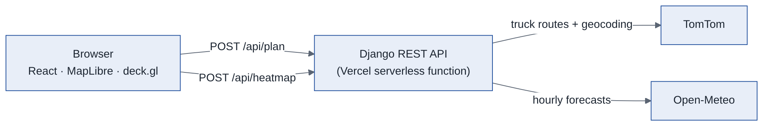
Figure 2. Request flow. The browser talks only to the Django API; API keys stay on the server.
- Routes. Django asks TomTom for truck routes between the two places, with the load converted to kilograms and the chosen departure time. TomTom's guidance steps also give the road numbers and states used to name each route's highways and states.
- Checkpoints. Checkpoints are placed at mile 0, every 10, 25 or 50 miles, and at the destination. Each checkpoint covers the road halfway to its neighbors, so the covered miles add up exactly to the route length.
- ETAs. TomTom's guidance instructions give the travel time to points along the route. The ETA at each checkpoint is interpolated from that profile, so it follows real road speeds rather than an average speed.
- Weather. Open-Meteo is asked for hourly wind, gusts, rain, showers and snowfall in mph and inches, in parallel batches of 50 locations. Nearby checkpoints share one lookup. Values are interpolated to each checkpoint's ETA.
- Risk and ranking. Each checkpoint is classified, each route is summarized as miles per level, and the routes are ranked and explained.
- Heatmap. Once the routes are on screen, the browser asks for the heatmap. The server scores every corridor cell for each of the 49 hours with the same classifier and returns them as one compact response.
The API is stateless, because it runs as a serverless function: the browser sends the route lines back for the heatmap request instead of the server remembering them.

4. Risk rules
Thresholds from the assessment. Bands are half-open (the lower number is included), and No Travel uses the brief's ≥ and > exactly.
Level | Wind (mph) | Rain (in/hr) | Snow (in/hr) | Score
Low | < 25 | < 0.10 | < 0.5 | 0
Moderate | 25 – < 35 | 0.10 – < 0.25 | 0.5 – < 1.0 | 1
High | 35 – < 45 | 0.25 – < 0.50 | 1.0 – < 2.0 | 2
Severe | 45 – < 55 | 0.50 – 1.00 | 2.0 – 3.0 | 3
No Travel | ≥ 55 | > 1.00 | > 3.0 | 4

Load rules
Load rules adjust the wind level before the three conditions are combined:
- Wind ≥ 55 mph is No Travel for any load.
- Wind 45 – < 55 mph with more than 30,000 lb becomes No Travel.
- Wind 35 – < 45 mph with more than 40,000 lb becomes Severe.
Exactly 30,000 or 40,000 lb is not escalated, because the brief says "more than".

Combining
A checkpoint's level is the worst of wind (after the load rules), rain and snow. Its reason names whatever set that level, for example "Wind 38.0 mph with 42,000 lb load". Values are classified at the precision shown on screen (0.1 mph, 0.01 in/hr), so a label never contradicts its number.

5. Recommendation
Routes are compared in this order, and the first difference decides:
- Fewest No Travel miles (added ahead of the brief's list, because it is clearly the worst outcome)
- Fewest Severe miles
- Fewest High miles
- Lowest distance-weighted average risk (Low 0 to No Travel 4)
- Shortest travel time
Miles are rounded to 0.1 and average risk to 0.01 before comparing, so floating-point noise can't pick the winner. The explanation compares the winner with the runner-up and, when the fastest route lost, says what made it riskier.

Worked example: load changes the recommendation
Chicago, IL to Denver, CO, under the same simulated winter storm, at two loads. These results are from the live deployment:
Load | Recommended | Explanation shown to the driver
25,000 lb | Route A | "Route A: 50 Severe miles vs 100 on Route B; 2 h 22 min faster."
45,000 lb | Route B | "Route B: 100 Severe miles vs 150 on Route C; 2 h 51 min faster. Route A is 2 h 22 min faster but has 50 No Travel miles."

At 45,000 lb the load rules turn Route A's strong-wind stretch into No Travel, so it drops to last despite being the fastest.

6. Interpretation decisions
The brief leaves some points open. These are the choices made and the reasons for them.
Topic | Decision | Why
"Every 10 / 25 / 50 miles" | The driver picks the interval; default 25 mi | Reads as a choice of resolution; a toggle shows all three
Threshold edges | Half-open bands; No Travel uses ≥ / > exactly | The table repeats edge values (0.25 appears in two columns)
Combining conditions | Worst of wind, rain and snow, after load rules | A stretch of road is as dangerous as its worst hazard
Wind metric | Sustained 10 m wind; gusts shown for information only | The thresholds match sustained-wind conventions
Rain | Open-Meteo rain + showers, not total precipitation | Total precipitation would count snow twice
Weather at the ETA | Interpolated between forecast hours; hourly totals treated as centered half an hour earlier | No jumps at the top of each hour
ETA | From TomTom's travel-time profile along the route | Follows real road speeds
No Travel in ranking | Ranked before Severe | Not in the brief's list, but the worst outcome
Fewer than 3 routes | Forced detours, duplicates dropped, honest note if still fewer | Meets "3 routes" where roads allow
Departure time | Up to 10 minutes in the past accepted; over 7 days ahead rejected | Clock drift; forecasts end at 7 days
Heatmap corridor | 40 km either side; 0.2° cells, growing to at most 1° to stay under 600 cells | Near the forecast models' resolution, bounded for long trips
Demo weather | Off by default; a labeled storm placed across the middle of any trip | Shows the rules when real weather is calm, without mixing demo and live data

7. Architecture and code
The backend separates pure logic from network access, so every rule can be tested without calling an API.
Path | Responsibility
backend/routing/domain/ | Pure logic, no network: risk classification, checkpoints and ETAs, ranking and explanations, geometry, forecast parsing and unit conversion, heatmap frames, route details (highways and states), demo weather
backend/routing/adapters/ | TomTom and Open-Meteo clients: timeouts, retries with backoff (longer waits on rate limits, honoring Retry-After), and the API key never written to logs or errors
backend/routing/services/ | Joins adapters and domain logic: plan_trip and corridor_heatmap
backend/routing/api/ | Request validation, response shapes, consistent JSON errors
api/index.py | Vercel entry point for the Django app
frontend/src/components/ | Trip form, route cards, map layers, checkpoint popup, heatmap slider, map guide
frontend/src/lib/, hooks/ | API types and client, formatting, route and heatmap helpers, data-loading hooks
scripts/smoke_test.py | End-to-end check of a deployed copy against the real APIs

API
Endpoint | Purpose
GET /api/health | Reports that the API is up and whether the TomTom key is set (never the key itself)
GET /api/geocode?q= | Up to five place matches for the autocomplete
POST /api/plan | Trip in; three scored routes, checkpoints, recommendation, explanation and warnings out
POST /api/heatmap | Route lines in; corridor cells and 49 hourly frames for four metrics out (one byte per cell per hour)

Errors always use one shape, {"error": {"code", "message"}}, with messages written for the driver, including for 404s and server errors.

8. User interface and performance

What the driver sees
- Route cards, safest first: distance, drive time, arrival time, miles per risk level, a strip map of where the risk sits along the drive, and the reason the recommended route won.
- Route details: each card names its main highways and the states it crosses, for example "Via I-88 → I-80 → I-76; Illinois, Iowa, Nebraska, Colorado", and each checkpoint popup names its highway. Both come from TomTom's own guidance (road numbers and state codes) in the routing response the app already makes, so there are no extra API calls.
- Map: risk-colored routes (the focused route on top, others dimmed), start and end markers, route labels, and checkpoint popups with ETA, wind, gusts, rain, snow, level and reason.
- Heatmap and slider: corridor weather for each of the next 48 hours, with play and scrub, four metrics, and a truck marker showing where each route's truck would be at that hour.
- Map guide (the Guide link in the legend): the thresholds for every level, the load rules, what each map layer shows and how the route is picked. A test fails if its numbers ever differ from the backend's rules.
- Demo weather: a clearly labeled simulated storm, off by default, with a banner on the results and a label on the map.
- States: loading, errors with a clear next step, a note when fewer than three routes exist, and a warning when every route crosses No Travel weather.

Performance
- The heatmap's 49 frames arrive once as bytes; the slider only changes which frame the colors are read from, and the map shapes are never rebuilt. Scrubbing was measured at a steady 60 frames per second.
- The routes appear before the heatmap loads, so the page never waits on the corridor forecast.
- The map library loads in its own chunk after the first paint. Route geometry is simplified on the server before it is sent.
- Animation is limited to one moment: the routes draw themselves on and the heatmap fades in. A crossfade between hours was removed because it doubled the frame time while scrubbing.

Accessibility
- Fully usable from the keyboard, with labels for screen readers and visible focus. Colors are always paired with text labels.
- Works down to 320 px phone width with no sideways scrolling. All motion is skipped when the system asks for reduced motion.
- Automated accessibility scans (axe) report no violations.

9. Quality and testing
Suite | What it covers
Backend, 318 tests (pytest) | Every threshold and load-rule edge (24.9/25.0 mph, 40,000/40,001 lb …); risk never decreasing as conditions worsen; checkpoint placement, coverage and ETAs; each ranking key and the explanation text; adapters against fake TomTom and Open-Meteo servers, including retries, rate limits, timeouts, unit conversion and the key never appearing in responses or logs; every validation error; heatmap frames and the demo load flip; highway and state names checked against a recorded real TomTom response for three routes
Frontend, 61 tests (Vitest) | API client, formatting, route and heatmap helpers, route card and its highway line, checkpoint popup, heatmap retry, intro animation, map guide behavior, and a check that the guide's thresholds match the backend
Browser tests (Playwright) | The full flow, errors, keyboard use, phone and tablet layouts, the slider and playback, demo labeling, and accessibility scans
Continuous integration | GitHub Actions runs linting, formatting, both test suites and the production build on every push
Live smoke test | scripts/smoke_test.py checks the deployed app against the real TomTom and Open-Meteo APIs: page, health, geocoding, a live plan with 3 routes and exact coverage, the heatmap, and the demo load flip

10. Deployment and security
- Deployed on Vercel as one project: the React app as static files and Django as a Python serverless function under /api, on one address, so no cross-origin setup is needed. Every push to main redeploys.
- TOMTOM_API_KEY, SECRET_KEY and DEBUG=False are Vercel environment variables. No secret is in the repository; the key is used only on the server and never reaches the browser, the responses or the logs.
- Open-Meteo's free plan limits requests per minute by IP address, and Vercel shares IP addresses between apps. The server waits and retries when rate limited, and the heatmap retries once on its own before showing an error.

11. Limitations and next steps
- Vehicle weight: TomTom receives the load as the vehicle weight. Adding an empty-truck weight would make bridge and weight restrictions more realistic.
- Forecast limits: heavy use can still hit Open-Meteo's free limits. A paid plan or a short-lived forecast cache would remove this.
- Heatmap resolution: cells are 0.2–1° wide, while routes use the exact checkpoint point, so a small, intense feature can look slightly different on the map than on the route.
- States on a route come from the state TomTom gives each guidance step: correct for the order a route crosses states, but not for the state at every mile, so checkpoints name their highway only.
- Truck markers move at constant speed between checkpoints: exact at checkpoint times and close in between.
- Next steps: suggest the earliest clear departure when every route crosses No Travel, record more real API responses as test fixtures, and add hazardous-load routing options.

