Pokedex User Guide

1. Opening Site

* While opening the Pokedex WebApp the text “Loading Pokemon Data” is going be displayed, while this happens the LoadPokemonTable Function runs and the Pokemon Data is being fetched and saved inside of the PokemonTable component that gets rendered inside the Index.

(this what the user sees then Opening the WebApp)



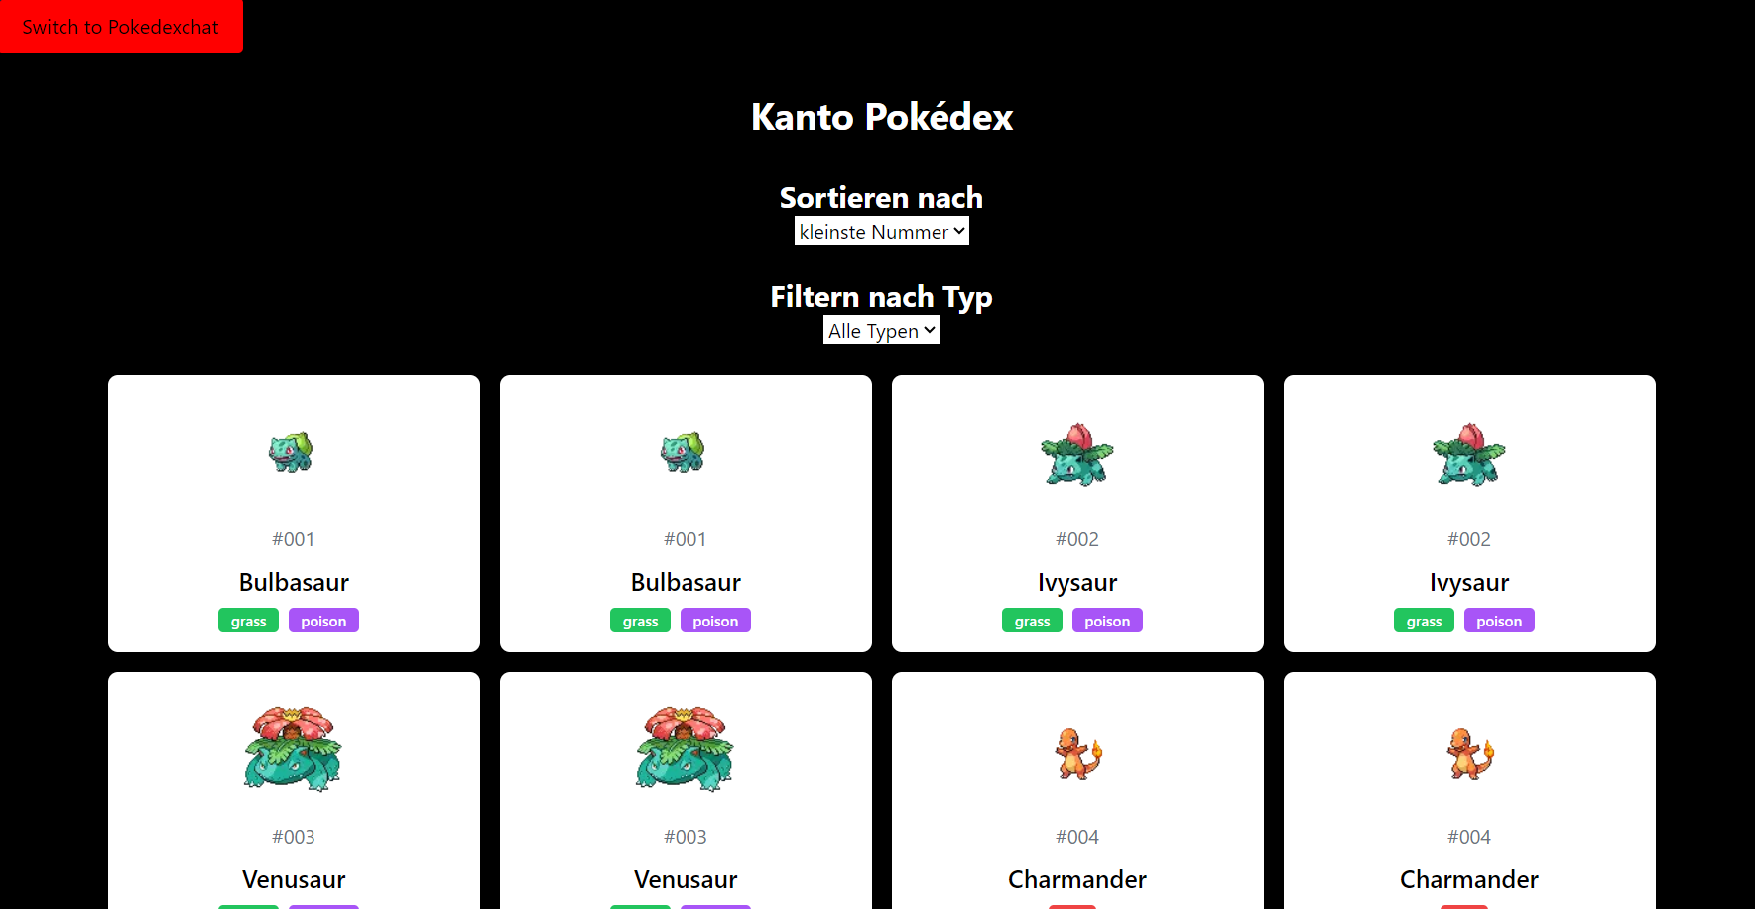

1. If you click on “Sortieren nach” you can decide to sort the Pokemons that get displayed by they index number of the Pokedex from the lowest one up to the highest one ( by defaulted) you can also decide to do this on the opposite so the Pokemon gets displayed from highest to lowest, additionally you can also decide to sort them by they names starting with A and ending with Z

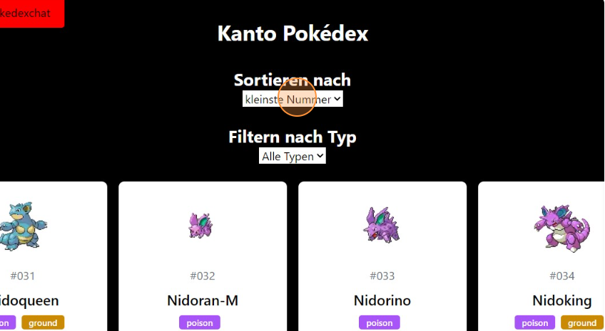

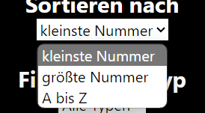

1. If you click on “Filter nach typ” you can decide the type of the Pokemons that gets displayed

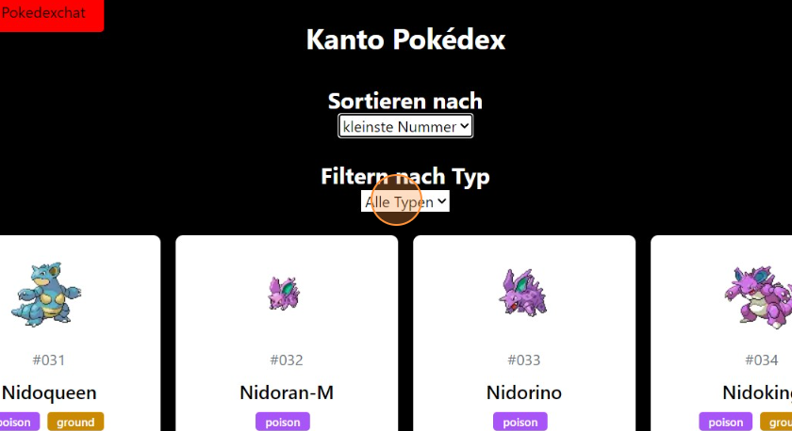

1. To see more Pokemon there is a ‘next’ Button on the bottom of the you can also use the ‘Previous’ button to go back to a page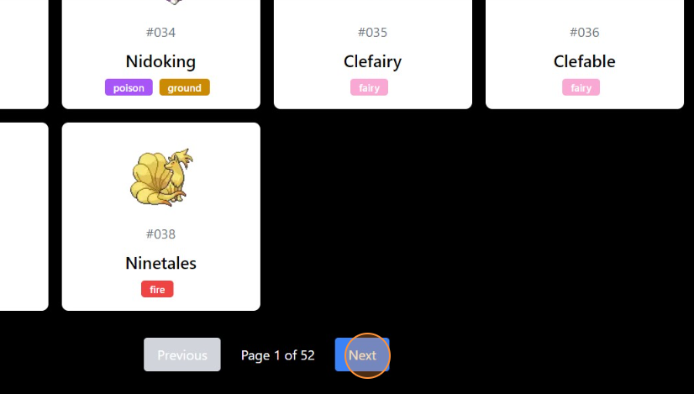
2. If you click on the top left the ”switch to Pokedexchat” the Pokedexchat gets displayed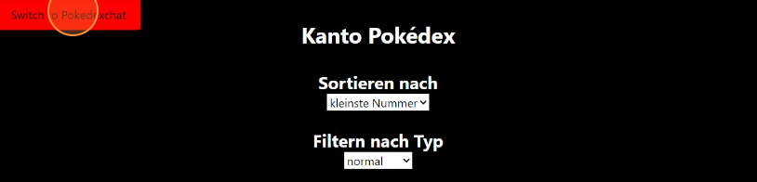

6. Click on the input bar an type you question

Ein Bild, das Screenshot, Text, Design enthält.

1. After pressing on the “Search” Button you will get an answer from the chat bot



1. example Chat, the text with the white color is you question and the text with the black color is the answer from the chatbot

