Scaling Groups in the

ACT Certification System (ACS)

September 2023

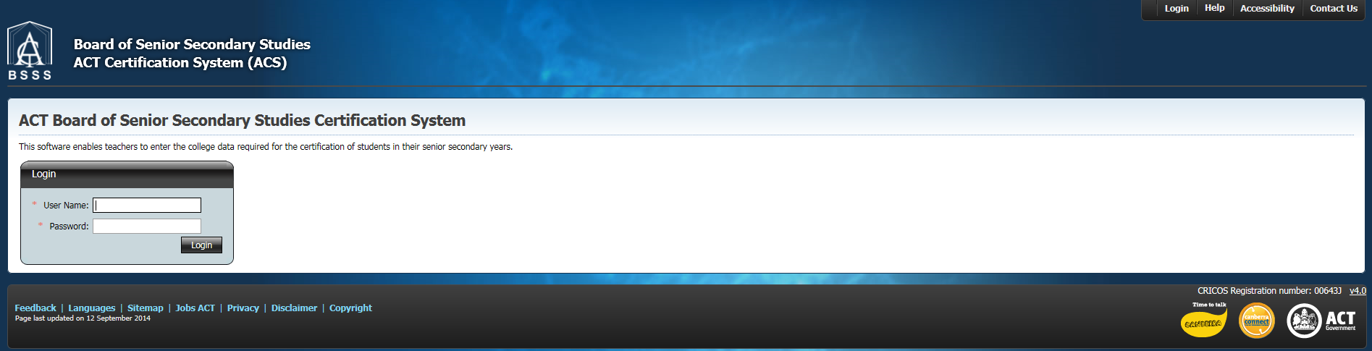

Table of Contents

Scaling Groups 3

Initial Standardisation 4

Backscaling 8

The Comparison List 10

Looking at courses and units in a scaling group 12

Histogram Tab 13

Providing access to scaling group lists 14

# 

# Scaling Groups

Scaling groups are used for the standardisation or scaling of student scores at the end of each semester.  
  
In the past, certification officers or teachers needed to create scaling group lists for data entry and lists for backscaling of T and H units. However, new ACS functionality means that this will automatically be done in the system via the **Scaling Groups - > Unit Scores** menu item.

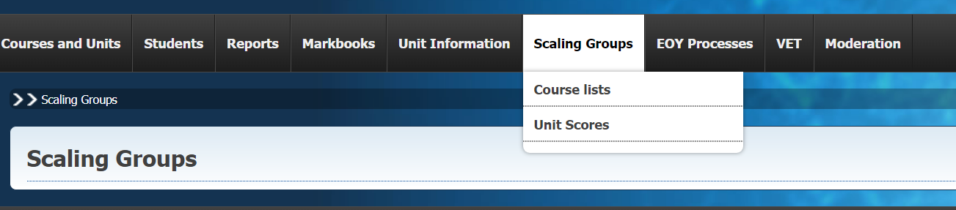

Selecting the **Unit Scores** menu item will take you to this page:

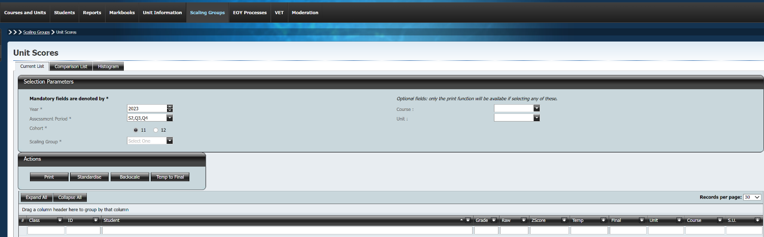  
The Current List tab is where standardisation or backscaling is done.

We use the Selection Parameters section to select the scaling group that we wish to standardise or backscale. We select the year, assessment period, cohort and scaling group that we are interested in by using the drop downs and the radio buttons.  
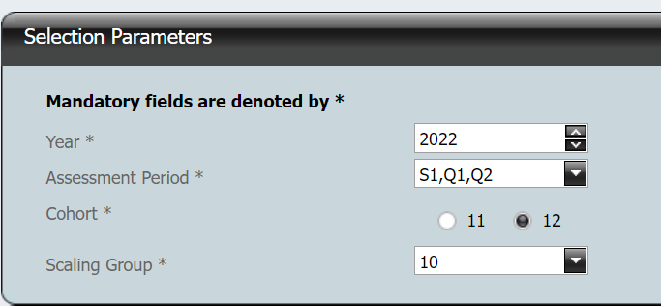

Note that ‘Cohort’ alwaysrefers to the *current* cohort. So, if we were currently in 2023, selecting the Cohort as ‘12’ means that we are looking at students who are in year 12 *now*. As we have selected the Year as 2022, we are looking at these students when most of them were in year 11.

This is what we will see in our list – students with grades, raw scores and z-scores against the units and courses that are part of the scaling group. It will also include the standard unit value for the unit that the student completed.

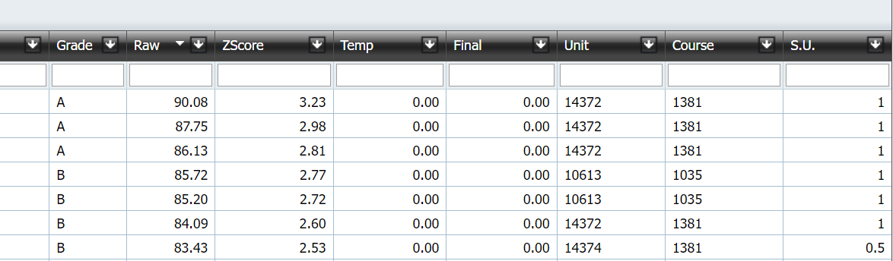

All scores need to have been finalised in the markbook, along with grades for all assessment items, for standardisation or backscaling to be completed. It will be assumed that the various courses have been properly meshed according to BSSS policies and your school’s meshing plan for this scaling group.

# Initial Standardisation

The unit scores for the first assessment period in year 11 are usually standardised to historical parameters. In each subsequent assessment period, the unit results are backscaled onto the results from the previous assessment period. This is BSSS policy (4.3.4.2).

Where a course has been identified as a small group, schools may decide to standardise or leave final unit scores as raw.

This is what we will see in our list – students with grades, raw scores and z-scores against the units and courses that are part of the scaling group. It will also include the standard unit value for the unit that the student completed.



The list of actions available to us in this screen is displayed as follows:

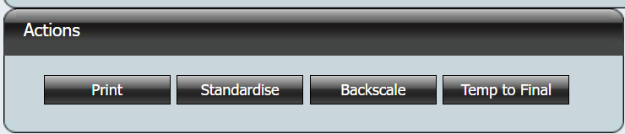

If we click on the ‘Backscale’ button by mistake, this is what we will see:  
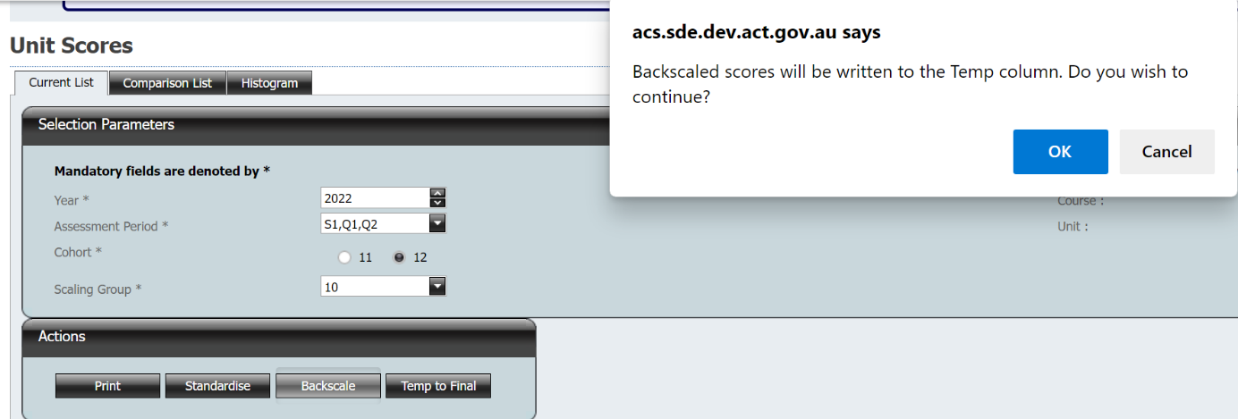

If we now click on ’OK’, this is what will happen:

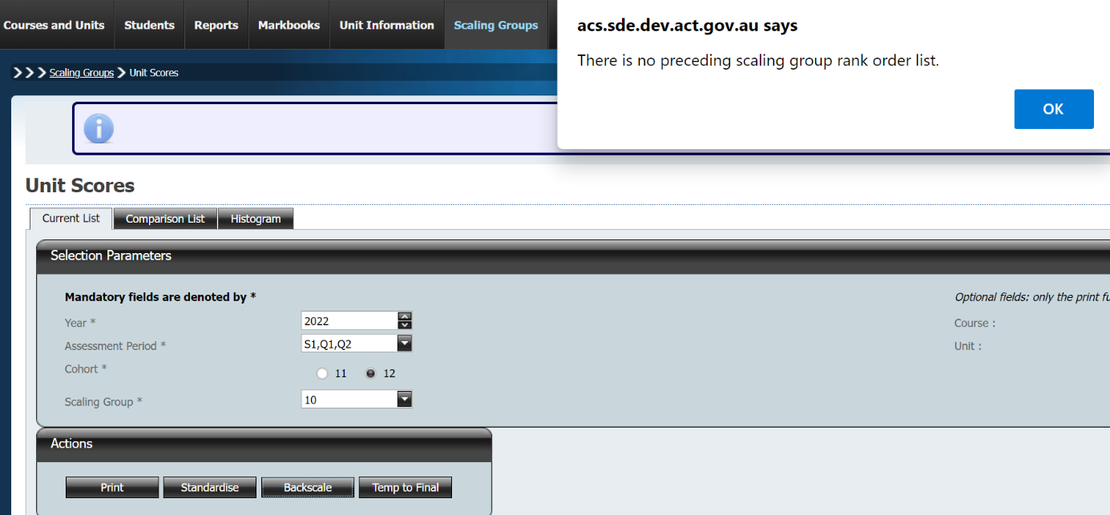

What this error means is that there is no list to backscale to for year 11 semester 1. This reminds you that you need to standardise.  
  
If we click on the ‘Standardise’ button, this is what we see:  
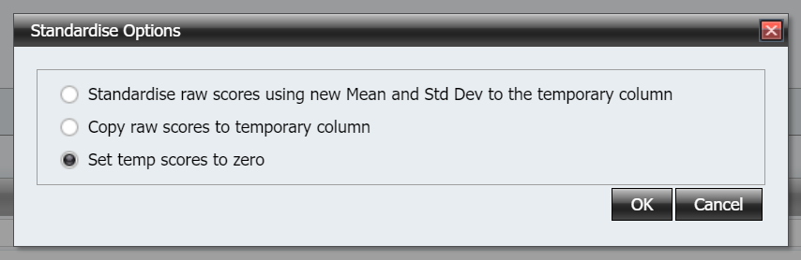

If we select ‘Standardise raw scores using new Mean and Std Dev to the temporary column’, this is what we see:  
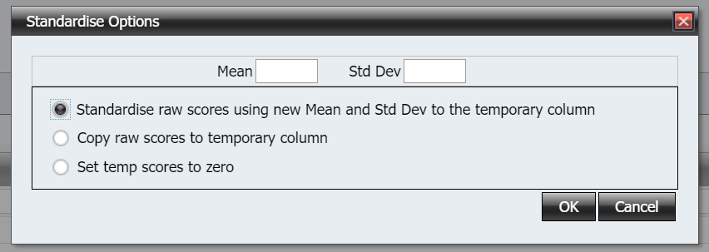

We will need to enter the mean and standard deviation (historical parameters) for this scaling group. This should have been determined from historical data or student results from things like NAPLAN to enable meaningful comparisons between scaling groups within a school. Note that getting these parameters ‘wrong’ is not an issue for end-of-year scaling. However, care should be taken when setting these to ensure that students get as reliable of a picture as possible for how they are going in one course compared to another.

When we have entered these values, we can press enter. This is what we see:

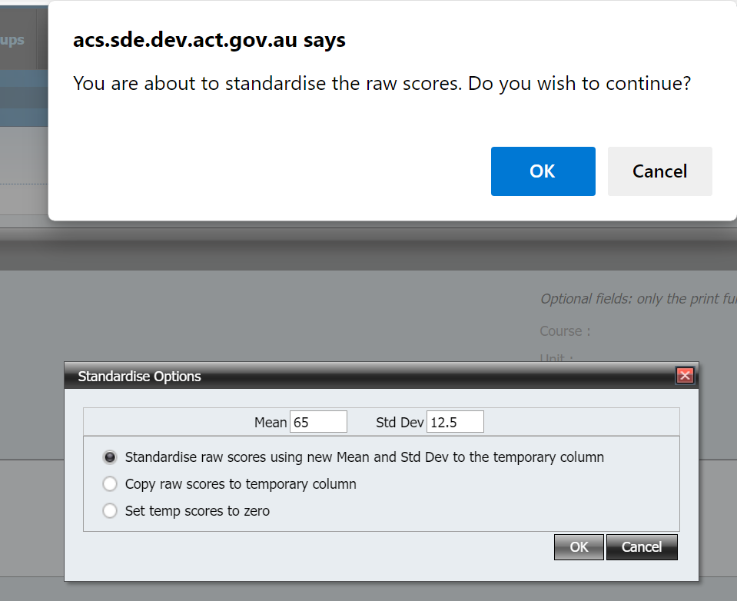

Note that the mean of 65 and the Std Dev of 12.5 is what has been set in this example. As stated above, you will need to have set these using the evidence available to you.

We press ‘OK’ and the scaled scores are calculated for us and written into the temporary column:  
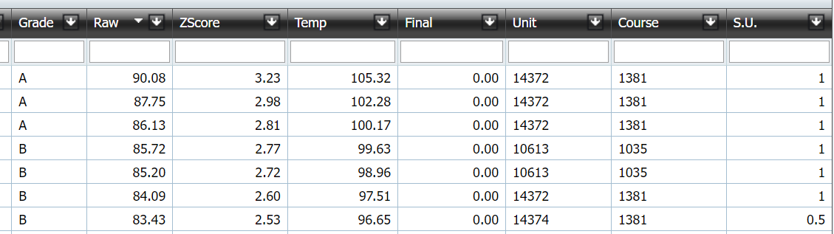

If we have done everything correctly, then we are now ready to set temp to final. 

Clicking on Temp to Final will bring up the below screen:

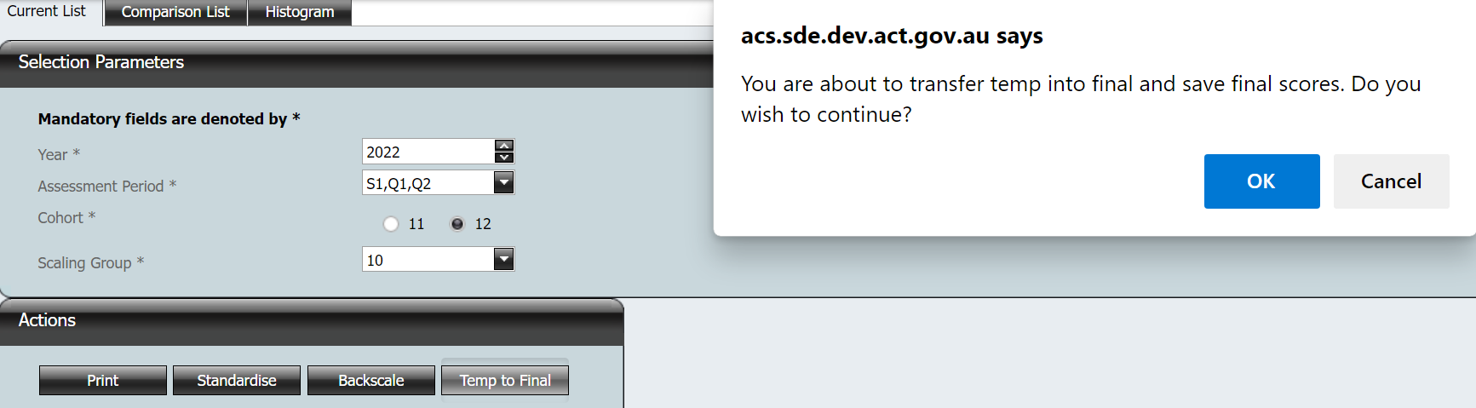

Click OK to complete the process:  
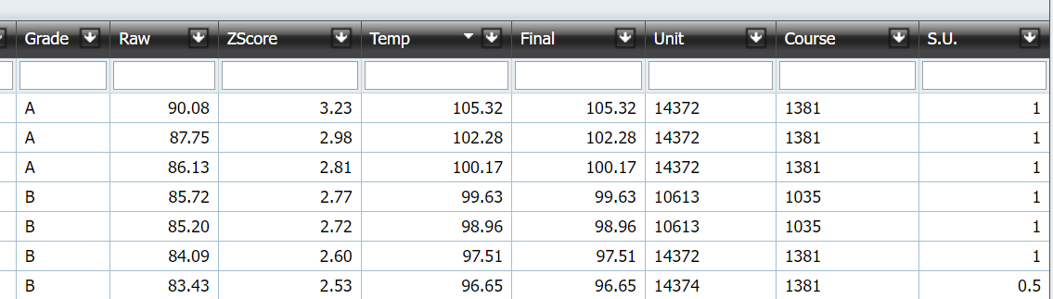

# Backscaling

Backscaling is almost identical to standardising. The only difference is that you use the backscale button. Having selected a scaling group, calendar year, cohort and assessment period, you hit backscale:

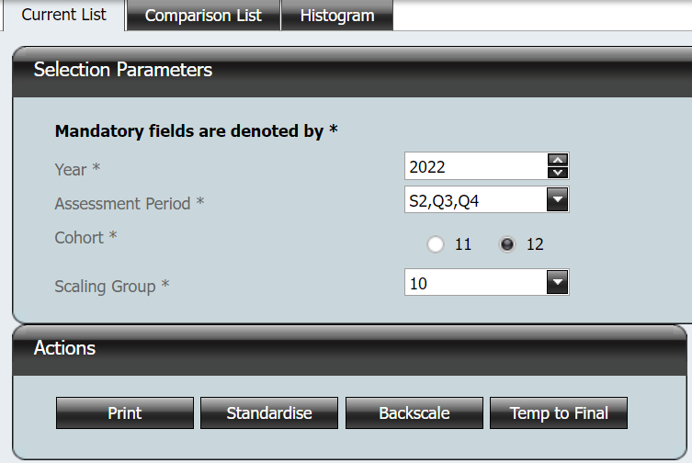

Note that again all results need to be in for all students in the scaling group:

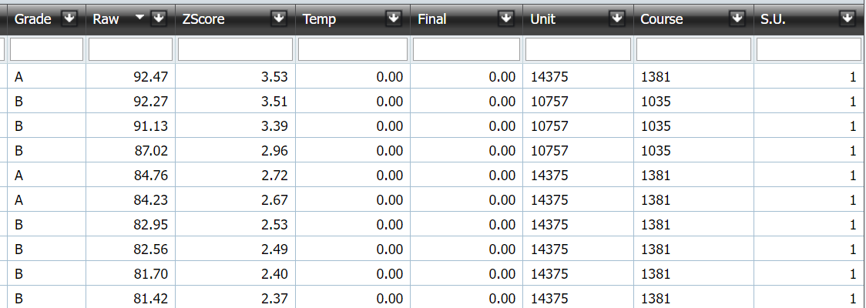

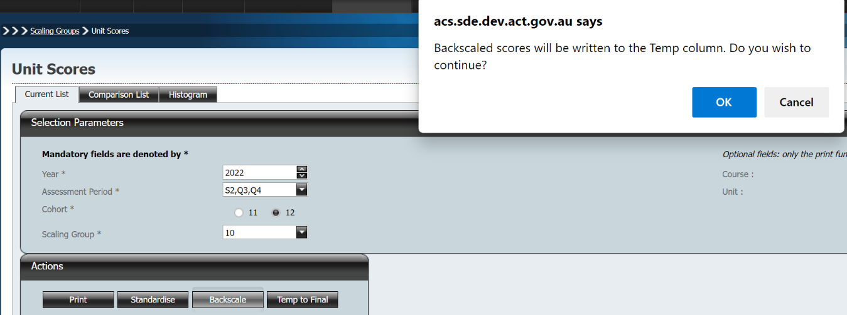

Clicking ‘OK’ will cause ACS to calculate the backscaled unit scores for all students in the scaling group.

The backscaled scores have been written to the Temp column:

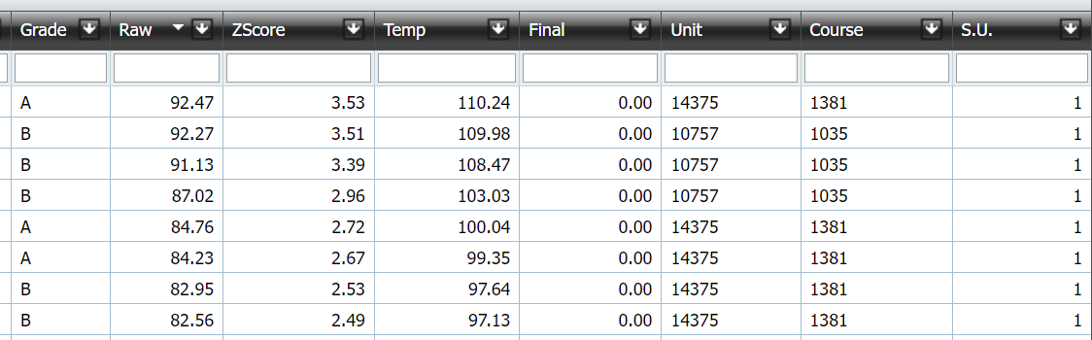

If we have done everything correctly, we then set the Temp scores to Final:



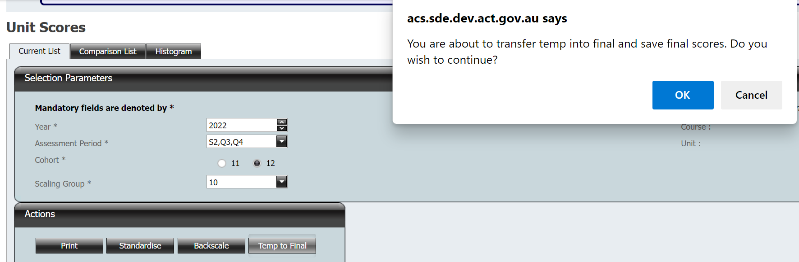

After clicking OK, the temporary scores have been written into the final column:  
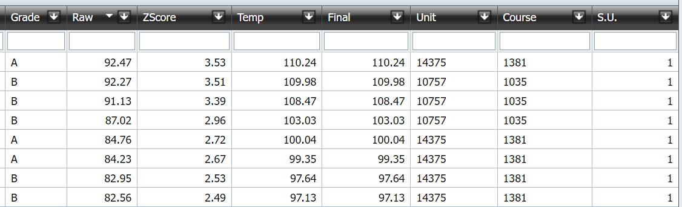

# The Comparison List

If you want to compare two scaling groups, the Comparison List tab is how you do that. 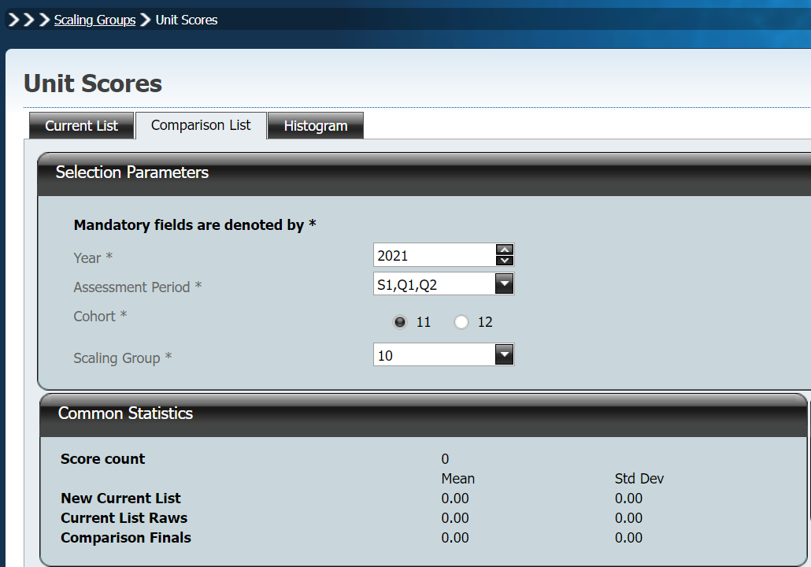

You can select any year, assessment period, cohort and scaling group to compare to the scaling group in your current list. However, the comparison is only looking at students common to both scaling groups. In this particular case, there are no common students so the common statistics are all zero.

If we select a scaling group list that has students in common with our current list, we will see this:

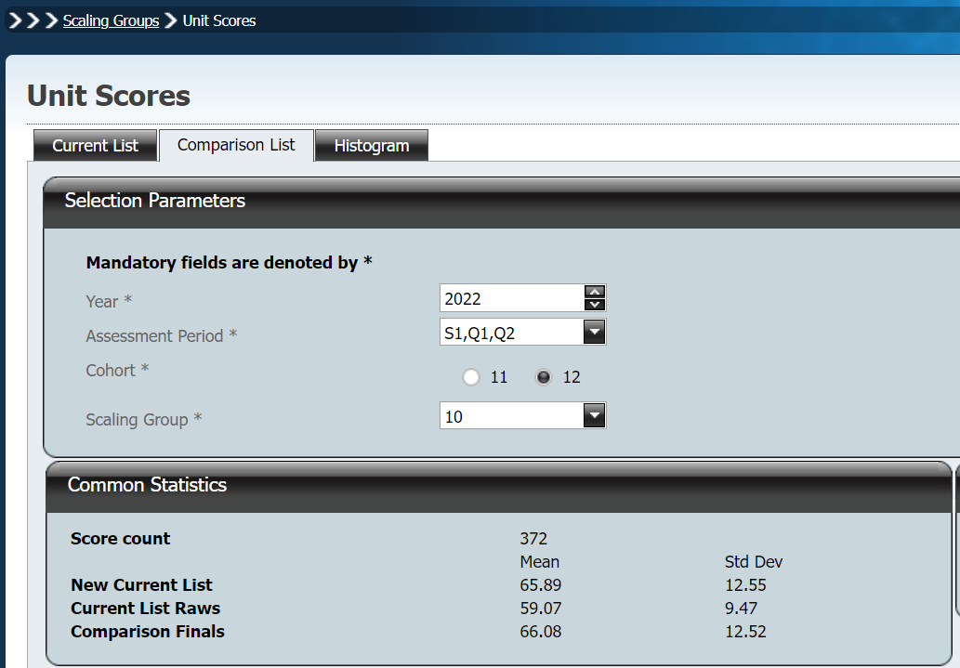

In this particular case, we have selected the scaling group that was used to backscale our current list. As such, we can see that the Comparison Finals and New Current List statistics are very similar.  
  
In the below situation, this is not the case:

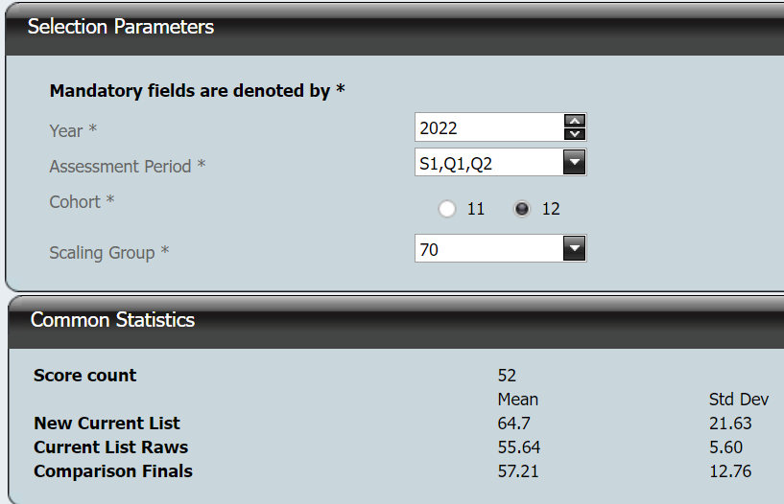

Remember: we are only comparing the students that are in both lists.

There is no necessity for you to look at these if you do not want to. Some schools, however, may want to compare their parameters for students between scaling groups, particularly in year 11, to ensure that things are behaving as expected. A school might also use the scaling parameters from similar scaling groups to standardise. For example, a school might use the statistics from the English scaling group to standardise the Humanities scaling group.

In the Comparison List, you will also see students in blue who are in both scaling groups and students in white who are not in the Current List:

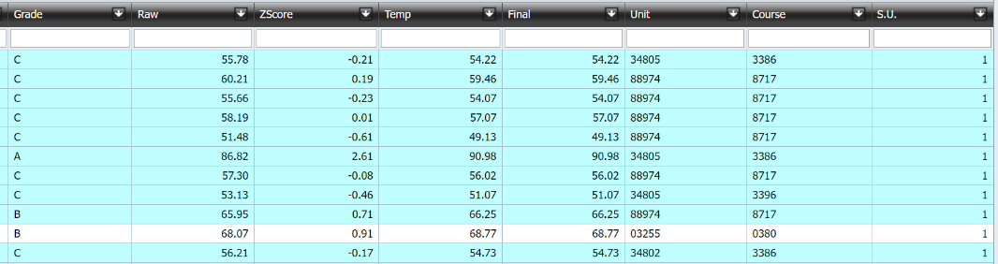

Similarly, in the Current List, you will see students in blue who are in both scaling groups and students in white who are not in the Comparison List: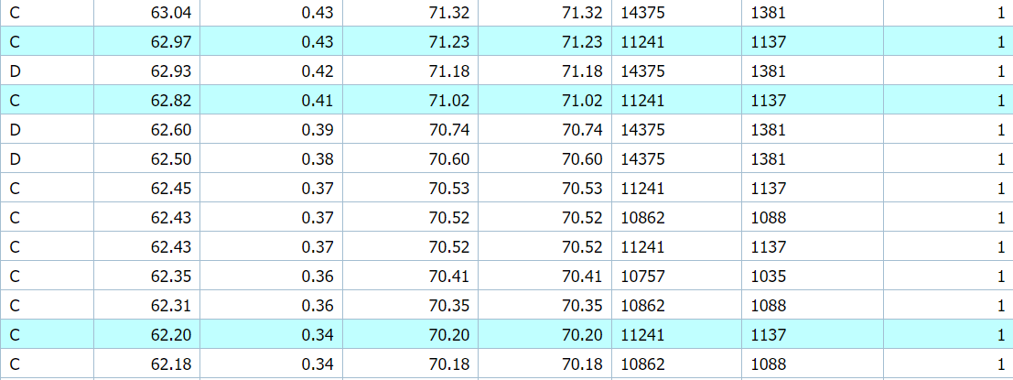

# Looking at courses and units in a scaling group

If we want to see student results from a course or unit within a scaling group, we can use the dropdowns on the right to do so.

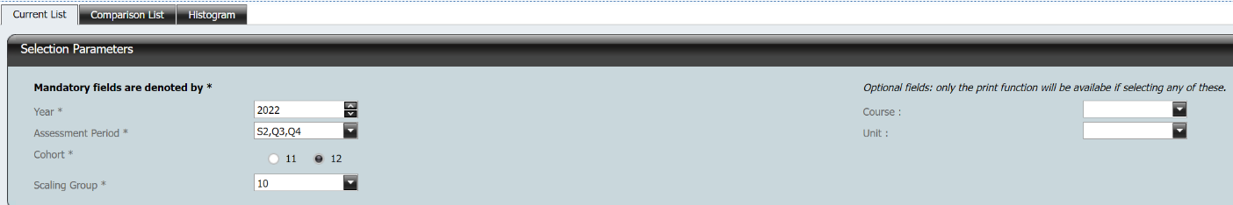

In scaling group 10, for example, we have the following courses:

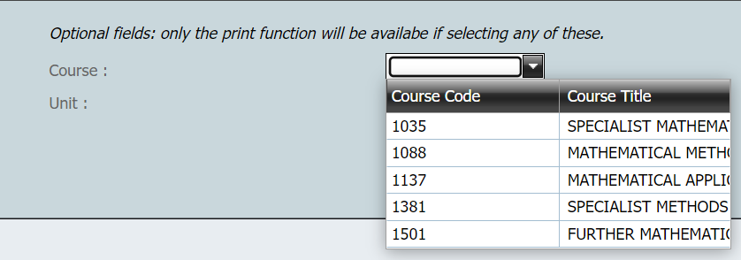

If we select Mathematical Methods, for example, we will see all Actions buttons grey out except Print:

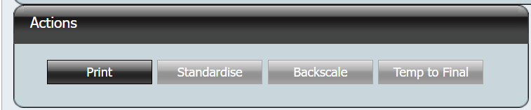

This is because backscaling is required by policy to be done at the scaling group level.

Our list will also change to only display students studying Mathematical Methods:

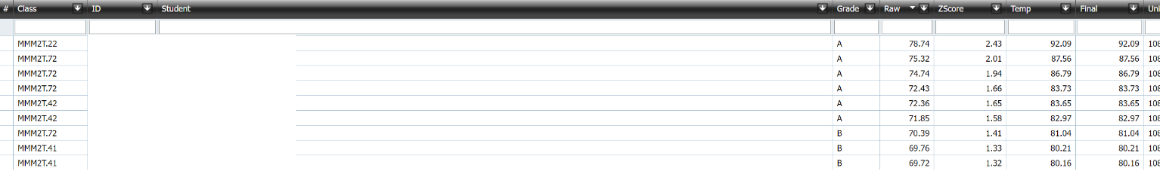

We can do the same thing in the Comparison List tab to compare courses and units: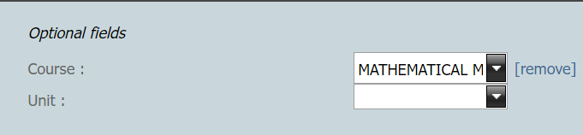  
This compares student results in methods from one semester to the other and may be useful for meshing courses in subsequent assessment periods:  
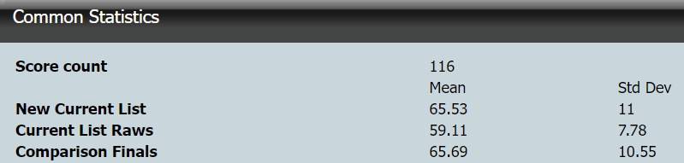

# Histogram Tab

To see the histograms for your scaling group lists, select the histogram tab:

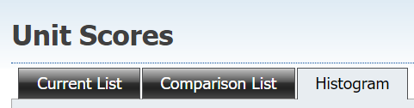

Then you will need to hit refresh on both the Current List histogram and the Comparison List histogram:

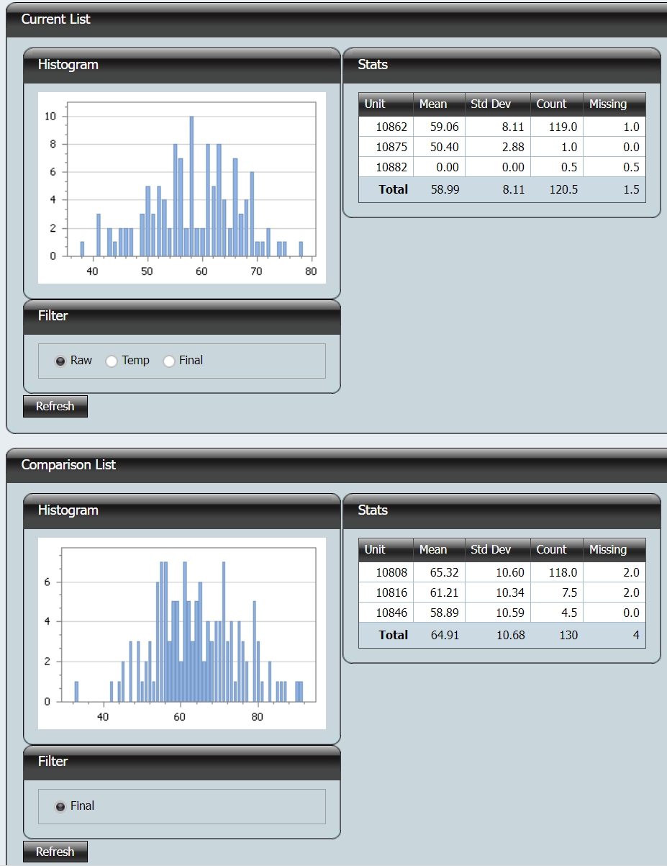

This will bring up the graphs and the statistics for your two scaling group lists, broken out by unit.

# Providing access to scaling group lists

Permissions to scaling groups follow the following guidelines:

* The Basic and Faculty Head users can access scaling group lists via the menu system
* Access to scaling groups lists is controlled via the markbook security set up for the user. In other words, if the user has been given access to scaling group 1 in markbook security, then this user can access all scaling group lists for scaling group 1.
* If users have only been granted access to specific markbooks only then they will NOT be able to access scaling group lists.
* By default those with Edit and above permissions can access all scaling groups. Access can be granted to specific scaling group lists. Users with access to a scaling group will have access to all scaling group lists, current or future, in that scaling group.

Under the **Markbooks** heading in the menu pane select **User Access** and the following screen will appear:

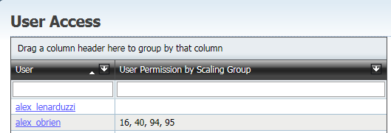

Click on the ***User Name*** hyperlink to select a user. To assist in finding users, the filter option is available. Only the Basic Users and VET Users are shown. The following screen appears:

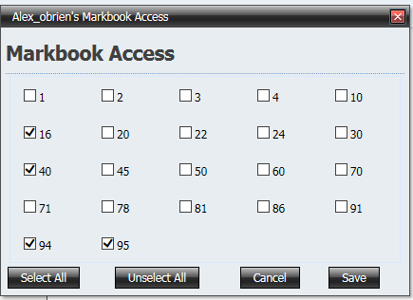

Click in the check boxes next to the scaling group number. The scaling group number is for both year 11 and year 12 scaling groups. (in other words, clicking on 5 gives the user access to all markbooks in scaling group 5 for both year 11 and 12 students).

Click on the ***Save*** button. The scaling groups for which that user has access will appear.  
  
To remove access, uncheck the check boxes in the **Markbook Access** screen and click the ***Save*** button.