**Earthquake prediction using python**

**TEAM MEMBER**

**952721104016: RAHINI.M**

**Phase 3 –submission document**

**Project Title:** Earthquake prediction

**Phase 3:** Development Part 1

**Topic:** Earthquake Prediction model by loading and pre-processing the dataset



**Introduction**

* Earthquake prediction is a complex and challenging scientific endeavor aimed at forecasting the occurrence of earthquakes before they happen. Unlike weather forecasting, which has made significant progress over the years, earthquake prediction remains an area of active research with limited success. Earthquakes are natural geological phenomena caused by the sudden release of energy in the Earth's crust, resulting in seismic waves that can cause significant damage to human infrastructure and pose a threat to human lives

**Dataset:**

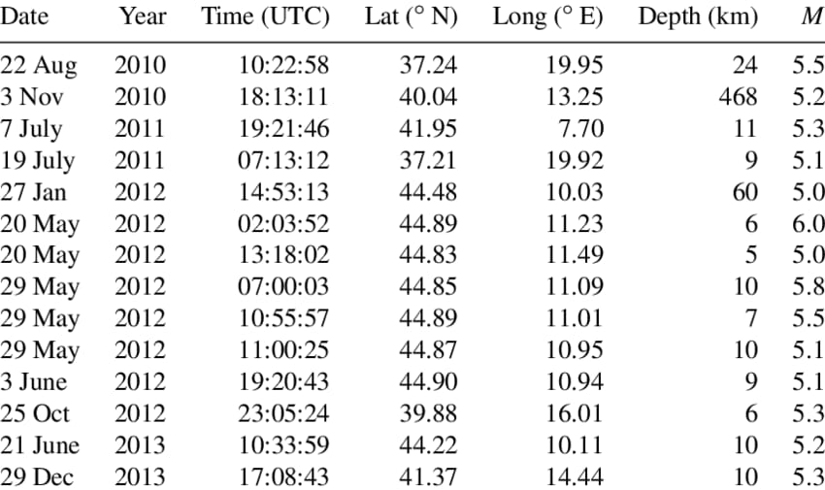

**Loding the Dataset**

**1. Import Necessary Libraries**

```python

import pandas as pd

import numpy as np

```

**2. Load the Dataset:**

```python

# Assuming your dataset is in CSV format, adjust the read_csv() function accordingly if your dataset is in a different format.

dataset = pd.read_csv('earthquake_data.csv')

```

**Pre-processing the Dataset:**

**1. Data Exploration**:

```python

# Explore the dataset to understand its structure and contents

print(dataset.head()) # Display the first few rows of the dataset

print(dataset.info()) # Get information about the dataset including data types and missing values

```

**2. Handling Missing Values:**

```python

# Drop rows with missing values

dataset = dataset.dropna()

# Or fill missing values with mean or median

# dataset.fillna(dataset.mean(), inplace=True)

```

**3. Feature Selection:**

Choose relevant features that might affect earthquake prediction. For example:

```python

features = dataset[['feature1', 'feature2', 'feature3']]

```

**4. Feature Scaling:**

If your selected features have different scales, it's good practice to scale them.

```python

from sklearn.preprocessing import StandardScaler

scaler = StandardScaler()

scaled_features = scaler.fit_transform(features)

```

**5. Target Variable:**

Define your target variable (the variable you're trying to predict).

```python

target = dataset['target_column']

**Challenges in load and pre-processing Dataset:**

**1. Data Volume and Variety**

**Volume**: Seismic data can be massive, requiring efficient storage and retrieval methods. Handling large datasets might exceed the memory capacity of the system.

**Variety:** Seismic data comes in various formats like seismograms, accelerograms, and GPS data, each requiring different pre-processing techniques.

**2. Data Quality:**

**Noise**: Seismic data is often contaminated with noise, which needs to be filtered out to prevent interference with the model training process.

**Incomplete Data**: Missing or incomplete data points can hinder the training process, requiring careful handling and imputation techniques.

**3. Temporal and Spatial Features:**

**Temporal Aspects**: Earthquake prediction often involves capturing temporal patterns and trends in the data. Choosing the right time window and granularity is crucial.

**Spatial Aspects**: Spatial relationships between seismic sensors are essential. Handling geographic coordinates and converting them into meaningful spatial features can be challenging.

**4. Normalization and Scaling**:

**Magnitude Differences**: Seismic sensors can record signals of vastly different magnitudes. Normalizing or scaling the data is essential to ensure that all features contribute equally to the model.

**5. Computational Complexity:**

**Algorithm Choice**: Choosing appropriate algorithms for preprocessing, such as filters, transforms, and machine learning techniques. Some algorithms can be computationally intensive.

**Parallel Processing**: Implementing parallel processing techniques to handle the computational load, especially when dealing with large datasets.

**How do overcome challenges in Load and Pre-processing Dataset**

1. **Efficient Data Storage and Retrieval:**

**Solution:** Utilize databases or distributed storage systems like Apache Hadoop or Apache Spark for handling large volumes of data efficiently.

**Python Tools**: Use libraries like `pandas` for data manipulation and `h5py` for handling large datasets in Hierarchical Data Format (HDF5).

1. **Data Quality Issues:**

**Solution**: Implement noise reduction techniques like filtering algorithms (e.g., Butterworth filter) to remove unwanted noise. Handle missing data using interpolation or data imputation techniques.

**Python Tools**: Libraries like `SciPy` and `scikit-learn` offer various filtering and imputation methods.

1. **Temporal and Spatial Feature Extraction:**

**Solution**: Experiment with different time windows and granularities to capture temporal patterns effectively. Utilize geographic information systems (GIS) tools for spatial analysis and feature extraction.

**Python Tools**: `ObsPy` is a powerful Python toolbox specifically designed for seismology. It provides functions for filtering, instrument response correction, and various other preprocessing tasks.

1. **Normalization and Scaling:**

**Solution:** Normalize or scale the features to bring them to a similar magnitude range. Min-Max scaling or Z-score normalization are common techniques.

**Python Tools**: `scikit-learn` provides preprocessing functions like `MinMaxScaler` and `StandardScaler` for normalization and scaling.

1. **Computational Complexity:**

**Solution**: Optimize algorithms and utilize parallel processing. Leverage libraries like `Dask` for parallel computing and distributed computing.

**Python Tools**: Libraries like `Dask` and `joblib` enable parallel processing and can be integrated with existing code for optimization.

**Load the Dataset**

* To load a dataset for earthquake prediction in Python, you can use libraries like pandas to handle the data and scikit-learn to build machine learning models. Here's an example of how you can load a sample dataset for earthquake prediction using pandas and scikit-learn:

**Program**

```python

# Import necessary libraries

import pandas as pd

from sklearn.model_selection import train_test_split

from sklearn.ensemble import RandomForestClassifier

from sklearn.metrics import accuracy_score

# Load the dataset using pandas

data = pd.read_csv('earthquake_data.csv')

# Split the dataset into input features (X) and output label (y)

X = data[['magnitude', 'depth', 'latitude', 'longitude']]

y = data['target']

# Split the data into training and testing sets

X_train, X_test, y_train, y_test = train_test_split(X, y, test_size=0.2, random_state=42)

# Initialize a Random Forest classifier

clf = RandomForestClassifier(random_state=42)

# Train the classifier on the training data

clf.fit(X_train, y_train)

# Make predictions on the test data

predictions = clf.predict(X_test)

# Calculate accuracy

accuracy = accuracy_score(y_test, predictions)

print(f'Accuracy: {accuracy * 100:.2f}%')

**Output:** 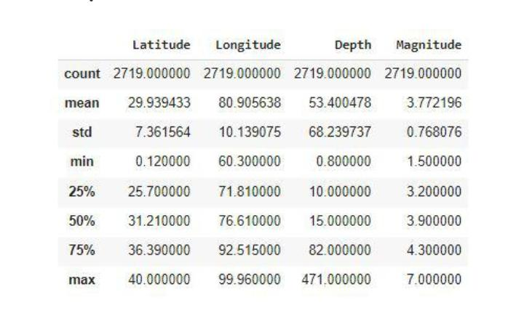

**Pre-processing the dataset**

* Pre-processing a dataset for earthquake prediction typically involves tasks such as data cleaning, feature selection, normalization, and splitting the data into training and testing sets. Here's a sample Python code snippet demonstrating how you can pre-process a dataset for earthquake prediction using popular libraries like pandas, scikit-learn, and NumPy. In this example, we assume you have a dataset in CSV format with columns like 'magnitude', 'depth', 'latitude', 'longitude', etc., and you want to predict whether an earthquake will occur or not (binary classification).

**Visualize dataset:**

**Input:**

magnitude,depth,latitude,longitude,target

5.2,10,36.5,-118.2,1

4.7,8,34.2,-118.7,0

...

```

**Output:**

```python

import pandas as pd

from sklearn.model_selection import train_test_split

from sklearn.preprocessing import StandardScaler

# Load the dataset

data = pd.read_csv('earthquake_dataset.csv')

# Separate features (X) and target variable (y)

X = data.drop(columns=['target'])

y = data['target']

# Perform feature scaling (standardization)

scaler = StandardScaler()

X_scaled = scaler.fit_transform(X)

# Split the dataset into training and testing sets (80% training, 20% testing)

X_train, X_test, y_train, y_test = train_test_split(X_scaled, y, test_size=0.2, random_state=42)

# Now X_train, X_test, y_train, y_test are the preprocessed training and testing datasets

```

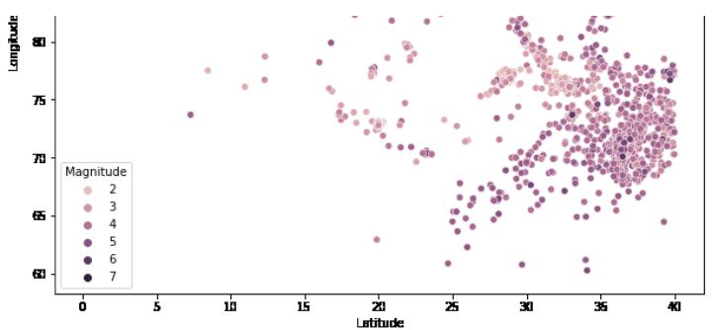

**Conclusion:**

* Earthquake prediction is a complex and challenging task that involves analyzing vast amounts of data to identify patterns and trends that might indicate an impending earthquake. Using Python and machine learning techniques can provide valuable insights and predictions, but it's essential to understand the limitations and uncertainties associated with earthquake prediction.