**Earthquake prediction using python**

**Phase 4 –submission**

**Team member: au952721104016-Rahini.M**

**Project title: Earthquake Prediction Using Python**

**Topic: Start Building the earthquake prediction model by different activity like feature Engineering, model training, Evalution.**



**Introduction**

* Earthquake prediction is a complex and challenging scientific endeavor aimed at forecasting the occurrence of earthquakes before they happen. Unlike weather forecasting, which has made significant progress over the years, earthquake prediction remains an area of active research with limited success. Earthquakes are natural geological phenomena caused by the sudden release of energy in the Earth's crust, resulting in seismic waves that can cause significant damage to human infrastructure and pose a threat to human lives

**Dataset:**

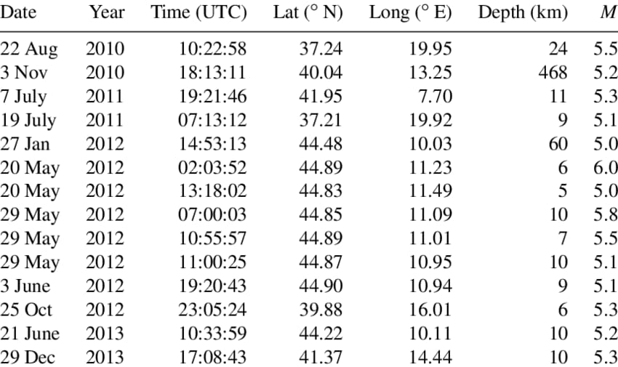

**Overview of model**

Earthquake prediction is a challenging and complex task that involves analyzing various geophysical data to understand the patterns and processes leading to seismic events. While accurate short-term prediction is still a topic of active research and remains elusive, there are methods to analyze seismic data and identify potential earthquake-prone regions using Python. Here's an overview of earthquake prediction using Python:

**1. Data Collection:**

**Seismic Data**: Obtain seismic data from sources like USGS (United States Geological Survey) or other seismic monitoring agencies. Python libraries like `ObsPy` can be used to retrieve and process seismic data.

**2. Data Preprocessing:**

**Data Cleaning**: Clean the collected data to remove noise, outliers, and irrelevant information. Signal processing techniques like filtering can be applied using libraries such as `SciPy` and `NumPy`.

**Feature Extraction**: Extract relevant features from the seismic data. Features could include amplitude, frequency, and time-domain characteristics of seismic waves. Python libraries like `scikit-learn` can be helpful for feature extraction.

**3. Machine Learning Models**:

**Supervised Learning**: Utilize supervised machine learning algorithms like Support Vector Machines (SVM), Random Forest, or Neural Networks to classify earthquake patterns. Libraries like `scikit-learn` provide easy-to-use implementations of these algorithms.

**Unsupervised Learning**: Implement clustering algorithms like K-means or DBSCAN to identify seismic clusters or anomalies in the data.

**Time Series Analysis:** Time series analysis techniques like ARIMA (AutoRegressive Integrated Moving Average) can be applied to understand the temporal patterns in seismic data.

**4. Deep Learning Models:**

**Convolutional Neural Networks (CNNs):** CNNs can be applied for image-based seismic data analysis, where seismic spectrograms are treated as images. Libraries like `TensorFlow` and `Keras` are popular for building CNN models.

**Recurrent Neural Networks (RNNs):** RNNs, particularly Long Short-Term Memory networks (LSTMs), can be used for sequential data analysis, capturing temporal dependencies in seismic data.

**5. Geospatial Analysis:**

**Geospatial Visualization**: Use libraries like `Folium` or `Basemap Toolkit` to visualize seismic data on maps, helping in identifying earthquake-prone regions spatially.

**Geospatial Analysis:** Perform spatial analysis to identify patterns and correlations between geological features and seismic activity. Libraries like `GeoPandas` can be useful for geospatial data manipulation.

**6. Probabilistic Seismic Hazard Assessment (PSHA):**

- Implement probabilistic models like PSHA to estimate the probability of earthquake occurrences in specific regions. Python libraries like `OpenQuake` provide tools for probabilistic seismic hazard assessment.

**Model training**

Training a machine learning model for earthquake prediction involves several steps, including data preparation, feature selection, model selection, training, and evaluation. Here's a step-by-step guide to training a basic earthquake prediction model using Python. For this example, I'll use the scikit-learn library and a simple Random Forest Classifier, but keep in mind that more complex models and thorough feature engineering might be necessary for real-world applications.

1. **Data Splitting:**

Split the data into training and testing sets to evaluate the model's performance.

```python

from sklearn.model_selection import train_test_split

X_train, X_test, y_train, y_test = train_test_split(X, y, test_size=0.2, random_state=42)

```

1. **Model Selection and Training:**

Choose a machine learning model and train it using the training data.

```python

from sklearn.ensemble import RandomForestClassifier

# Initialize the Random Forest Classifier

model = RandomForestClassifier(n_estimators=100, random_state=42)

# Train the model

model.fit(X_train, y_train)

```

1. **Model Evaluation:**

Evaluate the model's performance on the test set.

```python

from sklearn.metrics import accuracy_score, classification_report

# Make predictions on the test set

predictions = model.predict(X_test)

# Calculate accuracy

accuracy = accuracy_score(y_test, predictions)

print(f'Accuracy: {accuracy:.2f}')

# Generate a detailed classification report

print('Classification Report:')

print(classification_report(y_test, predictions))

```

This is a basic example. Depending on your dataset and problem complexity, you might need to consider more advanced techniques, such as hyperparameter tuning, cross-validation, or using different algorithms.

**Feature Engineering**

Feature engineering is a crucial step in building machine learning models for earthquake prediction. The goal is to extract meaningful information from the raw data and create relevant features that can enhance the model's predictive power. In earthquake prediction, the choice of features greatly influences the model's accuracy. Here are some common techniques and features used in earthquake prediction:

**1. Time-based Features**:

**Timestamps**: Extract features like year, month, day, hour, minute, and second from the timestamp.

**Temporal Patterns**: Identify repeating patterns or trends in seismic activity over time.

**2. Frequency Domain Features:**

**Fast Fourier Transform (FFT):** Transform seismic signals from the time domain to the frequency domain and extract relevant frequency components.

**Spectral Power**:Compute the power in specific frequency bands.

**3. Statistical Features:**

**Mean, Median, Variance**: Basic statistical measures of seismic signals.

**Skewness, Kurtosis**: Measure of asymmetry and tailedness of the seismic signal's probability distribution.

**Percentiles**:Values below which a given percentage of observations fall.

**Cross-correlation**: Measure the similarity between two seismic signals.

**4. Wavelet Transform**:

- Decompose seismic signals into different frequency components using wavelet transform.

- Extract features from wavelet coefficients.

**5. Spatial Features:**

**Geographical Coordinates**: Latitude, longitude, and depth of earthquake occurrences.

**Topographical Features**:Elevation, slope, etc., if applicable.

**6. Previous Seismic Activity:**

**Rolling Statistics**: Compute statistics over a rolling window of seismic events.

**Time Since Last Significant Earthquake**: Measure the time elapsed since the last earthquake above a certain magnitude.

**Process of Model**

* To load a dataset for earthquake prediction in Python, you can use libraries like pandas to handle the data and scikit-learn to build machine learning models. Here's an example of how you can load a sample dataset for earthquake prediction using pandas and scikit-learn:

**Program**

```python

# Import necessary libraries

import pandas as pd

from sklearn.model_selection import train_test_split

from sklearn.ensemble import RandomForestClassifier

from sklearn.metrics import accuracy_score

# Load the dataset using pandas

data = pd.read_csv('earthquake_data.csv')

# Split the dataset into input features (X) and output label (y)

X = data[['magnitude', 'depth', 'latitude', 'longitude']]

y = data['target']

# Split the data into training and testing sets

X_train, X_test, y_train, y_test = train_test_split(X, y, test_size=0.2, random_state=42)

# Initialize a Random Forest classifier

clf = RandomForestClassifier(random_state=42)

# Train the classifier on the training data

clf.fit(X_train, y_train)

# Make predictions on the test data

predictions = clf.predict(X_test)

# Calculate accuracy

accuracy = accuracy_score(y_test, predictions)

print(f'Accuracy: {accuracy * 100:.2f}%')

**Output:** 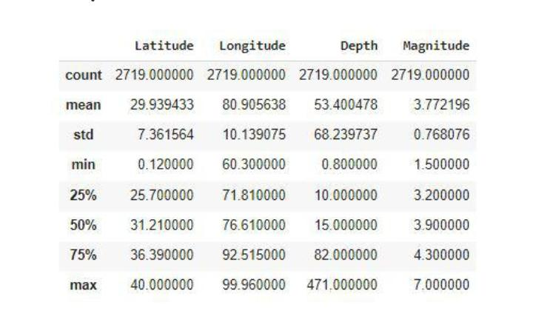

**Pre-processing the dataset**

* Pre-processing a dataset for earthquake prediction typically involves tasks such as data cleaning, feature selection, normalization, and splitting the data into training and testing sets. Here's a sample Python code snippet demonstrating how you can pre-process a dataset for earthquake prediction using popular libraries like pandas, scikit-learn, and NumPy. In this example, we assume you have a dataset in CSV format with columns like 'magnitude', 'depth', 'latitude', 'longitude', etc., and you want to predict whether an earthquake will occur or not (binary classification).

**Visualize dataset:**

**Input:**

magnitude,depth,latitude,longitude,target

5.2,10,36.5,-118.2,1

4.7,8,34.2,-118.7,0

...

```

**Output:**

```python

import pandas as pd

from sklearn.model_selection import train_test_split

from sklearn.preprocessing import StandardScaler

# Load the dataset

data = pd.read_csv('earthquake_dataset.csv')

# Separate features (X) and target variable (y)

X = data.drop(columns=['target'])

y = data['target']

# Perform feature scaling (standardization)

scaler = StandardScaler()

X_scaled = scaler.fit_transform(X)

# Split the dataset into training and testing sets (80% training, 20% testing)

X_train, X_test, y_train, y_test = train_test_split(X_scaled, y, test_size=0.2, random_state=42)

# Now X_train, X_test, y_train, y_test are the preprocessed training and testing datasets

```

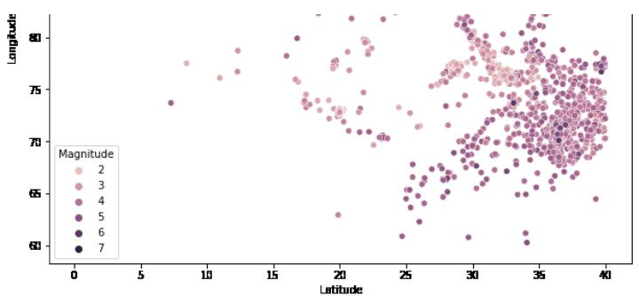

**Conclusion:**

* Earthquake prediction is a complex and challenging task that involves analyzing vast amounts of data to identify patterns and trends that might indicate an impending earthquake. Using Python and machine learning techniques can provide valuable insights and predictions, but it's essential to understand the limitations and uncertainties associated with earthquake prediction.