Computer Science
Practical File
(2020-21)

Name : Himanshu Raj
Roll Number : 26647854
Class : XII-A
INDEX
S.No. | Program | Remarks
1 | Function for factorial of the input no.
2 | Function for sum from 1 to the input no.
3 | Function for squares from 1 to input no.
4 | Function to calculate n power of base x
5 | sum of digits forming the number
6 | reverse the digits of the number
7 | Function to find lcm of 2 nos.
8 | Function to find hcf of 2 nos.
9 | Function to check armstrong no.
10 | No. upper and lower case letters(text file)
11 | No. words with 4 characters(txt file)
12 | Count the number of Vowels (txt file)
13 | Menu driven to read and write(txt file)
14 | Program to write/dump in binary file
15 | Dump and show with fees more than 4000
16 | check password length is atleast 8(csv)
17 | Wrie & show with salary more than 25000
18 | Combining lists
19 | Shifting elements in a list
20 | Stack implementation
21 | Stack implementation
22 | Creating database and table
23 | Adding records in table
24 | Deleting records from table
25 | Updating records in table
26 | Sorting records by marks

~~~ functions
- #factorial of the input no.
def factorial():
n=int(input('enter a number - '))
a=1
for i in range(1,n+1):
a*=i
print('factorial of ',n,' : ', a)

factorial()

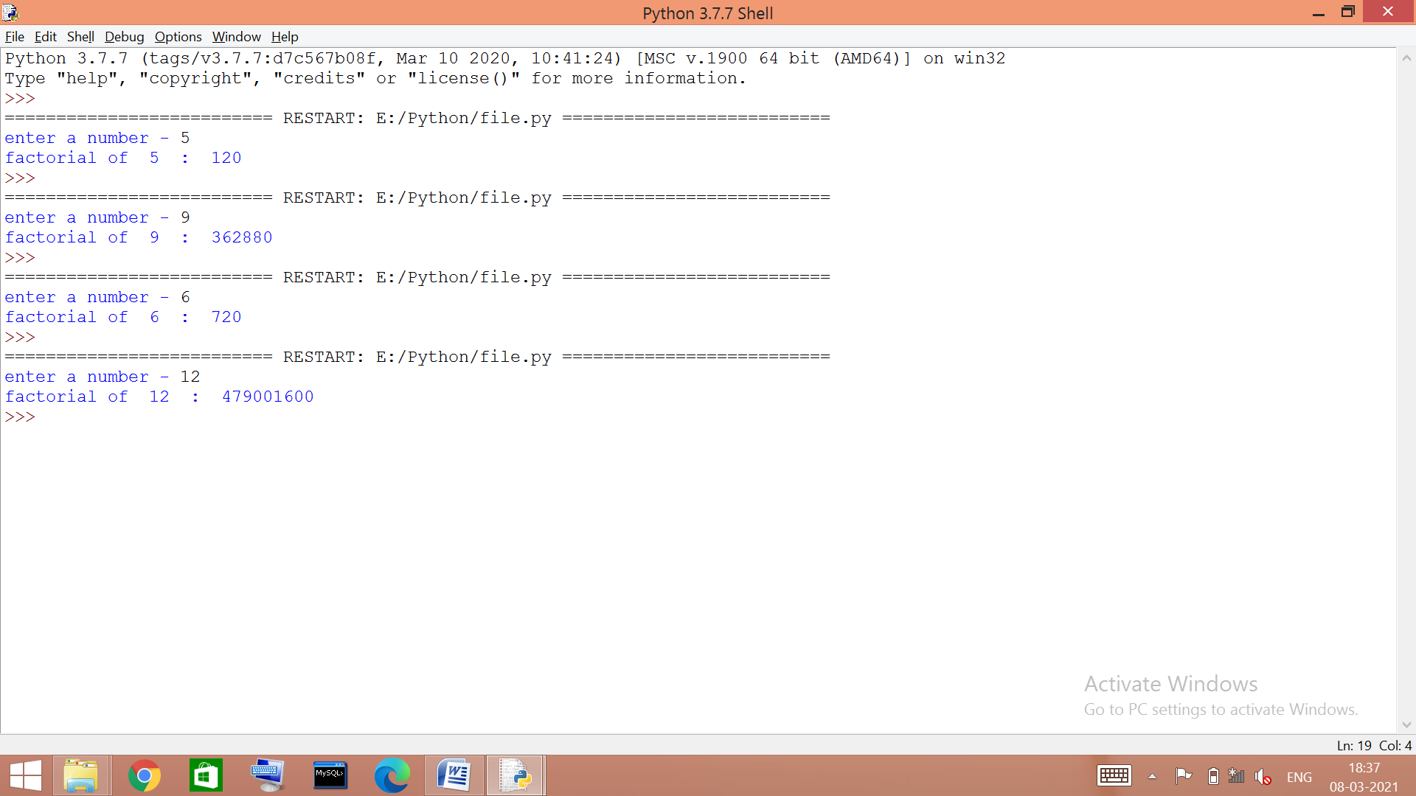

- #sum from 1 to the input no. / ap with common difference=1
def sum_n():
n=int(input('enter a number - '))
p=0
for i in range(1,n+1):
p+=i
print(p)

sum_n()

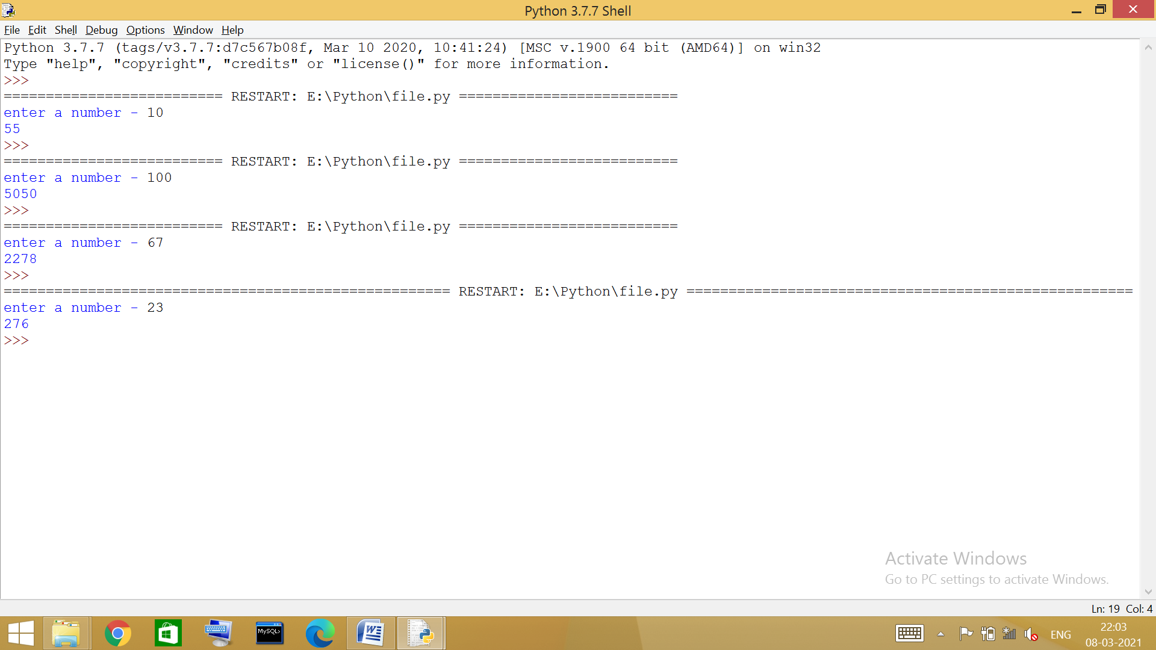

- #squares from 1 to the input no.
def squares_n():
n=int(input('enter a number - '))
for i in range(1,n+1):
print('square of ',i,'is ',i*i)

squares_n()

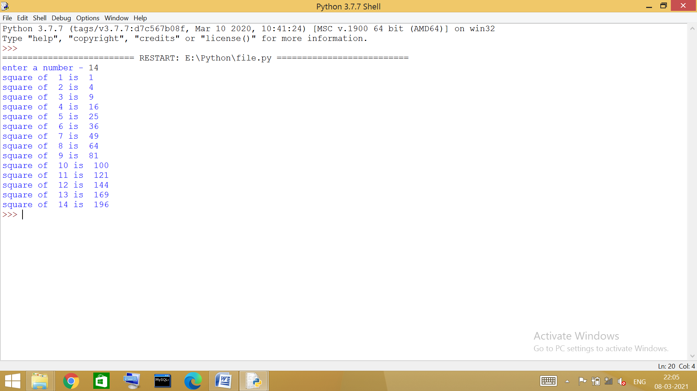

- #’n’ power of no. ‘x’
def xn():
x=int(input('enter a no. - '))
n=int(input('enter exponent - '))
p=1
for i in range(1,n+1):
p=x*p
print(p)

xn()

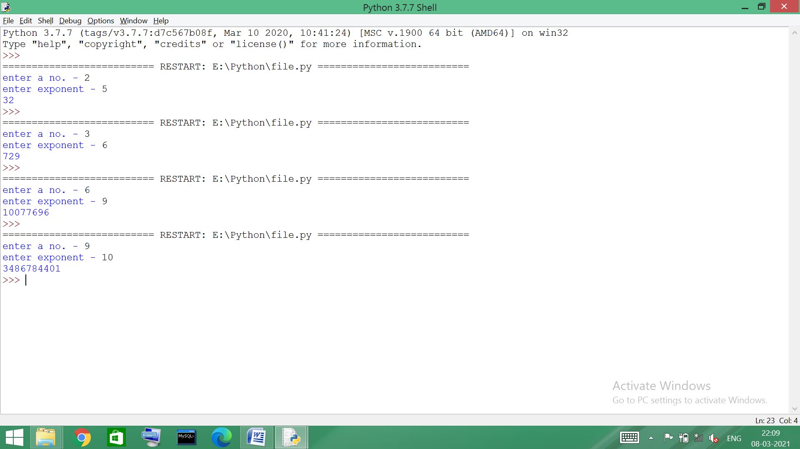

- #sum of digits forming the number
def sum():
n=int(input('enter a number - '))
s=0
while(n!=0):
r=n%10
s+=r
n=n//10
print('sum of digits : ',s)

sum()

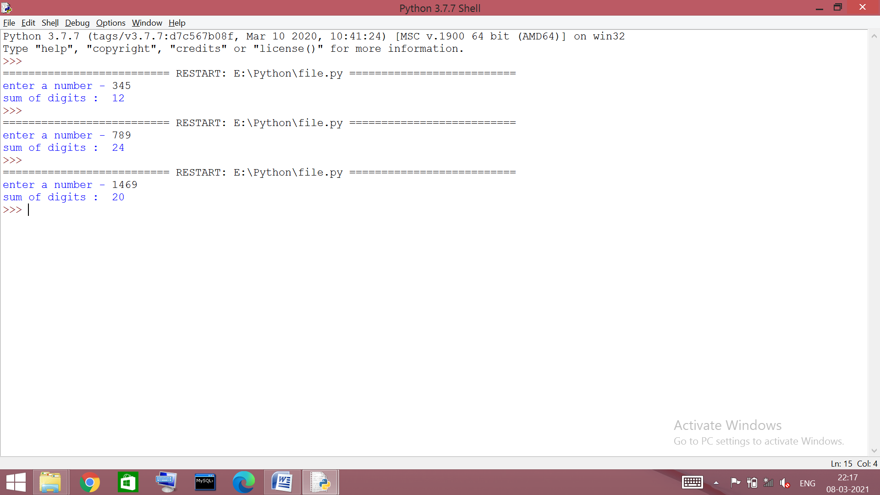
- #reverse the digits of the number
def reverse():
n=int(input('enter a number - '))
s=0
while(n!=0):
r=n%10
s=s*10+r
n=n//10
print('reverse : ',s)

reverse()

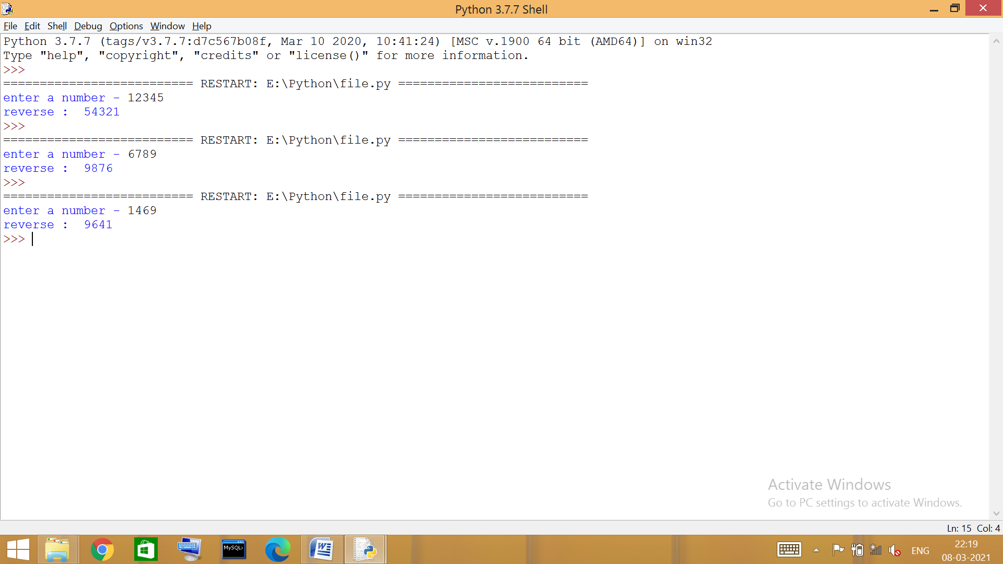
- #lcm of 2 nos.
def lcm():
a=int(input('enter no. - '))
b=int(input('enter no. - '))
ctr=1
while(1):
s=a*ctr
if(s%b==0):
print('lcm - ',s)
break
else:
ctr+=1

lcm()

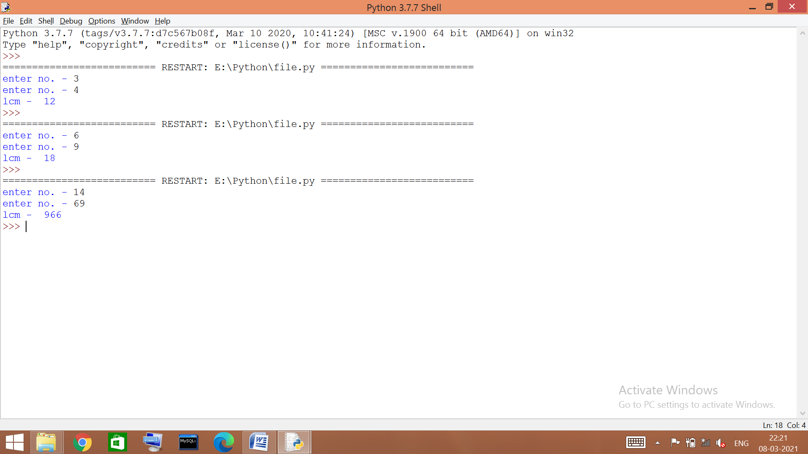
- #hcf of 2 nos.
def hcf():
a=int(input('enter no. - '))
b=int(input('enter no. - '))
if b>a:
a,b=b,a
while(1):
r=a%b
if(r!=0):
a,b=b,r
else:
print('hcf - ',b)
break

hcf()

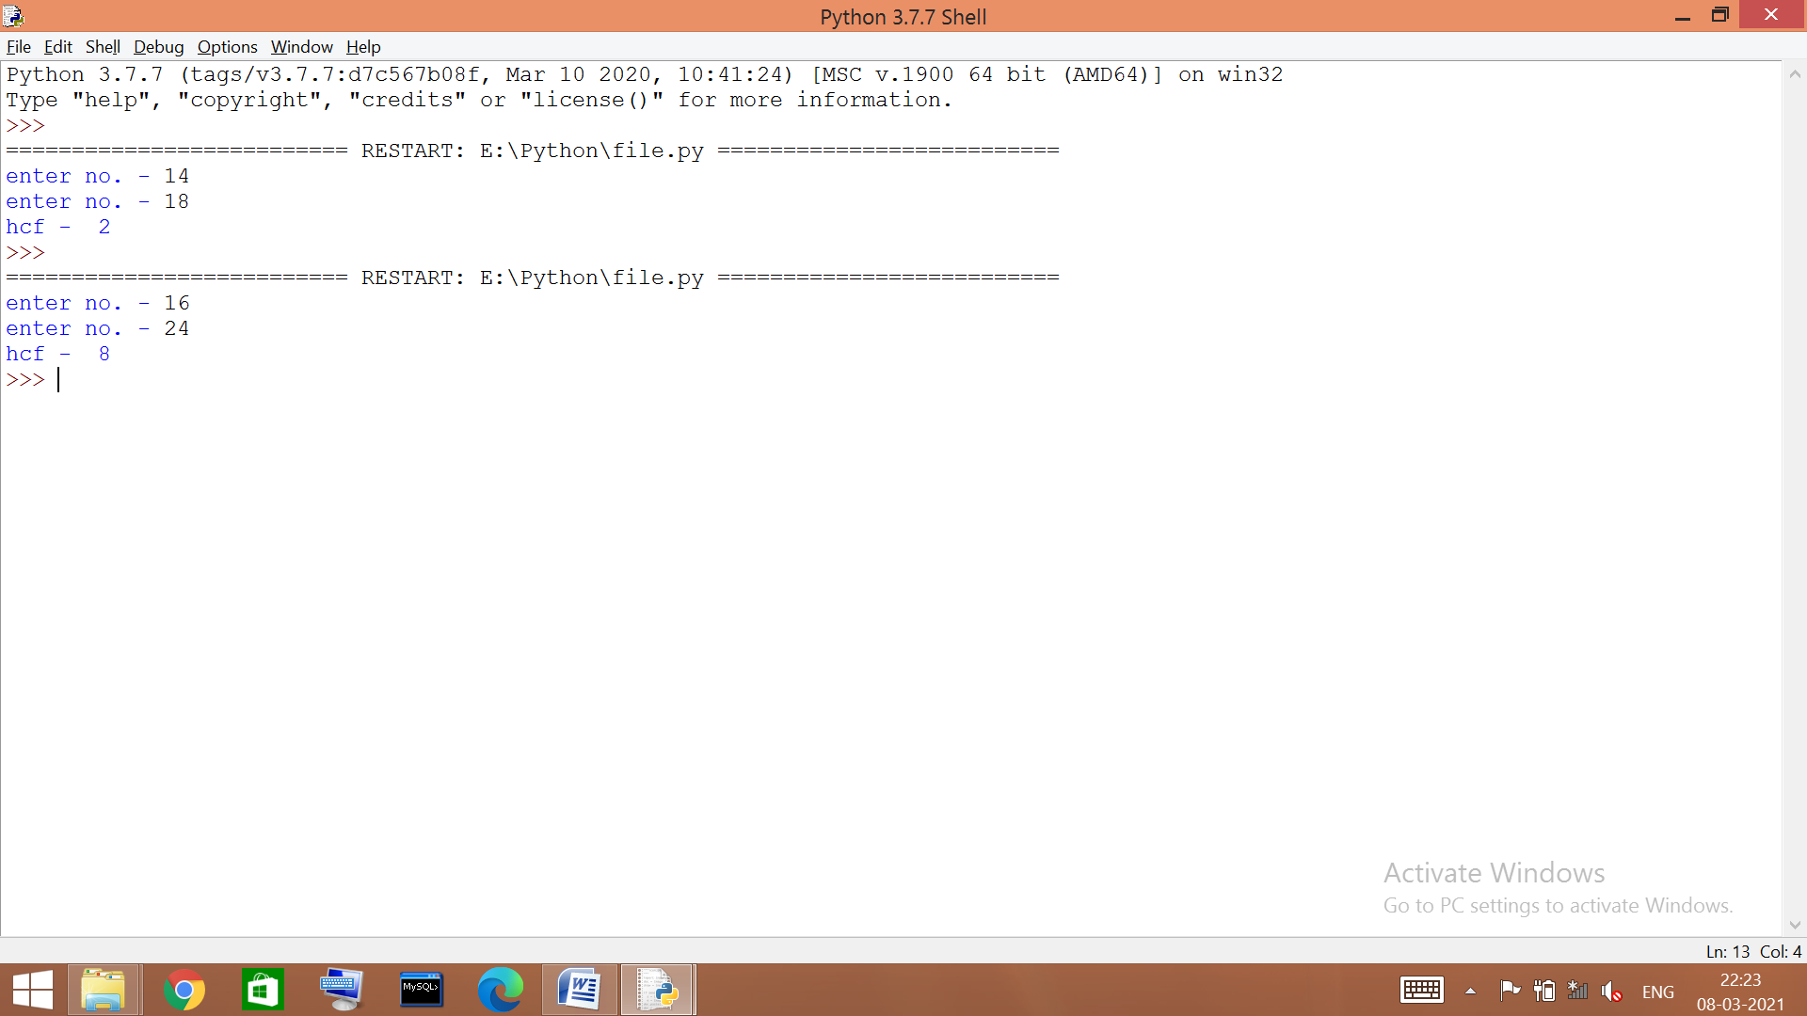
- #armstrong no.
def arm():
x=int(input('enter a no. -'))
s=0
n=x
while(x!=0):
r=x%10
s=s+r**3
x=x//10
if(s==n):
print('its a armstrong number')
else:
print('its not an armstrong number')

arm()

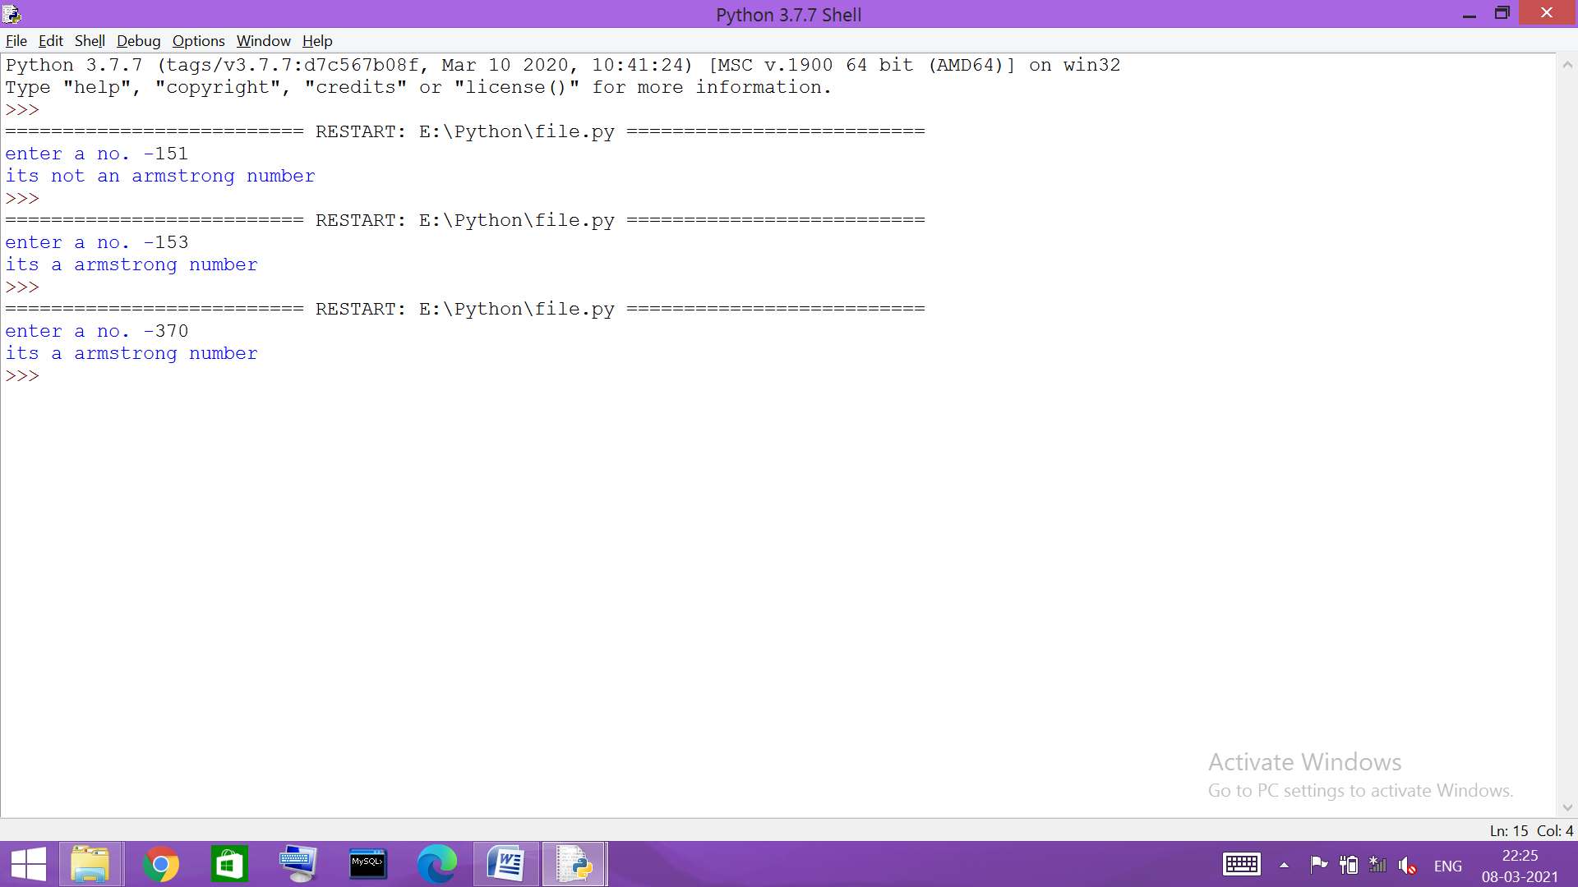
~~~ file handling

- #count the number of upper and lower case letters
f=open('story.txt')
a=f.read()
x,y = 0,0
for i in a:
if i>='A' and i<='Z':
x+=1
elif i>='a' and i<='z':
y+=1
print('upper case letters: ',x)
print('lower case letters: ',y)

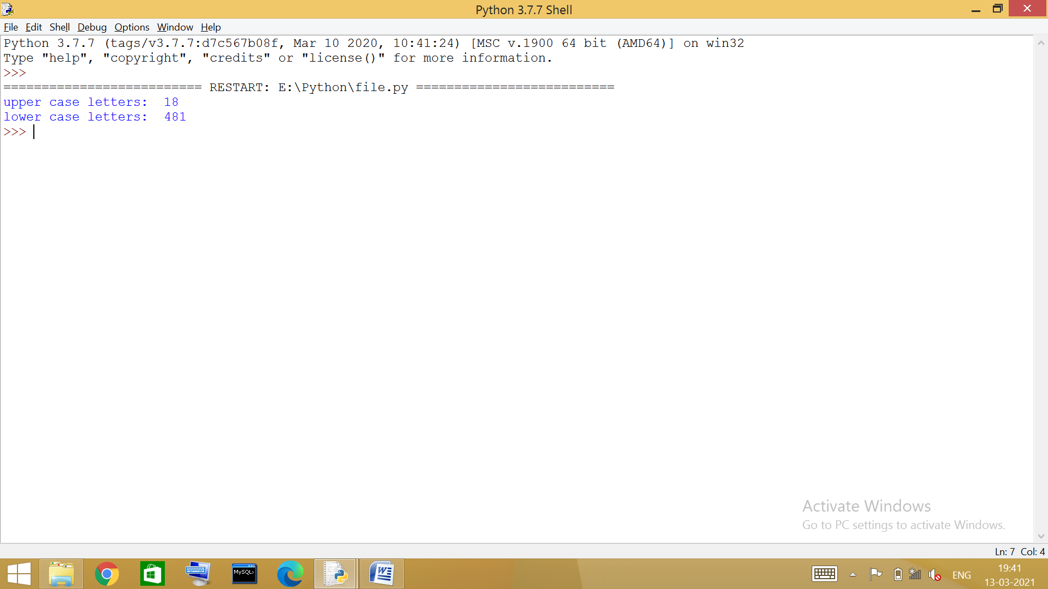

- #count the no. words having 4 characters
f=open('story.txt')
a=f.read()
b=a.split()
z=0
for i in b:
if len(i)==4:
z+=1
print('no. words having 4 characters: ',z)

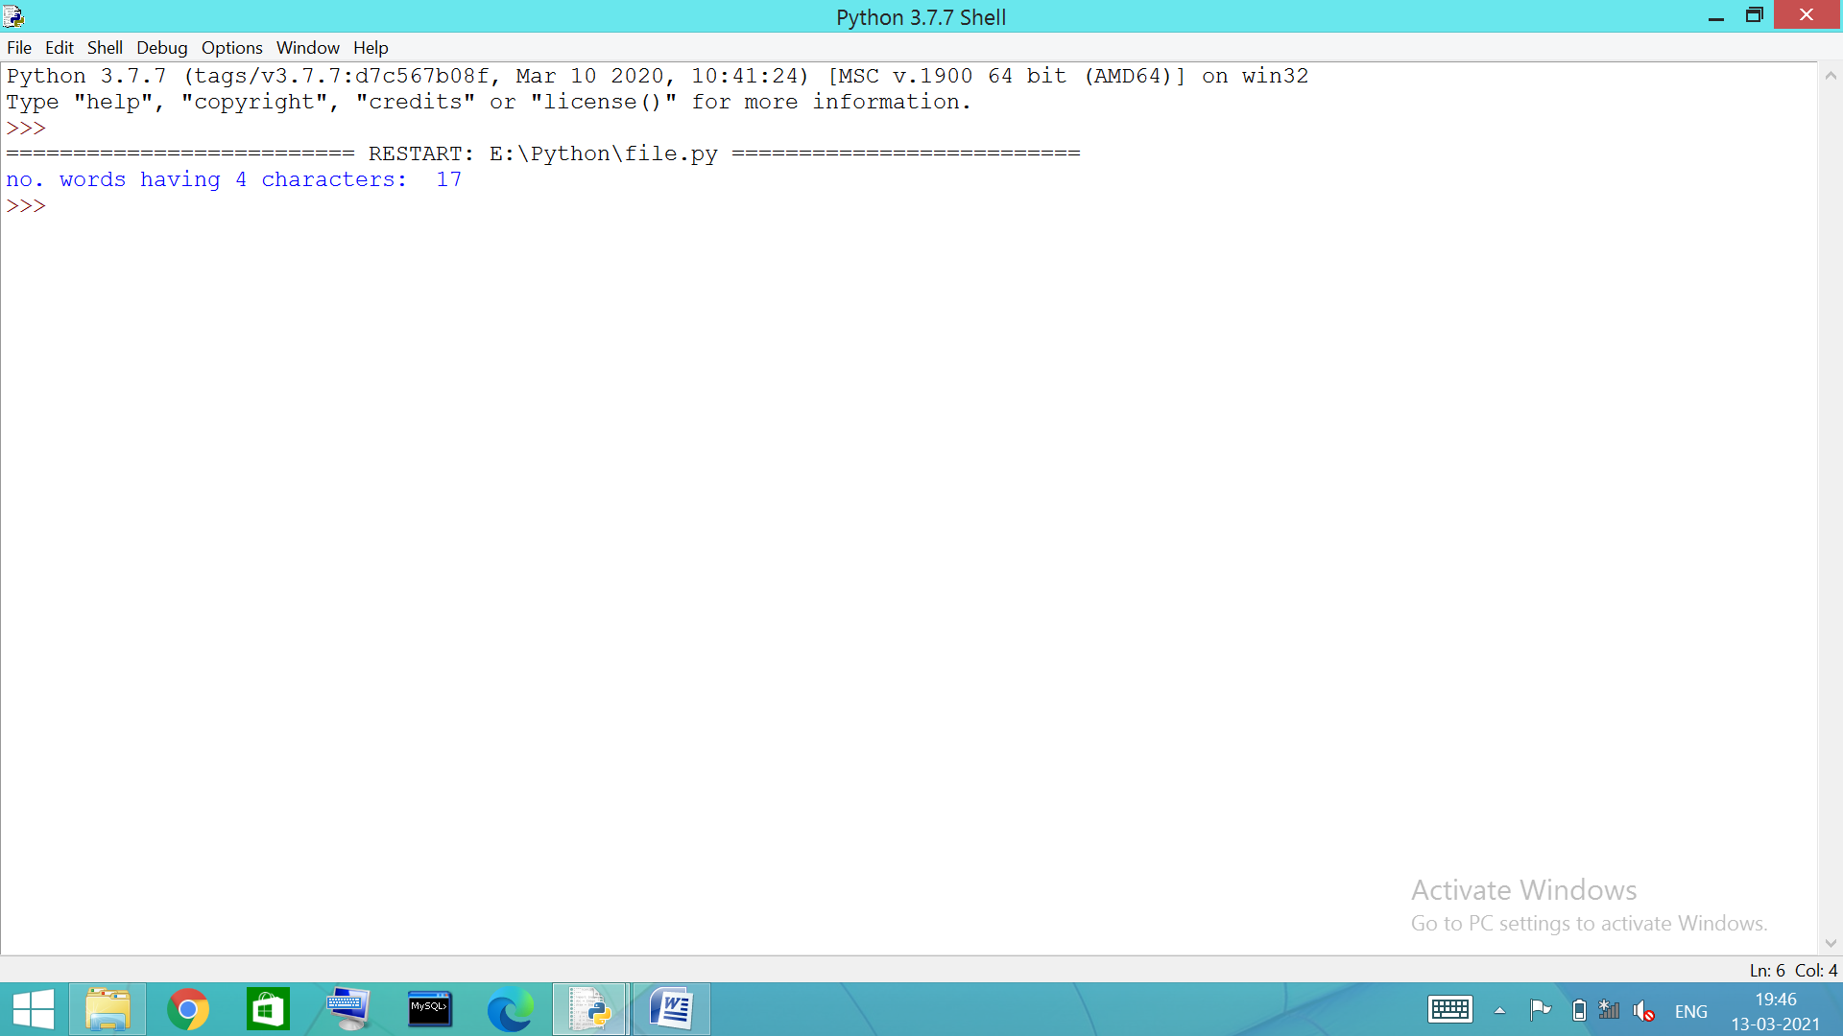

- #count the no. vowels
f=open('story.txt')
a=f.read()
z=0
for i in a:
if i in 'AEIOUaeiou':
z+=1
print('number of vowels: ',z)

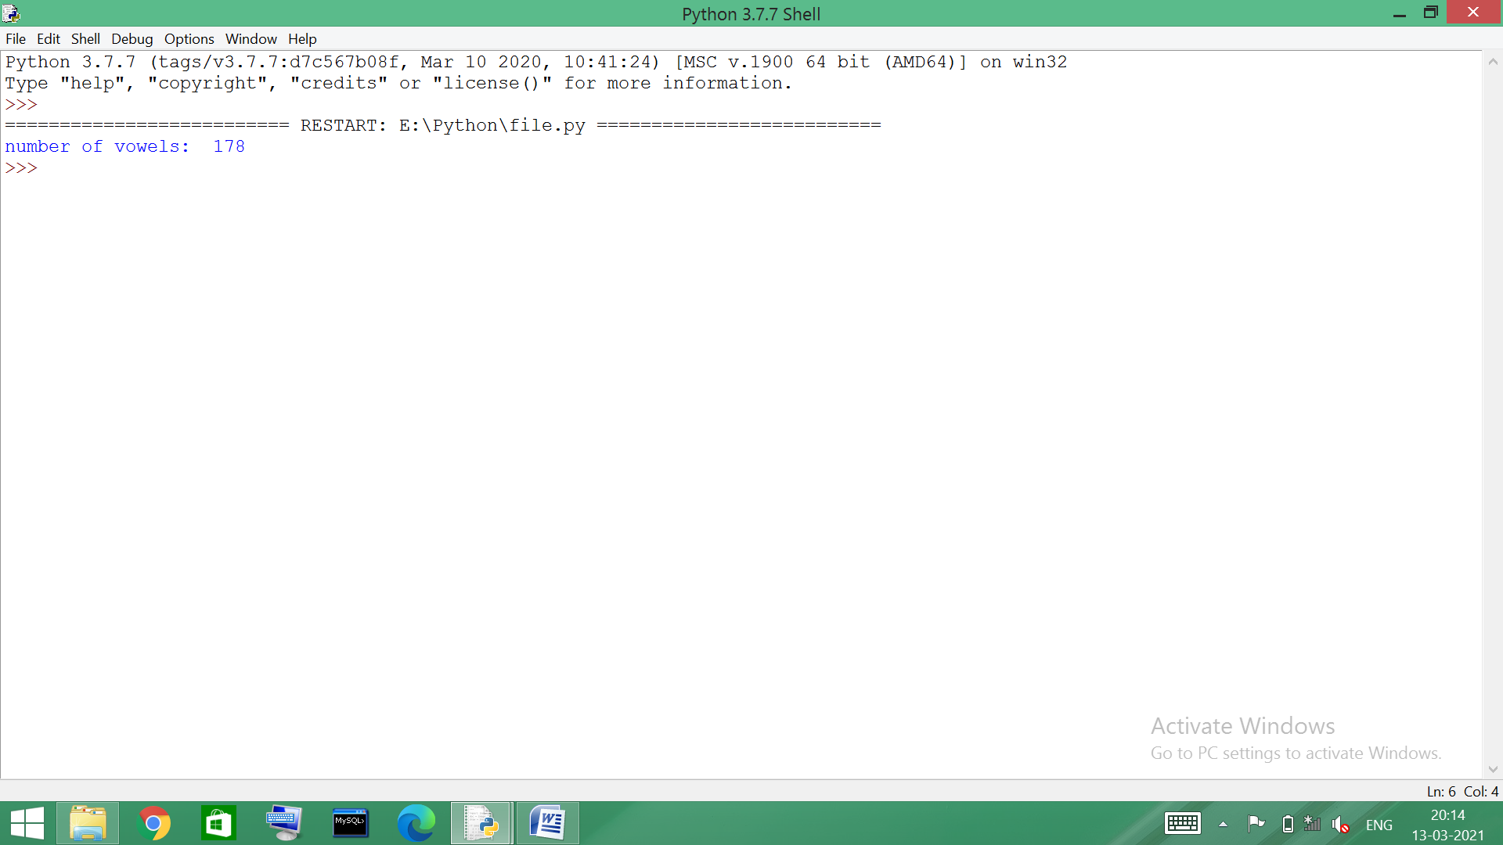

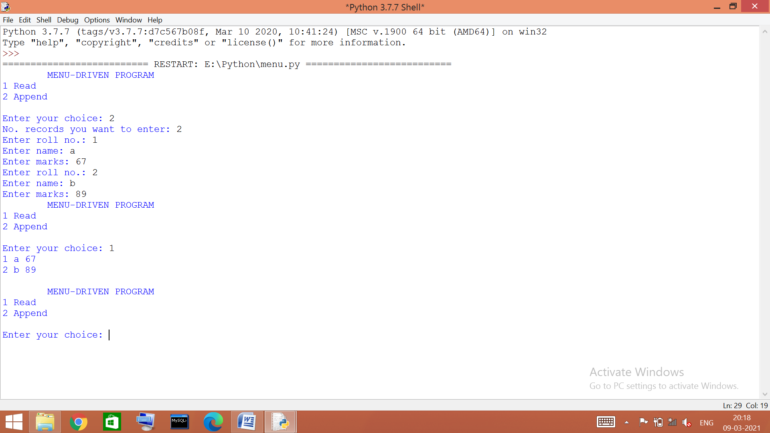
- # menu driven to read and write
def reda():
f=open('stud.txt')
f.seek(0)
s=f.read()
print(s)
def wr():
f=open('stud.txt','a+')
n=int(input('No. records you want to enter: '))
for i in range(0,n):
r=int(input('Enter roll no.: '))
n=input('Enter name: ')
m=int(input('Enter marks: '))
f.write(str(r)+' '+n+' '+str(m)+'\n')
f.close()
while(1):
print('\tMENU-DRIVEN PROGRAM\n1 Read\n2 Append\n')
a=int(input('Enter your choice: '))

if a==1:
reda()
elif a==2:
wr()

- #program to write/dump in binary file
import pickle
l=eval(input('enter a list/tuple :'))
with open('list.dat','ab') as f:
pickle.dump(l,f)
print("list added to binary file")

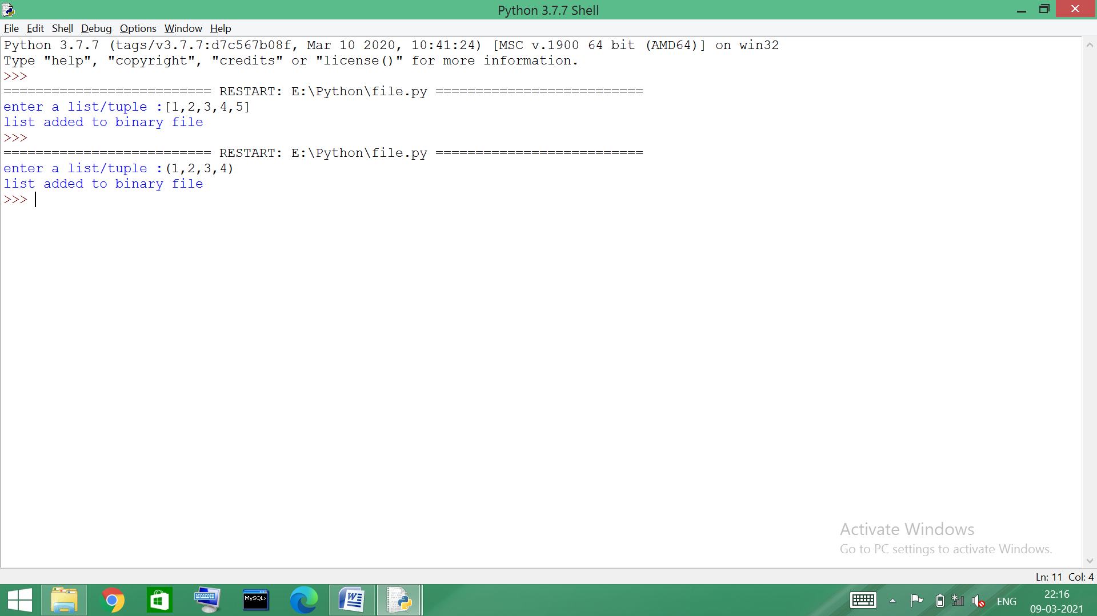

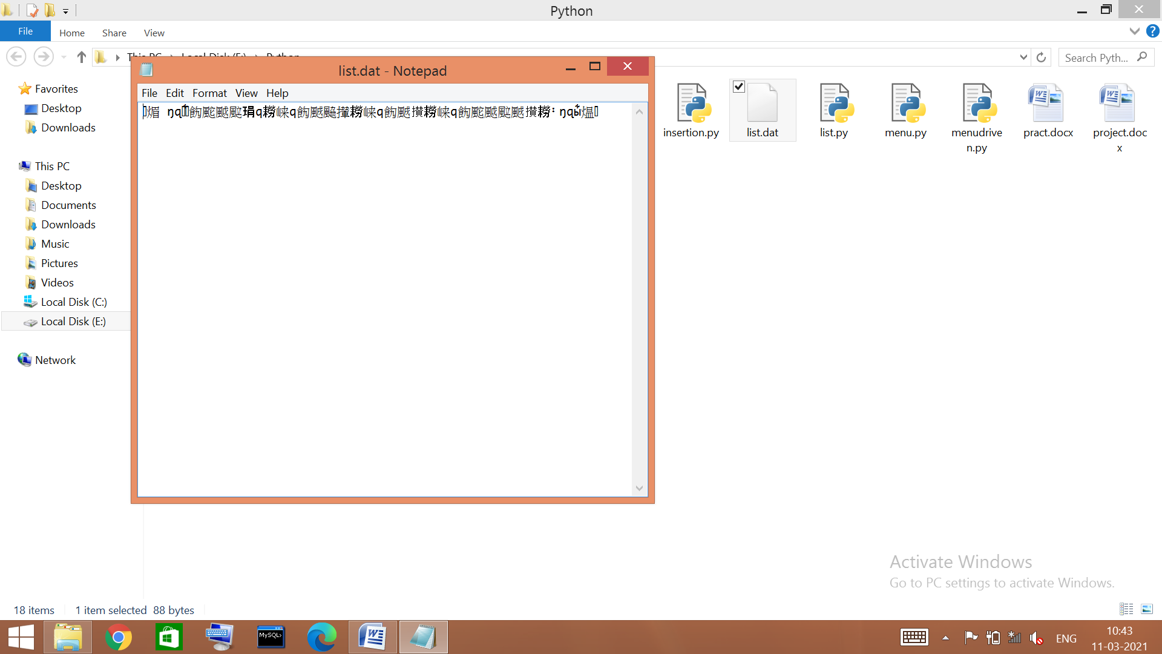

- #program to enter records and show with fees more than 4000
import pickle
def createfile():
f=open('student.dat','ab')
name=input('enter name:')
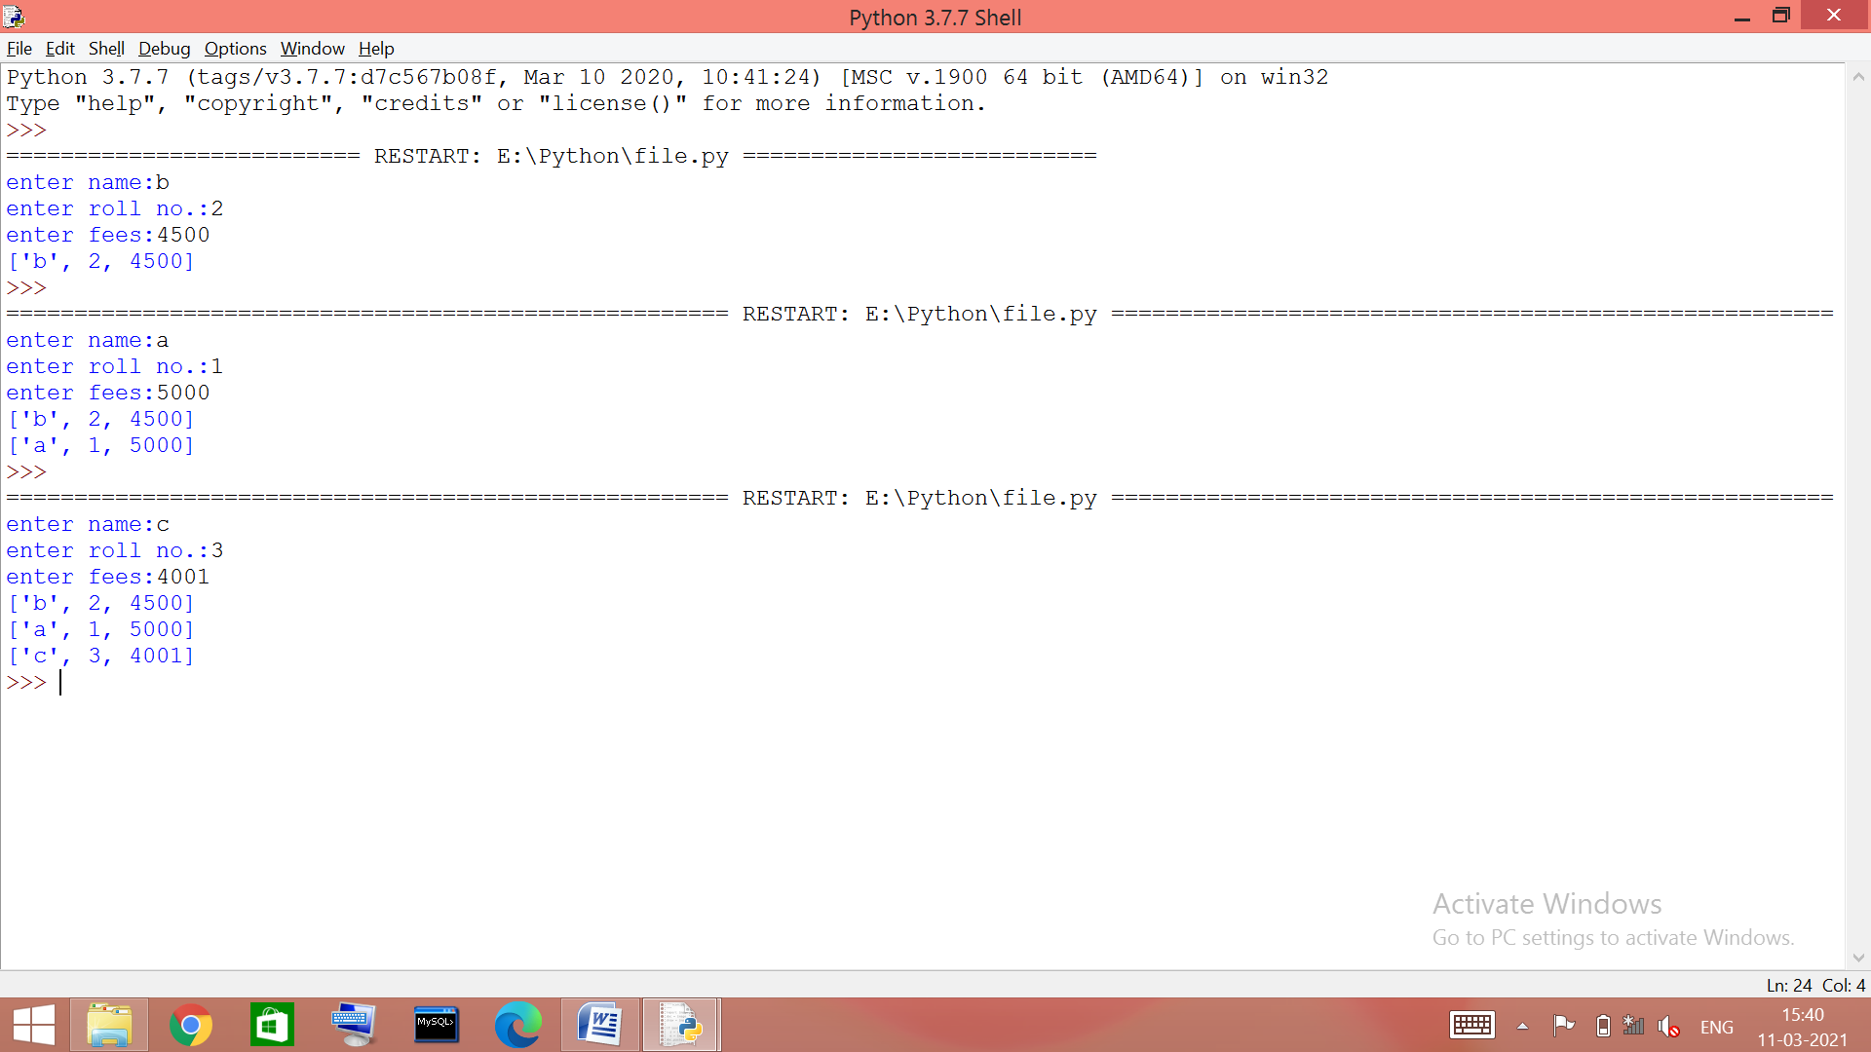
rollno=int(input('enter roll no.:'))
fee=int(input('enter fees:'))
rec=[name,rollno,fee]
pickle.dump(rec,f)
f.close()
def disrec():
f=open('student.dat','rb')
try:
while True:
rec=pickle.load(f)
if rec[2]>4000:
print(rec)
except EOFError:
f.close()
createfile()
disrec()

- # program to check password length is atleast 8
import csv
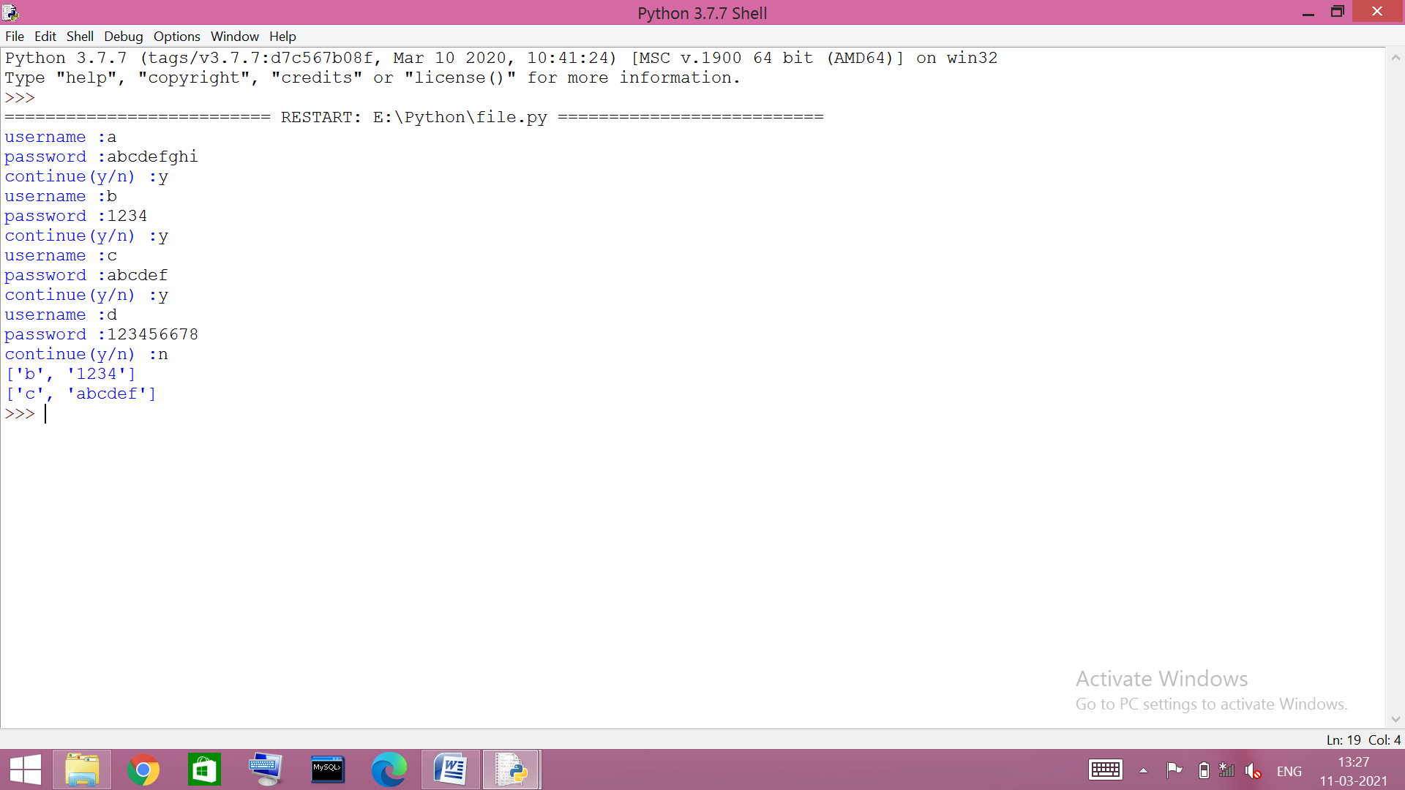
f=open('user.csv','a',newline='')
w=csv.writer(f)
while(1):
u=input('username :')
p=input('password :')
rec=[u,p]
w.writerow(rec)
a=input('continue(y/n) :')
if a!='y':
break
f.close()
f=open('user.csv','r',newline='')
r=csv.reader(f)
for i in r:
if len(i[1])<8:
print(i)

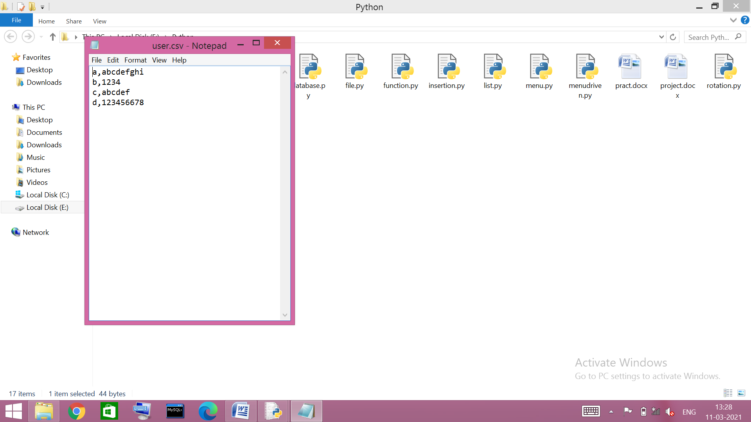

- # program to enter records and show with salary more than 25000
import csv
f=open('employee.csv','a+',newline='')
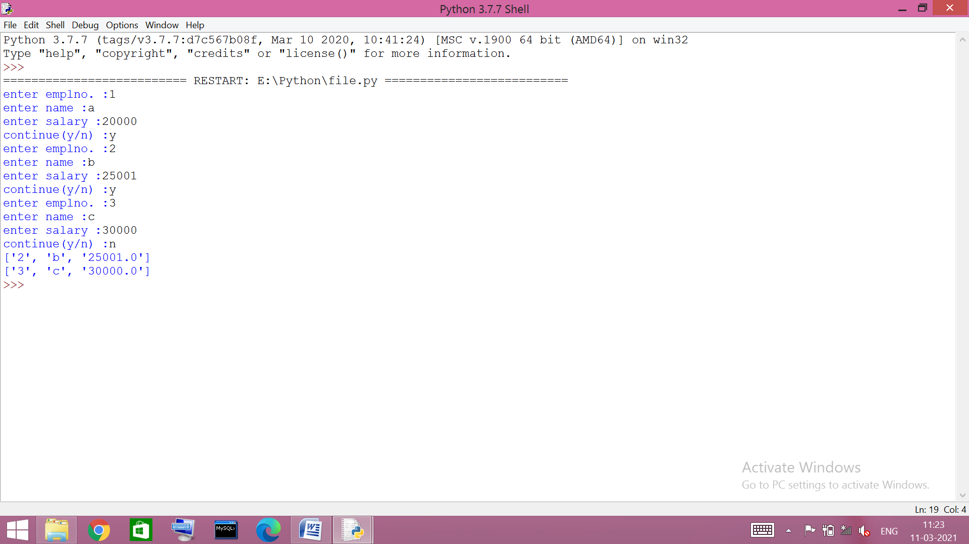
a='y'
while (a=='y'):
en=int(input('enter emplno. :'))
n=input('enter name :')
s=float(input('enter salary :'))
rec=[en,n,s]
w=csv.writer(f)
w.writerow(rec)
a=input('continue(y/n) :')
f.flush()
f.seek(0)
r=csv.reader(f)
for rec in r:
b=float(rec[2])
if b>25000:
print(rec)
f.close()
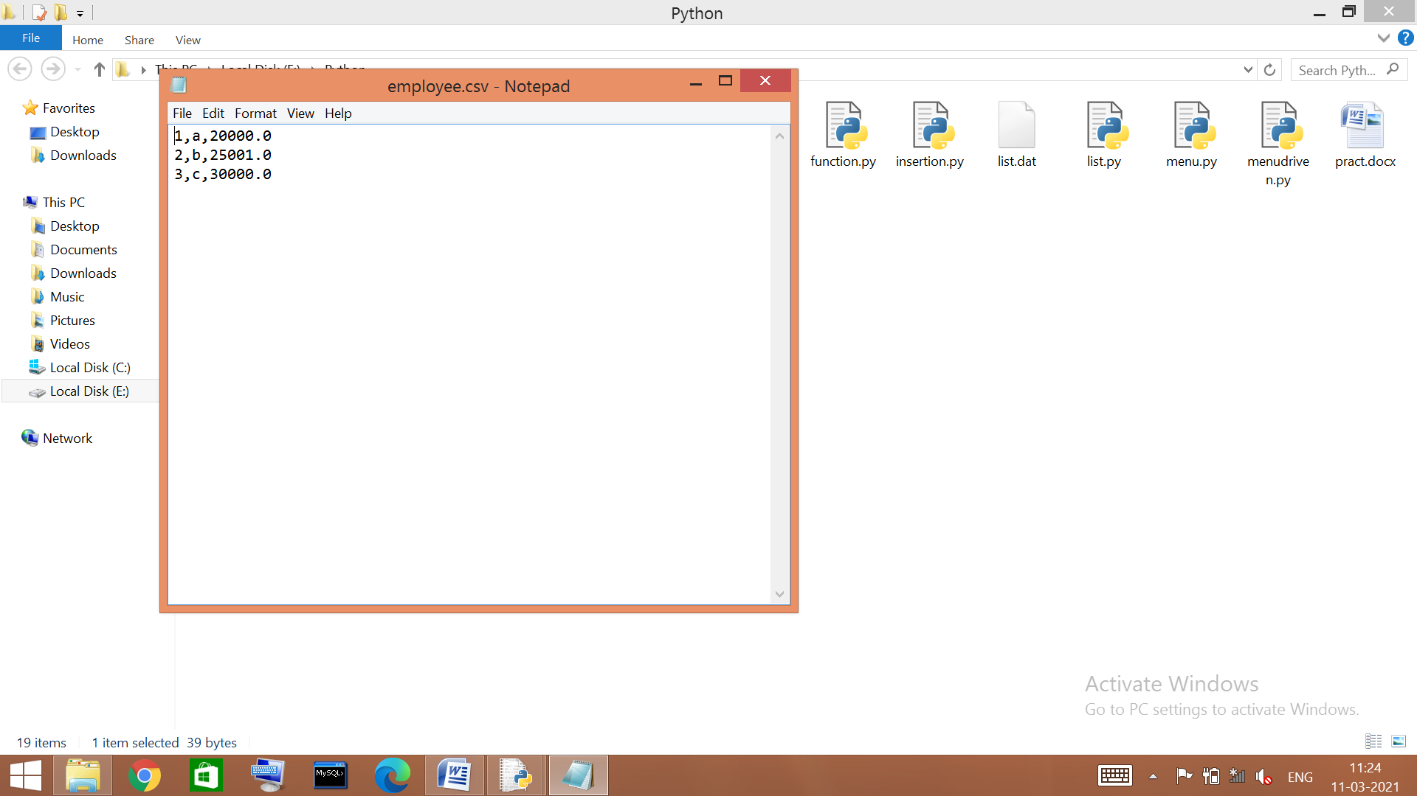

~~~ lists
- #combining 2 lists where odd no. From beginning of 1st list and even no. From ending of 2nd list
l1=[1,2,4,5,6,10,11]
l2=[2,3,4,6,89]
l3=[]
for i in l1:
if i%2!=0:
l3.append(i)
for j in l2:
if j%2!=0:
l3.append(j)
for m in range(-1,-(len(l2)+1),-1):
if l2[m]%2==0:
l3.append(l2[m])
for k in range(-1,-(len(l1)+1),-1):
if l1[k]%2==0:
l3.append(l1[k])
print(l1)
print(l2)
print(l3)

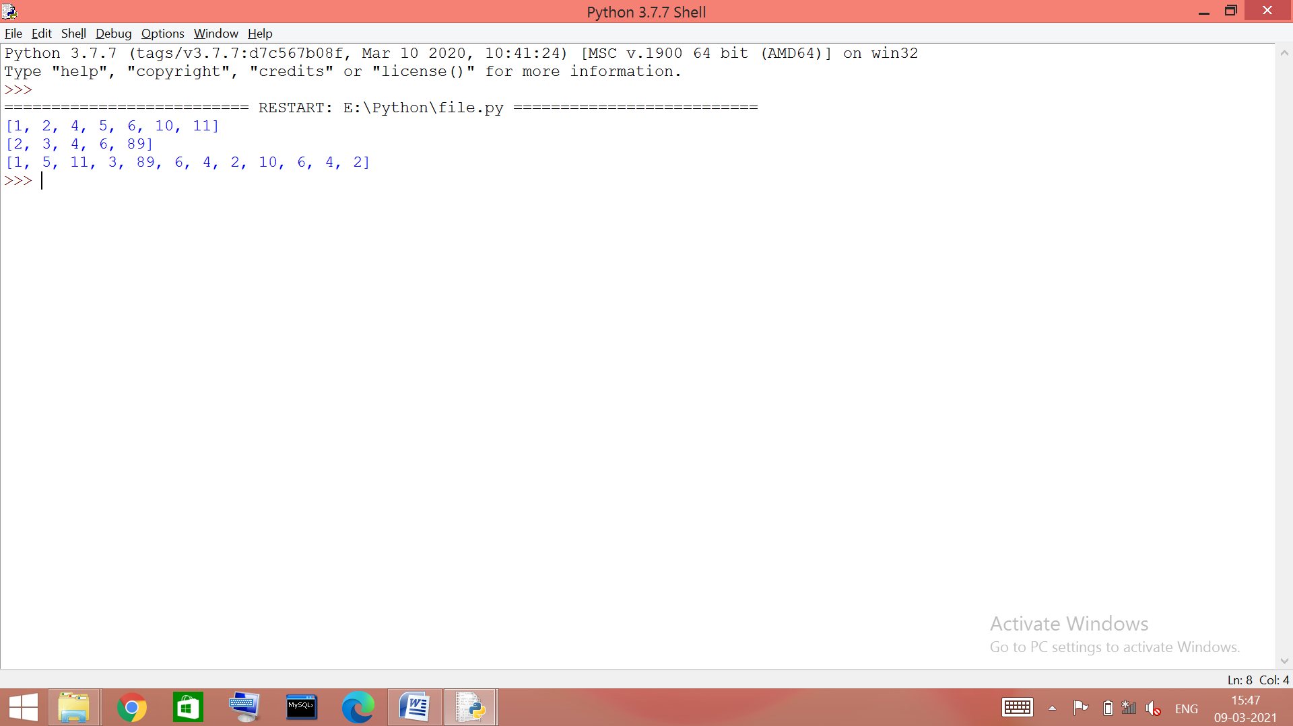
- #shifting elements of list by n to left
def LShift(l,n):
print(l)
a=l[:n]
for i in range(len(l)-n):
l[i] = l[i+n]
l[len(l)-n:] = a
print(l)
l=eval(input('enter list: '))
n=int(input('enter shift value: '))
LShift(l,n)

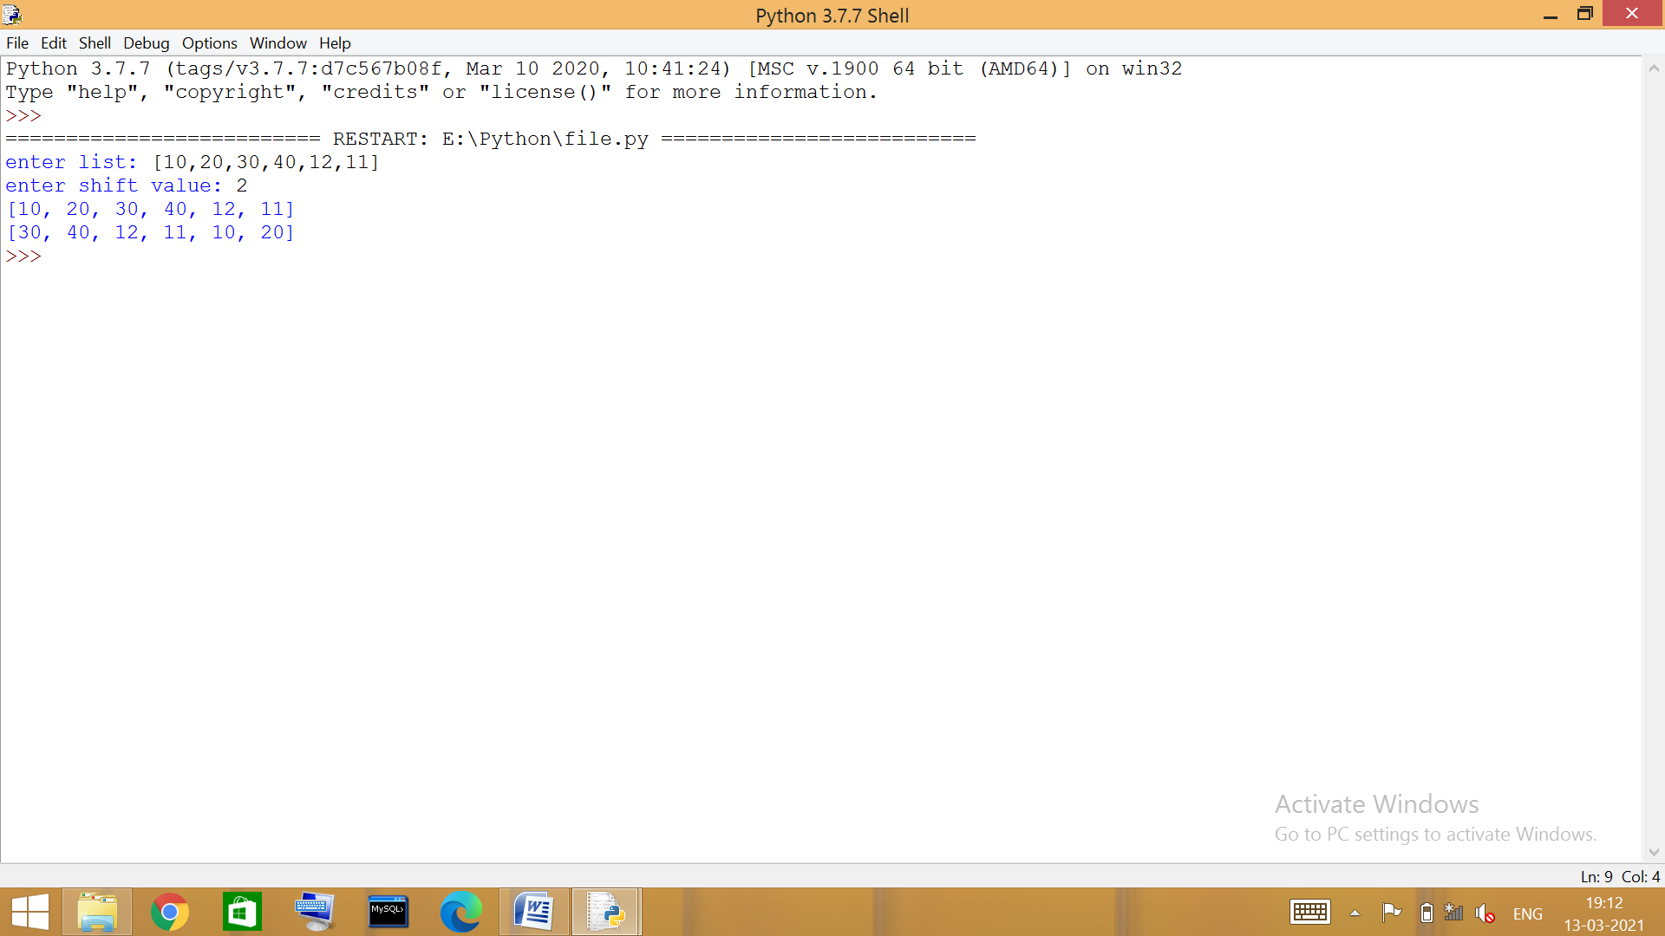

~~~stack implementation

- #push no. divisible by 5 into stack, display the adequate output
def push(arr):
l=[]
for i in arr:
if i % 5 == 0:
l.append(i)
if l == []:
print('none is divisible by 5, empty stack!')
else:
print('stack : ',l)
arr=eval(input('enter list: '))
push(arr)

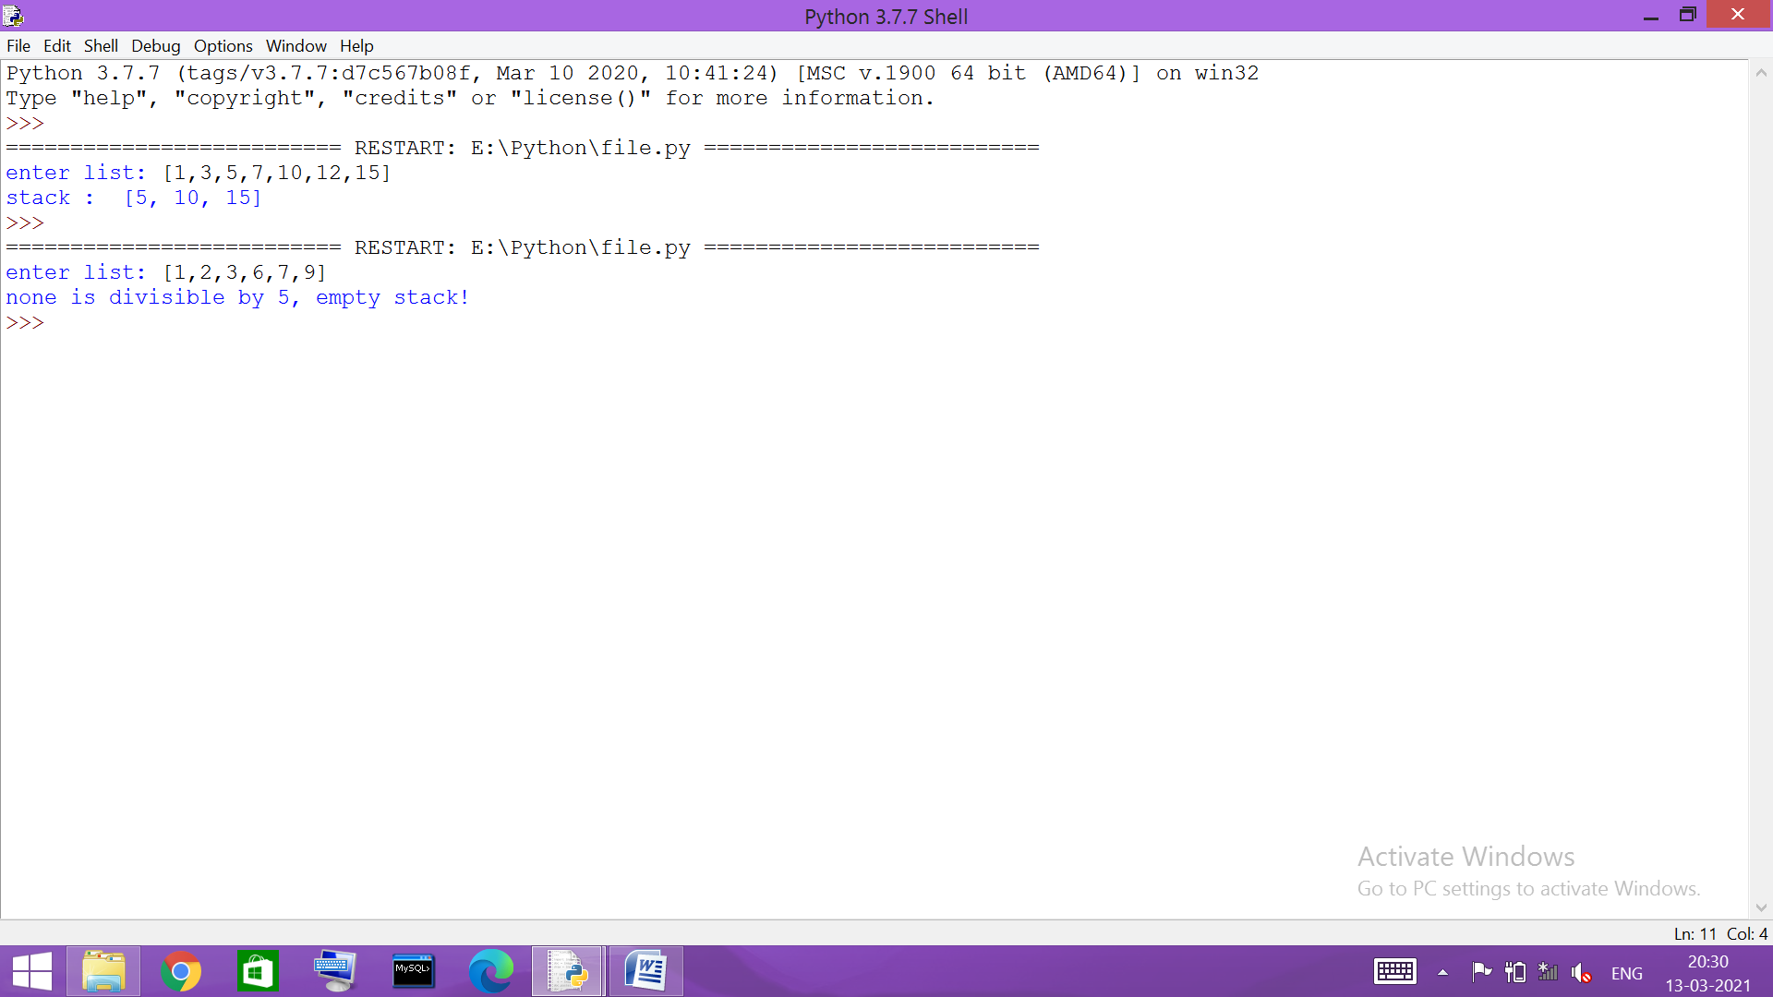
- #program to push and pop packages in a stack
def push(l):
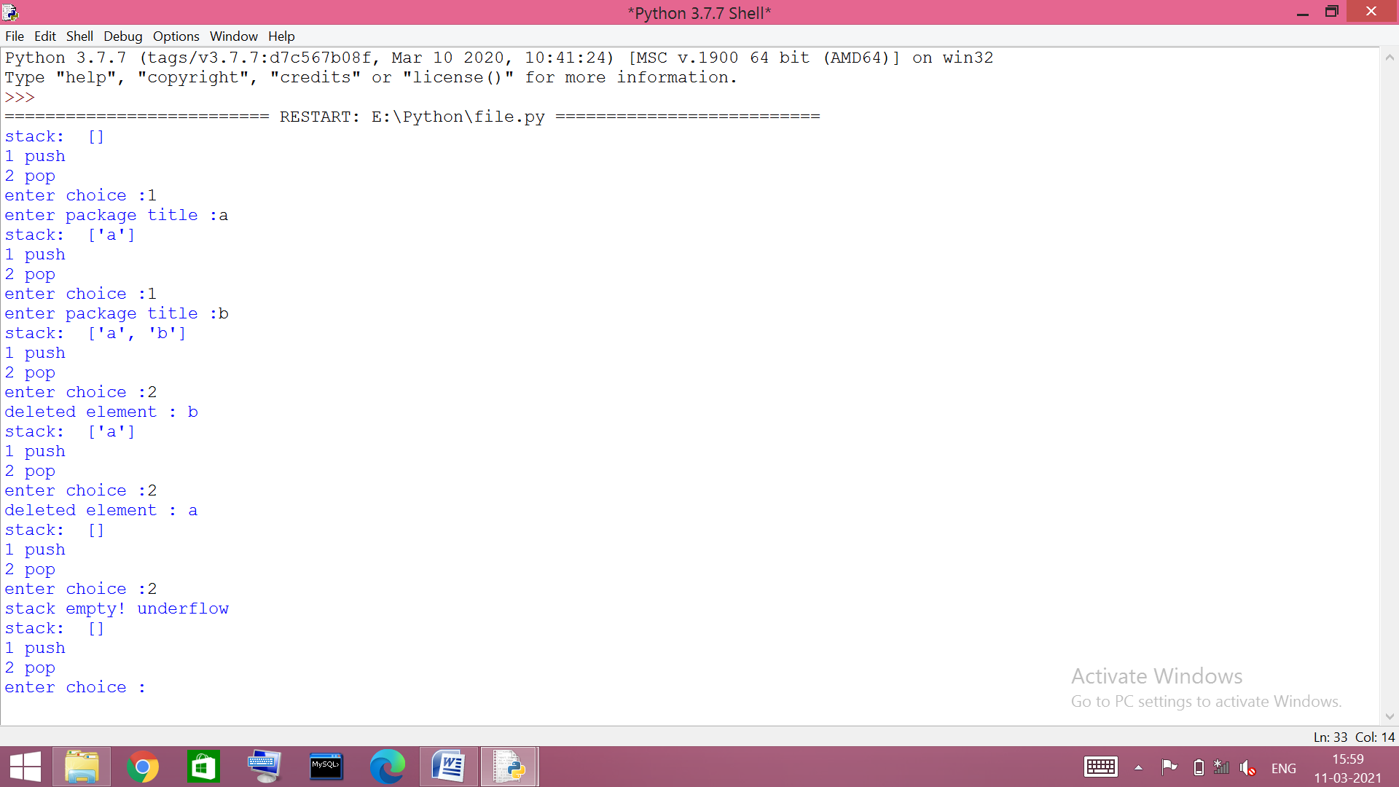
a=input('enter package title :')
l.append(a)
def pop(l):
if (l==[]):
print('stack empty! underflow')
else:
print('deleted element :',l.pop())
# __main__
l=[]
while(1):
print('stack: ',l,'\n1 push\n2 pop')
x=int(input('enter choice :'))
if x==1:
push(l)
elif x==2:
pop(l)
else:
break

~~~ database connectivity

- #creating database and table
import mysql.connector as ms
un=input('Enter MYSQL Username:')
ps=input('password:')
cn=ms.connect(host='localhost', user=un, passwd=ps, )
if cn.is_connected()==False:
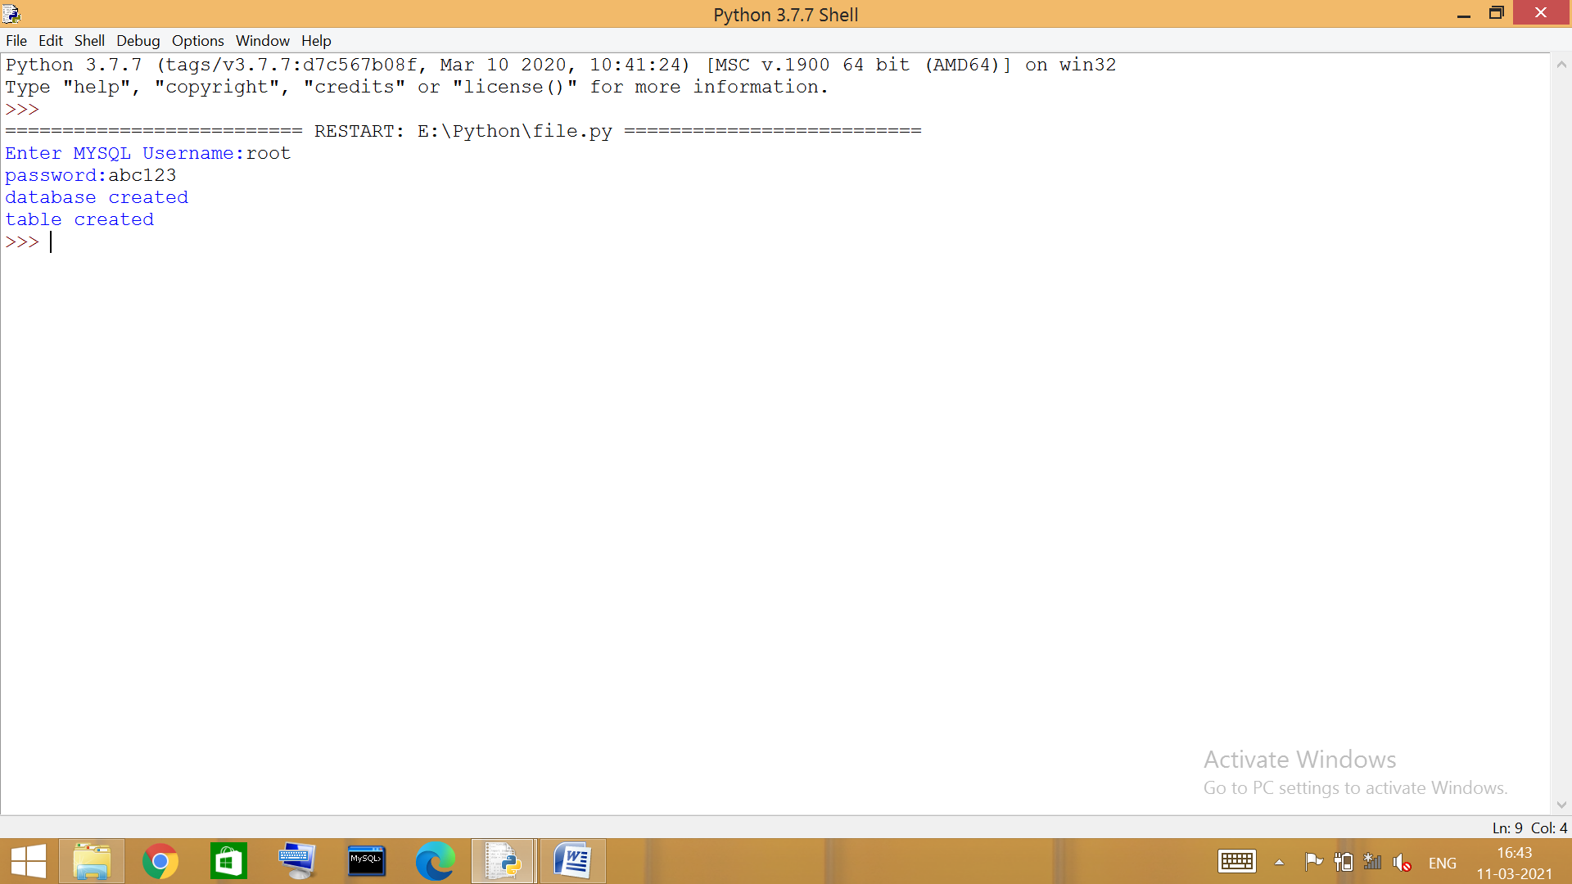
print('error connecting to databse')
cr=cn.cursor()
cr.execute('create database sample')
print('database created')
cr.execute('use sample')
cr.execute('''create table student
(rollno int(2) primary key,
name varchar(50),
marks int(3))''')
cn.commit()
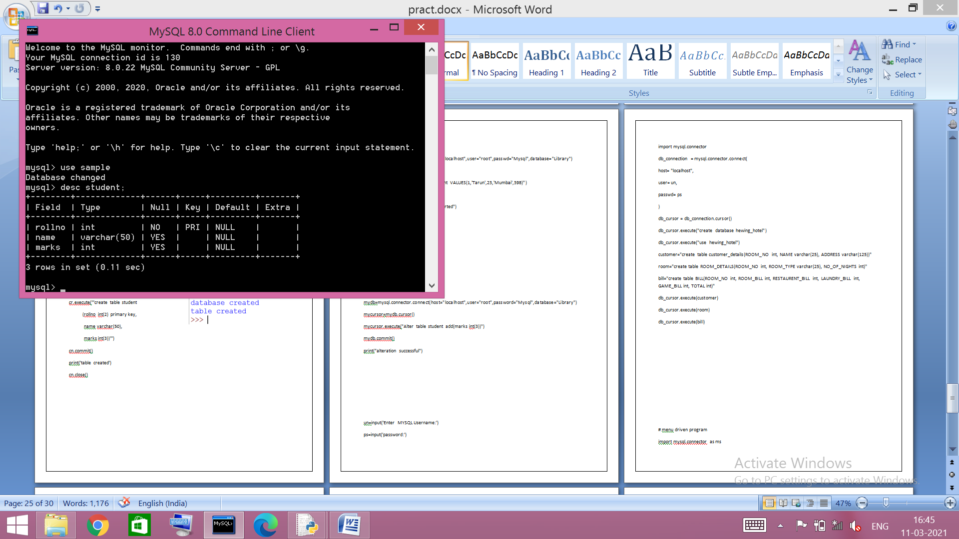
print('table created')
cn.close()

- # adding records in table
import mysql.connector as ms
cn=ms.connect(host='localhost', user='root', passwd='', database='sample')
if cn.is_connected()==False:
print('error connecting to databse')
try:
a= int(input('enter roll no. - '))
b= input('enter name - ')
c= int(input('enter total marks - '))
cr=cn.cursor()
cr.execute("insert into student values (%s,%s,%s)", (a,b,c))
cn.commit()
print('record inserted')
except:
print('error occured! \n maybe roll no. is already present')
cn.close()

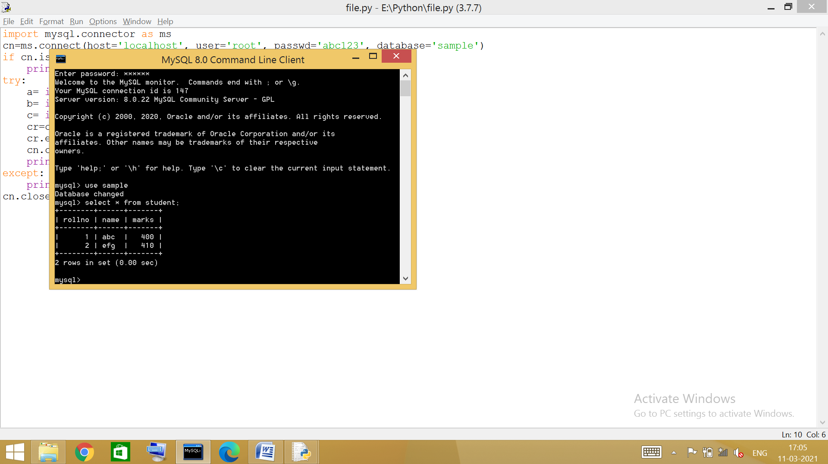
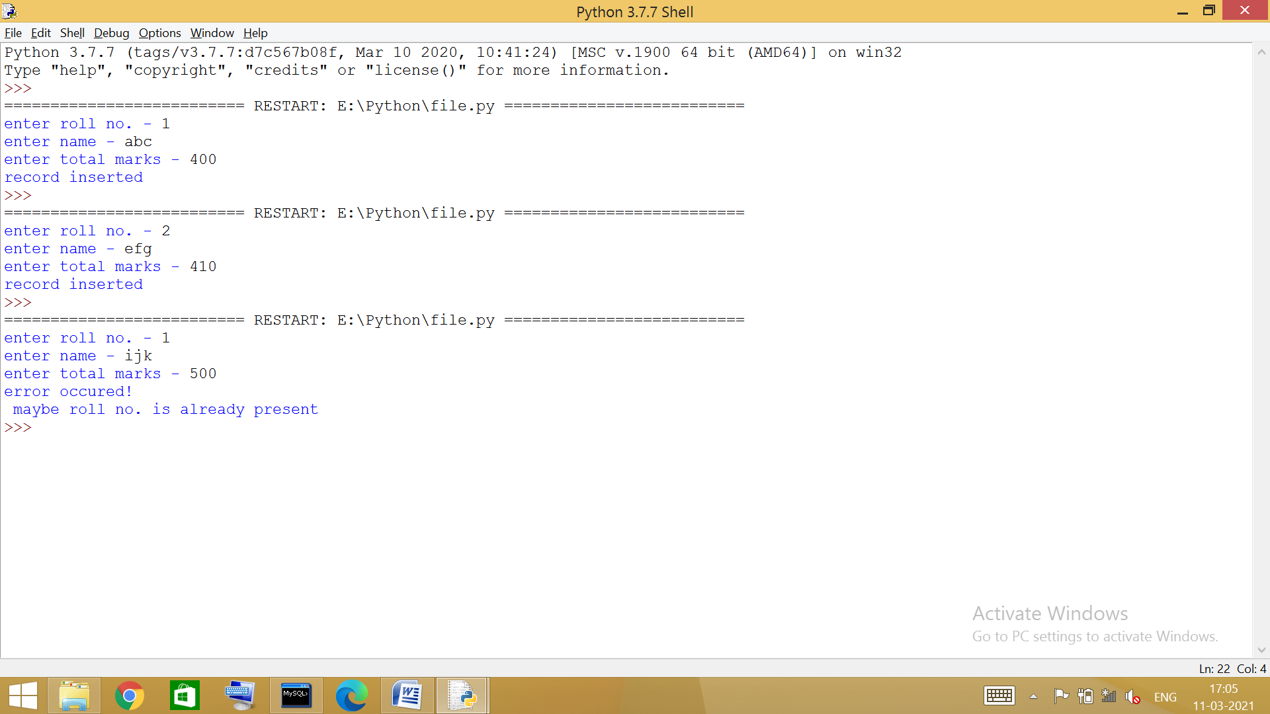

- # removing records from table
import mysql.connector as ms
cn=ms.connect(host='localhost', user='root', passwd='', database='sample')
if cn.is_connected()==False:
print('error connecting to databse')
try:
a= int(input('enter roll no. you want to remove - '))
cr=cn.cursor()
cr.execute(f"delete from student where rollno = {a}")
print('record deleted')
cn.commit()
except:
print('error occured!')
print('maybe roll no. is not already present')
cn.close()

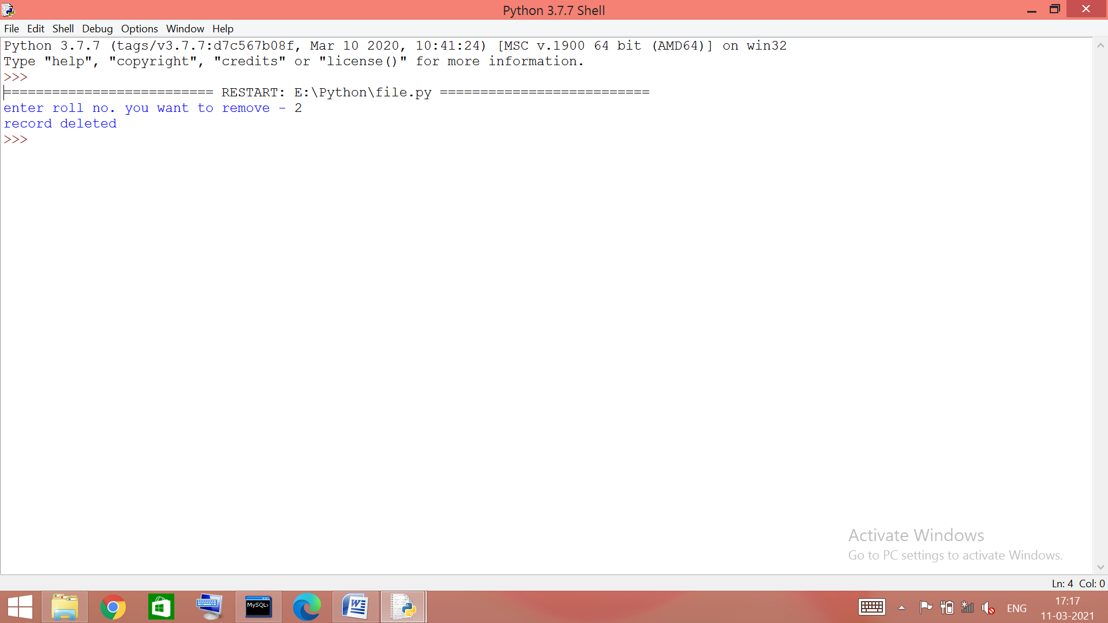

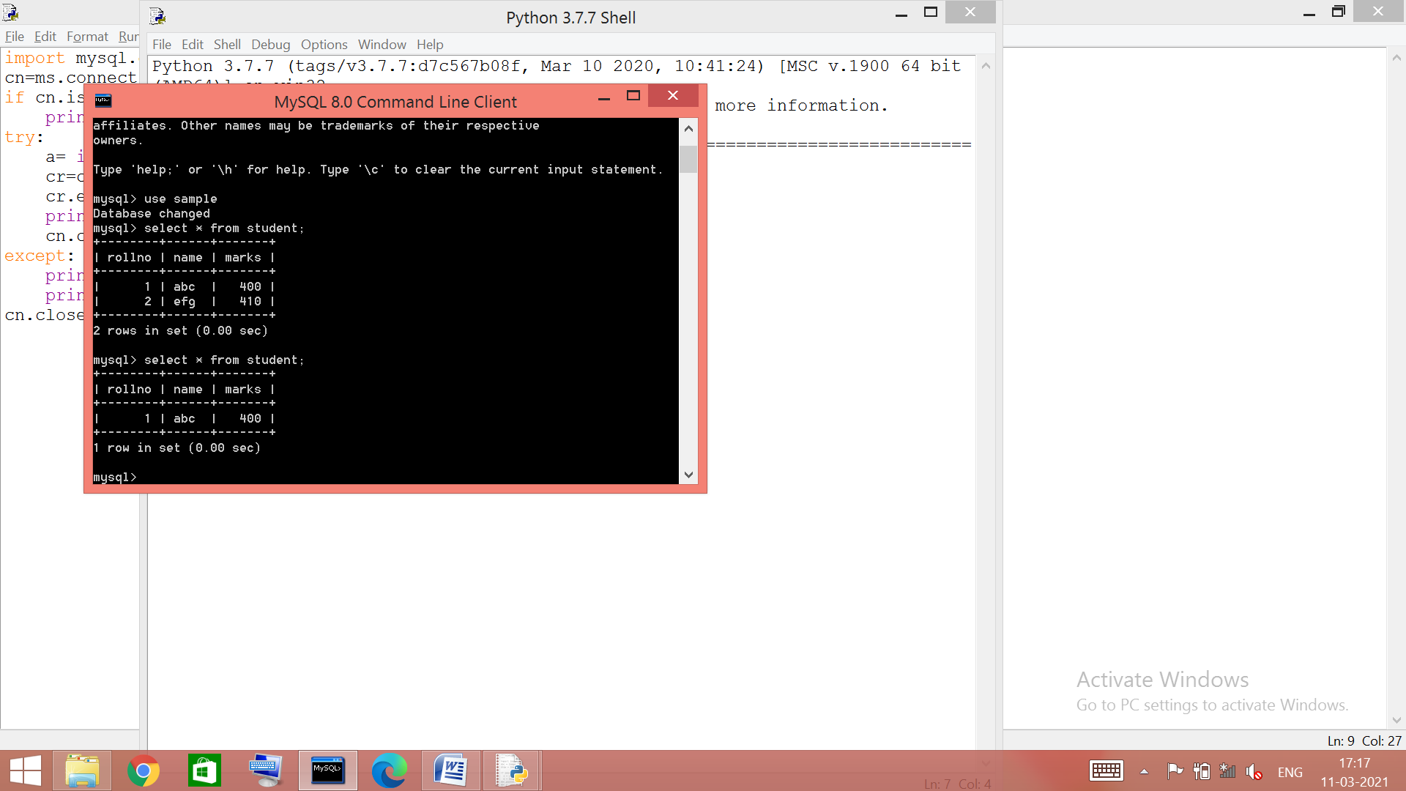

- # updating records in table
import mysql.connector as ms
cn=ms.connect(host='localhost', user='root', passwd='', database='sample')
if cn.is_connected()==False:
print('error connecting to databse')
try:
x= int(input('enter roll no. you want to update - '))
a= input('enter new name - ')
b= input('enter marks - ')
cr=cn.cursor()
cr.execute("update student set name = %s, marks = %s where rollno = %s", (a,b,x))
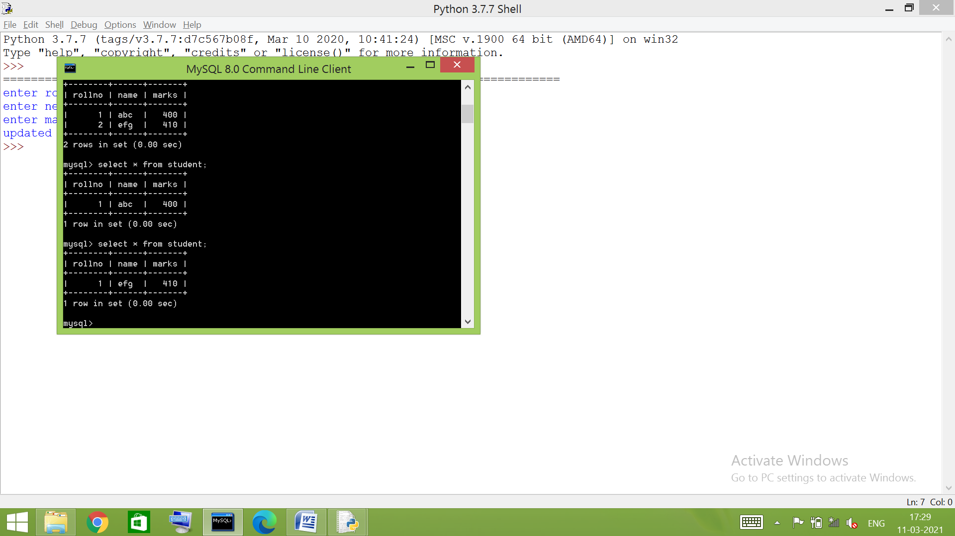
cn.commit()
print('updated successfully')
except:
print('error occured!')
print('maybe roll no. is not already present')
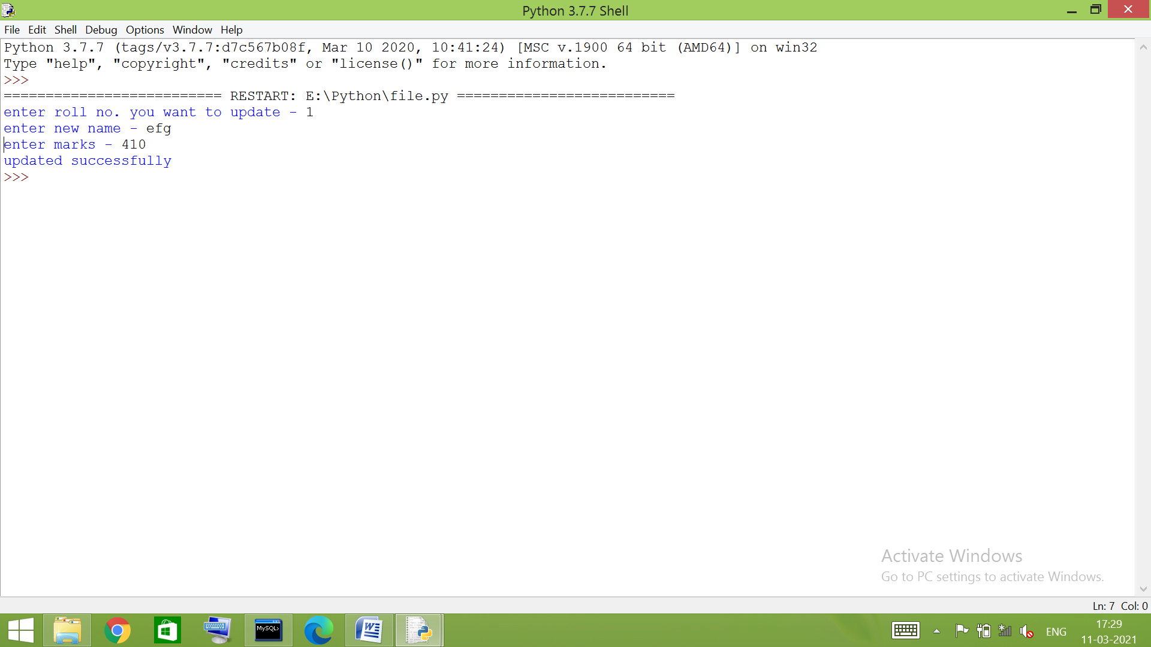
cn.close()

- # sorting records by marks
import mysql.connector as ms
cn=ms.connect(host='localhost', user='root', passwd='abc123', database='sample')
if cn.is_connected()==False:
print('error connecting to databse')
cr=cn.cursor()
cr.execute("select * from student order by marks")
a=cr.fetchall()
for i in a:
print(i)
cn.close()

