

**Computer Science Project**



**TEXT EDITOR**

Submitted by:

Himanshu Raj

XII – A

26647854

CERTIFICATE

This is to certify that *Himanshu Raj* of class *XII – A*, *Modern Child Public School* has completed this Computer Science project work titled *‘Text Editor’*, for class XII CBSE practical examinations in the year *2020 – 21* under my guidance.

Teacher’s Signature

ACKNOWLEDGEMENT

I would like to express my gratitude towards my computer science teacher ‘Mr. Prabhu Dayal’ for his vital support and guidance till the successful completion of this project by giving ideas and thoughts. Also, Internet was a major help.

I wish to thank my parents, friends for their undivided support with their valuable suggestions that have made the project easy.

CONTENTS

* Overview
* System Requirements
* Source Code
* Output screens
* Limitations
* Further Enhancements
* References

OVERVIEW

The main objective of this python project is to provide a fully functional text editor.

The user interface has been designed with Python’s tkinter module and it uses a mysql databse for saving data on back end, an effective application of mysql databse connectivity with python.

This project will attract those who wish to see things working in a rather unconventional way.

SYSTEM REQUIREMENTS

Software Requirements:

OS:Windows 7 / Mac OS X 10.6.1+ / Ubuntu 9.10

MySQL

Python (ver 3.0)

‘mysql.connector’ module ( from pip )

Hardware Requirements:

Any dual core processor ( Intel / AMD )

2 GB RAM

1 GB storage

SOURCE CODE

Database / Back-end code screening:

DBMS: MySQL

Database: project

Table: tetor

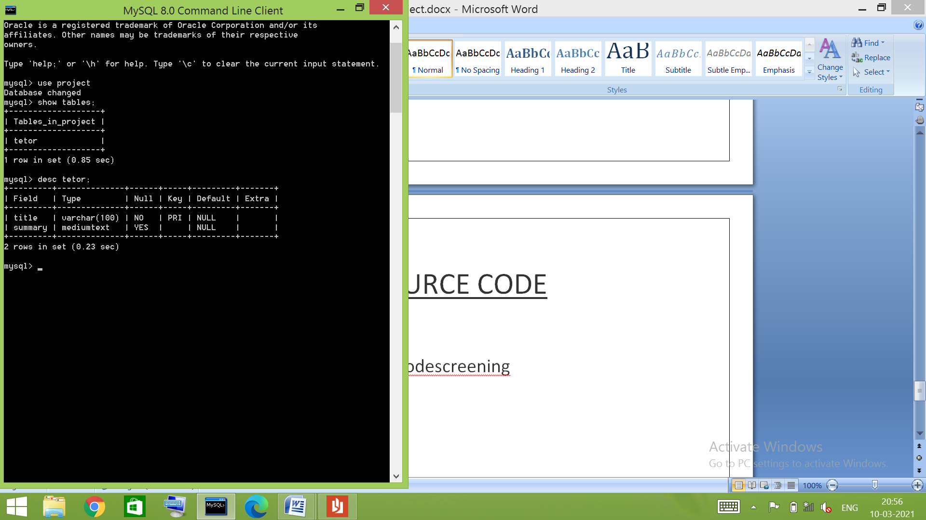

OUTPUT SCREENS

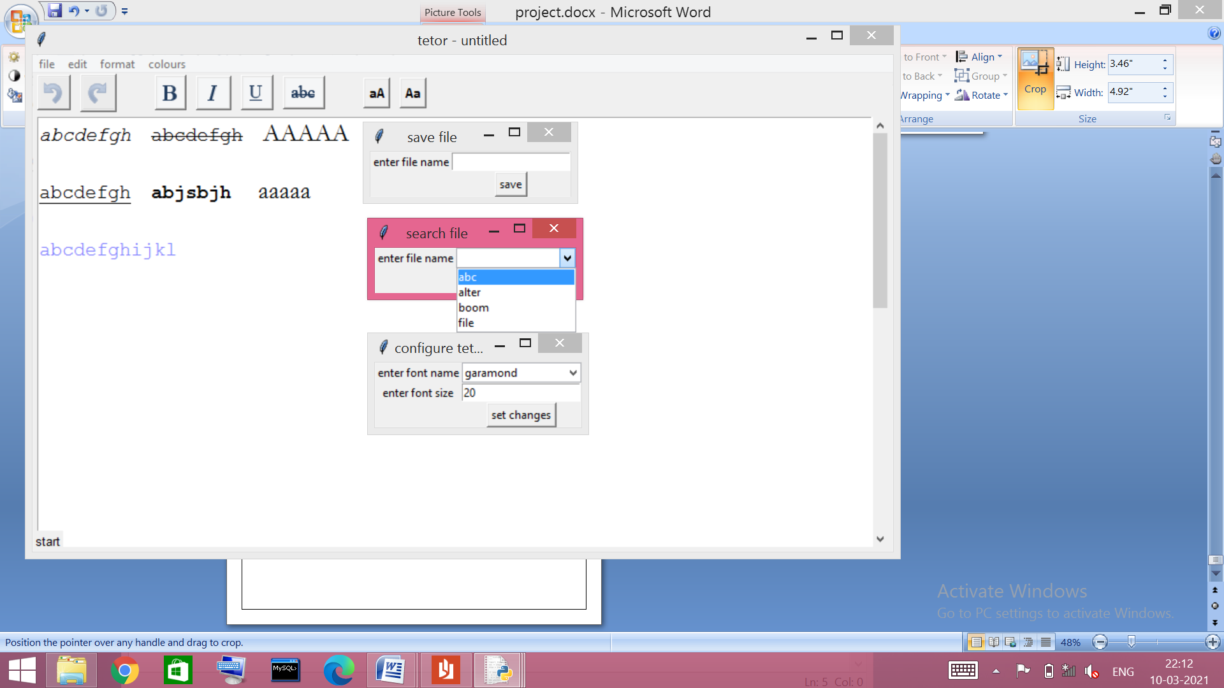

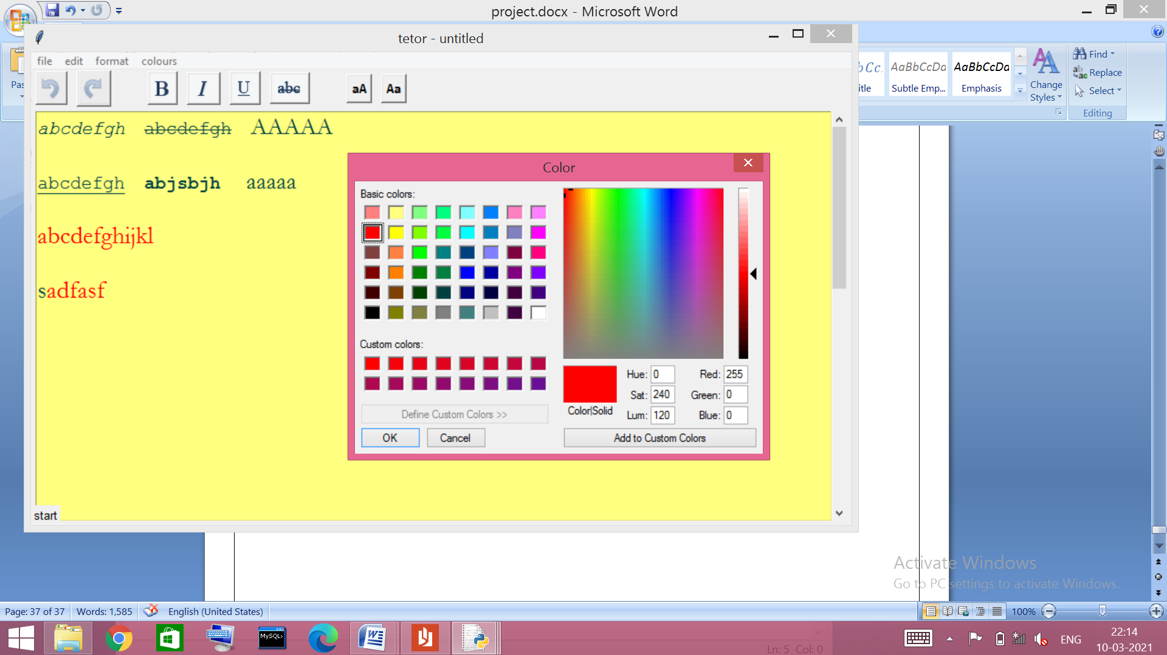

LIMITATIONS

* The undo and redo buttons don’t consider tags, i.e. if you use bold and want to reverse it with undo it will affect the action before changing of tags.
* If a save file is opened, all the related tags are lost, i.e. italic, bold, text colour & font (tags are not attached permanently).
* Two or more tags can’t be added to same text, i.e. selected text can’t be bold and italic at same time.
* There is a character limit of 65,535 characters equivalent to 64 KB as per maximum capacity of ‘TEXT’ to provide it an optimum speed and reduce time for saving and opening files. The size and character limit can be increased with ‘MEDIUMTEXT’ ‘LONGTEXT’ but at the stake of speed of processing files.

FURTHER ENHANCEMENTS

* The tags could be given a separate field in the database table to store them permanently and resolve the above issue.
* The configure option in format menu can be brought down to toolbar frame giving direct way to change font and text size.
* The alignment options can be added.
* There can be a Find & Replace option.
* There can be numerous changes in UI like binding a menu on mouse right click for changes in selected text, etc.

REFERENCES

* Computer Science with python by Sumita Arora
* Codemy.com (YouTube channel)
* GeeksforGeeks: <https://www.geeksforgeeks.org>
* Stack Overflow: <https://www.stackoverflow.com/>
* Tutorials Point: <https://www.tutorialspoint.com/>