Q4. (a)

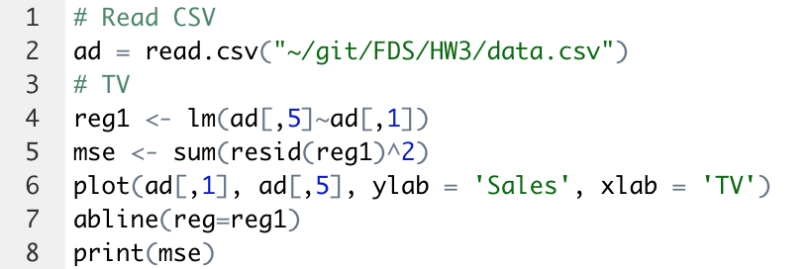

MSE (TV) = 5402.716