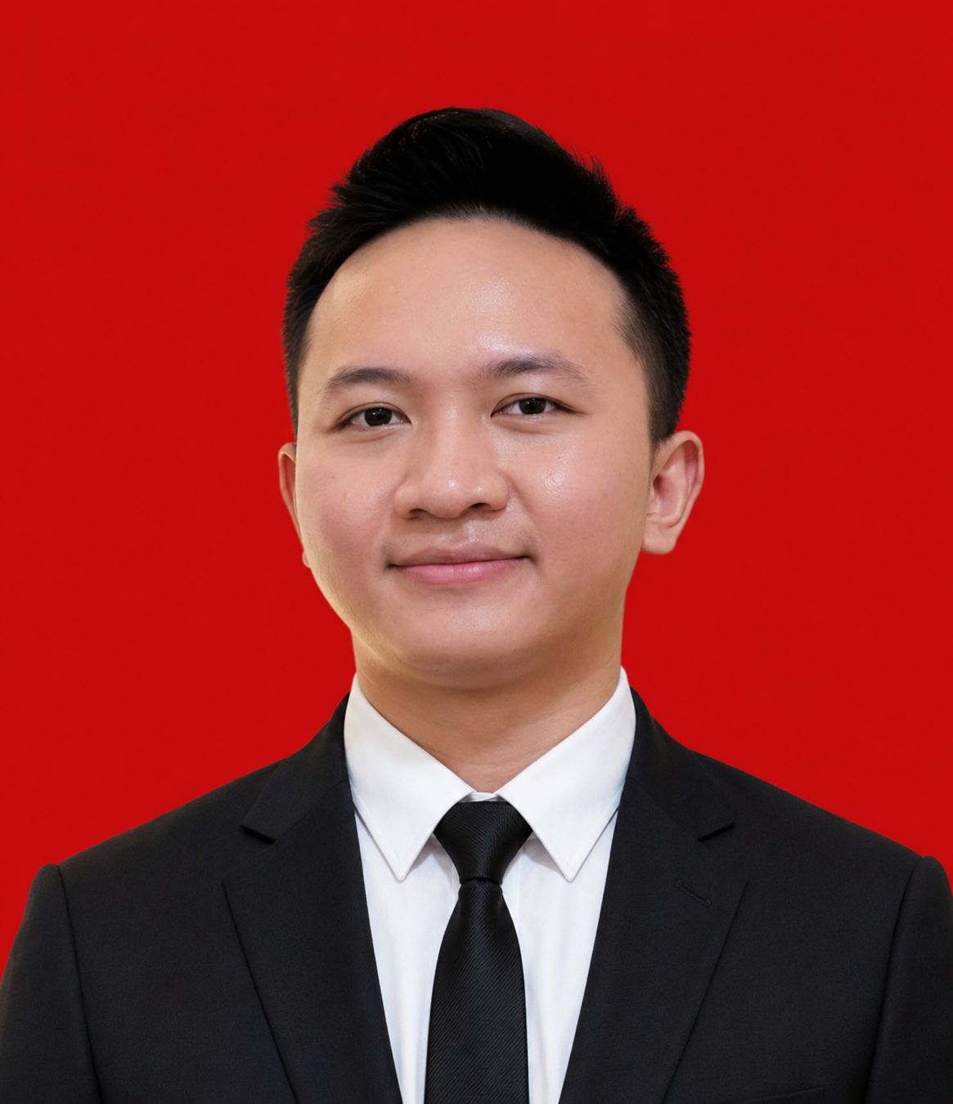
RAHMAWAN
Management Graduate | Administration | Front End Development
+62 878-4311-0141 | rahm2668@gmail.com
linkedin.com/in/rahmawan-9a3395215 | github.com/rahm2668-cpu
Portfolio: portofolio-website-sigma-liart.vercel.app

PROFILE
Management graduate with experience in administration, document management, data processing, and operational support. Skilled in Microsoft Excel and Word, with a detail-oriented and organized approach to work. Gained front end development experience through internships and independent hospitality web projects using React and Next.js. Brings communication, coordination, and problem-solving skills to administrative, hospitality, and digital support roles.

WORK EXPERIENCE

Front End Developer Intern
Codealpha | 2026
- Completed assigned tasks according to project instructions and deadlines.
- Documented work and reported task progress while developing time management and teamwork skills.

Front End Developer Project Based Virtual Intern
Core Initiative x Rakamin Academy | Depok | 2025
- Participated in a structured, project-based front end development internship.
- Collaborated on assigned tasks, maintained work documentation, and reported progress against deadlines.

Administration Staff
CV. Martiel Cahaya Perkasa | Bandung | 2021 - 2022
- Managed administrative documents, prepared reports, and maintained an organized filing system.
- Entered, updated, and processed data using Microsoft Excel; checked completeness and accuracy before processing.
- Coordinated with internal teams to support day-to-day administrative operations.

Part Time Driver
Grab | 2019 - 2020
- Delivered customer service professionally and managed working time independently to meet daily targets.

EDUCATION

Bachelor of Economics in Management
Universitas Garut | 2018 - 2022
GPA: 3.61
Academic Achievement Scholarship (PPA) recipient, Ministry of Education, Culture, Research, and Technology.

SELECTED PROJECTS

Kayarra Resort Hotel Website
kayarra-official-website.vercel.app
- Developed a responsive resort website presenting rooms, villas, facilities, photo galleries, and reservation inquiries.
Technologies: Next.js, React.

OTA Management System Hotel
kayarra-ota-management-system.vercel.app
- Built a hotel operations portfolio demo covering reservations, channel distribution, rate and inventory calendars, and revenue overviews using fictional sample data.
Technologies: Next.js, React.

SKILLS AND TOOLS
Administration: Microsoft Excel, Microsoft Word, data entry and processing, report preparation, document management, and operational support.
Web development: HTML, CSS, React, Next.js, Tailwind CSS. Tools: Visual Studio Code.
Professional skills: communication, coordination, teamwork, time management, attention to detail, and problem solving.
English: B2 Upper Intermediate (EF SET, 2025).

CERTIFICATIONS
- Core Initiative Frontend Project Based Internship Program | Core Initiative | 2026
- React Web Developer Expert | Dicoding | 2025
- Financial Literacy | Dicoding | 2025
- EF SET English Certificate, B2 Upper Intermediate | 2025
- Marketing | BNSP | 2021
- PTESOL | The Language Center, Indonesia University of Education | 2021

ORGANIZATIONAL EXPERIENCE

Ministry of External Relations
Badan Eksekutif Mahasiswa, Universitas Garut | 2019 - 2020
- Supported internal and external organizational relations, coordination between student organizations, and administrative activities.

Public Relations
BEM Sport and Art Competition Vol. 2 | 2019
- Communicated event information, responded to participant inquiries, and coordinated communication between the committee and external parties.

