

Umm Al Qura University

College of Engineering and Computers in Al-Qunfudhah

Department of Computer Science

" Software Documentation and Technical Writing"

“Digital Care”

|  |  |
| --- | --- |
| Name | ID |
| Rahma Ali | 444007907 |
| Aryam Hassan | 444003032 |

Dr. Mona Alofi

**Contents..**

**- Introduction……………………………………….2**

**- Chapter 1……………………………………………3**

**1.1 Digital care App Requirements…..………………………………4**

**1.2** **Digital care Task…………………………………………………..6**

**- Chapter 2……………………………………………7**

**2.1 Purpose Of The App ……………………………………………8**

**2.4 Display a survey based on asking some questions to people.…….9**

**2.5 Similar Applications…………………………...……………….12**

**- Chapter 3……………………………………13**

**3.1 Application design……………………………14**

**3.2 Conclusion…………………………………….16**

**- References…………………………………………..17**

**-introduction:**

**The Medical Consultation Application is an innovative platform aimed at providing specialized medical consultation services to users via smartphones or the internet. This application allows users to access reliable medical information, communicate with specialized doctors, and receive timely medical consultations. In light of the increasing health challenges, it has become essential to provide technological solutions that facilitate access to healthcare.**

**Chapter 1**

* 1. **Digital care App Requirements:-**

**:1.1.1 Functional Requirements**

1.1.1.1 Providing Remote Medical Consultations:

The system must allow users to obtain medical consultations via phone or video

1.1.1.2 User Registration:

The system must include an interface for registering new users and storing their personal information

1.1.1.3 Appointment Scheduling:

The system must enable users to schedule appointments according to their schedules

Providing Reliable Medical Information: 1.1.1.4

The system must include a library of medical information to help users understand their symptoms

1.1.1.5 Improving Communication between Patients and Doctors:

The system must provide effective means of personal communication between patients and doctors

Providing Continuous Support for Common Health problems: 1.1.1.6

The system must allow users to receive continuous support for common health problems

1.1.1.7 Securing Personal Data:

The system must include mechanisms to protect users' health information and personal data

**1.1.2 Non-Functional Requirements:**

1.1.2.1 Ease of Use:

The system must be user-friendly, with a simple and straightforward user interface.

1.1.2.2 Security and Privacy:

The system must include a strong security system to protect user data and ensure privacy.

1.1.2.3 Availability:

The system must be available 24/7 to meet users' needs at any time.

1.1.2.4 Cost:

The cost of the services should be reasonable, with subscription options suitable for students and low-income groups.

1.1.2.5 Performance:

The system must be able to handle a large number of users simultaneously without affecting performance.

1.1.2.6 Technical Support:

Technical support must be available to assist users with any issues they may encounter while using the system.

* 1. **Digital care Task:-**

1.2.1 Consultations:

Allow users to obtain medical consultations via phone or video.

1.2.2 System Availability:

Ensure the system is available 24/7 to meet users' needs at any time.

1.2.3 Cost Management:

Provide affordable service options with flexible subscription models.

1.2.4 Medical Information Library:

Provide access to a library of reliable medical information to help users understand their symptoms.

1.2.5 Data Security:

Ensure secure handling of users' health information and personal data.

1.2.6 Technical Support:

Provide technical support to assist users with any issues they may encounter while using the system.

**Chapter 2**

**2.1 Program Purpose:-**

The program aims to facilitate access to medical consultations through a Electronic platform, helping patients obtain convenient and fast healthcare without having to go to the hospital.

**2.2 Problems it solves:**

2.2.1 Inability to access healthcare: Some people face difficulty in reaching hospitals due to lack of transportation or long distance.

2.2.2 Long waiting in queues: Waiting for a long time to obtain medical advice is a major challenge for patients.

2.2.3 Concern about infection: Some may avoid going to the hospital due to infection.

**2.3 Needs it addresses:**

2.3.1 Providing immediate remote medical consultations to patients.

2.3.2 Continuous support for common health problems without having to visit hospitals.

Access to reliable medical information to help them understand their symptoms. 2.3.3

**2.4 Display a survey based on asking some questions to people:**

**We conducted a survey of students to collect their opinions about this program and the result was as follows:**

Based on the survey results, several points emerge about the importance of the program and improving program implementation

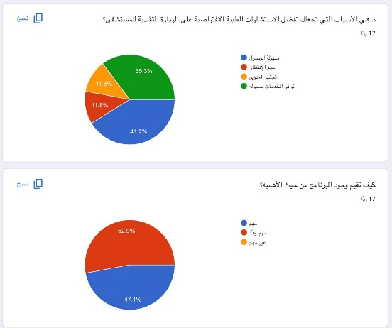



The reasons that make students prefer virtual consultations vary between ease of access (41.2%), not needing to move (35.3%), in addition to infection concerns.

The conclusion shows that most students consider virtual medical consultations important, as 52.9% feel that the presence of the program is very important and effective

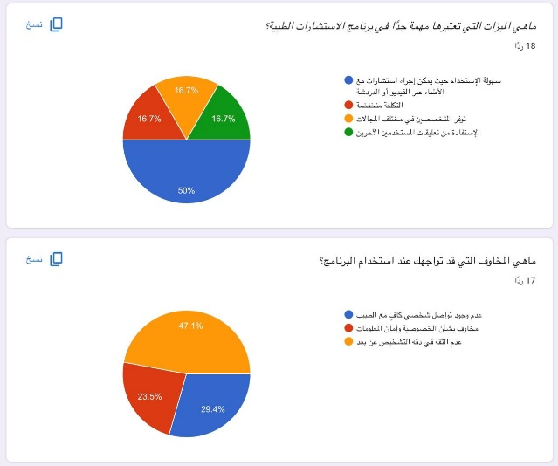

Among the important advantages that students expect are ease of use (50%) and reducing costs (16.7%). These points indicate that the program can attract more users if it focuses on simplifying the process and providing lower costs compared to going to hospital.

The most common concerns are the lack of personal communication with the doctor (47.1%), and concerns related to privacy and information security (29.4%). These concerns must be addressed by providing data protection and providing effective means of communication that allow the patient to feel comfortable...

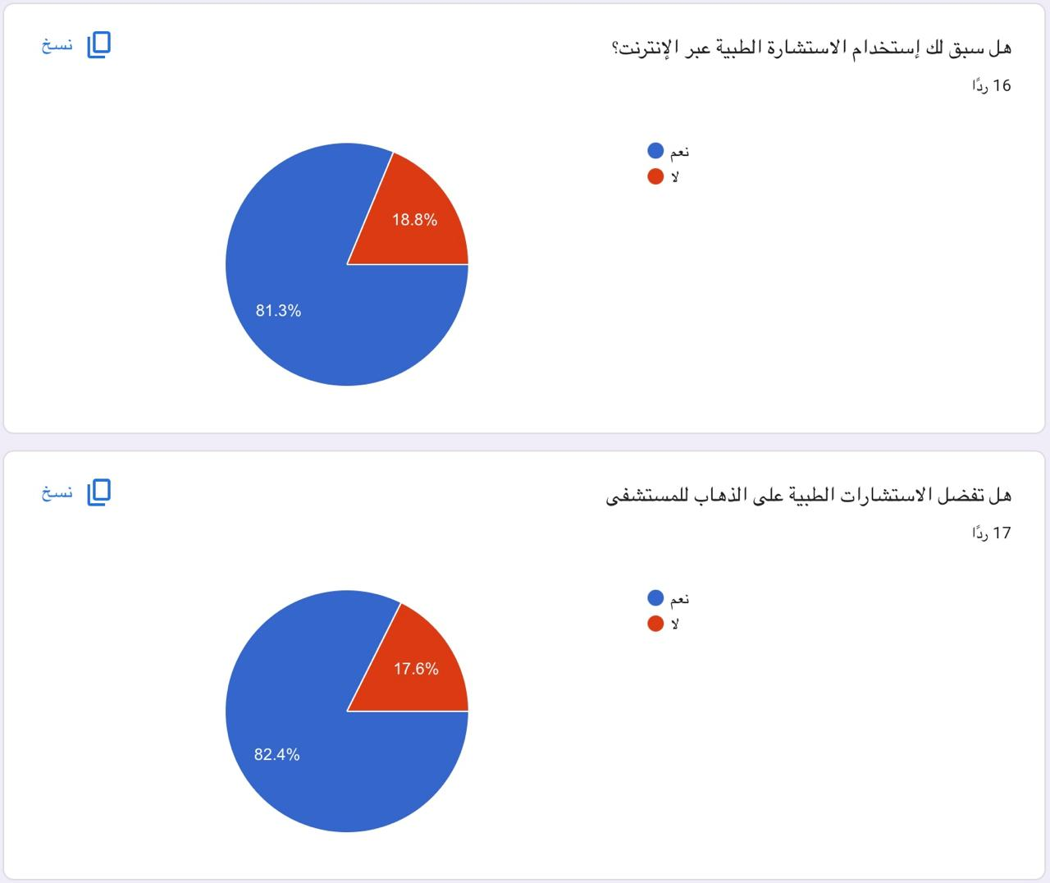

81.3% of students have previously used online medical consultations, indicating that this service has begun to gain wide acceptance among students.

2.4.1 How to improve the program:

2.4.1.1 Improve communication between patients and doctors:

Provide effective ways of personal communication so that the patient feels comfortable and reassured

2.4.1.2 Enhance protection and security:

Provide a strong security system that protects users' health information and personal data

2.4.1.3 Ease of use:

Ensure that the system is easy to use, and provide users with a guide on how to use it effectively

**2.5 Similar Applications:**

There is a similar program for **digital care**:

**2.5.1 Teladoc Health**

2.5.1.1 Advantages:

Provides medical consultations via phone or video.

Available 24 hours a day. Disadvantages: -

The cost of services may be high for some users.

Lack of specialists in all health fields.



|  |  |  |
| --- | --- | --- |
| Teladoc Health | digital care | In terms of |
| -Phone or video consultations with professional doctors  -Special services including mental health, dentistry, and other medical services  -Provides archives of health problems and the ability to communicate with specialist doctors | -Instant remote medical consultations.  -Support for common health problems.  -Providing reliable medical information.    -Telephone or video consultations with professional doctors. | Services provided |
| -Saves patient waiting time by providing instant consultations  -Addresses challenges related to accessing care in isolated areas  -provides medical support to patients who are afraid to go to hospitals | Lack of access to health care -  -Long waiting times for consultations  -Concern about infection, especially during epidemics | Problems it solves |
| Simple and easy to use interface but may require some initial registration. | focuses on facilitating appointments and consultations according to the user's schedule. | Ease of use |
| Service costs may vary and often require subscriptions | It can be more financially convenient for students or low-income groups because it is low cost | Cost |

digital care VS Teladoc Health:

**Chapter 3**

**3.1 Application design:**

**3.1.1 Use Case Diagram**

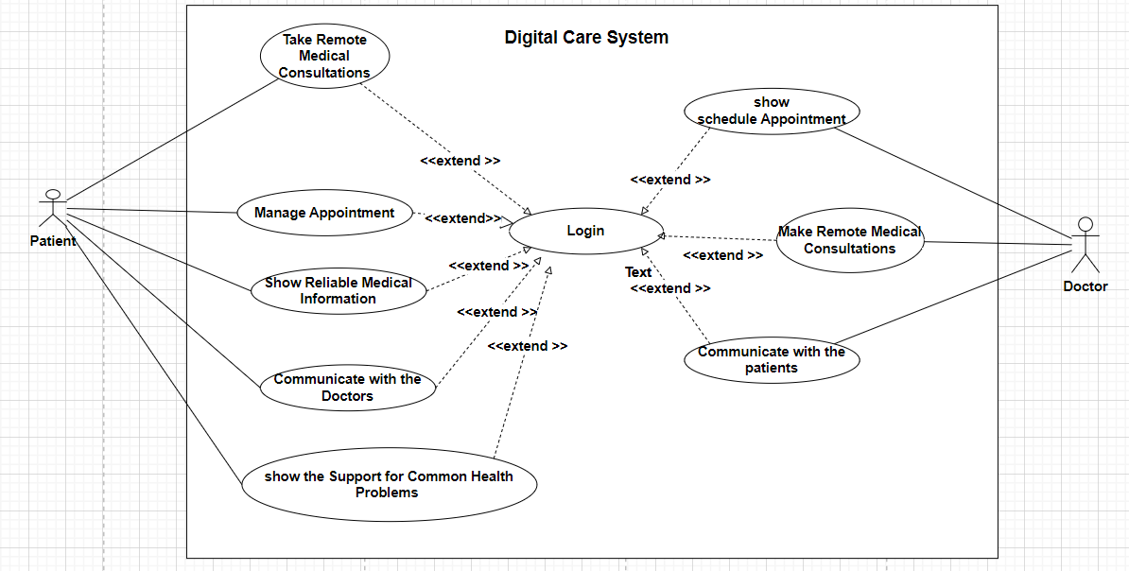

**The focuses on the system’s components and its main functions. The system starts with a login process, allowing patients and doctors to access a range of services. These services include:**

**3.1.1.1 Telemedicine consultations, enabling patients to receive medical advice from their homes**

**3.1.1.2 Appointment management, allowing users to organize their appointments**

**3.1.1.3 Communication with doctors, facilitating interaction between patients and healthcare providers**

**3.1.1.4 Display of reliable medical information and support for common health issues**

**3.1.2 Flowchart Diagram**

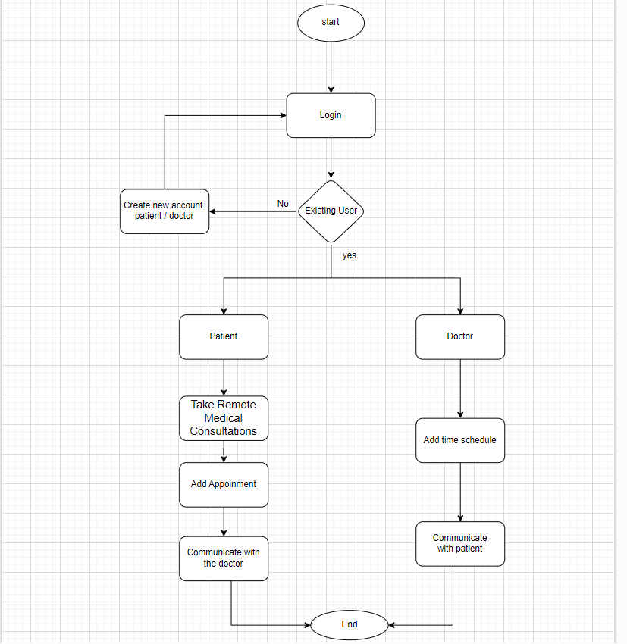

**It presents the workflow of the login system. The user begins with the login process, where they can choose to create a new account or log in as an existing user. If the user is a patient, they can access medical consultations and appointment management, while doctors can add schedules and communicate with patients. This diagram illustrates how the different functions are connected in a logical and organized manner**

**3.2 Conclusion**

**In conclusion, the requirements for implementing digital healthcare have been reviewed, encompassing both functional and non-functional requirements necessary to ensure the provision of reliable and effective medical consultation services. The importance of offering remote medical consultations, user registration, appointment scheduling, and securing personal data has been emphasized**

**Additionally, the primary purposes of the application were discussed, such as facilitating access to healthcare and reducing issues related to waiting in hospitals, as well as concerns about infections. The results of a survey conducted with students indicated a significant interest in virtual services, highlighting the importance of ease of use and low costs to attract more users**

**Finally, a comparison was made between the digital healthcare application and similar applications like Teladoc Health, emphasizing the features and drawbacks of each. The findings suggest that the digital healthcare application could be an ideal option to meet user needs if communication and security are improved, thereby enhancing their trust in using this service**