**6 Phases of Software Development Life Cycle**

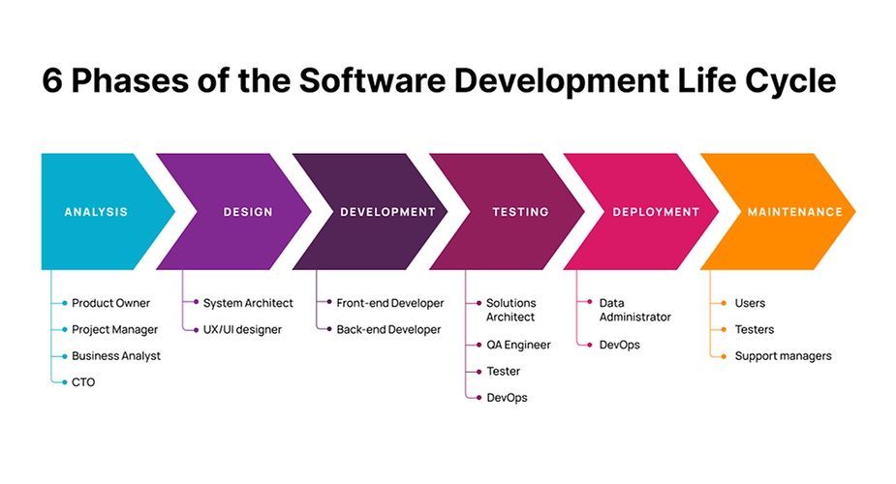

**Job title at each phase:**

1. Analysis

* Business Analyst\ He is the one who meet with client or stakeholder and he need to be familiar with the scope of the project the client seeks to implement also he is responsible of gathering the client requirements.
* Product Owner\ He is responsible of translate the business needs to functional specifications, user stories which the technical team can understand.
* Project Manager\ He is responsible of managing project time line which mean when every part of the project will be start and finish and which part is more important than the other parts.

**NOTE**

All these three-job title can be combined under one of them.

* CTO\ He is the highest-ranking person in terms of position and he is the decision-maker, his role is advisory rather than executive.

1. Design

* System Architect\ He is the one who will design the structure of the code, he will determine how the code will be divided, where the data will be stored and how also what he will done the back-end developer will implement.
* UI Design “User Interface Design” \ He does not have to be from a technical background but he must have the knowledge od drawing and dealing with colors and coordination in general and one tool can be used here is Figma.
* UX Design “User experience Design” \ He is the one who will determine how the user will navigate between the pages of the web app, he always tries to make the user navigation as easy as possible by making him reach the service he wants in the fewest possible steps and one tool can be used here is wireframe.

The result of UI\UX design will be given to the front-end developer to implement.

**NOTE**

1. Development

* Front-end Developer\ He is the one who draw the web app using code so whatever the user see is done by him.
* Back-end Developer\ He is the one who do the code that make the web app work so every action the web app do is done by him.

**NOTE**

* Laravel and .Net are framework for back-end developer however Bootstrap, React, Angular and MudBlazor are framework for front-end developer.
* Back-end contain three parts: database, programming language and framework.

1. Testing

* Solution Architect
* QA Engineer
* Tester
* DevOps

**NOTE**

Testing Type:

1. Self-testing: the web app test it-self.
2. Developer testing: developer test the code.
3. Integration testing: it is when we test the code after we combine two parts or more together.
4. Full testing: it is when we test the web app after it is done.
5. Deployment

* DevOps\ He is the One who publish the web app code so every one can access to it and use it.
* Data Administrator\ He is the one who take cares about the data and deal with the database and keep everything safe.

**NOTE**

In this phase we will publish the web app so everyone can use it and this is done using hosting and domain which happen in the server and most of the server run using Linux.

1. Maintenance

* Users
* Testers
* Support Managers
* The most important **phase in these six phases** is Development.
* The most important **thing in web design process** is Data.
* Data *is everything that can be store, read, update and deleted like text, image, voice, maps, video and number.*
* The most important **purpose of creating programs** is dealing with Data.

**NOTE**