After understanding the 6 phases of software development life cycle, it is necessary to explore the methods used to execute these phases. This is typically done using project management principles. Two of the most well-known approaches in project management for executing projects are the Waterfall model and Agile methodology.

* Waterfall and Agile can be used for anything in life not just for the software.
* The software life cycle phases are always the same the only thing change is the method used to execute them.

**NOTE**

**Waterfall**

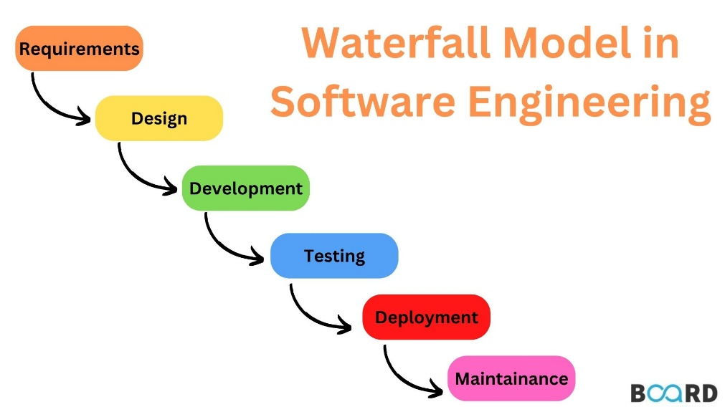

In software execution waterfall is a linear and sequential approach to software development, where the process flows downward through distinct phases, similar to a waterfall. Each phase must be fully completed before moving on to the next, with no overlap between stages.

Advantages:

* Structured and predictable process.
* Extensive documentation at each phase.
* Best suited for projects with well-defined and stable requirements.

Disadvantages:

* Difficult to accommodate changes once a phase is completed.
* Slow and takes a long time to complete the project

**NOTE**

Government ministries and agencies typically implement projects using Waterfall because they do not face competition. As a result, they can afford to take extended periods to transition their paperwork into a digital system or website.

**Agile**

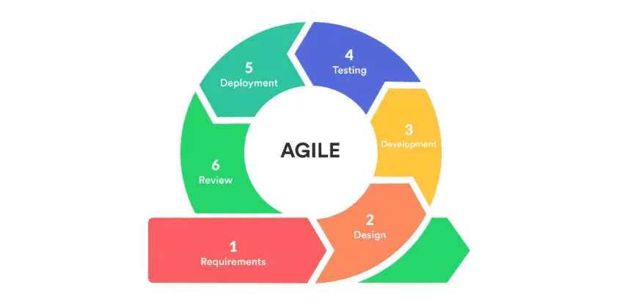

The Agile Method in software execution is an iterative and flexible approach to software development that focuses on collaboration, customer feedback, and continuous improvement. Instead of following a rigid, sequential process, Agile breaks the project into small, manageable increments called sprints or iterations. Each sprint delivers a functional part of the software, allowing teams to adapt to changes, incorporate feedback, and continuously refine the product.

Advantages:

* ***Iterative Development*** – Software is developed in cycles, with frequent releases.
* ***Customer Collaboration*** – Continuous communication with stakeholders ensures alignment with their needs.
* ***Adaptability*** – Agile allows for changes and improvements at any stage of development.
* ***Cross-functional Teams*** – Developers, designers, and testers work closely together.
* ***Continuous Testing & Integration*** – Quality assurance happens alongside development.

**NOTE**

* Software is often implemented using Agile, because it can be divided into a part which can be delivered to users in the form of version.
* In Agile, after dividing the project into parts, each part is considered a task. We then identify which of these tasks is most important to the user and start working on it first. This process is known as task priority.