Tugas Praktikum Analisis Algoritma



Disusun oleh:

Rahma Batari

140810180051

Program Studi S1 Teknik Informatika

Fakultas Matematika & Ilmu Pengetahuan Alam

Universitas Padjadjaran

**Studi Kasus**

**5. Mencari Pasangan Titik Terdekat (Closest Pair of Points)**

**a. Buatlah program untuk menyelesaikan problem closest pair of points menggunakan algoritma divide & conquer yang diberikan. Gunakan bahasa C++**

/*

Nama : Rahma Batari

NPM : 140810180051

Kelas: A

*/

// A divide and conquer program in C++

// to find the smallest distance from a

// given set of points.

#include <bits/stdc++.h>

using namespace std;

// A structure to represent a Point in 2D plane

class Point

{

public:

int x, y;

};

/* Following two functions are needed for library function qsort().

Refer: http://www.cplusplus.com/reference/clibrary/cstdlib/qsort/ */

// Needed to sort array of points

// according to X coordinate

int compareX(const void* a, const void* b)

{

Point *p1 = (Point *)a, *p2 = (Point *)b;

return (p1->x - p2->x);

}

// Needed to sort array of points according to Y coordinate

int compareY(const void* a, const void* b)

{

Point *p1 = (Point *)a, *p2 = (Point *)b;

return (p1->y - p2->y);

}

// A utility function to find the

// distance between two points

float dist(Point p1, Point p2)

{

return sqrt( (p1.x - p2.x)*(p1.x - p2.x) +

(p1.y - p2.y)*(p1.y - p2.y)

);

}

// A Brute Force method to return the

// smallest distance between two points

// in P[] of size n

float bruteForce(Point P[], int n)

{

float min = FLT_MAX;

for (int i = 0; i < n; ++i)

for (int j = i+1; j < n; ++j)

if (dist(P[i], P[j]) < min)

min = dist(P[i], P[j]);

return min;

}

// A utility function to find

// minimum of two float values

float min(float x, float y)

{

return (x < y)? x : y;

}

// A utility function to find the

// distance beween the closest points of

// strip of given size. All points in

// strip[] are sorted accordint to

// y coordinate. They all have an upper

// bound on minimum distance as d.

// Note that this method seems to be

// a O(n^2) method, but it's a O(n)

// method as the inner loop runs at most 6 times

float stripClosest(Point strip[], int size, float d)

{

float min = d; // Initialize the minimum distance as d

qsort(strip, size, sizeof(Point), compareY);

// Pick all points one by one and try the next points till the difference

// between y coordinates is smaller than d.

// This is a proven fact that this loop runs at most 6 times

for (int i = 0; i < size; ++i)

for (int j = i+1; j < size && (strip[j].y - strip[i].y) < min; ++j)

if (dist(strip[i],strip[j]) < min)

min = dist(strip[i], strip[j]);

return min;

}

// A recursive function to find the

// smallest distance. The array P contains

// all points sorted according to x coordinate

float closestUtil(Point P[], int n)

{

// If there are 2 or 3 points, then use brute force

if (n <= 3)

return bruteForce(P, n);

// Find the middle point

int mid = n/2;

Point midPoint = P[mid];

// Consider the vertical line passing

// through the middle point calculate

// the smallest distance dl on left

// of middle point and dr on right side

float dl = closestUtil(P, mid);

float dr = closestUtil(P + mid, n - mid);

// Find the smaller of two distances

float d = min(dl, dr);

// Build an array strip[] that contains

// points close (closer than d)

// to the line passing through the middle point

Point strip[n];

int j = 0;

for (int i = 0; i < n; i++)

if (abs(P[i].x - midPoint.x) < d)

strip[j] = P[i], j++;

// Find the closest points in strip.

// Return the minimum of d and closest

// distance is strip[]

return min(d, stripClosest(strip, j, d) );

}

// The main functin that finds the smallest distance

// This method mainly uses closestUtil()

float closest(Point P[], int n)

{

qsort(P, n, sizeof(Point), compareX);

// Use recursive function closestUtil()

// to find the smallest distance

return closestUtil(P, n);

}

// Driver code

int main()

{

Point P[] = {{2, 3}, {12, 30}, {40, 50}, {5, 1}, {12, 10}, {3, 4}};

int n = sizeof(P) / sizeof(P[0]);

cout << "The smallest distance is " << closest(P, n);

return 0;

}

Screenshot:

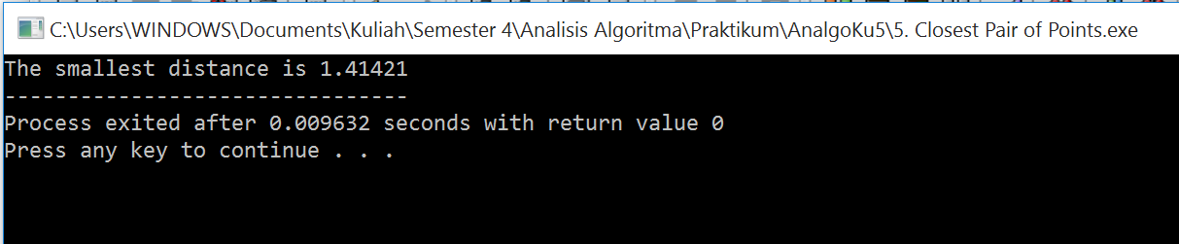

**b. Tentukan rekurensi dari algoritma tersebut, dan selesaikan rekurensinya menggunakan metode recursion tree untuk membuktikan bahwa algoritma tersebut memiliki Big-O (n lg n)**

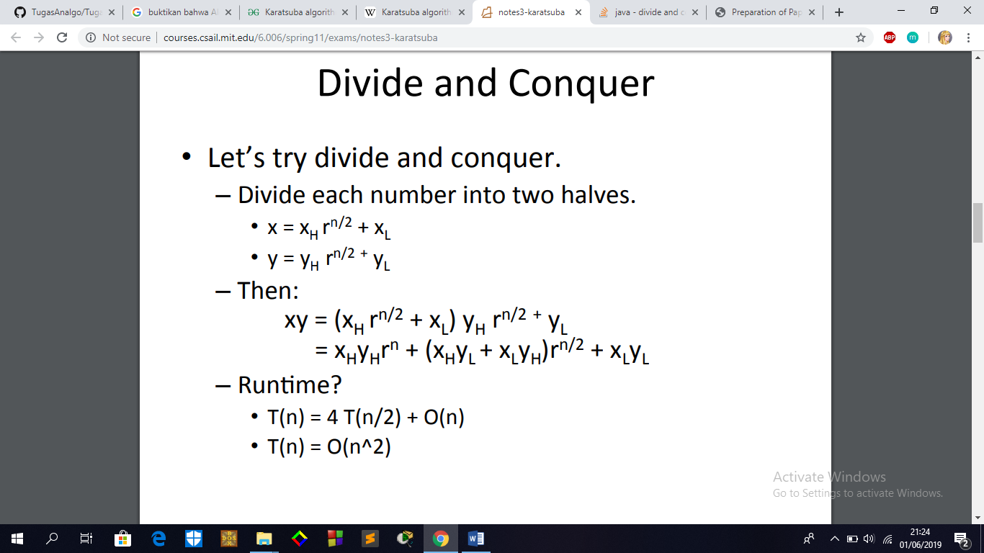

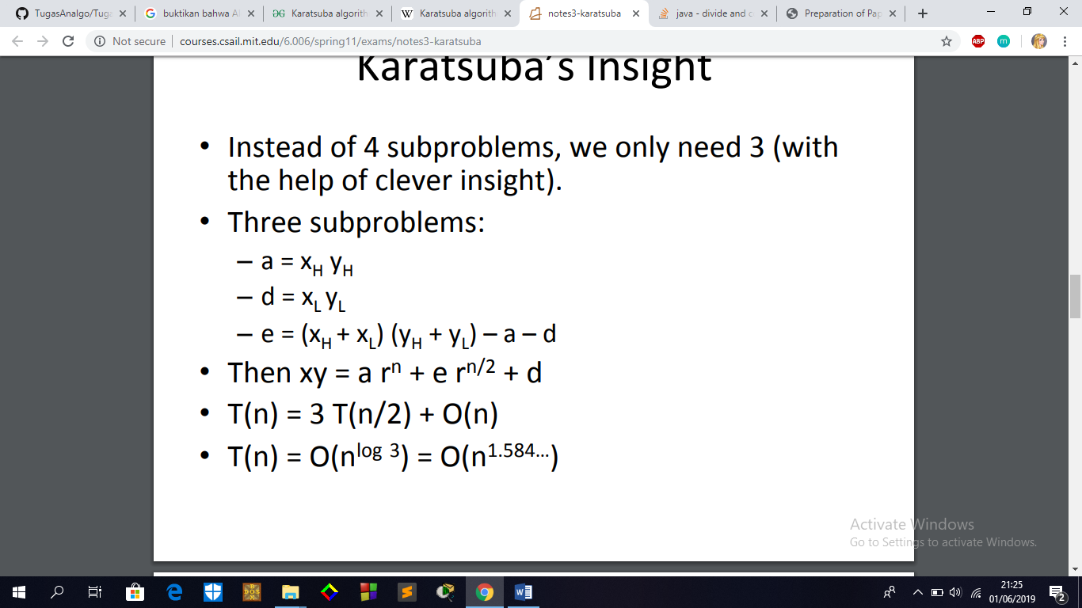

**6. Algoritma Karatsuba untuk Perkalian Cepat**

**a. Buatlah program untuk menyelesaikan fast multiplication menggunakan algoritma divide & conquer yang diberikan (Algoritma Karatsuba). Gunakan bahasa C++**

/*

Nama : Rahma Batari

NPM : 140810180051

Kelas: A

*/

// C++ implementation of Karatsuba algorithm for bit string multiplication.

#include<iostream>

#include<stdio.h>

using namespace std;

// FOLLOWING TWO FUNCTIONS ARE COPIED FROM http://goo.gl/q0OhZ

// Helper method: given two unequal sized bit strings, converts them to

// same length by adding leading 0s in the smaller string. Returns the

// the new length

int makeEqualLength(string &str1, string &str2)

{

int len1 = str1.size();

int len2 = str2.size();

if (len1 < len2)

{

for (int i = 0 ; i < len2 - len1 ; i++)

str1 = '0' + str1;

return len2;

}

else if (len1 > len2)

{

for (int i = 0 ; i < len1 - len2 ; i++)

str2 = '0' + str2;

}

return len1; // If len1 >= len2

}

// The main function that adds two bit sequences and returns the addition

string addBitStrings( string first, string second )

{

string result; // To store the sum bits

// make the lengths same before adding

int length = makeEqualLength(first, second);

int carry = 0; // Initialize carry

// Add all bits one by one

for (int i = length-1 ; i >= 0 ; i--)

{

int firstBit = first.at(i) - '0';

int secondBit = second.at(i) - '0';

// boolean expression for sum of 3 bits

int sum = (firstBit ^ secondBit ^ carry)+'0';

result = (char)sum + result;

// boolean expression for 3-bit addition

carry = (firstBit&secondBit) | (secondBit&carry) | (firstBit&carry);

}

// if overflow, then add a leading 1

if (carry) result = '1' + result;

return result;

}

// A utility function to multiply single bits of strings a and b

int multiplyiSingleBit(string a, string b)

{ return (a[0] - '0')*(b[0] - '0'); }

// The main function that multiplies two bit strings X and Y and returns

// result as long integer

long int multiply(string X, string Y)

{

// Find the maximum of lengths of x and Y and make length

// of smaller string same as that of larger string

int n = makeEqualLength(X, Y);

// Base cases

if (n == 0) return 0;

if (n == 1) return multiplyiSingleBit(X, Y);

int fh = n/2; // First half of string, floor(n/2)

int sh = (n-fh); // Second half of string, ceil(n/2)

// Find the first half and second half of first string.

// Refer http://goo.gl/lLmgn for substr method

string Xl = X.substr(0, fh);

string Xr = X.substr(fh, sh);

// Find the first half and second half of second string

string Yl = Y.substr(0, fh);

string Yr = Y.substr(fh, sh);

// Recursively calculate the three products of inputs of size n/2

long int P1 = multiply(Xl, Yl);

long int P2 = multiply(Xr, Yr);

long int P3 = multiply(addBitStrings(Xl, Xr), addBitStrings(Yl, Yr));

// Combine the three products to get the final result.

return P1*(1<<(2*sh)) + (P3 - P1 - P2)*(1<<sh) + P2;

}

// Driver program to test aboev functions

int main()

{

printf ("%ld\n", multiply("1100", "1010"));

printf ("%ld\n", multiply("110", "1010"));

printf ("%ld\n", multiply("11", "1010"));

printf ("%ld\n", multiply("1", "1010"));

printf ("%ld\n", multiply("0", "1010"));

printf ("%ld\n", multiply("111", "111"));

printf ("%ld\n", multiply("11", "11"));

}

Screenshot:

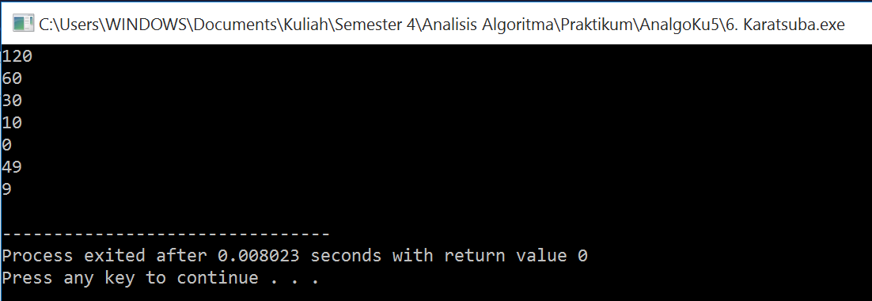

**b. Rekurensi dari algoritma tersebut adalah T (n) = 3T (n / 2) + O (n), dan selesaikan rekurensinya menggunakan metode substitusi untuk membuktikan bahwa algoritma tersebut memiliki Big-O (n lg n)**





**7. Permasalahan Tata Letak Keramik Lantai**

**a. Buatlah program untuk menyelesaikan problem tilling menggunakan algoritma divide & conquer yang diberikan. Gunakan bahasa C++**

/*

Nama : Rahma Batari

NPM : 140810180051

Kelas: A

*/

// C++ implementation to count number of ways to

// tile a floor of size n x m using 1 x m tiles

#include <bits/stdc++.h>

using namespace std;

// function to count the total number of ways

int countWays(int n, int m)

{

// table to store values

// of subproblems

int count[n + 1];

count[0] = 0;

// Fill the table upto value n

for (int i = 1; i <= n; i++) {

// recurrence relation

if (i > m)

count[i] = count[i - 1] + count[i - m];

// base cases

else if (i < m)

count[i] = 1;

// i = = m

else

count[i] = 2;

}

// required number of ways

return count[n];

}

// Driver program to test above

int main()

{

int n = 2, m = 2;

cout << "Number of ways = "

<< countWays(n, m);

return 0;

}

Screenshot:

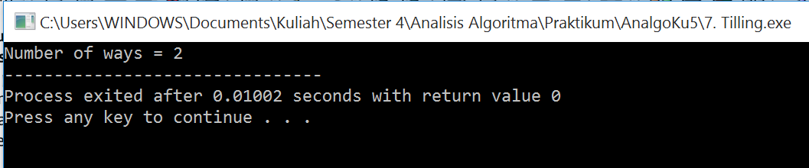

**b. Relasi rekurensi untuk algoritma rekursif diatas dapat ditulis seperti dibawah ini. C adalah konstanta. T(n)=4T (n/2) + C. Selesaikan rekurensi tersebut dengan Metode Master**

Kompleksitas Waktu:

Relasi perulangan untuk algoritma rekursif di atas dapat ditulis seperti di bawah ini. C adalah konstanta.

T (n) = 4T (n / 2) + C

Rekursi di atas dapat diselesaikan dengan menggunakan Metode Master dan kompleksitas waktu adalah O (n2)

Bagaimana cara kerjanya?

Pengerjaan algoritma Divide and Conquer dapat dibuktikan menggunakan Mathematical Induction. Biarkan kuadrat input berukuran 2k x 2k di mana k> = 1.

Kasus Dasar: Kita tahu bahwa masalahnya dapat diselesaikan untuk k = 1. Kami memiliki 2 x 2 persegi dengan satu sel hilang.

Hipotesis Induksi: Biarkan masalah dapat diselesaikan untuk k-1.

Sekarang perlu dibuktikan untuk membuktikan bahwa masalah dapat diselesaikan untuk k jika dapat diselesaikan untuk k-1. Untuk k, ditempatkan ubin berbentuk L di tengah dan memiliki empat subsqure dengan dimensi 2k-1 x 2k-1 seperti yang ditunjukkan pada gambar 2 di atas. Jadi jika dapat menyelesaikan 4 subskuares, dapat menyelesaikan kuadrat lengkap.