Tugas Praktikum Analisis Algoritma



Disusun oleh:

Rahma Batari

140810180051

Program Studi S1 Teknik Informatika

Fakultas Matematika & Ilmu Pengetahuan Alam

Universitas Padjadjaran

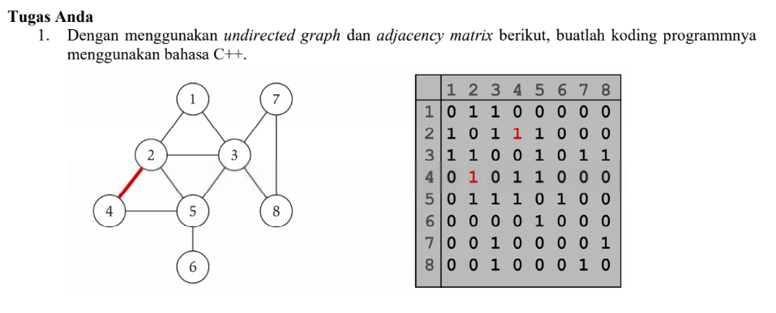

**/\***

**Nama : Rahma Batari**

**NPM : 140810180051**

**Kelas: A**

**\*/**

**/\***

**\* C++ Program to Implement Adjacency Matrix**

**\*/**

**#include <iostream>**

**#include <cstdlib>**

**using namespace std;**

**#define MAX 20**

**/\***

**\* Class untuk Adjacency Matrix**

**\*/**

**class AdjacencyMatrix**

**{**

**private:**

**int n;**

**int **adj;**

**bool *visited;**

**public:**

**AdjacencyMatrix(int n)**

**{**

**this->n = n;**

**visited = new bool [n];**

**adj = new int* [n];**

**for (int i = 0; i < n; i++)**

**{**

**adj[i] = new int [n];**

**for(int j = 0; j < n; j++)**

**{**

**adj[i][j] = 0;**

**}**

**}**

**}**

**/\***

**\* Menambahkan edge ke graf**

**\*/**

**void add_edge(int origin, int destin)**

**{**

**if( origin > n || destin > n || origin < 0 || destin < 0)**

**{**

**cout<<"Invalid edge!\n";**

**}**

**else**

**{**

**adj[origin - 1][destin - 1] = 1;**

**}**

**}**

**/\***

**\* Mencetak graf**

**\*/**

**void display()**

**{**

**int i,j;**

**for(i = 0;i < n;i++)**

**{**

**for(j = 0; j < n; j++)**

**cout<<adj[i][j]<<" ";**

**cout<<endl;**

**}**

**}**

**};**

**/\***

**\* Main**

**\*/**

**int main()**

**{**

**int nodes, max_edges, origin, destin;**

**cout<<"Enter number of nodes: ";**

**cin>>nodes;**

**AdjacencyMatrix am(nodes);**

**max_edges = nodes * (nodes - 1);**

**for (int i = 0; i < max_edges; i++)**

**{**

**cout<<"Enter edge (-1 -1 to exit): ";**

**cin>>origin>>destin;**

**if((origin == -1) && (destin == -1))**

**break;**

**am.add_edge(origin, destin);**

**}**

**am.display();**

**return 0;**

**}**

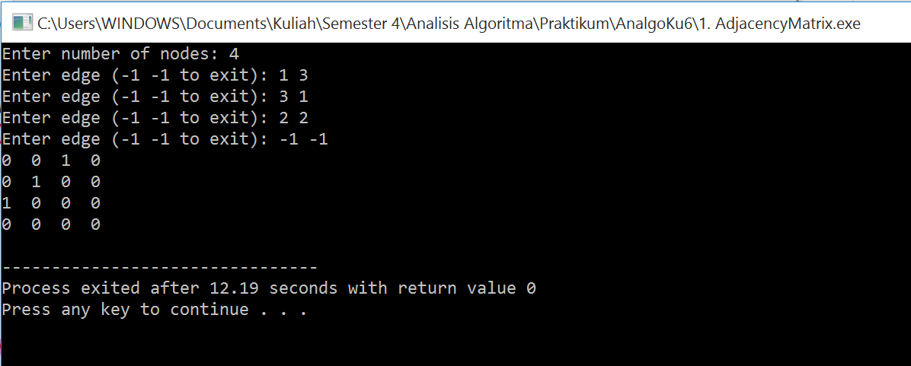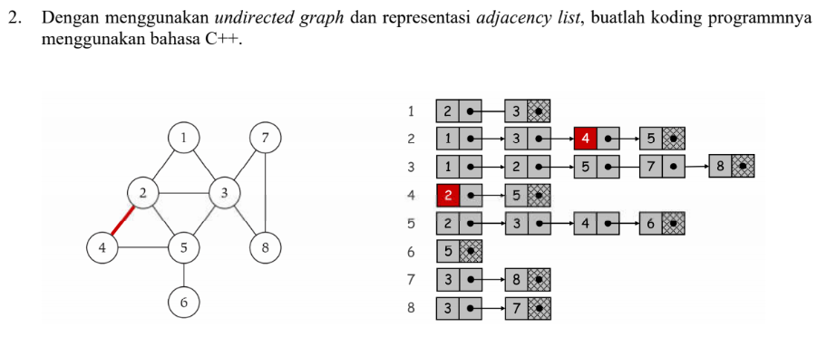

**/\***

**Nama : Rahma Batari**

**NPM : 140810180051**

**Kelas: A**

**\*/**

**/\***

**\* C++ Program to Implement Adjacency List**

**\*/**

**#include <iostream>**

**#include <cstdlib>**

**using namespace std;**

**/\***

**\* Adjacency List Node**

**\*/**

**struct AdjListNode**

**{**

**int dest;**

**struct AdjListNode* next;**

**};**

**/\***

**\* Adjacency List**

**\*/**

**struct AdjList**

**{**

**struct AdjListNode *head;**

**};**

**/\***

**\* Class Graph**

**\*/**

**class Graph**

**{**

**private:**

**int V;**

**struct AdjList* array;**

**public:**

**Graph(int V)**

**{**

**this->V = V;**

**array = new AdjList [V];**

**for (int i = 0; i < V; ++i)**

**array[i].head = NULL;**

**}**

**/\***

**\* Creating New Adjacency List Node**

**\*/**

**AdjListNode* newAdjListNode(int dest)**

**{**

**AdjListNode* newNode = new AdjListNode;**

**newNode->dest = dest;**

**newNode->next = NULL;**

**return newNode;**

**}**

**/\***

**\* Adding Edge to Graph**

**\*/**

**void addEdge(int src, int dest)**

**{**

**AdjListNode* newNode = newAdjListNode(dest);**

**newNode->next = array[src].head;**

**array[src].head = newNode;**

**newNode = newAdjListNode(src);**

**newNode->next = array[dest].head;**

**array[dest].head = newNode;**

**}**

**/\***

**\* Print the graph**

**\*/**

**void printGraph()**

**{**

**int v;**

**for (v = 1; v <= V; ++v)**

**{**

**AdjListNode* pCrawl = array[v].head;**

**cout<<"\n Adjacency list of vertex "<<v<<"\n head ";**

**while (pCrawl)**

**{**

**cout<<"-> "<<pCrawl->dest;**

**pCrawl = pCrawl->next;**

**}**

**cout<<endl;**

**}**

**}**

**};**

**/\***

**\* Main**

**\*/**

**int main()**

**{**

**Graph gh(8);**

**gh.addEdge(1, 2);**

**gh.addEdge(1, 3);**

**gh.addEdge(2, 4);**

**gh.addEdge(2, 5);**

**gh.addEdge(2, 3);**

**gh.addEdge(3, 7);**

**gh.addEdge(3, 8);**

**gh.addEdge(4, 5);**

**gh.addEdge(5, 3);**

**gh.addEdge(5, 6);**

**gh.addEdge(7, 8);**

**// print the adjacency list representation of the above graph**

**gh.printGraph();**

**return 0;**

**}**

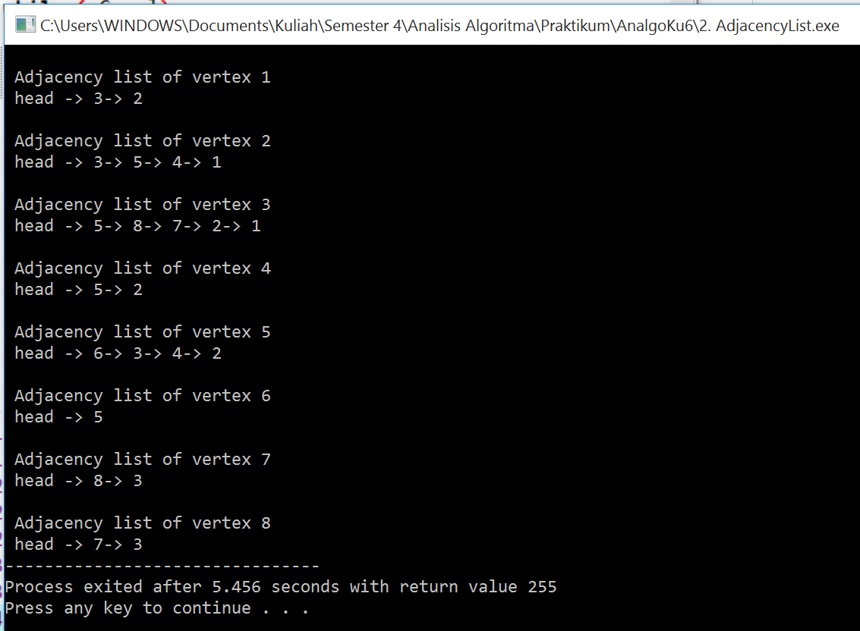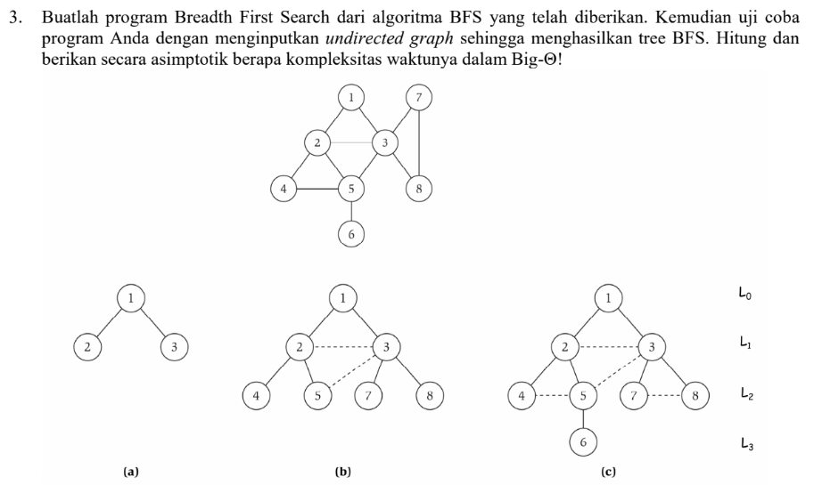

**/\***

**Nama : Rahma Batari**

**NPM : 140810180051**

**Kelas: A**

**\*/**

**// Program to print BFS traversal from a given**

**// source vertex. BFS(int s) traverses vertices**

**// reachable from s.**

**#include<iostream>**

**#include <list>**

**using namespace std;**

**// This class represents a directed graph using**

**// adjacency list representation**

**class Graph**

**{**

**int V; // No. of vertices**

**// Pointer to an array containing adjacency**

**// lists**

**list<int> *adj;**

**public:**

**Graph(int V); // Constructor**

**// function to add an edge to graph**

**void addEdge(int v, int w);**

**// prints BFS traversal from a given source s**

**void BFS(int s);**

**};**

**Graph::Graph(int V)**

**{**

**this->V = V;**

**adj = new list<int>[V];**

**}**

**void Graph::addEdge(int v, int w)**

**{**

**adj[v].push_back(w); // Add w to v’s list.**

**}**

**void Graph::BFS(int s)**

**{**

**// Mark all the vertices as not visited**

**bool *visited = new bool[V];**

**for(int i = 0; i < V; i++)**

**visited[i] = false;**

**// Create a queue for BFS**

**list<int> queue;**

**// Mark the current node as visited and enqueue it**

**visited[s] = true;**

**queue.push_back(s);**

**// 'i' will be used to get all adjacent**

**// vertices of a vertex**

**list<int>::iterator i;**

**while(!queue.empty())**

**{**

**// Dequeue a vertex from queue and print it**

**s = queue.front();**

**cout << s << " ";**

**queue.pop_front();**

**// Get all adjacent vertices of the dequeued**

**// vertex s. If a adjacent has not been visited,**

**// then mark it visited and enqueue it**

**for (i = adj[s].begin(); i != adj[s].end(); ++i)**

**{**

**if (!visited[*i])**

**{**

**visited[*i] = true;**

**queue.push_back(*i);**

**}**

**}**

**}**

**}**

**// Driver program to test methods of graph class**

**int main()**

**{**

**// Create a graph given in the above diagram**

**Graph g(8);**

**g.addEdge(1, 2);**

**g.addEdge(1, 3);**

**g.addEdge(2, 4);**

**g.addEdge(2, 5);**

**g.addEdge(2, 3);**

**g.addEdge(3, 7);**

**g.addEdge(3, 8);**

**g.addEdge(4, 5);**

**g.addEdge(5, 3);**

**g.addEdge(5, 6);**

**g.addEdge(7, 8);**

**cout << "Following is Breadth First Traversal "**

**<< "(starting from vertex 1) \n";**

**g.BFS(1);**

**return 0;**

**}**

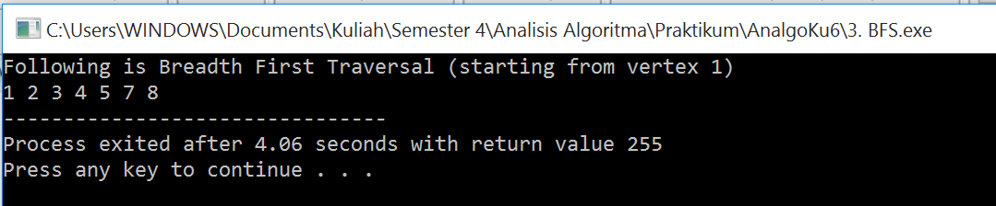

Karena Big-O dari BFS adalah O(V+E) dimana V itu jumlah vector dan E itu adalah jumlah edges maka Big-O = O(n) dimana n = v+e

Maka dari itu Big-Ө nya adalah Ө(n).

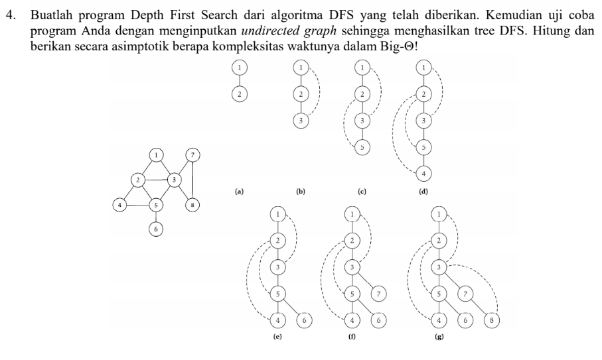

**/\***

**Nama : Rahma Batari**

**NPM : 140810180051**

**Kelas: A**

**\*/**

**#include<iostream>**

**#include<list>**

**using namespace std;**

**// Graph class merepresentasikan graf berarah menggunakan representasi adjacency list**

**class Graph**

**{**

**int V; // No. simpul**

**// Pointer ke array yang memiliki adjacency lists**

**list<int> *adj;**

**// Fungsi rekursif yang digunakan DFS**

**void DFSUtil(int v, bool visited[]);**

**public:**

**Graph(int V); // Constructor**

**// fungsi untuk menambah tepian ke graf**

**void addEdge(int v, int w);**

**// DFS traversal dari simpul yang terjangkau dari v**

**void DFS(int v);**

**};**

**Graph::Graph(int V)**

**{**

**this->V = V;**

**adj = new list<int>[V];**

**}**

**void Graph::addEdge(int v, int w)**

**{**

**adj[v].push_back(w); // Menambah w ke list v.**

**}**

**void Graph::DFSUtil(int v, bool visited[])**

**{**

**// Menandakan node bersangkutan sudah dikunjungi lalu cetak**

**visited[v] = true;**

**cout << v << " ";**

**// Ulang simpul berdekatan ke node ini**

**list<int>::iterator i;**

**for (i = adj[v].begin(); i != adj[v].end(); ++i)**

**if (!visited[*i])**

**DFSUtil(*i, visited);**

**}**

**// DFS traversal dari simpul terjangkau dari v.**

**// Menggunakan rekursif DFSUtil()**

**void Graph::DFS(int v)**

**{**

**// Menandakan semua simpul belum dikunjungi**

**bool *visited = new bool[V];**

**for (int i = 0; i < V; i++)**

**visited[i] = false;**

**// Memanggil fungsi rekursif pembantu untuk mencetak DFS traversal**

**DFSUtil(v, visited);**

**}**

**int main()**

**{**

**// Membuat graf di diagram**

**Graph g(8);**

**g.addEdge(1, 2);**

**g.addEdge(1, 3);**

**g.addEdge(2, 5);**

**g.addEdge(2, 4);**

**g.addEdge(5, 6);**

**g.addEdge(3, 7);**

**g.addEdge(3, 8);**

**g.addEdge(7, 8);**

**cout << "Depth First Traversal"**

**" (dimulai dari node 1) \n";**

**g.DFS(1);**

**return 0;**

**}**

