Tugas Praktikum Analisis Algoritma



Disusun oleh:

Rahma Batari

140810180051

Program Studi S1 Teknik Informatika

Fakultas Matematika & Ilmu Pengetahuan Alam

Universitas Padjadjaran

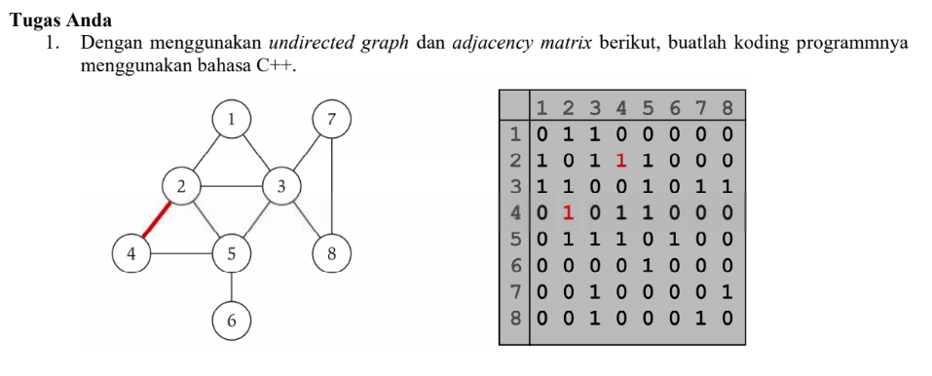

**/\***

**Nama : Rahma Batari**

**NPM : 140810180051**

**Kelas: A**

**\*/**

**/\***

**\* C++ Program to Implement Adjacency Matrix**

**\*/**

**#include <iostream>**

**#include <cstdlib>**

**using namespace std;**

**#define MAX 20**

**/\***

**\* Class untuk Adjacency Matrix**

**\*/**

**class AdjacencyMatrix**

**{**

**private:**

**int n;**

**int **adj;**

**bool *visited;**

**public:**

**AdjacencyMatrix(int n)**

**{**

**this->n = n;**

**visited = new bool [n];**

**adj = new int* [n];**

**for (int i = 0; i < n; i++)**

**{**

**adj[i] = new int [n];**

**for(int j = 0; j < n; j++)**

**{**

**adj[i][j] = 0;**

**}**

**}**

**}**

**/\***

**\* Menambahkan edge ke graf**

**\*/**

**void add_edge(int origin, int destin)**

**{**

**if( origin > n || destin > n || origin < 0 || destin < 0)**

**{**

**cout<<"Invalid edge!\n";**

**}**

**else**

**{**

**adj[origin - 1][destin - 1] = 1;**

**}**

**}**

**/\***

**\* Mencetak graf**

**\*/**

**void display()**

**{**

**int i,j;**

**for(i = 0;i < n;i++)**

**{**

**for(j = 0; j < n; j++)**

**cout<<adj[i][j]<<" ";**

**cout<<endl;**

**}**

**}**

**};**

**/\***

**\* Main**

**\*/**

**int main()**

**{**

**int nodes, max_edges, origin, destin;**

**cout<<"Enter number of nodes: ";**

**cin>>nodes;**

**AdjacencyMatrix am(nodes);**

**max_edges = nodes * (nodes - 1);**

**for (int i = 0; i < max_edges; i++)**

**{**

**cout<<"Enter edge (-1 -1 to exit): ";**

**cin>>origin>>destin;**

**if((origin == -1) && (destin == -1))**

**break;**

**am.add_edge(origin, destin);**

**}**

**am.display();**

**return 0;**

**}**

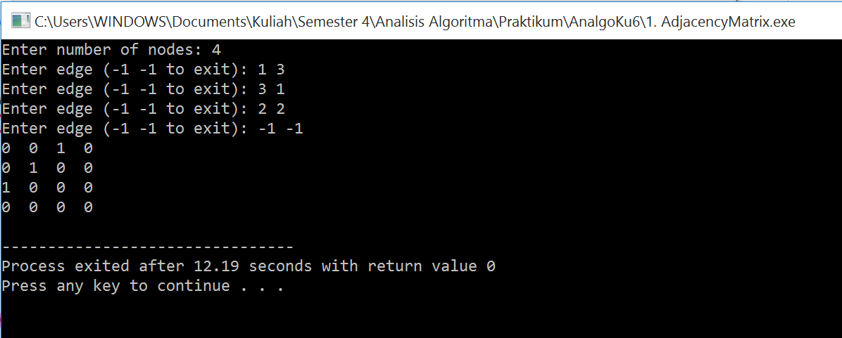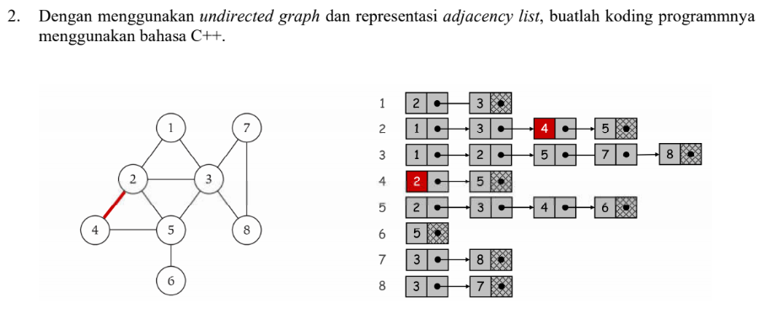

**/\***

**Nama : Rahma Batari**

**NPM : 140810180051**

**Kelas: A**

**\*/**

**/\***

**\* C++ Program to Implement Adjacency List**

**\*/**

**#include <iostream>**

**#include <cstdlib>**

**using namespace std;**

**/\***

**\* Adjacency List Node**

**\*/**

**struct AdjListNode**

**{**

**int dest;**

**struct AdjListNode* next;**

**};**

**/\***

**\* Adjacency List**

**\*/**

**struct AdjList**

**{**

**struct AdjListNode *head;**

**};**

**/\***

**\* Class Graph**

**\*/**

**class Graph**

**{**

**private:**

**int V;**

**struct AdjList* array;**

**public:**

**Graph(int V)**

**{**

**this->V = V;**

**array = new AdjList [V];**

**for (int i = 0; i < V; ++i)**

**array[i].head = NULL;**

**}**

**/\***

**\* Creating New Adjacency List Node**

**\*/**

**AdjListNode* newAdjListNode(int dest)**

**{**

**AdjListNode* newNode = new AdjListNode;**

**newNode->dest = dest;**

**newNode->next = NULL;**

**return newNode;**

**}**

**/\***

**\* Adding Edge to Graph**

**\*/**

**void addEdge(int src, int dest)**

**{**

**AdjListNode* newNode = newAdjListNode(dest);**

**newNode->next = array[src].head;**

**array[src].head = newNode;**

**newNode = newAdjListNode(src);**

**newNode->next = array[dest].head;**

**array[dest].head = newNode;**

**}**

**/\***

**\* Print the graph**

**\*/**

**void printGraph()**

**{**

**int v;**

**for (v = 1; v <= V; ++v)**

**{**

**AdjListNode* pCrawl = array[v].head;**

**cout<<"\n Adjacency list of vertex "<<v<<"\n head ";**

**while (pCrawl)**

**{**

**cout<<"-> "<<pCrawl->dest;**

**pCrawl = pCrawl->next;**

**}**

**cout<<endl;**

**}**

**}**

**};**

**/\***

**\* Main**

**\*/**

**int main()**

**{**

**Graph gh(8);**

**gh.addEdge(1, 2);**

**gh.addEdge(1, 3);**

**gh.addEdge(2, 4);**

**gh.addEdge(2, 5);**

**gh.addEdge(2, 3);**

**gh.addEdge(3, 7);**

**gh.addEdge(3, 8);**

**gh.addEdge(4, 5);**

**gh.addEdge(5, 3);**

**gh.addEdge(5, 6);**

**gh.addEdge(7, 8);**

**// print the adjacency list representation of the above graph**

**gh.printGraph();**

**return 0;**

**}**

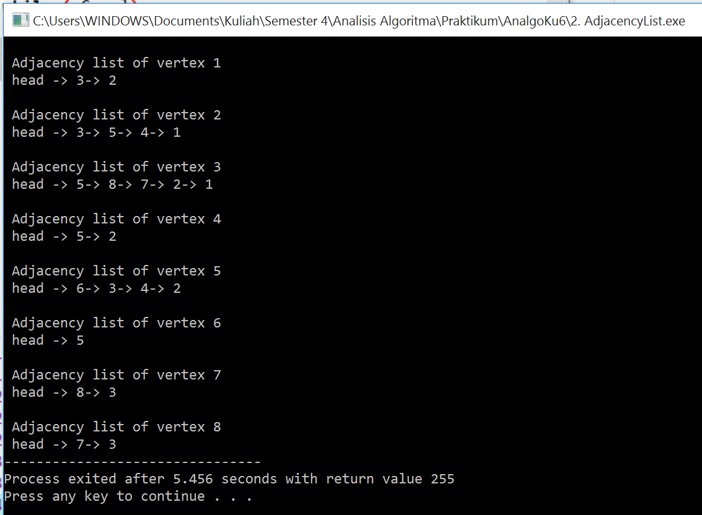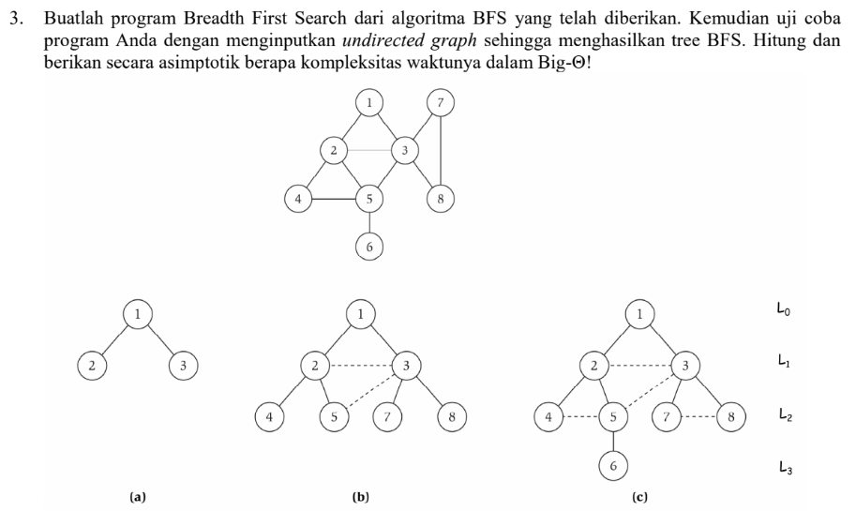

**/\***

**Nama : Rahma Batari**

**NPM : 140810180051**

**Kelas: A**

**\*/**

**// Program to print BFS traversal from a given**

**// source vertex. BFS(int s) traverses vertices**

**// reachable from s.**

**#include<iostream>**

**#include <list>**

**using namespace std;**

**// This class represents a directed graph using**

**// adjacency list representation**

**class Graph**

**{**

**int V; // No. of vertices**

**// Pointer to an array containing adjacency**

**// lists**

**list<int> *adj;**

**public:**

**Graph(int V); // Constructor**

**// function to add an edge to graph**

**void addEdge(int v, int w);**

**// prints BFS traversal from a given source s**

**void BFS(int s);**

**};**

**Graph::Graph(int V)**

**{**

**this->V = V;**

**adj = new list<int>[V];**

**}**

**void Graph::addEdge(int v, int w)**

**{**

**adj[v].push_back(w); // Add w to v’s list.**

**}**

**void Graph::BFS(int s)**

**{**

**// Mark all the vertices as not visited**

**bool *visited = new bool[V];**

**for(int i = 0; i < V; i++)**

**visited[i] = false;**

**// Create a queue for BFS**

**list<int> queue;**

**// Mark the current node as visited and enqueue it**

**visited[s] = true;**

**queue.push_back(s);**

**// 'i' will be used to get all adjacent**

**// vertices of a vertex**

**list<int>::iterator i;**

**while(!queue.empty())**

**{**

**// Dequeue a vertex from queue and print it**

**s = queue.front();**

**cout << s << " ";**

**queue.pop_front();**

**// Get all adjacent vertices of the dequeued**

**// vertex s. If a adjacent has not been visited,**

**// then mark it visited and enqueue it**

**for (i = adj[s].begin(); i != adj[s].end(); ++i)**

**{**

**if (!visited[*i])**

**{**

**visited[*i] = true;**

**queue.push_back(*i);**

**}**

**}**

**}**

**}**

**// Driver program to test methods of graph class**

**int main()**

**{**

**// Create a graph given in the above diagram**

**Graph g(8);**

**g.addEdge(1, 2);**

**g.addEdge(1, 3);**

**g.addEdge(2, 4);**

**g.addEdge(2, 5);**

**g.addEdge(2, 3);**

**g.addEdge(3, 7);**

**g.addEdge(3, 8);**

**g.addEdge(4, 5);**

**g.addEdge(5, 3);**

**g.addEdge(5, 6);**

**g.addEdge(7, 8);**

**cout << "Following is Breadth First Traversal "**

**<< "(starting from vertex 1) \n";**

**g.BFS(1);**

**return 0;**

**}**

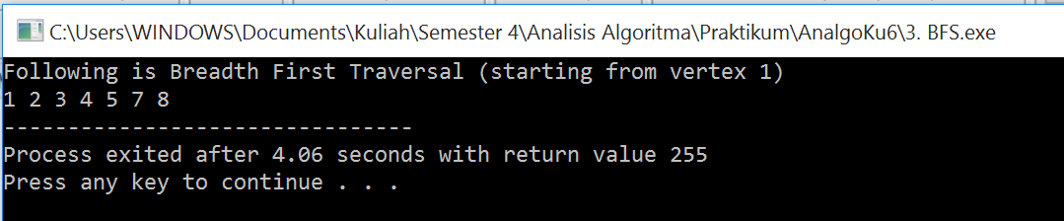

BFS merupakan metode pencarian secara melebar sehingga mengunjungi node dari kiri ke kanan di level yang sama. Apabila semua node pada suatu level sudah dikunjungi semua, maka akan berpindah ke level selanjutnya. Dalam worst case BFS harus mempertimbangkan semua jalur (path) untuk semua node yang mungkin, maka nilai kompleksitas waktu dari BFS adalah O( |V| + |E| ).

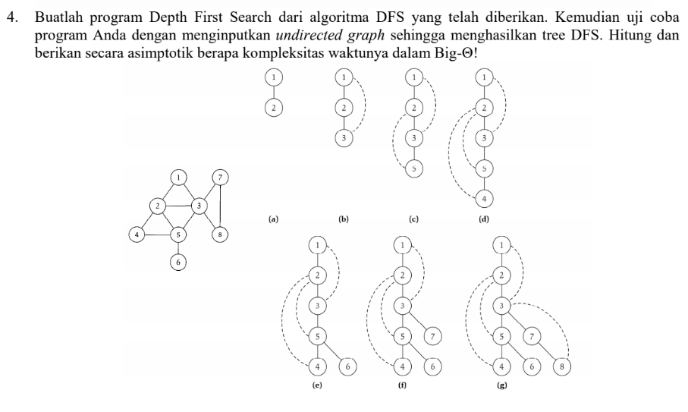

**/\***

**Nama : Rahma Batari**

**NPM : 140810180051**

**Kelas: A**

**\*/**

**#include<iostream>**

**#include<list>**

**using namespace std;**

**// Graph class merepresentasikan graf berarah menggunakan representasi adjacency list**

**class Graph**

**{**

**int V; // No. simpul**

**// Pointer ke array yang memiliki adjacency lists**

**list<int> *adj;**

**// Fungsi rekursif yang digunakan DFS**

**void DFSUtil(int v, bool visited[]);**

**public:**

**Graph(int V); // Constructor**

**// fungsi untuk menambah tepian ke graf**

**void addEdge(int v, int w);**

**// DFS traversal dari simpul yang terjangkau dari v**

**void DFS(int v);**

**};**

**Graph::Graph(int V)**

**{**

**this->V = V;**

**adj = new list<int>[V];**

**}**

**void Graph::addEdge(int v, int w)**

**{**

**adj[v].push_back(w); // Menambah w ke list v.**

**}**

**void Graph::DFSUtil(int v, bool visited[])**

**{**

**// Menandakan node bersangkutan sudah dikunjungi lalu cetak**

**visited[v] = true;**

**cout << v << " ";**

**// Ulang simpul berdekatan ke node ini**

**list<int>::iterator i;**

**for (i = adj[v].begin(); i != adj[v].end(); ++i)**

**if (!visited[*i])**

**DFSUtil(*i, visited);**

**}**

**// DFS traversal dari simpul terjangkau dari v.**

**// Menggunakan rekursif DFSUtil()**

**void Graph::DFS(int v)**

**{**

**// Menandakan semua simpul belum dikunjungi**

**bool *visited = new bool[V];**

**for (int i = 0; i < V; i++)**

**visited[i] = false;**

**// Memanggil fungsi rekursif pembantu untuk mencetak DFS traversal**

**DFSUtil(v, visited);**

**}**

**int main()**

**{**

**// Membuat graf di diagram**

**Graph g(8);**

**g.addEdge(1, 2);**

**g.addEdge(1, 3);**

**g.addEdge(2, 5);**

**g.addEdge(2, 4);**

**g.addEdge(5, 6);**

**g.addEdge(3, 7);**

**g.addEdge(3, 8);**

**g.addEdge(7, 8);**

**cout << "Depth First Traversal"**

**" (dimulai dari node 1) \n";**

**g.DFS(1);**

**return 0;**

**}**

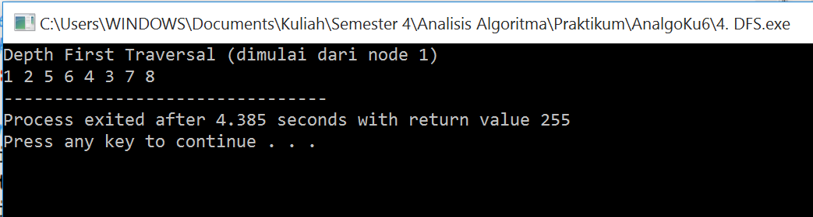

DFS merupakan metode pencarian mendalam, yang mengunjungi semua node dari yang terkiri lalu geser ke kanan hingga semua node dikunjungi. Kompleksitas ruang algoritma DFS adalah O(bm), karena kita hanya hanya perlu menyimpan satu buah lintasan tunggal dari akar sampai daun, ditambah dengan simpul-simpul saudara kandungnya yang belum dikembangkan.