You will create two frames.
In one frame you will draw the following. Both horizontal lines are the same size.
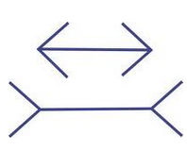
In another frame you will draw the following. Both circles are the same size


You can get all the information that you need by reading 8.1 thru 8.6 in the Sabzevary book. As you are working on this assignment, I would recommend that you do it incrementally. Experiment by drawing just a straight line and then a diagonal and then a circle and playing with the background and then put it all together.

class GraphicsPaint {
public static void main(String[] args) {
Create FrameA
Create FrameB
}
}

class FrameA extends JFrame{
public FrameA(String title){ }

public void paint(Graphics g){ }
}

class FrameB extends JFrame{
public FrameB(String title){ }
public void paint(Graphics g){ }
}

