HR DATA WAREHOUSE
& Analytics Project
Technical & Business Documentation
Human Resources / Workforce Analytics Domain
Project Name: HR Data Warehouse & Analytics
Prepared by: Group 3
Technologies: SQL Server, SSMS, T-SQL, SQL Server Agent, Power BI
Date: 26 July 2026
Project Type: Data Warehouse & Power BI
Repository: rahmahamdy590-del/HR-DataWarehouse-Project
Team Members:
Team Leader: Rahma Hamdy
Angham Atef (Create Database & Bronze Load Layer)
Samah Ali (Bronze Profiling Layer)
Hend Mostafa (Silver Layer)
Rahma Hamdy (Gold Layer)
Raghad Atef (Diagrams)

Table of Contents
Table of Contents 1
📌 Executive Summary 1
Business Problem 1
Business Value 1
Expected Users 1
Business Benefits 1
Expected Results 1
🎯 Project Objectives 1
📋 Business Requirements 1
🛠️ Technology Stack 1
📁 Folder Structure 1
📊 Dataset Description 1
Key Fields and Business Meaning 1
Data Quality (identified during Bronze profiling) 1
🏗️ High-Level Architecture 1
Mermaid Representation (source, for portability) 1
⚙️ Installation Guide 1
🧾 SQL Scripts Analysis 1
🔎 Line-by-Line SQL Explanation 1
00_initialize_database.sql 1
01a_bronze_load.sql 1
01b_bronze_profiling.sql 1
02_silver_transformation.sql 1
03_gold.sql 1
🥉 Bronze Layer 1
🔍 Bronze Profiling 1
Business Observations 1
Data Quality Assessment 1
🥈 Silver Layer 1
Tables Produced 1
Cleaning & Standardization 1
Normalization & Business Rules 1
Deduplication 1
Dimension & Fact Preparation 1
Expected Output 1
🥇 Gold Layer 1
Objects 1
Surrogate & Business Keys 1
Fact Loading 1
Built-In Validation 1
Expected Output 1
🔄 ETL Pipeline 1
Mermaid Representation (source, for portability) 1
🤖 ETL Automation (SQL Server Agent) 1
Job Steps (in execution order) 1
🧬 Data Lineage 1
Why Every Transformation Exists 1
⭐ Star Schema 1
📖 Data Dictionary 1
gold.dim_emp 1
gold.dim_position 1
gold.dim_manager 1
gold.dim_department 1
gold.dim_recruitment 1
gold.dim_performance 1
gold.dim_emp_status 1
gold.fact_hr_snapshot 1
🧠 SQL Design Decisions 1
📊 Power BI 1
DAX Measures Captured 1
KPIs, Design, and Storytelling 1
🔗 Power BI Data Model 1
🖥️ Dashboard Walkthrough 1
Page 1 — Workforce 1
Page 2 — Turnover & Retention Rate 1
Page 3 — Recruitment & Hiring 1
Page 4 — Organization Insights 1
💡 Business Insights 1
⚠️ Known Deviations from the Original Design 1
🧗 Challenges 1
📘 Lessons Learned 1
🚀 Future Improvements 1
✅ Conclusion 1
🏅 Technologies Used 1
📚 References 1
📬 Contact 1
📎 Appendix A — Complete Original SQL Scripts 1
00_initialize_database.sql 1
01a_bronze_load.sql 1
01b_bronze_profiling.sql 1
02_silver_transformation.sql 1
03_gold.sql 1
04_sql_agent_job.sql 1
📎 Appendix B — Complete Original DAX Code 1
DAX Query File: Query 1.dax 1
DAX Query File: Query 2.dax 1
DAX Query File: Query 3.dax 1

📌 Executive Summary

Business Problem
HR departments accumulate large volumes of employee data — demographics, compensation, performance, recruitment source, tenure, and termination reasons — but this data typically lives in a single flat operational extract that is not structured for analysis. Without a proper analytical model, HR stakeholders cannot reliably answer questions such as which departments lose the most people, whether pay is equitable across departments, or which recruitment channels produce the best long-term hires.

Business Value
This project converts a single flat HR dataset (HRDataset_v14.csv, 311 employees, 36 columns) into a governed, three-layer SQL Server data warehouse and a Power BI semantic model, enabling repeatable, trustworthy, self-service HR reporting instead of one-off spreadsheet analysis.

Expected Users
- HR Business Partners and HR Managers (workforce, turnover, and retention reporting)
- Talent Acquisition / Recruitment teams (recruitment-source effectiveness)
- Department Managers and Executives (headcount, salary, and performance oversight)
- Data/BI teams maintaining the warehouse and dashboard going forward

Business Benefits
- A single source of truth (Silver layer) for all HR reporting, replacing ad-hoc spreadsheet manipulation.
- A presentation-ready star schema (Gold layer) that Power BI can consume directly with Import mode.
- Automated, scheduled rebuilds via SQL Server Agent instead of manual script execution.
- A 4-page interactive Power BI dashboard answering the business questions defined in the project brief.

Expected Results
A working, rebuildable pipeline (00 → 01a → 01b → 02 → 03) that takes the raw CSV from zero to a fully modeled star schema, plus a Power BI report surfacing workforce composition, turnover/retention, recruitment effectiveness, and organizational insights.

🎯 Project Objectives
- Build a complete, three-layer (Bronze/Silver/Gold) SQL Server data warehouse from a single raw HR CSV file.
- Apply the Medallion architecture discipline: Bronze = raw & untouched, Silver = cleaned & conformed, Gold = presentation-ready.
- Profile the raw data thoroughly before writing any cleaning logic, and let the profiling results drive every transformation decision.
- Design a star schema (fact + dimensions) that directly supports the business questions defined for the HR domain.
- Automate the entire pipeline using SQL Server Agent so it can be re-run without manual intervention.
- Build a Power BI report, connected to the Gold layer in Import mode, with real DAX measures answering specific business questions.
- Document the project to a professional, portfolio-ready standard.

📋 Business Requirements
The dashboard and data model are built to answer the following HR analytics requirement areas:
Requirement Area | Business Question(s) Addressed | Where Answered
Employee Analysis | How many employees are active/terminated? What is the gender split? | Workforce page
Department Analysis | Which departments drive headcount, hiring, and turnover? | Workforce, Turnover, Recruitment
Salary Analysis | How does salary vary by department? Min/max/average? | Workforce, Turnover pages
Performance Analysis | Which managers oversee the most satisfied employees? | Organization Insights page
Recruitment Analysis | Which recruitment sources produce the most hires? | Recruitment & Hiring page
Attrition Analysis | Overall turnover rate and top termination reasons? | Turnover & Retention page
Retention Analysis | Overall retention rate and its trend? | Turnover & Retention page
Manager Performance | Which managers supervise the largest / most satisfied teams? | Organization Insights page
Employee Satisfaction | Average satisfaction and engagement score? | Workforce, Org Insights
Workforce Demographics | Marital status / gender / recruitment-source breakdown? | Workforce page

🛠️ Technology Stack
Every technology in this stack was chosen deliberately rather than by default; the rationale for each is below.
Technology | Role | Why It Was Chosen
Microsoft SQL Server | Hosts HR_Project database & bronze/silver/gold schemas | Industry-standard RDBMS with native schema support, BULK INSERT, and SQL Server Agent scheduling — everything needed for an on-prem warehouse in one engine
SSMS | Development & execution environment | Native T-SQL authoring/debugging and SQL Server Agent job management
T-SQL | All ETL logic | Keeps heavy cleaning/modeling logic close to the data — no separate ETL engine required at this scale
SQL Server Agent | Schedules the 5-step ETL pipeline | Native scheduling; enforces fail-fast behavior between dependent steps
Power BI Desktop | Semantic model + DAX + 4-page report | Enterprise-grade DAX for time-intelligence measures (turnover/retention) and native star-schema modeling
CSV / Excel | Raw source format | Matches the real-world scenario of HR data exported from an HRIS as a flat file
GitHub | Version control & delivery | Single source of truth for scripts, docs, and the Power BI file

📁 Folder Structure
The repository follows the structure required by the project brief:
project root/
├─ README.md
├─ data/
├─ HRDataset_v14.csv
└─ README.md
├─ scripts/
│ ├─ 00_initialize_database.sql
│ ├─ 01a_bronze_load.sql
│ ├─ 01b_bronze_profiling.sql
│ ├─ 02_silver_transformation.sql
│ ├─ 03_gold.sql
│ └─ 04_sql_agent_job.sql
├─ docs/
│ ├─ architecture.jpeg
│ ├─ data_flow.jpeg
│ ├─ star_schema.jpeg
│ └─ technical report (this document)
└─ power bi/
├─ HR_Analysis_Dashboard_project.pbix
├─ pbi_model_view.jpeg
└─ dashboard_1.png … dashboard_4.png
Folder | Purpose
data/ | Raw, unmodified CSV extract exactly as downloaded, plus a provenance note
scripts/ | All T-SQL scripts, numbered in required execution order
docs/ | Architecture, lineage, and star-schema diagrams, plus this technical report
power bi/ | The .pbix file and screenshots of every report page and the model view

📊 Dataset Description
Attribute | Value
Source | Human Resources Data Set (HRDataset_v14) — Kaggle
Format | Single flat CSV file
Rows | 311 employee records
Columns | 36
Grain | One row per employee

Key Fields and Business Meaning
Field | Business Meaning
EmpID | Unique employee identifier (business key)
Employee_Name | Employee full name, stored as "Last, First" in the raw file
DeptID / Department | Department the employee belongs to
PositionID / Position | Job title/role
ManagerID / ManagerName | The employee's direct manager
Salary | Annual salary
DateofHire / DateofTermination | Employment start/end dates
EmploymentStatus / Termd / TermReason | Whether the employee is active, and if not, why
PerformanceScore | Latest performance rating
EngagementSurvey / EmpSatisfaction | Engagement (0–5) and satisfaction (1–5) scores
RecruitmentSource | Channel through which the employee was hired
DaysLateLast30 / Absences | Attendance metrics
Sex, MaritalDesc, CitizenDesc, HispanicLatino, RaceDesc, State, DOB | Workforce demographic attributes

Data Quality (identified during Bronze profiling)
The raw file is largely well-formed for a teaching dataset, but profiling specifically checks for: duplicate EmpIDs, duplicate employee names, missing name/department/position/ManagerID, invalid salary (≤ 0), out-of-range engagement (outside 0–5) and satisfaction (outside 1–5) scores, negative absences/late-days, orphaned ManagerIDs (managers who don't themselves appear as an employee row, including cases where the ID is stored as "22.0" instead of 22), invalid hire/termination dates, and missing performance scores.
The warehouse follows a classic Bronze → Silver → Gold medallion pattern, all inside a single SQL Server instance, feeding a single Power BI Import-mode model.

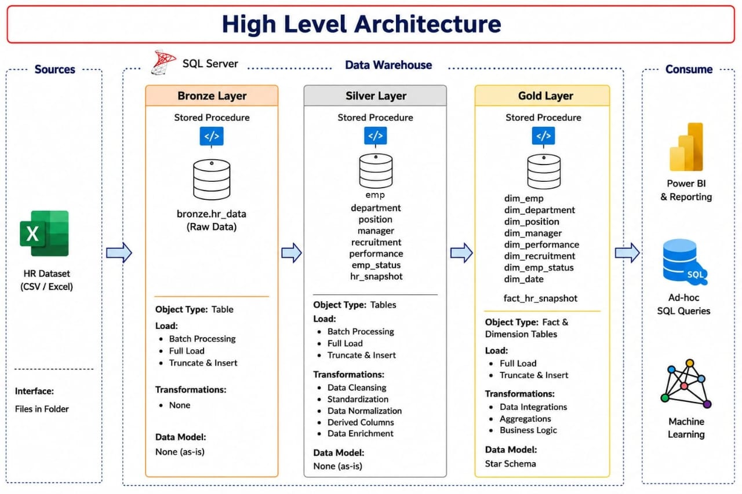
Figure 1 — High-Level Architecture: source → Bronze → Silver → Gold → Power BI.

Mermaid Representation (source, for portability)
flowchart LR
-- A [HR Dataset CSV]
--> B [Bronze Layer: bronze.hr_data, raw/untouched]
--> C [Silver Layer: emp, department, position, manager, recruitment, performance, emp_status, hr_snapshot]
--> D [Gold Layer: 7 dimensions + 1 fact - Star Schema]
--> E [Power BI - Import Mode]
--> F [Ad-hoc SQL Queries]
Layer | Responsibility
Bronze | Raw, untouched copy of the source CSV, loaded via BULK INSERT. Every column is VARCHAR(MAX) — no typing, no cleaning.
Silver | Cleaning, type-casting, standardization, deduplication, and conforming into 8 normalized tables. This is the single source of truth.
Gold | Presentation-ready star schema: 7 dimension tables + 1 fact table, built as physical tables with IDENTITY surrogate keys.
Power BI | Connects to the Gold layer only, in Import mode, and applies light Power Query shaping plus DAX measures for reporting.

Note: The architecture diagram (Figure 1) labels each layer as a "Stored Procedure." In the delivered scripts, each layer is implemented as a sequential batch of plain DDL/DML statements (executed directly or via a SQL Server Agent job step), not as CREATE PROCEDURE objects. See the Known Deviations chapter for the full discussion.

⚙️ Installation Guide
- Install SQL Server (Developer or Express edition is sufficient for this dataset size).
- Install SQL Server Management Studio (SSMS) to author and execute the scripts.
- Clone or download this repository to your local machine.
- Place the raw CSV at the path referenced inside 01a_bronze_load.sql, or update the BULK INSERT ... FROM path to point at your local copy of data/HRDataset_v14.csv.
- Run the scripts in SSMS in exact order: 00 → 01a → 01b → 02 → 03.
- (Optional) Deploy 04_sql_agent_job.sql on an instance with SQL Server Agent running, to schedule the full pipeline.
- Open Power BI Desktop and open HR_Analysis_Dashboard_project.pbix.
- In Power BI, point the data source connections at your own HR_Project gold schema (Transform Data → Data Source Settings) and Refresh.
Warning: The shipped script hardcodes a Windows path (C:\Users\pc\Documents\GitHub\...). This must be changed to your own machine's path before running.

🧾 SQL Scripts Analysis
This chapter summarizes every script's purpose, dependencies, and outputs. Full script contents live in scripts/ — this document explains why and how each script works rather than reproducing it line for line.
Script | Purpose | Depends On | Objects Created
00_initialize_database.sql | Creates the database and 3-schema namespace | 00 | HR_Project database; bronze/silver/gold schemas
01a_bronze_load.sql | Loads the raw CSV, untouched, via BULK INSERT | 01a | bronze.hr_data
01b_bronze_profiling.sql | Runs 15 data-quality diagnostics | 01b | None persisted (result sets only)
02_silver_transformation.sql | Cleans, types, standardizes, dedups, conforms | 02 | 8 tables in silver schema
03_gold.sql | Builds the star schema, validates row-count parity | 03 | 7 dimension tables + 1 fact table
04_sql_agent_job.sql | Automates and schedules all of the above | 04 | 1 SQL Server Agent job, 5 steps, daily schedule

🔎 Line-by-Line SQL Explanation

00_initialize_database.sql
Situation before: no database or schema namespace exists on the SQL Server instance.
Problem solved: establishes the empty container everything else depends on.
CREATE DATABASE HR_Project — creates the dedicated warehouse database.
CREATE SCHEMA bronze / silver / gold — establishes the three-layer medallion namespace used by every subsequent script.
Expected result after execution: an empty HR_Project database with three empty schemas, ready to receive objects.
Note: This standalone script has no IF NOT EXISTS guard, so re-running it against an existing database will fail with a 'database already exists' error. The SQL Server Agent job wraps the same logic with IF DB_ID(...) IS NULL / IF NOT EXISTS guards, making that version safely re-runnable.

01a_bronze_load.sql
Situation before: only the empty bronze schema exists; the raw CSV lives only on disk.
Problem solved: gets the raw HR data into SQL Server without altering a single value, so downstream layers always have a faithful, replayable source.
DROP TABLE IF EXISTS bronze.hr_data — ensures a clean re-load on every run.
CREATE TABLE bronze.hr_data (... VARCHAR(MAX) ...) — every one of the 36 columns is typed as VARCHAR(MAX); this is a deliberate decision to avoid any type coercion or data loss at the landing stage.
BULK INSERT ... WITH (FORMAT='CSV', FIRSTROW=2, FIELDQUOTE='"', FIELDTERMINATOR=',', ROWTERMINATOR='0x0d0a', CODEPAGE='65001', TABLOCK) — FIRSTROW=2 skips the header row; CODEPAGE=65001 ensures UTF-8 characters load correctly; TABLOCK improves bulk-load performance by taking a table-level lock instead of row-level locks.
SELECT COUNT(*) ... / SELECT COUNT(*) FROM INFORMATION_SCHEMA.COLUMNS ... — two validation queries confirming 311 rows and 36 columns loaded.
Expected result after execution: bronze.hr_data populated with exactly 311 rows and 36 columns, all as untyped text.
Warning: The BULK INSERT FROM path is a hardcoded local Windows path specific to the original author's machine. This is the single biggest portability blocker in the repository and must be edited before the script will run elsewhere.

01b_bronze_profiling.sql
Situation before: bronze.hr_data is loaded but its quality is unknown.
Problem solved: quantifies exactly what is wrong with the raw data before any cleaning decision is made — directly implementing the brief's 'profile before you clean' principle.
15 independent SELECT diagnostics are run, each returning Table | Anomaly_Type | Affected_Row_Count, with several also returning the actual offending keys via STUFF(...FOR XML PATH...) string aggregation.
Checks covered: duplicate EmpID, missing Employee_Name/Department/Position/ManagerID, invalid Salary (<=0), invalid EngagementSurvey (outside 0-5), invalid EmpSatisfaction (outside 1-5), negative Absences, negative DaysLateLast30, duplicate Employee_Name, orphan ManagerID (with the FLOAT-cast fix), invalid DateofHire, invalid DateofTermination, missing PerformanceScore.
The orphan-ManagerID check is the most consequential: a code comment in the script explicitly documents that ManagerID/EmpID may be stored as text with a decimal point (e.g. '1.0'), which a direct TRY_CAST(...AS INT) would reject and null out; casting through FLOAT first fixes this.
Expected result after execution: 15 diagnostic result sets that inform every cleaning rule written in 02_silver_transformation.sql. Nothing is persisted to a table — the queries themselves are the deliverable.

02_silver_transformation.sql
Situation before: bronze.hr_data holds untyped, unstandardized, potentially duplicated raw text.
Problem solved: produces a clean, typed, standardized, deduplicated, business-key-based layer that becomes the single source of truth for reporting.
DROP TABLE IF EXISTS on all 8 silver tables — clean re-run every execution.
CREATE TABLE silver.emp / position / manager / department / recruitment / performance / emp_status / hr_snapshot — 8 tables, typed appropriately (INT, VARCHAR(n), DATE, DECIMAL, BIT) instead of bronze's blanket VARCHAR(MAX).
INSERT INTO silver.emp ... SELECT DISTINCT ... — casts EmpID via TRY_CAST(TRIM(EmpID) AS INT); reformats Employee_Name from 'Last, First' to 'FIRST LAST' using CHARINDEX/SUBSTRING/UPPER/LTRIM; standardizes every text field via UPPER(TRIM(...)).
INSERT INTO silver.position / manager / department / performance / emp_status — each uses GROUP BY <business_id> + MAX(...) to collapse any duplicate rows sharing the same ID into a single conformed row.
INSERT INTO silver.manager specifically casts ManagerID via TRY_CAST(TRY_CAST(TRIM(ManagerID) AS FLOAT) AS INT) — the direct fix flowing from the 01b profiling finding.
INSERT INTO silver.recruitment — uses a CASE expression to standardize null/blank RecruitmentSource to 'UNKNOWN' rather than excluding those rows, preserving headcount in recruitment-source reporting; FromDiversityJobFairID is COALESCEd to 0.
INSERT INTO silver.hr_snapshot — the wide grain table: COALESCEs every numeric measure (salary, absences, dayslatelast30, engagementsurvey, empsatisfaction, specialprojectscount) to 0 rather than leaving NULL, and carries forward every business foreign key needed by Gold.
Expected result after execution: 8 populated, standardized silver tables; row-count parity between silver.hr_snapshot and bronze.hr_data (each bronze row produces exactly one snapshot row).
Note: Treating 'not provided' as zero (via COALESCE) rather than NULL is a deliberate but consequential modeling choice — it means a report cannot distinguish 'zero absences' from 'absences not recorded' without going back to bronze.

03_gold.sql
Situation before: silver holds clean, conformed, but still normalized (non-dimensional) tables.
Problem solved: reshapes silver into a star schema Power BI can consume directly, structured around the HR domain's business questions.
DROP TABLE IF EXISTS on all gold objects — clean re-run every execution.
CREATE TABLE gold.dim_emp / dim_position / dim_manager / dim_department / dim_recruitment / dim_performance / dim_emp_status — each with an IDENTITY(1,1) surrogate key as PRIMARY KEY, and its natural business key declared UNIQUE.
CREATE TABLE gold.fact_hr_snapshot — IDENTITY surrogate key, 7 foreign-key columns each with REFERENCES back to a dimension's surrogate key, plus all measures and the 3 date columns.
INSERT INTO gold.dim_* ... SELECT DISTINCT ... FROM silver.* — populates every dimension from its silver counterpart.
INSERT INTO gold.fact_hr_snapshot ... FROM silver.hr_snapshot s LEFT JOIN gold.dim_* ON <business key> = <business key> — resolves every business key to its surrogate key. LEFT JOIN (not INNER JOIN) is used deliberately so a failed dimension match produces a NULL foreign key rather than dropping the row from the fact table.
Validation block 1 — a UNION ALL row-count comparison between silver.hr_snapshot and gold.fact_hr_snapshot, confirming no rows were lost.
Validation block 2 — a SELECT * FROM gold.fact_hr_snapshot WHERE <any sk_* IS NULL>, surfacing every row with an unresolved dimension lookup.
Validation block 3 — a dynamic drill-down (no hardcoded IDs) tracing any sk_manager gaps back to the original bronze.hr_data rows via EmpID.

Final ad-hoc block — a manual investigation of one specific case (manager_name = 'WEBSTER BUTLER'), tracing it from silver.hr_snapshot to silver.manager to bronze.hr_data, to confirm the root cause of that specific orphan-manager anomaly.

Expected result after execution: 7 populated dimensions + 1 populated fact table with row-count parity to silver.hr_snapshot, and either zero NULL foreign keys or a documented, understood explanation for any that remain.

Warning: The assignment brief explicitly calls for a file named 03_gold_views.sql containing views only, with no physical tables in Gold. The actual implementation builds physical TABLEs named 03_gold.sql. This is a real deviation from the stated requirement — see the Known Deviations chapter.

🥉 Bronze Layer
Purpose: land the raw HR CSV inside SQL Server exactly as delivered, with zero transformation, so there is always a faithful, replayable copy of the original source.
- Raw Data Storage: bronze.hr_data — every one of the 36 columns is typed VARCHAR(MAX), deliberately avoiding any type coercion at this stage.
- Bulk Insert: BULK INSERT with FORMAT='CSV', FIRSTROW=2 (skips the header row), FIELDQUOTE='"', FIELDTERMINATOR=',', ROWTERMINATOR='0x0d0a', CODEPAGE='65001' (UTF-8), and TABLOCK for load performance.
- CSV Import: source file is HRDataset_v14.csv, referenced via a local Windows file path.
- Profiling: handled separately in 01b_bronze_profiling.sql — Bronze itself performs no validation.
- Expected Output: 311 rows, 36 columns, verified immediately after load by two COUNT(*) sanity checks.

🔍 Bronze Profiling
01b_bronze_profiling.sql runs 15 independent diagnostic checks against bronze.hr_data:
# | Check | What It Detects
1 | Duplicate Employee IDs | Same EmpID appearing more than once
2 | Missing Employee Name | Null/blank Employee_Name
3 | Missing Department | Null/blank Department
4 | Missing Position | Null/blank Position
5 | Missing ManagerID | Null/blank ManagerID
6 | Invalid Salary | Salary <= 0
7 | Invalid Engagement Survey | Score outside 0–5
8 | Invalid Employee Satisfaction | Score outside 1–5
9 | Negative Absences | Absences < 0
10 | Negative Days Late | DaysLateLast30 < 0
11 | Duplicate Employee Names | Same Employee_Name more than once
12 | Orphan Manager IDs | ManagerID with no matching EmpID (incl. '22.0'-style values)
13 | Invalid Hire Date | DateofHire that doesn't convert to a valid date
14 | Invalid Termination Date | DateofTermination that doesn't convert (when non-blank)
15 | Missing Performance Score | Null/blank PerformanceScore

Business Observations
The orphan-ManagerID check (#12) is the most consequential finding in this project — it directly drives a design fix carried into Silver (casting ManagerID through FLOAT before INT) and is followed up with hand-written investigative queries at the end of 03_gold.sql tracing one specific manager ("Webster Butler") from Silver back to Bronze to confirm the root cause.

Data Quality Assessment
No specific counts are hard-coded into this documentation, since they depend on the actual data in the connected environment; the profiling queries themselves are the deliverable and should be executed to obtain current figures.

🥈 Silver Layer
Purpose: turn the untyped Bronze copy into a clean, standardized, deduplicated, business-key-based layer — the single source of truth for everything downstream.

Tables Produced
silver.emp, silver.position, silver.manager, silver.department, silver.recruitment, silver.performance, silver.emp_status, and the wide silver.hr_snapshot (one row per employee, holding every foreign business key plus every measure).

Cleaning & Standardization
- All text fields: UPPER(TRIM(...)) for consistent casing and no leading/trailing whitespace.
- Employee_Name: reformatted from 'Last, First' to 'FIRST LAST'.
- All numeric/date fields: TRY_CAST / TRY_CONVERT, which null out unparseable values instead of failing the entire load.

Normalization & Business Rules
- RecruitmentSource: blank/null values standardized to 'UNKNOWN' rather than dropped.
- ManagerID: cast FLOAT → INT to correctly parse values stored as '22.0'.
- FromDiversityJobFairID and every numeric measure on hr_snapshot are COALESCEd to 0 rather than left NULL.

Deduplication
Each reference table (position, manager, department, recruitment, performance, emp_status) is built via GROUP BY <business_id> + MAX(...), collapsing multiple raw rows sharing the same ID into one row per ID.

Dimension & Fact Preparation
silver.hr_snapshot is the direct precursor to the Gold fact table: it retains every business key (emp_id, position_id, manager_id, dept_id, performance_id, empstatus_id, RecruitmentSource) alongside every measure, ready for Gold to resolve into surrogate keys.

Expected Output
8 populated tables; row-count parity between silver.hr_snapshot and bronze.hr_data; no explicit assertion query in this script — validation is deferred to 03_gold.sql.

🥇 Gold Layer
Purpose: reshape Silver into a star schema that Power BI can consume directly, structured around the business questions the dashboard needs to answer.

Objects
- 7 Dimension Tables: dim_emp, dim_position, dim_manager, dim_department, dim_recruitment, dim_performance, dim_emp_status
- 1 Calender:
- 1 Fact Table: fact_hr_snapshot

Surrogate & Business Keys
Every dimension has an IDENTITY(1,1) surrogate key (sk_<dimension>) as its PRIMARY KEY, and its natural/business key is UNIQUE — guaranteeing one surrogate row per business key.

Fact Loading
fact_hr_snapshot is populated by LEFT JOINing silver.hr_snapshot to every dimension on business key = business key, selecting each dimension's surrogate key. A LEFT JOIN means a record that fails to match a dimension gets a NULL foreign key rather than being dropped from the fact table — a deliberate choice to preserve row-count parity with Silver.

Built-In Validation
- A row-count parity check between silver.hr_snapshot and gold.fact_hr_snapshot.
- A query returning every fact row with any NULL surrogate key.
- A drill-down query tracing any sk_manager gaps back to the original Bronze rows (dynamic — no hardcoded IDs).
- A manual, ad-hoc investigation of the 'WEBSTER BUTLER' case, tracing it through Silver and Bronze to confirm the anomaly's root cause.

Expected Output
Row-count parity confirmed; a documented explanation for any remaining NULL foreign keys rather than silently ignoring them.
Warning: The Gold layer here is built as physical tables, not views, diverging from the assignment brief's requirement of view-only Gold objects. See the Known Deviations chapter.

🔄 ETL Pipeline
Stage | Input | Processing | Output | Business Purpose
Bronze | Raw CSV | BULK INSERT, no transformation | bronze.hr_data | Preserve an auditable original copy
Silver | bronze.hr_data | Type-cast, standardize, dedupe, conform | 8 normalized tables | Single trusted source for HR reporting
Gold | 8 Silver tables | Surrogate key generation, dimensional joins | 7 dims + 1 fact | Answer specific HR business questions efficiently
Power BI | Gold layer | Import, Power Query renaming, DAX measures | 4-page report | Deliver self-service HR analytics

Mermaid Representation (source, for portability)
flowchart TD
CSV [HRDataset_v14.csv]
--> B1 [bronze.hr_data]
--> S1.S8 [8 silver tables]
--> G1.G8 [7 gold dimensions + 1 gold fact]
--> PBI [Power BI Import Model]

🤖 ETL Automation (SQL Server Agent)
Purpose: remove manual, error-prone re-execution of the 5 scripts by scheduling them as a single, ordered SQL Server Agent job.

Job Steps (in execution order)
Step | Name | What Runs
1 | 00_Initialize | Creates the database/schemas — guarded with IF DB_ID(...) IS NULL / IF NOT EXISTS, safe to re-run
2 | 01a_Bronze_Load | Drops/recreates bronze.hr_data, then BULK INSERTs the CSV
3 | 01b_Bronze_Profiling | Runs all 15 profiling checks
4 | 02_Silver | Rebuilds all 8 Silver tables
5 | 03_Gold | Rebuilds the star schema and runs the validation queries
- Execution order is enforced via on_success_action = 3 ('go to next step') on every step.
- Failure handling: every step's on_fail_action = 2 ('quit the job, reporting failure') — the pipeline never silently continues past a failed step.
- Scheduling: the job ('Daily ETL') runs once per day at 09:00, starting 2026-07-25, with no end date.
- Automation Benefits: consistent, unattended rebuilds; a single point of failure detection; no manual script execution required after initial setup.
- Monitoring: SQL Server Agent's built-in job history/notification mechanisms can be used to alert on failure (not separately configured in the delivered job).
Warning: Since the source is a static, one-time CSV extract loaded from a fixed local file path, a daily schedule does not actually pick up new data — see Future Improvements for a parameterization recommendation.

🧬 Data Lineage
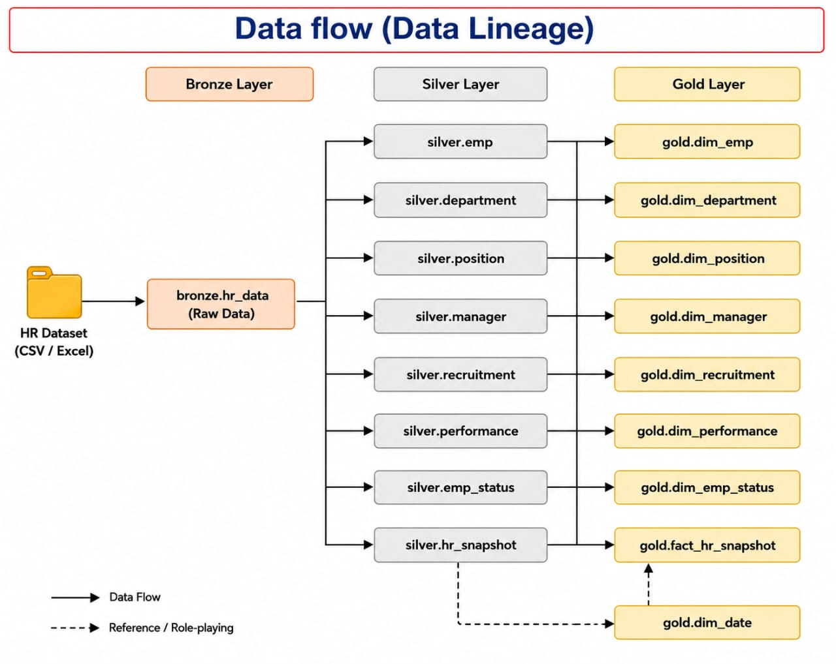
Figure 2 — Data Lineage: CSV → Bronze → Silver → Gold.

Why Every Transformation Exists
- CSV → Bronze: preserves an untouched audit trail of the original extract.
- Bronze → Silver: applies exactly the cleaning rules the profiling step (01b) surfaced as necessary.
- Silver → Gold: resolves business keys to surrogate keys and reshapes the wide snapshot into a fact table referencing seven conformed dimensions.

⭐ Star Schema
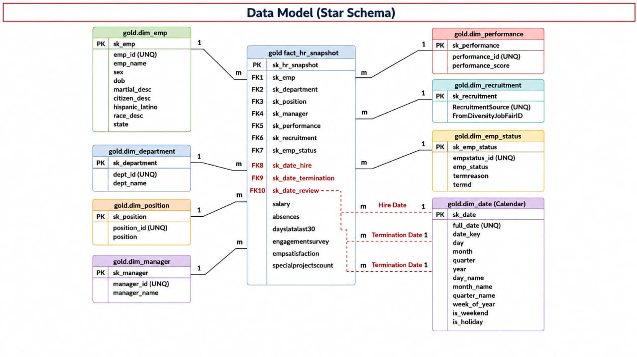
Figure 3 — Gold-layer Star Schema.
- Fact Table: gold.fact_hr_snapshot — grain: one row per employee snapshot record.
- Dimension Tables: dim_emp, dim_position, dim_manager, dim_department, dim_recruitment, dim_performance, dim_emp_status.
- Relationships / Cardinality: each dimension has a 1-to-many relationship into the fact table.
- Business Keys vs. Surrogate Keys: business keys are preserved as UNIQUE columns on each dimension for traceability, while the IDENTITY surrogate key is what the fact table references — the standard Kimball-style pattern.
- Why a Star Schema: minimizes join complexity, compresses well in Power BI's VertiPaq engine, and maps directly onto how business users think about the data.
Note: The diagram in Figure 3 depicts an idealized gold.dim_date role-playing dimension that is not implemented in the SQL — see the Known Deviations chapter.

📖 Data Dictionary

gold.dim_emp
Column | Type | Description | PK/FK | Nullable
sk_emp | INT (IDENTITY) | Surrogate key | PK | No
emp_id | INT (UNIQUE) | Business key — employee ID | — | Yes
emp_name | VARCHAR(100) | Employee full name (standardized) | — | Yes
sex | VARCHAR(20) | Gender | — | Yes
dob | DATE | Date of birth | — | Yes
marital_desc | VARCHAR(50) | Marital status | — | Yes
citizen_desc | VARCHAR(50) | Citizenship status | — | Yes
hispanic_latino | VARCHAR(20) | Hispanic/Latino indicator | — | Yes
race_desc | VARCHAR(50) | Race/ethnicity descriptor | — | Yes
state | VARCHAR(50) | Employee's US state | — | Yes

gold.dim_position
Column | Type | Description | PK/FK | Nullable
sk_position | INT (IDENTITY) | Surrogate key | PK | No
position_id | INT (UNIQUE) | Business key — position ID | — | Yes
position | VARCHAR(100) | Job title | — | Yes

gold.dim_manager
Column | Type | Description | PK/FK | Nullable
sk_manager | INT (IDENTITY) | Surrogate key | PK | No
manager_id | INT (UNIQUE) | Business key — manager ID | — | Yes
manager_name | VARCHAR(100) | Manager's full name | — | Yes

gold.dim_department
Column | Type | Description | PK/FK | Nullable
sk_department | INT (IDENTITY) | Surrogate key | PK | No
dept_id | INT (UNIQUE) | Business key — department ID | — | Yes
dept_name | VARCHAR(100) | Department name | — | Yes

gold.dim_recruitment
Column | Type | Description | PK/FK | Nullable
sk_recruitment | INT (IDENTITY) | Surrogate key | PK | No
RecruitmentSource | VARCHAR(100) (UNIQUE) | Business key — recruitment channel; blanks standardized to UNKNOWN | — | Yes
FromDiversityJobFairID | INT | Flag/ID indicating diversity job fair sourcing | — | Yes

gold.dim_performance
Column | Type | Description | PK/FK | Nullable
sk_performance | INT (IDENTITY) | Surrogate key | PK | No
performance_id | INT (UNIQUE) | Business key — performance rating ID | — | Yes
performance_score | VARCHAR(50) | Performance rating label | — | Yes

gold.dim_emp_status
Column | Type | Description | PK/FK | Nullable
sk_emp_status | INT (IDENTITY) | Surrogate key | PK | No
empstatus_id | INT (UNIQUE) | Business key — employment status ID | — | Yes
emp_status | VARCHAR(100) | Status label | — | Yes
termreason | VARCHAR(255) | Reason for termination, if applicable | — | Yes
termd | BIT | Terminated flag | — | Yes

gold.fact_hr_snapshot
Column | Type | Description | PK/FK | Nullable
sk_hr_snapshot | INT (IDENTITY) | Surrogate key | PK | No
sk_emp | INT | FK → dim_emp | FK | Yes
sk_position | INT | FK → dim_position | FK | Yes
sk_manager | INT | FK → dim_manager | FK | Yes
sk_department | INT | FK → dim_department | FK | Yes
sk_performance | INT | FK → dim_performance | FK | Yes
sk_emp_status | INT | FK → dim_emp_status | FK | Yes
sk_recruitment | INT | FK → dim_recruitment | FK | Yes
salary | DECIMAL(18,2) | Annual salary | — | Yes
absences | INT | Total absences | — | Yes
dayslatelast30 | INT | Days late in the last 30 days | — | Yes
engagementsurvey | DECIMAL(5,2) | Engagement survey score (0–5) | — | Yes
empsatisfaction | INT | Satisfaction score (1–5) | — | Yes
specialprojectscount | INT | Count of special projects | — | Yes
date_hiring | DATE | Hire date | — | Yes
date_termination | DATE | Termination date | — | Yes
LastPerformanceReview_Date | DATE | Date of last performance review | — | Yes

🧠 SQL Design Decisions
Decision | Rationale
Three schemas (bronze/silver/gold) | Clean separation of raw, cleaned, and presentation layers, enforcing the medallion discipline at the object-namespace level
Naming convention | snake_case throughout Silver/Gold; sk_ prefix on surrogate keys; _id suffix on business keys; dim_/fact_ table prefixes
Surrogate keys (IDENTITY) | Decouples the warehouse from source-system key changes/reuse; compact integer join keys for Power BI
UNIQUE constraint on every business key | Guarantees one dimension row per real-world entity — prevents fan-out during the fact load
LEFT JOIN (not INNER JOIN) building the fact table | Preserves every Silver row even if a dimension lookup fails, surfacing the gap as a NULL FK instead of silently dropping data
TRY_CAST / TRY_CONVERT everywhere in Silver | Prevents one malformed value from failing an entire batch load
GROUP BY + MAX(...) for reference tables | Simple, explicit deduplication strategy for reference data sharing the same business ID
No indexes beyond PK/UNIQUE constraints | Dataset size (311 rows) does not warrant additional indexing at this scale

📊 Power BI
- Connection: Power BI Desktop connects to the gold schema via Import mode, per the brief's requirement to connect only to Gold.
- Data Model: built around FACT_Employees (the Power-Query-renamed view of gold.fact_hr_snapshot) and a DIM_Date calendar table, alongside the standard Gold dimensions.

DAX Measures Captured
- No. of Emp = COUNT(FACT_Employees[Employee ID])
- No. of Emp Beginning/End of Period — headcount snapshots using CALCULATE with hire/exit date filters and USERELATIONSHIP against DIM_Date
- No. of Emp Exit in Period / No. of Emp Hired in Period
- Turnover Rate = DIVIDE(exits in period, average of beginning/ending headcount)
- Retention Rate = 1 - [Turnover Rate]
- Time-boxed 2021 variants of the same measures, suggesting validation against a specific historical year
- Bonus Amount = SUMX(FACT_Employees, [Annual Salary] * [Bonus %])

KPIs, Design, and Storytelling
- KPIs: total headcount, gender split, average/sum salary, min/max salary by department, overall turnover/retention rate, hires by department/gender/year, recruitment source ranking, most/least common position, top/least manager by team size, average satisfaction by manager.
- Dashboard Design: 4 pages, each with a consistent header/navigation bar, KPI cards up top, supporting charts below, and slicers for interactivity.
- Filters / Slicers: dropdown slicers plus a Chiclet Slicer custom visual for department, present on every page.
- Navigation: in-report page tabs plus a pageNavigator visual and an actionButton visual on several pages.
- Business Storytelling: each page is framed around explicit questions in the visuals themselves, directly tying visuals to the business questions in the brief.

🔗 Power BI Data Model
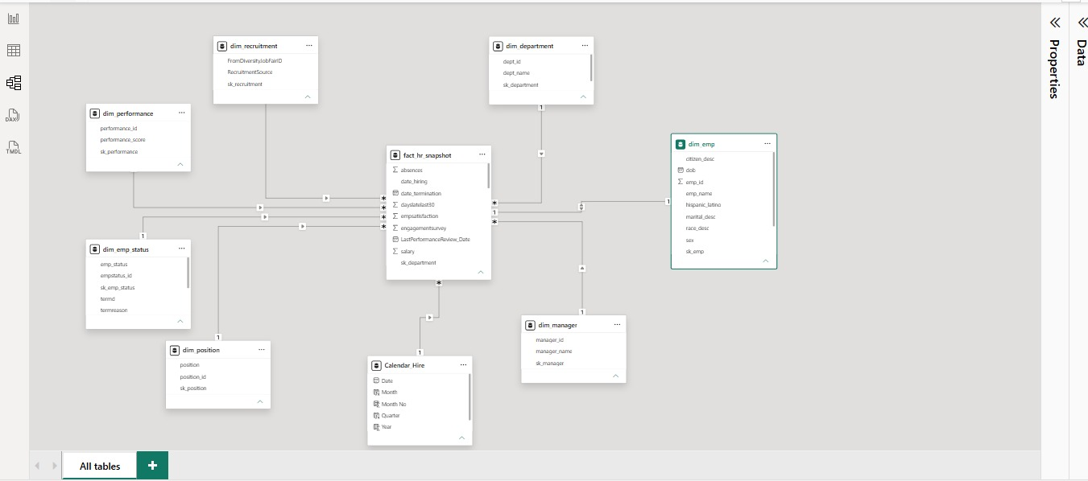
Figure 4 — Power BI Model view, showing the Gold-layer relationships as built in the report.
- Relationships: fact_hr_snapshot connects to dim_emp, dim_department, dim_position, dim_manager, dim_performance, dim_recruitment, dim_emp_status, and a Calendar Hire date table.
- Relationship Type / Cardinality: each dimension is on the '1' side, the fact table on the 'many' side (1:* one-to-many) — the standard star-schema pattern.
- Filter Direction: single-direction filtering from dimension → fact, per the Model view screenshot.
- Why a Star Schema Improves Power BI Performance: VertiPaq is optimized for star schemas — fewer, well-defined relationships reduce query-plan complexity, dimension tables compress extremely well due to low cardinality, and DAX filter propagation behaves predictably.

🖥️ Dashboard Walkthrough

Page 1 — Workforce

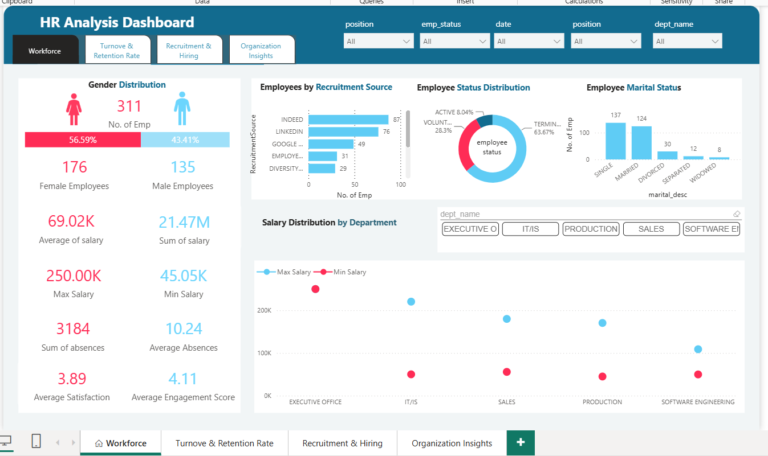
Figure 5 — Workforce page.
- Purpose / Business Question: 'What does our current workforce look like?'
- KPIs: 311 total employees (176 Female / 56.59%, 135 Male / 43.41%), average salary $69.02K, sum of salary $21.47M, max salary $250.00K, min salary $45.05K, sum of absences 3,184, average absences 10.24, average satisfaction 3.89, average engagement score 4.11.
- Visuals: Employees by Recruitment Source (bar), Employee Status Distribution (donut: Active 8.04%, Terminated 63.67% + Voluntary), Employee Marital Status (column: Single 137, Married 124, Divorced 30, Separated 12, Widowed 8), Salary Distribution by Department (max/min combo), department slicer.
- Why these visuals: gives an executive a single-page census of the workforce before drilling into turnover or recruitment specifics on later pages.
- Business Insight: the workforce skews female (56.6%) and single/married (84% combined); salary ranges vary substantially by department.

Page 2 — Turnover & Retention Rate
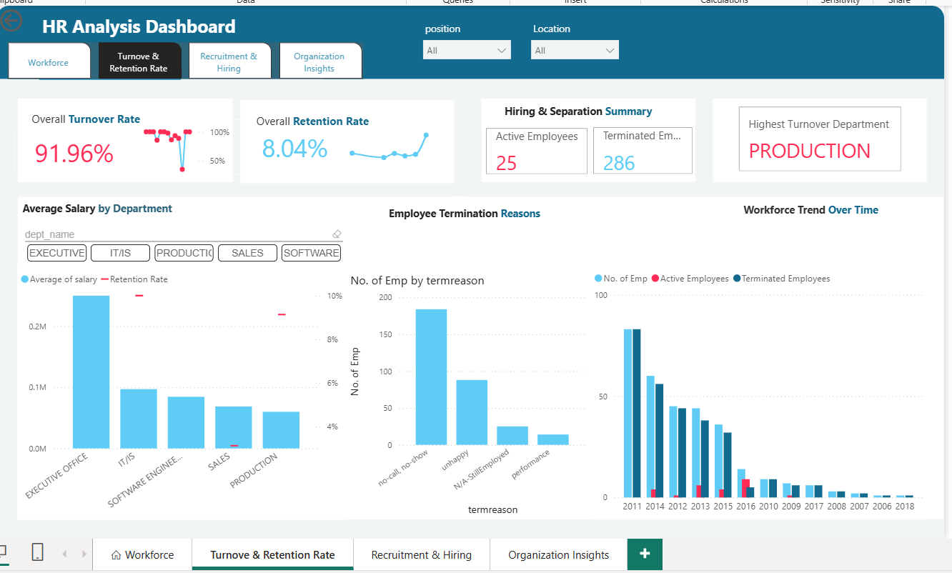
Figure 6 — Turnover & Retention Rate page.
- Purpose / Business Question: 'How much attrition are we experiencing, and why?'
- KPIs: Overall Turnover Rate 91.96%, Overall Retention Rate 8.04%, Active Employees 25, Terminated Employees 286, Highest Turnover Department: Production.
- Visuals: Average Salary by Department (combo with Retention Rate), Employee Termination Reasons (bar: 'no-call, no-show' leads, then 'unhappy', 'N/A-StillEmployed', 'performance'), Workforce Trend Over Time (2006–2018), position/location slicers.
- Why these visuals: directly answers the brief's suggested question on department-level turnover and termination reasons.
- Business Insight: Production is both the largest department and the highest-turnover department; 'no-call, no-show' is a distinct, actionable signal separate from voluntary/performance-based turnover.
Note: The card values shown (91.96% turnover / 8.04% retention) reflect the full historical dataset rather than a single trailing period, distinct from the period-based DAX Turnover Rate/Retention Rate measures captured in the .pbix — see Business Insights for the reconciliation caveat.

Page 3 — Recruitment & Hiring
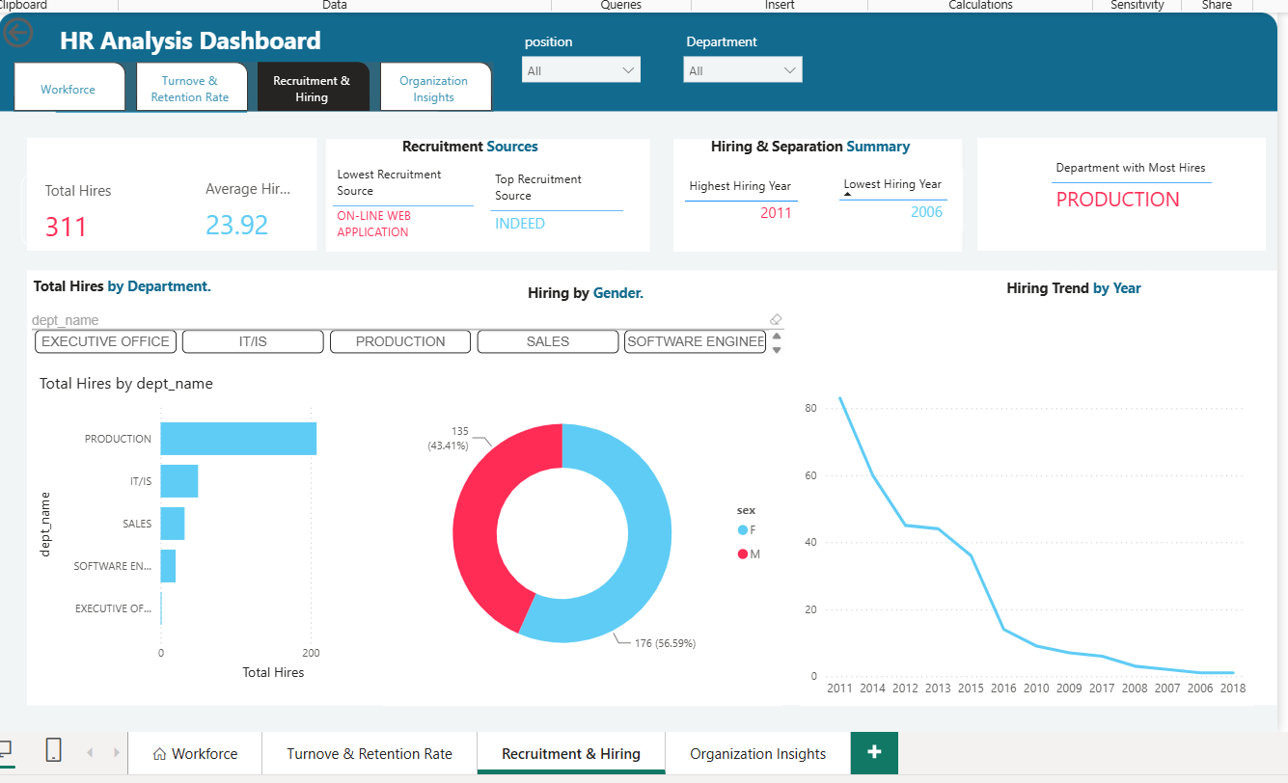
Figure 7 — Recruitment & Hiring page.
- Purpose / Business Question: 'Which recruitment channels are working, and when do we hire?'
- KPIs: Total Hires 311, Average Hiring (year-over-year) 23.92, Top Recruitment Source: Indeed, Lowest: On-line Web Application, Highest Hiring Year: 2011, Lowest Hiring Year: 2006, Department with Most Hires: Production.
- Visuals: Total Hires by Department (bar), Hiring by Gender (donut: 56.59% F / 43.41% M), Hiring Trend by Year (line, 2011 down to 2018), department slicer, Timeline custom visual.
- Why these visuals: directly supports the brief's suggested question about recruitment-source effectiveness by first establishing which sources are used most.
- Business Insight: Indeed outperforms LinkedIn and Google as the leading recruitment source; hiring volume peaked in 2011 and has declined every year since within this dataset's window.

Page 4 — Organization Insights
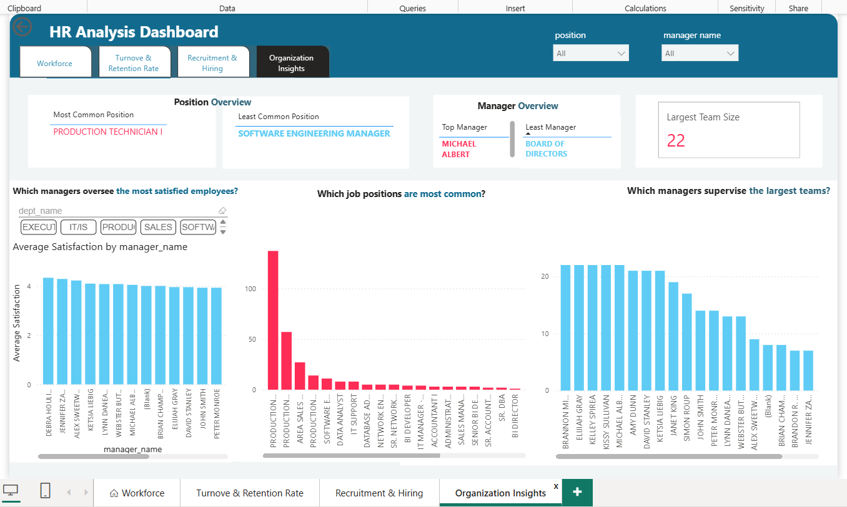
Figure 8 — Organization Insights page.
- Purpose / Business Question: 'How is the organization structured, and how are managers performing?'
- KPIs: Most Common Position: Production Technician I, Least Common Position: Software Engineering Manager, Top Manager (by team size): Michael Albert, smallest team: Board of Directors, Largest Team Size: 22.
- Visuals: Average Satisfaction by Manager (bar), Which Job Positions Are Most Common (bar, dominated by Production roles), Which Managers Supervise the Largest Teams (bar), department slicer.
- Why these visuals: directly supports the brief's suggested question on manager/team performance relationships by first surfacing team size and satisfaction by manager.
- Business Insight: satisfaction scores are fairly consistent across managers (mostly clustered around 3.5–4.0), while team size varies far more widely (1 up to 22).

💡 Business Insights
The following are drawn strictly from the KPI values and visuals visible in the supplied dashboard screenshots.
Insight | Evidence | Recommendation
Production is the largest, highest-turnover, and most-hired-into department | Dashboards 1, 2, 4 | Prioritize a targeted retention review for Production first
'No-call, no-show' is the single largest termination reason | Dashboard 2 | Investigate whether this reflects an attendance-policy, onboarding, or engagement gap
Indeed is the strongest recruitment source; On-line Web Application the weakest | Dashboard 1 | Reallocate recruitment effort toward Indeed, pending a cost-per-hire view
Hiring volume trended downward every year 2011–2018 | Dashboards 1, 2 | Contextualize against company headcount targets given high cumulative turnover
Workforce is 56.6% female / 43.4% male, consistent across pages | Dashboards 1, 4 | No material hiring-stage gender skew evident in this dataset
Manager satisfaction clusters tightly (3.5–4.0) while team size varies widely (1–22) | Dashboard 3 | Team size alone does not explain satisfaction differences; deeper cohort analysis needed

⚠️ Known Deviations from the Original Design
Documenting these transparently is itself good engineering practice — a professional report should show what was built, not just what was planned.
Area | Planned Design | Actual Implementation | Why It Matters
Gold layer object type | 03_gold_views.sql — views only, no physical tables | Physical TABLEs for all 7 dimensions and the fact table | Gold data goes stale unless the whole ETL job re-runs; views would reflect Silver live
Date dimension | gold.dim_date role-playing dimension per the star-schema & data-flow diagrams | No dim_date in SQL; DIM_Date built only inside Power BI | SQL consumers other than this specific .pbix have no date dimension available
Layer labeling | Architecture diagram labels each layer 'Stored Procedure' | Each layer is a plain sequential T-SQL script/batch, not CREATE PROCEDURE | Terminology gap between diagram and implementation; no functional impact
Hardcoded file path | Repo should be rebuildable by anyone who checks it out | BULK INSERT FROM path is a specific local Windows path | Reduces portability; must be edited before running elsewhere
00_initialize re-run safety | Should support a full from-scratch rebuild | Standalone script has no IF NOT EXISTS guard (Agent job version does) | Minor inconsistency between standalone script and Agent job step
Daily schedule vs. static source | Automation implies ongoing, refreshable data | Source is a one-time static CSV extract from a fixed local path | Daily cadence doesn't currently correspond to a changing data source
Turnover/Retention KPI framing | Dashboard cards labeled 'Overall Turnover/Retention Rate' | Values (91.96%/8.04%) reflect the cumulative dataset, not the period-based DAX measures | Card-level and measure-level figures should be reconciled/labeled clearly

🧗 Challenges
- Data Cleaning: reconciling text-stored numeric IDs (ManagerID as '22.0') required an explicit FLOAT → INT cast fix, discovered through profiling rather than assumed up front.
- Data Quality: deciding how to treat missing RecruitmentSource values (standardize to 'UNKNOWN' rather than drop) required a conscious completeness-vs-accuracy trade-off.
- Relationships: ensuring the Gold fact table preserved every Silver row even when a dimension lookup failed required deliberate LEFT JOIN usage plus explicit NULL-FK validation queries.
- SQL: balancing simplicity (no stored procedures, no extra indexing) against enterprise-pattern expectations, appropriate for a 311-row teaching dataset.
- Power BI: reconciling business-friendly Power Query column names against the underlying Gold schema's snake_case names, and building period-aware DAX for turnover/retention.
- ETL Automation: structuring the SQL Server Agent job so the database/schema-creation step could safely run either standalone or repeatedly inside the job.
- Modeling: deciding not to implement a SQL-layer date dimension despite the original design diagrams calling for one, building it directly in Power BI instead.

📘 Lessons Learned
- Profiling before cleaning is not a formality — the single most important fix in this project (the ManagerID float-cast) came directly from a profiling query.
- TRY_CAST/TRY_CONVERT combined with LEFT JOIN is a robust pattern for building a warehouse that degrades gracefully instead of failing hard or silently dropping rows.
- A star schema's value is not just query performance — the dimension/fact split maps directly onto how business stakeholders phrase their questions.
- Diagrams and documentation can drift from implementation; reconciling the two explicitly is itself a valuable engineering discipline.
- Automating a pipeline surfaces design questions — such as whether a daily schedule actually matches a static data source — that don't arise when running scripts manually.

🚀 Future Improvements
- Incremental Load: move Bronze from a full DROP/reload pattern to an incremental/upsert pattern.
- Stored Procedures: wrap each layer's logic in CREATE PROCEDURE objects, matching the architecture diagram's original intent.
- True Gold Views: convert gold.* from physical tables to views, matching the assignment's original requirement.
- SQL-Native Date Dimension: build gold.dim_date in T-SQL so any BI tool inherits a proper calendar dimension.
- SSIS / Azure Data Factory / Microsoft Fabric: replace ad-hoc BULK INSERT with a managed ingestion pipeline.
- Power BI Service: publish the report and configure a scheduled dataset refresh.
- Row-Level Security (RLS): restrict department managers to their own department's data.
- CI/CD: add automated schema/deployment scripts instead of manually running .sql files in order.
- Cloud Deployment: migrate the warehouse to Azure SQL Database / Fabric Warehouse.
- Parameterize the Bulk Load Path: replace the hardcoded local file path with a configurable variable or network/blob location.

✅ Conclusion
This project delivers a working, end-to-end HR data warehouse: a raw CSV is loaded untouched into Bronze, cleaned and conformed into Silver through explicit, profiling-driven transformation rules, and reshaped into a Gold-layer star schema that a 4-page Power BI report consumes to answer the HR domain's core workforce, turnover, recruitment, and organizational questions. The pipeline is automated end-to-end via a scheduled SQL Server Agent job. A small number of gaps between the original design diagrams and the final implementation are documented transparently rather than hidden, which is itself part of demonstrating real engineering judgment rather than only assignment completion.

🏅 Technologies Used
- SQL Server
- T-SQL
- SSMS
- SQL Server Agent
- Power BI Desktop
- DAX
- CSV / Excel
- GitHub

📎 Appendix A — Complete Original SQL Scripts
The following are the complete, unmodified contents of every SQL script in this project, in execution order. These are reproduced verbatim from the delivered .sql files for full technical traceability.

00_initialize_database.sql
CREATE DATABASE HR_Project;
GO

USE HR_Project;
GO

CREATE SCHEMA bronze;
GO

CREATE SCHEMA silver;
GO

CREATE SCHEMA gold;
GO

01a_bronze_load.sql
USE HR_Project;
GO

DROP TABLE IF EXISTS bronze.hr_data;
GO

CREATE TABLE bronze.hr_data (
Employee_Name VARCHAR(MAX),
EmpID VARCHAR(MAX),
MarriedID VARCHAR(MAX),
MaritalStatusID VARCHAR(MAX),
GenderID VARCHAR(MAX),
EmpStatusID VARCHAR(MAX),
DeptID VARCHAR(MAX),
PerfScoreID VARCHAR(MAX),
FromDiversityJobFairID VARCHAR(MAX),
Salary VARCHAR(MAX),
Termd VARCHAR(MAX),
PositionID VARCHAR(MAX),
Position VARCHAR(MAX),
State VARCHAR(MAX),
Zip VARCHAR(MAX),
DOB VARCHAR(MAX),
Sex VARCHAR(MAX),
MaritalDesc VARCHAR(MAX),
CitizenDesc VARCHAR(MAX),
HispanicLatino VARCHAR(MAX),
RaceDesc VARCHAR(MAX),
DateofHire VARCHAR(MAX),
DateofTermination VARCHAR(MAX),
TermReason VARCHAR(MAX),
EmploymentStatus VARCHAR(MAX),
Department VARCHAR(MAX),
ManagerName VARCHAR(MAX),
ManagerID VARCHAR(MAX),
RecruitmentSource VARCHAR(MAX),
PerformanceScore VARCHAR(MAX),
EngagementSurvey VARCHAR(MAX),
EmpSatisfaction VARCHAR(MAX),
SpecialProjectsCount VARCHAR(MAX),
LastPerformanceReview_Date VARCHAR(MAX),
DaysLateLast30 VARCHAR(MAX),
Absences VARCHAR(MAX)
);
GO

BULK INSERT bronze.hr_data
FROM 'C:\Users\pc\Documents\GitHub\HR-DataWarehouse-Project\HR-DataWarehouse-Project\data\HRDataset_v14.csv'
WITH (
FORMAT = 'CSV',
FIRSTROW = 2,
FIELDQUOTE = '"',
FIELDTERMINATOR = ',',
ROWTERMINATOR = '0x0d0a',
CODEPAGE = '65001',
TABLOCK
);
GO

SELECT COUNT(*) AS row_count FROM bronze.hr_data;

SELECT COUNT(*) AS column_count
FROM INFORMATION_SCHEMA.COLUMNS
WHERE TABLE_SCHEMA = 'bronze' AND TABLE_NAME = 'hr_data';

01b_bronze_profiling.sql
USE HR_Project;
GO

/*=========================================================
1. Duplicate EmpID
=========================================================*/
SELECT
'hr_data' AS [Table],
'Duplicate Employee IDs' AS [Anomaly_Type],
COUNT(*) AS [Affected_Row_Count],
STUFF((
SELECT DISTINCT ', ' + TRIM(EmpID)
FROM bronze.hr_data
GROUP BY TRIM(EmpID)
HAVING COUNT(*) > 1
FOR XML PATH(''),TYPE).value('.','NVARCHAR(MAX)'),1,2,'') AS [Duplicate_Keys]
FROM (
SELECT TRIM(EmpID) AS EmpID
FROM bronze.hr_data
GROUP BY TRIM(EmpID)
HAVING COUNT(*)>1
) D;
GO

/*=========================================================
2. Missing Employee Name
=========================================================*/
SELECT
'hr_data' AS [Table],
'Missing Employee Name' AS [Anomaly_Type],
COUNT(*) AS [Affected_Row_Count]
FROM bronze.hr_data
WHERE Employee_Name IS NULL
OR TRIM(Employee_Name)='';
GO

/*=========================================================
3. Missing Department
=========================================================*/
SELECT
'hr_data' AS [Table],
'Missing Department' AS [Anomaly_Type],
COUNT(*) AS [Affected_Row_Count]
FROM bronze.hr_data
WHERE Department IS NULL
OR TRIM(Department)='';
GO

/*=========================================================
4. Missing Position
=========================================================*/
SELECT
'hr_data' AS [Table],
'Missing Position' AS [Anomaly_Type],
COUNT(*) AS [Affected_Row_Count]
FROM bronze.hr_data
WHERE Position IS NULL
OR TRIM(Position)='';
GO

/*=========================================================
5. Missing ManagerID
=========================================================*/
SELECT
'hr_data' AS [Table],
'Missing ManagerID' AS [Anomaly_Type],
COUNT(*) AS [Affected_Row_Count]
FROM bronze.hr_data
WHERE ManagerID IS NULL
OR TRIM(ManagerID)='';
GO
/*=========================================================
6. Invalid Salary
=========================================================*/
SELECT
'hr_data' AS [Table],
'Invalid Salary (<=0)' AS [Anomaly_Type],
COUNT(*) AS [Affected_Row_Count]
FROM bronze.hr_data
WHERE TRY_CAST(Salary AS FLOAT)<=0;
GO
/*=========================================================
7. Invalid Engagement Survey
=========================================================*/
SELECT
'hr_data' AS [Table],
'Invalid Engagement Survey' AS [Anomaly_Type],
COUNT(*) AS [Affected_Row_Count]
FROM bronze.hr_data
WHERE TRY_CAST(EngagementSurvey AS FLOAT) NOT BETWEEN 0 AND 5;
GO

/*=========================================================
8. Invalid Employee Satisfaction
=========================================================*/
SELECT
'hr_data' AS [Table],
'Invalid Employee Satisfaction' AS [Anomaly_Type],
COUNT(*) AS [Affected_Row_Count]
FROM bronze.hr_data
WHERE TRY_CAST(EmpSatisfaction AS INT) NOT BETWEEN 1 AND 5;
GO

/*=========================================================
9. Invalid Absences
=========================================================*/
SELECT
'hr_data' AS [Table],
'Negative Absences' AS [Anomaly_Type],
COUNT(*) AS [Affected_Row_Count]
FROM bronze.hr_data
WHERE TRY_CAST(Absences AS INT)<0;
GO

/*=========================================================
10. Invalid Days Late
=========================================================*/
SELECT
'hr_data' AS [Table],
'Negative Days Late' AS [Anomaly_Type],
COUNT(*) AS [Affected_Row_Count]
FROM bronze.hr_data
WHERE TRY_CAST(DaysLateLast30 AS INT)<0;
GO

/*=========================================================
11. Duplicate Employee Names
=========================================================*/
SELECT
'hr_data' AS [Table],
'Duplicate Employee Names' AS [Anomaly_Type],
COUNT(*) AS [Affected_Row_Count],
STUFF((
SELECT DISTINCT ', '+Employee_Name
FROM bronze.hr_data
GROUP BY Employee_Name
HAVING COUNT(*)>1
FOR XML PATH(''),TYPE).value('.','NVARCHAR(MAX)'),1,2,'') AS [Duplicate_Names]
FROM(
SELECT Employee_Name
FROM bronze.hr_data
GROUP BY Employee_Name
HAVING COUNT(*)>1
)X;
GO

/*=========================================================
12. Invalid ManagerID (Orphan Records)
-- FIX: ManagerID/EmpID may be stored as text with a decimal point
-- (e.g. "1.0"), which TRY_CAST(... AS INT) directly rejects and
-- returns NULL for. Casting ManagerID through FLOAT first, and
-- TRIM-ing EmpID before casting, keeps this join reliable.
=========================================================*/
SELECT
'hr_data' AS [Table],
'Orphan Manager IDs' AS [Anomaly_Type],
COUNT(*) AS [Affected_Row_Count],
STUFF((
SELECT DISTINCT ', '+TRIM(e2.ManagerID)
FROM bronze.hr_data e2
LEFT JOIN bronze.hr_data m
ON TRY_CAST(TRY_CAST(e2.ManagerID AS FLOAT) AS INT) = TRY_CAST(TRIM(m.EmpID) AS INT)
WHERE e2.ManagerID IS NOT NULL
AND TRIM(e2.ManagerID)<>''
AND m.EmpID IS NULL
FOR XML PATH(''),TYPE).value('.','NVARCHAR(MAX)'),1,2,'') AS [Missing_ManagerIDs]
FROM bronze.hr_data e
LEFT JOIN bronze.hr_data m
ON TRY_CAST(TRY_CAST(e.ManagerID AS FLOAT) AS INT) = TRY_CAST(TRIM(m.EmpID) AS INT)
WHERE e.ManagerID IS NOT NULL
AND TRIM(e.ManagerID)<>''
AND m.EmpID IS NULL;
GO

/*=========================================================
13. Invalid Hire Date
=========================================================*/
SELECT
'hr_data' AS [Table],
'Invalid Hire Date' AS [Anomaly_Type],
COUNT(*) AS [Affected_Row_Count]
FROM bronze.hr_data
WHERE TRY_CONVERT(date,DateofHire) IS NULL;
GO

/*=========================================================
14. Invalid Termination Date
=========================================================*/
SELECT
'hr_data' AS [Table],
'Invalid Termination Date' AS [Anomaly_Type],
COUNT(*) AS [Affected_Row_Count]
FROM bronze.hr_data
WHERE DateofTermination IS NOT NULL
AND TRIM(DateofTermination)<>''
AND TRY_CONVERT(date,DateofTermination) IS NULL;
GO

/*=========================================================
15. Missing Performance Score
=========================================================*/
SELECT
'hr_data' AS [Table],
'Missing Performance Score' AS [Anomaly_Type],
COUNT(*) AS [Affected_Row_Count]
FROM bronze.hr_data
WHERE PerformanceScore IS NULL
OR TRIM(PerformanceScore)='';
GO

02_silver_transformation.sql
USE HR_Project;
GO
DROP TABLE IF EXISTS silver.hr_snapshot;
DROP TABLE IF EXISTS silver.emp;
DROP TABLE IF EXISTS silver.position;
DROP TABLE IF EXISTS silver.manager;
DROP TABLE IF EXISTS silver.department;
DROP TABLE IF EXISTS silver.recruitment;
DROP TABLE IF EXISTS silver.performance;
DROP TABLE IF EXISTS silver.emp_status;
GO
-----------------DDL
CREATE TABLE silver.emp
(
emp_id INT,
emp_name VARCHAR(100),
sex VARCHAR(20),
dob DATE,
marital_desc VARCHAR(50),
citizen_desc VARCHAR(50),
hispanic_latino VARCHAR(20),
race_desc VARCHAR(50),
state VARCHAR(50)
);
CREATE TABLE silver.position
(
position_id INT,
position VARCHAR(100)
);
CREATE TABLE silver.manager
(
manager_id INT,
manager_name VARCHAR(100)
);
CREATE TABLE silver.department
(
dept_id INT,
dept_name VARCHAR(100)
);
CREATE TABLE silver.recruitment
(
RecruitmentSource VARCHAR(100),
FromDiversityJobFairID INT
);
CREATE TABLE silver.performance
(
performance_id INT,
performance_score VARCHAR(50)
);
CREATE TABLE silver.emp_status
(
empstatus_id INT,
emp_status VARCHAR(100),
termreason VARCHAR(255),
termd BIT
);
CREATE TABLE silver.hr_snapshot
(
salary DECIMAL(18,2),
absences INT,
dayslatelast30 INT,
engagementsurvey DECIMAL(5,2),
empsatisfaction INT,
empstatus_id INT,
specialprojectscount INT,
date_hiring DATE,
date_termination DATE,
LastPerformanceReview_Date DATE,
RecruitmentSource VARCHAR(100),
position_id INT,
manager_id INT,
dept_id INT,
performance_id INT,
emp_id INT
);
GO
-------------------DML
INSERT INTO silver.emp
(
emp_id,
emp_name,
sex,
dob,
marital_desc,
citizen_desc,
hispanic_latino,
race_desc,
state
)
SELECT DISTINCT
TRY_CAST(TRIM(EmpID) AS INT),
CASE
WHEN CHARINDEX(',', Employee_Name) > 0 THEN
UPPER(
LTRIM(SUBSTRING(Employee_Name, CHARINDEX(',', Employee_Name) + 1, LEN(Employee_Name)))
+ ' ' +
LTRIM(LEFT(Employee_Name, CHARINDEX(',', Employee_Name) - 1))
)
ELSE
UPPER(TRIM(Employee_Name))
END,
UPPER(TRIM(Sex)),
TRY_CONVERT(DATE, DOB),
UPPER(TRIM(MaritalDesc)),
UPPER(TRIM(CitizenDesc)),
UPPER(TRIM(HispanicLatino)),
UPPER(TRIM(RaceDesc)),
UPPER(TRIM(State))
FROM bronze.hr_data;
GO
INSERT INTO silver.position
(
position_id,
position
)
SELECT
TRY_CAST(TRIM(PositionID) AS INT),
MAX(UPPER(TRIM(Position)))
FROM bronze.hr_data
WHERE TRY_CAST(TRIM(PositionID) AS INT) IS NOT NULL
GROUP BY TRY_CAST(TRIM(PositionID) AS INT);
GO
INSERT INTO silver.manager
(
manager_id,
manager_name
)
SELECT
TRY_CAST(TRY_CAST(TRIM(ManagerID) AS FLOAT) AS INT),
MAX(UPPER(TRIM(ManagerName)))
FROM bronze.hr_data
WHERE TRY_CAST(TRY_CAST(TRIM(ManagerID) AS FLOAT) AS INT) IS NOT NULL
GROUP BY TRY_CAST(TRY_CAST(TRIM(ManagerID) AS FLOAT) AS INT);
GO
INSERT INTO silver.department
(
dept_id,
dept_name
)
SELECT
TRY_CAST(TRIM(DeptID) AS INT),
MAX(UPPER(TRIM(Department)))
FROM bronze.hr_data
WHERE TRY_CAST(TRIM(DeptID) AS INT) IS NOT NULL
GROUP BY TRY_CAST(TRIM(DeptID) AS INT);
GO

INSERT INTO silver.recruitment
(
RecruitmentSource,
FromDiversityJobFairID
)
SELECT
CASE
WHEN RecruitmentSource IS NULL OR TRIM(RecruitmentSource)='' THEN 'UNKNOWN'
ELSE UPPER(TRIM(RecruitmentSource))
END,
MAX(COALESCE(TRY_CAST(FromDiversityJobFairID AS INT),0))
FROM bronze.hr_data
GROUP BY
CASE
WHEN RecruitmentSource IS NULL OR TRIM(RecruitmentSource)='' THEN 'UNKNOWN'
ELSE UPPER(TRIM(RecruitmentSource))
END;
GO

INSERT INTO silver.performance
(
performance_id,
performance_score
)
SELECT
TRY_CAST(TRIM(PerfScoreID) AS INT),
MAX(UPPER(TRIM(PerformanceScore)))
FROM bronze.hr_data
WHERE TRY_CAST(TRIM(PerfScoreID) AS INT) IS NOT NULL
GROUP BY TRY_CAST(TRIM(PerfScoreID) AS INT);
GO

INSERT INTO silver.emp_status
(
empstatus_id,
emp_status,
termreason,
termd
)
SELECT
TRY_CAST(TRIM(EmpStatusID) AS INT),
MAX(UPPER(TRIM(EmploymentStatus))),
MAX(TRIM(TermReason)),
CAST(MAX(CAST(Termd AS INT)) AS BIT)
FROM bronze.hr_data
WHERE TRY_CAST(TRIM(EmpStatusID) AS INT) IS NOT NULL
GROUP BY TRY_CAST(TRIM(EmpStatusID) AS INT);
GO
---------------------DML - HR_snapshot
INSERT INTO silver.hr_snapshot
(
salary,
absences,
dayslatelast30,
engagementsurvey,
empsatisfaction,
specialprojectscount,
empstatus_id,
date_hiring,
date_termination,
LastPerformanceReview_Date,
RecruitmentSource,
position_id,
manager_id,
dept_id,
performance_id,
emp_id
)
SELECT
COALESCE(TRY_CAST(Salary AS DECIMAL(18,2)),0),
COALESCE(TRY_CAST(Absences AS INT),0),
COALESCE(TRY_CAST(DaysLateLast30 AS INT),0),
COALESCE(TRY_CAST(EngagementSurvey AS DECIMAL(5,2)),0),
COALESCE(TRY_CAST(EmpSatisfaction AS INT),0),
COALESCE(TRY_CAST(SpecialProjectsCount AS INT),0),
TRY_CAST(TRIM(EmpStatusID) AS INT),
TRY_CONVERT(DATE, DateofHire),
TRY_CONVERT(DATE, DateofTermination),
TRY_CONVERT(DATE, LastPerformanceReview_Date),
CASE
WHEN RecruitmentSource IS NULL
OR TRIM(RecruitmentSource)='' THEN 'UNKNOWN'
ELSE UPPER(TRIM(RecruitmentSource))
END,
TRY_CAST(TRIM(PositionID) AS INT),
TRY_CAST(TRY_CAST(TRIM(ManagerID) AS FLOAT) AS INT),
TRY_CAST(TRIM(DeptID) AS INT),
TRY_CAST(TRIM(PerfScoreID) AS INT),
TRY_CAST(TRIM(EmpID) AS INT)
FROM bronze.hr_data;
GO

03_gold.sql
USE HR_Project;
GO
DROP TABLE IF EXISTS gold.fact_hr_snapshot;
DROP TABLE IF EXISTS gold.dim_emp;
DROP TABLE IF EXISTS gold.dim_position;
DROP TABLE IF EXISTS gold.dim_manager;
DROP TABLE IF EXISTS gold.dim_department;
DROP TABLE IF EXISTS gold.dim_recruitment;
DROP TABLE IF EXISTS gold.dim_performance;
DROP TABLE IF EXISTS gold.dim_emp_status;
GO
-----------DDL - DIMENSIONS (surrogate key = sk_<dimension>, NOT NULL by definition of IDENTITY PK; business key = UNIQUE, so no duplicate surrogate rows for the same source key)
CREATE TABLE gold.dim_emp
(
sk_emp INT IDENTITY(1,1) NOT NULL PRIMARY KEY,
emp_id INT UNIQUE,
emp_name VARCHAR(100),
sex VARCHAR(20),
dob DATE,
marital_desc VARCHAR(50),
citizen_desc VARCHAR(50),
hispanic_latino VARCHAR(20),
race_desc VARCHAR(50),
state VARCHAR(50)
);
CREATE TABLE gold.dim_position
(
sk_position INT IDENTITY(1,1) NOT NULL PRIMARY KEY,
position_id INT UNIQUE,
position VARCHAR(100)
);
CREATE TABLE gold.dim_manager
(
sk_manager INT IDENTITY(1,1) NOT NULL PRIMARY KEY,
manager_id INT UNIQUE,
manager_name VARCHAR(100)
);
CREATE TABLE gold.dim_department
(
sk_department INT IDENTITY(1,1) NOT NULL PRIMARY KEY,
dept_id INT UNIQUE,
dept_name VARCHAR(100)
);
CREATE TABLE gold.dim_recruitment
(
sk_recruitment INT IDENTITY(1,1) NOT NULL PRIMARY KEY,
RecruitmentSource VARCHAR(100) UNIQUE,
FromDiversityJobFairID INT
);
CREATE TABLE gold.dim_performance
(
sk_performance INT IDENTITY(1,1) NOT NULL PRIMARY KEY,
performance_id INT UNIQUE,
performance_score VARCHAR(50)
);
CREATE TABLE gold.dim_emp_status
(
sk_emp_status INT IDENTITY(1,1) NOT NULL PRIMARY KEY,
empstatus_id INT UNIQUE,
emp_status VARCHAR(100),
termreason VARCHAR(255),
termd BIT
);
GO
--------DDL - FACT (surrogate key + FKs to dimension surrogate keys)
CREATE TABLE gold.fact_hr_snapshot
(
sk_hr_snapshot INT IDENTITY(1,1) NOT NULL PRIMARY KEY,
sk_emp INT REFERENCES gold.dim_emp(sk_emp),
sk_position INT REFERENCES gold.dim_position(sk_position),
sk_manager INT REFERENCES gold.dim_manager(sk_manager),
sk_department INT REFERENCES gold.dim_department(sk_department),
sk_performance INT REFERENCES gold.dim_performance(sk_performance),
sk_emp_status INT REFERENCES gold.dim_emp_status(sk_emp_status),
sk_recruitment INT REFERENCES gold.dim_recruitment(sk_recruitment),
salary DECIMAL(18,2),
absences INT,
dayslatelast30 INT,
engagementsurvey DECIMAL(5,2),
empsatisfaction INT,
specialprojectscount INT,
date_hiring DATE,
date_termination DATE,
LastPerformanceReview_Date DATE
);
GO
-----------DML - DIMENSIONS (DISTINCT + surrogate keys are NOT listed/inserted -> SQL Server generates them.)
INSERT INTO gold.dim_emp
(
emp_id,
emp_name,
sex,
dob,
marital_desc,
citizen_desc,
hispanic_latino,
race_desc,
state
)
SELECT DISTINCT
emp_id,
emp_name,
sex,
dob,
marital_desc,
citizen_desc,
hispanic_latino,
race_desc,
state
FROM silver.emp;
GO
INSERT INTO gold.dim_position
(
position_id,
position
)
SELECT DISTINCT
position_id,
position
FROM silver.position;
GO
INSERT INTO gold.dim_manager
(
manager_id,
manager_name
)
SELECT DISTINCT
manager_id,
manager_name
FROM silver.manager;
GO
INSERT INTO gold.dim_department
(
dept_id,
dept_name
)
SELECT DISTINCT
dept_id,
dept_name
FROM silver.department;
GO
INSERT INTO gold.dim_recruitment
(
RecruitmentSource,
FromDiversityJobFairID
)
SELECT DISTINCT
RecruitmentSource,
FromDiversityJobFairID
FROM silver.recruitment;
GO
INSERT INTO gold.dim_performance
(
performance_id,
performance_score
)
SELECT DISTINCT
performance_id,
performance_score
FROM silver.performance;
GO
INSERT INTO gold.dim_emp_status
(
empstatus_id,
emp_status,
termreason,
termd
)
SELECT DISTINCT
empstatus_id,
emp_status,
termreason,
termd
FROM silver.emp_status;
GO
-------DML - FACT_HR_SNAPSHOT (look up each dimension's surrogate key via its business key)
INSERT INTO gold.fact_hr_snapshot
(
sk_emp,
sk_position,
sk_manager,
sk_department,
sk_performance,
sk_emp_status,
sk_recruitment,
salary,
absences,
dayslatelast30,
engagementsurvey,
empsatisfaction,
specialprojectscount,
date_hiring,
date_termination,
LastPerformanceReview_Date
)
SELECT
de.sk_emp,
dp.sk_position,
dm.sk_manager,
dd.sk_department,
dpf.sk_performance,
des.sk_emp_status,
dr.sk_recruitment,
s.salary,
s.absences,
s.dayslatelast30,
s.engagementsurvey,
s.empsatisfaction,
s.specialprojectscount,
s.date_hiring,
s.date_termination,
s.LastPerformanceReview_Date
FROM silver.hr_snapshot s
LEFT JOIN gold.dim_emp de ON de.emp_id = s.emp_id
LEFT JOIN gold.dim_position dp ON dp.position_id = s.position_id
LEFT JOIN gold.dim_manager dm ON dm.manager_id = s.manager_id
LEFT JOIN gold.dim_department dd ON dd.dept_id = s.dept_id
LEFT JOIN gold.dim_performance dpf ON dpf.performance_id = s.performance_id
LEFT JOIN gold.dim_emp_status des ON des.empstatus_id = s.empstatus_id
LEFT JOIN gold.dim_recruitment dr ON dr.RecruitmentSource = s.RecruitmentSource;
GO
---------------VALIDATION
SELECT
'Silver HR Snapshot' AS Layer,
COUNT(*) AS Row_Count
FROM silver.hr_snapshot
UNION ALL
SELECT
'Gold Fact HR Snapshot',
COUNT(*)
FROM gold.fact_hr_snapshot;
GO

-- Rows in the fact table missing any surrogate key
SELECT * FROM gold.fact_hr_snapshot
WHERE sk_emp IS NULL OR sk_position IS NULL OR sk_department IS NULL
OR sk_manager IS NULL OR sk_performance IS NULL OR sk_emp_status IS NULL
OR sk_recruitment IS NULL;
GO

-- Drill down: raw bronze rows behind any sk_manager gaps found above
-- (dynamic - no hardcoded IDs, re-runs correctly on any future load)
SELECT b.EmpID, b.Employee_Name, b.ManagerID, b.ManagerName, b.Position
FROM bronze.hr_data b
WHERE TRY_CAST(TRIM(b.EmpID) AS INT) IN (
SELECT de.emp_id
FROM gold.fact_hr_snapshot f
JOIN gold.dim_emp de ON de.sk_emp = f.sk_emp
WHERE f.sk_manager IS NULL
);
GO
------------check for null
SELECT
emp_id,
manager_id
FROM silver.hr_snapshot
WHERE emp_id IN
(
10277,
10184,
10154,
10136,
10214,
10077,
10011,
10071
);
SELECT *
FROM silver.manager
WHERE manager_name = 'WEBSTER BUTLER';

SELECT
EmpID,
ManagerID,
ManagerName
FROM bronze.hr_data
WHERE ManagerName = 'Webster Butler';

04_sql_agent_job.sql
USE [msdb]
GO

/****** Object: Job [HR ETL Pipeline] Script Date: 7/25/2026 8:58:08 AM ******/
BEGIN TRANSACTION
DECLARE @ReturnCode INT
SELECT @ReturnCode = 0
/****** Object: JobCategory [[Uncategorized (Local)]] Script Date: 7/25/2026 8:58:08 AM ******/
IF NOT EXISTS (SELECT name FROM msdb.dbo.syscategories WHERE name=N'[Uncategorized (Local)]' AND category_class=1)
BEGIN
EXEC @ReturnCode = msdb.dbo.sp_add_category @class=N'JOB', @type=N'LOCAL', @name=N'[Uncategorized (Local)]'
IF (@@ERROR <> 0 OR @ReturnCode <> 0) GOTO QuitWithRollback

END

DECLARE @jobId BINARY(16)
EXEC @ReturnCode = msdb.dbo.sp_add_job @job_name=N'HR ETL Pipeline',
@enabled=1,
@notify_level_eventlog=0,
@notify_level_email=0,
@notify_level_netsend=0,
@notify_level_page=0,
@delete_level=0,
@description=N'No description available.',
@category_name=N'[Uncategorized (Local)]',
@owner_login_name=N'sa', @job_id = @jobId OUTPUT
IF (@@ERROR <> 0 OR @ReturnCode <> 0) GOTO QuitWithRollback
/****** Object: Step [00_Initialize] Script Date: 7/25/2026 8:58:09 AM ******/
EXEC @ReturnCode = msdb.dbo.sp_add_jobstep @job_id=@jobId, @step_name=N'00_Initialize',
@step_id=1,
@cmdexec_success_code=0,
@on_success_action=3,
@on_success_step_id=0,
@on_fail_action=2,
@on_fail_step_id=0,
@retry_attempts=0,
@retry_interval=0,
@os_run_priority=0, @subsystem=N'TSQL',
@command=N'IF DB_ID(''HR_Project'') IS NULL
BEGIN
CREATE DATABASE HR_Project;
END
GO

USE HR_Project;
GO

IF NOT EXISTS (SELECT * FROM sys.schemas WHERE name = ''bronze'')
EXEC(''CREATE SCHEMA bronze'');
GO

IF NOT EXISTS (SELECT * FROM sys.schemas WHERE name = ''silver'')
EXEC(''CREATE SCHEMA silver'');
GO

IF NOT EXISTS (SELECT * FROM sys.schemas WHERE name = ''gold'')
EXEC(''CREATE SCHEMA gold'');
GO',
@database_name=N'master',
@flags=0
IF (@@ERROR <> 0 OR @ReturnCode <> 0) GOTO QuitWithRollback
/****** Object: Step [01a_Bronze_Load] Script Date: 7/25/2026 8:58:09 AM ******/
EXEC @ReturnCode = msdb.dbo.sp_add_jobstep @job_id=@jobId, @step_name=N'01a_Bronze_Load',
@step_id=2,
@cmdexec_success_code=0,
@on_success_action=3,
@on_success_step_id=0,
@on_fail_action=2,
@on_fail_step_id=0,
@retry_attempts=0,
@retry_interval=0,
@os_run_priority=0, @subsystem=N'TSQL',
@command=N'USE HR_Project;
GO

DROP TABLE IF EXISTS bronze.hr_data;
GO

CREATE TABLE bronze.hr_data (
Employee_Name VARCHAR(MAX),
EmpID VARCHAR(MAX),
MarriedID VARCHAR(MAX),
MaritalStatusID VARCHAR(MAX),
GenderID VARCHAR(MAX),
EmpStatusID VARCHAR(MAX),
DeptID VARCHAR(MAX),
PerfScoreID VARCHAR(MAX),
FromDiversityJobFairID VARCHAR(MAX),
Salary VARCHAR(MAX),
Termd VARCHAR(MAX),
PositionID VARCHAR(MAX),
Position VARCHAR(MAX),
State VARCHAR(MAX),
Zip VARCHAR(MAX),
DOB VARCHAR(MAX),
Sex VARCHAR(MAX),
MaritalDesc VARCHAR(MAX),
CitizenDesc VARCHAR(MAX),
HispanicLatino VARCHAR(MAX),
RaceDesc VARCHAR(MAX),
DateofHire VARCHAR(MAX),
DateofTermination VARCHAR(MAX),
TermReason VARCHAR(MAX),
EmploymentStatus VARCHAR(MAX),
Department VARCHAR(MAX),
ManagerName VARCHAR(MAX),
ManagerID VARCHAR(MAX),
RecruitmentSource VARCHAR(MAX),
PerformanceScore VARCHAR(MAX),
EngagementSurvey VARCHAR(MAX),
EmpSatisfaction VARCHAR(MAX),
SpecialProjectsCount VARCHAR(MAX),
LastPerformanceReview_Date VARCHAR(MAX),
DaysLateLast30 VARCHAR(MAX),
Absences VARCHAR(MAX)
);
GO

BULK INSERT bronze.hr_data
FROM ''C:\Users\pc\Documents\GitHub\HR-DataWarehouse-Project\HR-DataWarehouse-Project\data\HRDataset_v14.csv''
WITH (
FORMAT = ''CSV'',
FIRSTROW = 2,
FIELDQUOTE = ''"'',
FIELDTERMINATOR = '','',
ROWTERMINATOR = ''0x0d0a'',
CODEPAGE = ''65001'',
TABLOCK
);
GO

SELECT COUNT(*) AS row_count FROM bronze.hr_data;

SELECT COUNT(*) AS column_count
FROM INFORMATION_SCHEMA.COLUMNS
WHERE TABLE_SCHEMA = ''bronze'' AND TABLE_NAME = ''hr_data'';',
@database_name=N'HR_Project',
@flags=0
IF (@@ERROR <> 0 OR @ReturnCode <> 0) GOTO QuitWithRollback
/****** Object: Step [01b_Bronze_Profiling] Script Date: 7/25/2026 8:58:09 AM ******/
EXEC @ReturnCode = msdb.dbo.sp_add_jobstep @job_id=@jobId, @step_name=N'01b_Bronze_Profiling',
@step_id=3,
@cmdexec_success_code=0,
@on_success_action=3,
@on_success_step_id=0,
@on_fail_action=2,
@on_fail_step_id=0,
@retry_attempts=0,
@retry_interval=0,
@os_run_priority=0, @subsystem=N'TSQL',
@command=N'USE HR_Project;
GO
SET ANSI_NULLS ON;
SET QUOTED_IDENTIFIER ON;
GO
/*=========================================================
1. Duplicate EmpID
=========================================================*/
SELECT
''hr_data'' AS [Table],
''Duplicate Employee IDs'' AS [Anomaly_Type],
COUNT(*) AS [Affected_Row_Count],
STUFF((
SELECT DISTINCT '', '' + TRIM(EmpID)
FROM bronze.hr_data
GROUP BY TRIM(EmpID)
HAVING COUNT(*) > 1
FOR XML PATH(''''),TYPE).value(''.'',''NVARCHAR(MAX)''),1,2,'''') AS [Duplicate_Keys]
FROM (
SELECT TRIM(EmpID) AS EmpID
FROM bronze.hr_data
GROUP BY TRIM(EmpID)
HAVING COUNT(*)>1
) D;
GO

/*=========================================================
2. Missing Employee Name
=========================================================*/
SELECT
''hr_data'' AS [Table],
''Missing Employee Name'' AS [Anomaly_Type],
COUNT(*) AS [Affected_Row_Count]
FROM bronze.hr_data
WHERE Employee_Name IS NULL
OR TRIM(Employee_Name)='''';
GO

/*=========================================================
3. Missing Department
=========================================================*/
SELECT
''hr_data'' AS [Table],
''Missing Department'' AS [Anomaly_Type],
COUNT(*) AS [Affected_Row_Count]
FROM bronze.hr_data
WHERE Department IS NULL
OR TRIM(Department)='''';
GO

/*=========================================================
4. Missing Position
=========================================================*/
SELECT
''hr_data'' AS [Table],
''Missing Position'' AS [Anomaly_Type],
COUNT(*) AS [Affected_Row_Count]
FROM bronze.hr_data
WHERE Position IS NULL
OR TRIM(Position)='''';
GO

/*=========================================================
5. Missing ManagerID
=========================================================*/
SELECT
''hr_data'' AS [Table],
''Missing ManagerID'' AS [Anomaly_Type],
COUNT(*) AS [Affected_Row_Count]
FROM bronze.hr_data
WHERE ManagerID IS NULL
OR TRIM(ManagerID)='''';
GO

/*=========================================================
6. Invalid Salary
=========================================================*/
SELECT
''hr_data'' AS [Table],
''Invalid Salary (<=0)'' AS [Anomaly_Type],
COUNT(*) AS [Affected_Row_Count]
FROM bronze.hr_data
WHERE TRY_CAST(Salary AS FLOAT)<=0;
GO

/*=========================================================
7. Invalid Engagement Survey
=========================================================*/
SELECT
''hr_data'' AS [Table],
''Invalid Engagement Survey'' AS [Anomaly_Type],
COUNT(*) AS [Affected_Row_Count]
FROM bronze.hr_data
WHERE TRY_CAST(EngagementSurvey AS FLOAT) NOT BETWEEN 0 AND 5;
GO

/*=========================================================
8. Invalid Employee Satisfaction
=========================================================*/
SELECT
''hr_data'' AS [Table],
''Invalid Employee Satisfaction'' AS [Anomaly_Type],
COUNT(*) AS [Affected_Row_Count]
FROM bronze.hr_data
WHERE TRY_CAST(EmpSatisfaction AS INT) NOT BETWEEN 1 AND 5;
GO

/*=========================================================
9. Invalid Absences
=========================================================*/
SELECT
''hr_data'' AS [Table],
''Negative Absences'' AS [Anomaly_Type],
COUNT(*) AS [Affected_Row_Count]
FROM bronze.hr_data
WHERE TRY_CAST(Absences AS INT)<0;
GO

/*=========================================================
10. Invalid Days Late
=========================================================*/
SELECT
''hr_data'' AS [Table],
''Negative Days Late'' AS [Anomaly_Type],
COUNT(*) AS [Affected_Row_Count]
FROM bronze.hr_data
WHERE TRY_CAST(DaysLateLast30 AS INT)<0;
GO

/*=========================================================
11. Duplicate Employee Names
=========================================================*/
SELECT
''hr_data'' AS [Table],
''Duplicate Employee Names'' AS [Anomaly_Type],
COUNT(*) AS [Affected_Row_Count],
STUFF((
SELECT DISTINCT '', ''+Employee_Name
FROM bronze.hr_data
GROUP BY Employee_Name
HAVING COUNT(*)>1
FOR XML PATH(''''),TYPE).value(''.'',''NVARCHAR(MAX)''),1,2,'''') AS [Duplicate_Names]
FROM(
SELECT Employee_Name
FROM bronze.hr_data
GROUP BY Employee_Name
HAVING COUNT(*)>1
)X;
GO

/*=========================================================
12. Invalid ManagerID (Orphan Records)
-- FIX: ManagerID/EmpID may be stored as text with a decimal point
-- (e.g. "1.0"), which TRY_CAST(... AS INT) directly rejects and
-- returns NULL for. Casting ManagerID through FLOAT first, and
-- TRIM-ing EmpID before casting, keeps this join reliable.
=========================================================*/
SELECT
''hr_data'' AS [Table],
''Orphan Manager IDs'' AS [Anomaly_Type],
COUNT(*) AS [Affected_Row_Count],
STUFF((
SELECT DISTINCT '', ''+TRIM(e2.ManagerID)
FROM bronze.hr_data e2
LEFT JOIN bronze.hr_data m
ON TRY_CAST(TRY_CAST(e2.ManagerID AS FLOAT) AS INT) = TRY_CAST(TRIM(m.EmpID) AS INT)
WHERE e2.ManagerID IS NOT NULL
AND TRIM(e2.ManagerID)<>''''
AND m.EmpID IS NULL
FOR XML PATH(''''),TYPE).value(''.'',''NVARCHAR(MAX)''),1,2,'''') AS [Missing_ManagerIDs]
FROM bronze.hr_data e
LEFT JOIN bronze.hr_data m
ON TRY_CAST(TRY_CAST(e.ManagerID AS FLOAT) AS INT) = TRY_CAST(TRIM(m.EmpID) AS INT)
WHERE e.ManagerID IS NOT NULL
AND TRIM(e.ManagerID)<>''''
AND m.EmpID IS NULL;
GO

/*=========================================================
13. Invalid Hire Date
=========================================================*/
SELECT
''hr_data'' AS [Table],
''Invalid Hire Date'' AS [Anomaly_Type],
COUNT(*) AS [Affected_Row_Count]
FROM bronze.hr_data
WHERE TRY_CONVERT(date,DateofHire) IS NULL;
GO

/*=========================================================
14. Invalid Termination Date
=========================================================*/
SELECT
''hr_data'' AS [Table],
''Invalid Termination Date'' AS [Anomaly_Type],
COUNT(*) AS [Affected_Row_Count]
FROM bronze.hr_data
WHERE DateofTermination IS NOT NULL
AND TRIM(DateofTermination)<>''''
AND TRY_CONVERT(date,DateofTermination) IS NULL;
GO

/*=========================================================
15. Missing Performance Score
=========================================================*/
SELECT
''hr_data'' AS [Table],
''Missing Performance Score'' AS [Anomaly_Type],
COUNT(*) AS [Affected_Row_Count]
FROM bronze.hr_data
WHERE PerformanceScore IS NULL
OR TRIM(PerformanceScore)='''';
GO',
@database_name=N'HR_Project',
@flags=0
IF (@@ERROR <> 0 OR @ReturnCode <> 0) GOTO QuitWithRollback
/****** Object: Step [02_Silver] Script Date: 7/25/2026 8:58:10 AM ******/
EXEC @ReturnCode = msdb.dbo.sp_add_jobstep @job_id=@jobId, @step_name=N'02_Silver',
@step_id=4,
@cmdexec_success_code=0,
@on_success_action=3,
@on_success_step_id=0,
@on_fail_action=2,
@on_fail_step_id=0,
@retry_attempts=0,
@retry_interval=0,
@os_run_priority=0, @subsystem=N'TSQL',
@command=N'USE HR_Project;
GO
DROP TABLE IF EXISTS silver.hr_snapshot;
DROP TABLE IF EXISTS silver.emp;
DROP TABLE IF EXISTS silver.position;
DROP TABLE IF EXISTS silver.manager;
DROP TABLE IF EXISTS silver.department;
DROP TABLE IF EXISTS silver.recruitment;
DROP TABLE IF EXISTS silver.performance;
DROP TABLE IF EXISTS silver.emp_status;
GO
-----------------DDL
CREATE TABLE silver.emp
(
emp_id INT,
emp_name VARCHAR(100),
sex VARCHAR(20),
dob DATE,
marital_desc VARCHAR(50),
citizen_desc VARCHAR(50),
hispanic_latino VARCHAR(20),
race_desc VARCHAR(50),
state VARCHAR(50)
);
CREATE TABLE silver.position
(
position_id INT,
position VARCHAR(100)
);
CREATE TABLE silver.manager
(
manager_id INT,
manager_name VARCHAR(100)
);
CREATE TABLE silver.department
(
dept_id INT,
dept_name VARCHAR(100)
);
CREATE TABLE silver.recruitment
(
RecruitmentSource VARCHAR(100),
FromDiversityJobFairID INT
);
CREATE TABLE silver.performance
(
performance_id INT,
performance_score VARCHAR(50)
);
CREATE TABLE silver.emp_status
(
empstatus_id INT,
emp_status VARCHAR(100),
termreason VARCHAR(255),
termd BIT
);
CREATE TABLE silver.hr_snapshot
(
salary DECIMAL(18,2),
absences INT,
dayslatelast30 INT,
engagementsurvey DECIMAL(5,2),
empsatisfaction INT,
empstatus_id INT,
specialprojectscount INT,
date_hiring DATE,
date_termination DATE,
LastPerformanceReview_Date DATE,
RecruitmentSource VARCHAR(100),
position_id INT,
manager_id INT,
dept_id INT,
performance_id INT,
emp_id INT
);
GO
-------------------DML
INSERT INTO silver.emp
(
emp_id,
emp_name,
sex,
dob,
marital_desc,
citizen_desc,
hispanic_latino,
race_desc,
state
)
SELECT DISTINCT
TRY_CAST(TRIM(EmpID) AS INT),
CASE
WHEN CHARINDEX('','', Employee_Name) > 0 THEN
UPPER(
LTRIM(SUBSTRING(Employee_Name, CHARINDEX('','', Employee_Name) + 1, LEN(Employee_Name)))
+ '' '' +
LTRIM(LEFT(Employee_Name, CHARINDEX('','', Employee_Name) - 1))
)
ELSE
UPPER(TRIM(Employee_Name))
END,
UPPER(TRIM(Sex)),
TRY_CONVERT(DATE, DOB),
UPPER(TRIM(MaritalDesc)),
UPPER(TRIM(CitizenDesc)),
UPPER(TRIM(HispanicLatino)),
UPPER(TRIM(RaceDesc)),
UPPER(TRIM(State))
FROM bronze.hr_data;
GO
INSERT INTO silver.position
(
position_id,
position
)
SELECT
TRY_CAST(TRIM(PositionID) AS INT),
MAX(UPPER(TRIM(Position)))
FROM bronze.hr_data
WHERE TRY_CAST(TRIM(PositionID) AS INT) IS NOT NULL
GROUP BY TRY_CAST(TRIM(PositionID) AS INT);
GO
INSERT INTO silver.manager
(
manager_id,
manager_name
)
SELECT
TRY_CAST(TRY_CAST(TRIM(ManagerID) AS FLOAT) AS INT),
MAX(UPPER(TRIM(ManagerName)))
FROM bronze.hr_data
WHERE TRY_CAST(TRY_CAST(TRIM(ManagerID) AS FLOAT) AS INT) IS NOT NULL
GROUP BY TRY_CAST(TRY_CAST(TRIM(ManagerID) AS FLOAT) AS INT);
GO
INSERT INTO silver.department
(
dept_id,
dept_name
)
SELECT
TRY_CAST(TRIM(DeptID) AS INT),
MAX(UPPER(TRIM(Department)))
FROM bronze.hr_data
WHERE TRY_CAST(TRIM(DeptID) AS INT) IS NOT NULL
GROUP BY TRY_CAST(TRIM(DeptID) AS INT);
GO

INSERT INTO silver.recruitment
(
RecruitmentSource,
FromDiversityJobFairID
)
SELECT
CASE
WHEN RecruitmentSource IS NULL OR TRIM(RecruitmentSource)='''' THEN ''UNKNOWN''
ELSE UPPER(TRIM(RecruitmentSource))
END,
MAX(COALESCE(TRY_CAST(FromDiversityJobFairID AS INT),0))
FROM bronze.hr_data
GROUP BY
CASE
WHEN RecruitmentSource IS NULL OR TRIM(RecruitmentSource)='''' THEN ''UNKNOWN''
ELSE UPPER(TRIM(RecruitmentSource))
END;
GO

INSERT INTO silver.performance
(
performance_id,
performance_score
)
SELECT
TRY_CAST(TRIM(PerfScoreID) AS INT),
MAX(UPPER(TRIM(PerformanceScore)))
FROM bronze.hr_data
WHERE TRY_CAST(TRIM(PerfScoreID) AS INT) IS NOT NULL
GROUP BY TRY_CAST(TRIM(PerfScoreID) AS INT);
GO

INSERT INTO silver.emp_status
(
empstatus_id,
emp_status,
termreason,
termd
)
SELECT
TRY_CAST(TRIM(EmpStatusID) AS INT),
MAX(UPPER(TRIM(EmploymentStatus))),
MAX(TRIM(TermReason)),
CAST(MAX(CAST(Termd AS INT)) AS BIT)
FROM bronze.hr_data
WHERE TRY_CAST(TRIM(EmpStatusID) AS INT) IS NOT NULL
GROUP BY TRY_CAST(TRIM(EmpStatusID) AS INT);
GO
---------------------DML - HR_snapshot
INSERT INTO silver.hr_snapshot
(
salary,
absences,
dayslatelast30,
engagementsurvey,
empsatisfaction,
specialprojectscount,
empstatus_id,
date_hiring,
date_termination,
LastPerformanceReview_Date,
RecruitmentSource,
position_id,
manager_id,
dept_id,
performance_id,
emp_id
)
SELECT
COALESCE(TRY_CAST(Salary AS DECIMAL(18,2)),0),
COALESCE(TRY_CAST(Absences AS INT),0),
COALESCE(TRY_CAST(DaysLateLast30 AS INT),0),
COALESCE(TRY_CAST(EngagementSurvey AS DECIMAL(5,2)),0),
COALESCE(TRY_CAST(EmpSatisfaction AS INT),0),
COALESCE(TRY_CAST(SpecialProjectsCount AS INT),0),
TRY_CAST(TRIM(EmpStatusID) AS INT),
TRY_CONVERT(DATE, DateofHire),
TRY_CONVERT(DATE, DateofTermination),
TRY_CONVERT(DATE, LastPerformanceReview_Date),
CASE
WHEN RecruitmentSource IS NULL
OR TRIM(RecruitmentSource)='''' THEN ''UNKNOWN''
ELSE UPPER(TRIM(RecruitmentSource))
END,
TRY_CAST(TRIM(PositionID) AS INT),
TRY_CAST(TRY_CAST(TRIM(ManagerID) AS FLOAT) AS INT),
TRY_CAST(TRIM(DeptID) AS INT),
TRY_CAST(TRIM(PerfScoreID) AS INT),
TRY_CAST(TRIM(EmpID) AS INT)
FROM bronze.hr_data;
GO
',
@database_name=N'HR_Project',
@flags=0
IF (@@ERROR <> 0 OR @ReturnCode <> 0) GOTO QuitWithRollback
/****** Object: Step [03_Gold] Script Date: 7/25/2026 8:58:10 AM ******/
EXEC @ReturnCode = msdb.dbo.sp_add_jobstep @job_id=@jobId, @step_name=N'03_Gold',
@step_id=5,
@cmdexec_success_code=0,
@on_success_action=1,
@on_success_step_id=0,
@on_fail_action=2,
@on_fail_step_id=0,
@retry_attempts=0,
@retry_interval=0,
@os_run_priority=0, @subsystem=N'TSQL',
@command=N'USE HR_Project;
GO
DROP TABLE IF EXISTS gold.fact_hr_snapshot;
DROP TABLE IF EXISTS gold.dim_emp;
DROP TABLE IF EXISTS gold.dim_position;
DROP TABLE IF EXISTS gold.dim_manager;
DROP TABLE IF EXISTS gold.dim_department;
DROP TABLE IF EXISTS gold.dim_recruitment;
DROP TABLE IF EXISTS gold.dim_performance;
DROP TABLE IF EXISTS gold.dim_emp_status;
GO
-----------DDL - DIMENSIONS (surrogate key = sk_<dimension>, NOT NULL by definition of IDENTITY PK; business key = UNIQUE, so no duplicate surrogate rows for the same source key)
CREATE TABLE gold.dim_emp
(
sk_emp INT IDENTITY(1,1) NOT NULL PRIMARY KEY,
emp_id INT UNIQUE,
emp_name VARCHAR(100),
sex VARCHAR(20),
dob DATE,
marital_desc VARCHAR(50),
citizen_desc VARCHAR(50),
hispanic_latino VARCHAR(20),
race_desc VARCHAR(50),
state VARCHAR(50)
);
CREATE TABLE gold.dim_position
(
sk_position INT IDENTITY(1,1) NOT NULL PRIMARY KEY,
position_id INT UNIQUE,
position VARCHAR(100)
);
CREATE TABLE gold.dim_manager
(
sk_manager INT IDENTITY(1,1) NOT NULL PRIMARY KEY,
manager_id INT UNIQUE,
manager_name VARCHAR(100)
);
CREATE TABLE gold.dim_department
(
sk_department INT IDENTITY(1,1) NOT NULL PRIMARY KEY,
dept_id INT UNIQUE,
dept_name VARCHAR(100)
);
CREATE TABLE gold.dim_recruitment
(
sk_recruitment INT IDENTITY(1,1) NOT NULL PRIMARY KEY,
RecruitmentSource VARCHAR(100) UNIQUE,
FromDiversityJobFairID INT
);
CREATE TABLE gold.dim_performance
(
sk_performance INT IDENTITY(1,1) NOT NULL PRIMARY KEY,
performance_id INT UNIQUE,
performance_score VARCHAR(50)
);
CREATE TABLE gold.dim_emp_status
(
sk_emp_status INT IDENTITY(1,1) NOT NULL PRIMARY KEY,
empstatus_id INT UNIQUE,
emp_status VARCHAR(100),
termreason VARCHAR(255),
termd BIT
);
GO
--------DDL - FACT (surrogate key + FKs to dimension surrogate keys)
CREATE TABLE gold.fact_hr_snapshot
(
sk_hr_snapshot INT IDENTITY(1,1) NOT NULL PRIMARY KEY,
sk_emp INT REFERENCES gold.dim_emp(sk_emp),
sk_position INT REFERENCES gold.dim_position(sk_position),
sk_manager INT REFERENCES gold.dim_manager(sk_manager),
sk_department INT REFERENCES gold.dim_department(sk_department),
sk_performance INT REFERENCES gold.dim_performance(sk_performance),
sk_emp_status INT REFERENCES gold.dim_emp_status(sk_emp_status),
sk_recruitment INT REFERENCES gold.dim_recruitment(sk_recruitment),
salary DECIMAL(18,2),
absences INT,
dayslatelast30 INT,
engagementsurvey DECIMAL(5,2),
empsatisfaction INT,
specialprojectscount INT,
date_hiring DATE,
date_termination DATE,
LastPerformanceReview_Date DATE
);
GO
-----------DML - DIMENSIONS (DISTINCT + surrogate keys are NOT listed/inserted -> SQL Server generates them.)
INSERT INTO gold.dim_emp
(
emp_id,
emp_name,
sex,
dob,
marital_desc,
citizen_desc,
hispanic_latino,
race_desc,
state
)
SELECT DISTINCT
emp_id,
emp_name,
sex,
dob,
marital_desc,
citizen_desc,
hispanic_latino,
race_desc,
state
FROM silver.emp;
GO
INSERT INTO gold.dim_position
(
position_id,
position
)
SELECT DISTINCT
position_id,
position
FROM silver.position;
GO
INSERT INTO gold.dim_manager
(
manager_id,
manager_name
)
SELECT DISTINCT
manager_id,
manager_name
FROM silver.manager;
GO
INSERT INTO gold.dim_department
(
dept_id,
dept_name
)
SELECT DISTINCT
dept_id,
dept_name
FROM silver.department;
GO
INSERT INTO gold.dim_recruitment
(
RecruitmentSource,
FromDiversityJobFairID
)
SELECT DISTINCT
RecruitmentSource,
FromDiversityJobFairID
FROM silver.recruitment;
GO
INSERT INTO gold.dim_performance
(
performance_id,
performance_score
)
SELECT DISTINCT
performance_id,
performance_score
FROM silver.performance;
GO
INSERT INTO gold.dim_emp_status
(
empstatus_id,
emp_status,
termreason,
termd
)
SELECT DISTINCT
empstatus_id,
emp_status,
termreason,
termd
FROM silver.emp_status;
GO
-------DML - FACT_HR_SNAPSHOT (look up each dimension''s surrogate key via its business key)
INSERT INTO gold.fact_hr_snapshot
(
sk_emp,
sk_position,
sk_manager,
sk_department,
sk_performance,
sk_emp_status,
sk_recruitment,
salary,
absences,
dayslatelast30,
engagementsurvey,
empsatisfaction,
specialprojectscount,
date_hiring,
date_termination,
LastPerformanceReview_Date
)
SELECT
de.sk_emp,
dp.sk_position,
dm.sk_manager,
dd.sk_department,
dpf.sk_performance,
des.sk_emp_status,
dr.sk_recruitment,
s.salary,
s.absences,
s.dayslatelast30,
s.engagementsurvey,
s.empsatisfaction,
s.specialprojectscount,
s.date_hiring,
s.date_termination,
s.LastPerformanceReview_Date
FROM silver.hr_snapshot s
LEFT JOIN gold.dim_emp de ON de.emp_id = s.emp_id
LEFT JOIN gold.dim_position dp ON dp.position_id = s.position_id
LEFT JOIN gold.dim_manager dm ON dm.manager_id = s.manager_id
LEFT JOIN gold.dim_department dd ON dd.dept_id = s.dept_id
LEFT JOIN gold.dim_performance dpf ON dpf.performance_id = s.performance_id
LEFT JOIN gold.dim_emp_status des ON des.empstatus_id = s.empstatus_id
LEFT JOIN gold.dim_recruitment dr ON dr.RecruitmentSource = s.RecruitmentSource;
GO
---------------VALIDATION
SELECT
''Silver HR Snapshot'' AS Layer,
COUNT(*) AS Row_Count
FROM silver.hr_snapshot
UNION ALL
SELECT
''Gold Fact HR Snapshot'',
COUNT(*)
FROM gold.fact_hr_snapshot;
GO

-- Rows in the fact table missing any surrogate key
SELECT * FROM gold.fact_hr_snapshot
WHERE sk_emp IS NULL OR sk_position IS NULL OR sk_department IS NULL
OR sk_manager IS NULL OR sk_performance IS NULL OR sk_emp_status IS NULL
OR sk_recruitment IS NULL;
GO

-- Drill down: raw bronze rows behind any sk_manager gaps found above
-- (dynamic - no hardcoded IDs, re-runs correctly on any future load)
SELECT b.EmpID, b.Employee_Name, b.ManagerID, b.ManagerName, b.Position
FROM bronze.hr_data b
WHERE TRY_CAST(TRIM(b.EmpID) AS INT) IN (
SELECT de.emp_id
FROM gold.fact_hr_snapshot f
JOIN gold.dim_emp de ON de.sk_emp = f.sk_emp
WHERE f.sk_manager IS NULL
);
GO
------------check for null
SELECT
emp_id,
manager_id
FROM silver.hr_snapshot
WHERE emp_id IN
(
10277,
10184,
10154,
10136,
10214,
10077,
10011,
10071
);
SELECT *
FROM silver.manager
WHERE manager_name = ''WEBSTER BUTLER'';

SELECT
EmpID,
ManagerID,
ManagerName
FROM bronze.hr_data
WHERE ManagerName = ''Webster Butler'';',
@database_name=N'HR_Project',
@flags=0
IF (@@ERROR <> 0 OR @ReturnCode <> 0) GOTO QuitWithRollback
EXEC @ReturnCode = msdb.dbo.sp_update_job @job_id = @jobId, @start_step_id = 1
IF (@@ERROR <> 0 OR @ReturnCode <> 0) GOTO QuitWithRollback
EXEC @ReturnCode = msdb.dbo.sp_add_jobschedule @job_id=@jobId, @name=N'Daily ETL',
@enabled=1,
@freq_type=4,
@freq_interval=1,
@freq_subday_type=1,
@freq_subday_interval=0,
@freq_relative_interval=0,
@freq_recurrence_factor=0,
@active_start_date=20260725,
@active_end_date=99991231,
@active_start_time=90000,
@active_end_time=235959,
@schedule_uid=N'94ca6bf7-e69c-47ba-89a7-c4f75a32c450'
IF (@@ERROR <> 0 OR @ReturnCode <> 0) GOTO QuitWithRollback
EXEC @ReturnCode = msdb.dbo.sp_add_jobserver @job_id = @jobId, @server_name = N'(local)'
IF (@@ERROR <> 0 OR @ReturnCode <> 0) GOTO QuitWithRollback
COMMIT TRANSACTION
GOTO EndSave
QuitWithRollback:
IF (@@TRANCOUNT > 0) ROLLBACK TRANSACTION
EndSave:
GO

📎 Appendix B — Complete Original DAX Code
The following are the complete, unmodified DAX query/measure definitions captured directly from the delivered Power BI file's saved DAX query files, reproduced verbatim.

DAX Query File: Query 1.dax
// Learn more about DAX queries at https://aka.ms/dax-queries

// Here is a sample DAX query from your model, click 'Run'
// Try other DAX queries by right clicking a table, column, or measure in the data pane and choosing one from 'Quick queries'
EVALUATE
TOPN(100, 'FACT_Employees')
-e

DAX Query File: Query 2.dax
DEFINE
MEASURE 'DIM_Date'[Bonus Amount] = SUMX(
FACT_Employees,
FACT_Employees[Annual Salary] * FACT_Employees[Bonus %]
)
MEASURE 'Measure'[No. of Emp] = COUNT(FACT_Employees[Employee ID])
MEASURE 'Measure'[No. of Emp Begining of 2021] = CALCULATE(
[No. of Emp],
FACT_Employees[Hire Date] <= DATE(2021, 1, 1),
FACT_Employees[Exit Date] > DATE(2021, 1, 1) || ISBLANK(FACT_Employees[Exit Date])
)
MEASURE 'Measure'[No. of Emp End of 2021] = CALCULATE(
[No. of Emp],
FACT_Employees[Hire Date] <= DATE(2021, 12, 31),
FACT_Employees[Exit Date] > DATE(2021, 12, 31) || ISBLANK(FACT_Employees[Exit Date])
)
MEASURE 'Measure'[No. of Emp Exit in 2021] = CALCULATE(
[No. of Emp],
FACT_Employees[Exit Date] >= DATE(2021, 1, 1),
FACT_Employees[Exit Date] <= DATE(2021, 12, 31)
)
MEASURE 'Measure'[Turnover Rate 2021] = VAR AvgEmp = DIVIDE(
[No. of Emp Begining of 2021] + [No. of Emp End of 2021],
2
)
VAR ExitEmp = [No. of Emp Exit in 2021]
RETURN
DIVIDE(
ExitEmp,
AvgEmp
)

// Divide([No. of Emp Exit in 2021], DIVIDE([No. of Emp Begining of 2021]+[No. of Emp End of 2021], 2))
MEASURE 'Measure'[No. of Emp Begining of Period] = CALCULATE(
[No. of Emp],
FACT_Employees[Hire Date] <= MIN(DIM_Date[Date]),
FACT_Employees[Exit Date] > MIN(DIM_Date[Date]) || ISBLANK(FACT_Employees[Exit Date]),
USERELATIONSHIP(
DIM_Date[Date],
FACT_Employees[Exit Date]
),
ALL(DIM_Date)
)
MEASURE 'Measure'[No. of Emp End of Period] = CALCULATE(
[No. of Emp],
FACT_Employees[Hire Date] <= MAX(DIM_Date[Date]),
FACT_Employees[Exit Date] > MAX(DIM_Date[Date]) || ISBLANK(FACT_Employees[Exit Date]),
USERELATIONSHIP(
DIM_Date[Date],
FACT_Employees[Exit Date]
),
ALL(DIM_Date)
)
MEASURE 'Measure'[No. of Emp Exit in Period] = CALCULATE(
[No. of Emp] + 0,
FACT_Employees[Exit Date] >= MIN(DIM_Date[Date]),
FACT_Employees[Exit Date] <= MAX(DIM_Date[Date]),
USERELATIONSHIP(
DIM_Date[Date],
FACT_Employees[Exit Date]
),
ALL(DIM_Date)
)
MEASURE 'Measure'[Turnover Rate] = VAR AvgEmp = DIVIDE(
[No. of Emp Begining of Period] + [No. of Emp End of Period],
2
)
VAR ExitEmp = [No. of Emp Exit in Period]
RETURN
DIVIDE(
ExitEmp,
AvgEmp
)
MEASURE 'Measure'[Retention Rate] = 1 - [Turnover Rate]
MEASURE 'Measure'[No. of Emp Begining of LY] = CALCULATE(
[No. of Emp],
FACT_Employees[Hire Date] <= MIN(DIM_Date[Date]),
DIM_Date[Year] = MAX(DIM_Date[Year]) - 1,
FACT_Employees[Exit Date] > MIN(DIM_Date[Date]) || ISBLANK(FACT_Employees[Exit Date]),
USERELATIONSHIP(
DIM_Date[Date],
FACT_Employees[Exit Date]
),
ALL(DIM_Date)
)
MEASURE 'Measure'[No. of Emp Hired in Period] = CALCULATE(
[No. of Emp] + 0,
FACT_Employees[Hire Date] >= MIN(DIM_Date[Date]),
FACT_Employees[Hire Date] <= MAX(DIM_Date[Date]),
ALL(DIM_Date)
)

EVALUATE
SUMMARIZECOLUMNS(
"Bonus Amount", 'DIM_Date'[Bonus Amount],
"No. of Emp", 'Measure'[No. of Emp],
"No. of Emp Begining of 2021", 'Measure'[No. of Emp Begining of 2021],
"No. of Emp End of 2021", 'Measure'[No. of Emp End of 2021],
"No. of Emp Exit in 2021", 'Measure'[No. of Emp Exit in 2021],
"Turnover Rate 2021", 'Measure'[Turnover Rate 2021],
"No. of Emp Begining of Period", 'Measure'[No. of Emp Begining of Period],
"No. of Emp End of Period", 'Measure'[No. of Emp End of Period],
"No. of Emp Exit in Period", 'Measure'[No. of Emp Exit in Period],
"Turnover Rate", 'Measure'[Turnover Rate],
"Retention Rate", 'Measure'[Retention Rate],
"No. of Emp Begining of LY", 'Measure'[No. of Emp Begining of LY],
"No. of Emp Hired in Period", 'Measure'[No. of Emp Hired in Period]
)-e

DAX Query File: Query 3.dax
DEFINE
MEASURE 'Measure'[No. of Emp] = COUNT(FACT_Employees[Employee ID])
MEASURE 'Measure'[No. of Emp Begining of 2021] = CALCULATE(
[No. of Emp],
FACT_Employees[Hire Date] <= DATE(2021, 1, 1),
FACT_Employees[Exit Date] > DATE(2021, 1, 1) || ISBLANK(FACT_Employees[Exit Date])
)
MEASURE 'Measure'[No. of Emp End of 2021] = CALCULATE(
[No. of Emp],
FACT_Employees[Hire Date] <= DATE(2021, 12, 31),
FACT_Employees[Exit Date] > DATE(2021, 12, 31) || ISBLANK(FACT_Employees[Exit Date])
)
MEASURE 'Measure'[No. of Emp Exit in 2021] = CALCULATE(
[No. of Emp],
FACT_Employees[Exit Date] >= DATE(2021, 1, 1),
FACT_Employees[Exit Date] <= DATE(2021, 12, 31)
)
MEASURE 'Measure'[Turnover Rate 2021] = VAR AvgEmp = DIVIDE(
[No. of Emp Begining of 2021] + [No. of Emp End of 2021],
2
)
VAR ExitEmp = [No. of Emp Exit in 2021]
RETURN
DIVIDE(
ExitEmp,
AvgEmp
)
MEASURE 'Measure'[No. of Emp Begining of Period] = CALCULATE(
[No. of Emp],
FACT_Employees[Hire Date] <= MIN(DIM_Date[Date]),
FACT_Employees[Exit Date] > MIN(DIM_Date[Date]) || ISBLANK(FACT_Employees[Exit Date]),
USERELATIONSHIP(
DIM_Date[Date],
FACT_Employees[Exit Date]),
ALL(DIM_Date))
MEASURE 'Measure'[No. of Emp End of Period] = CALCULATE(
[No. of Emp],
FACT_Employees[Hire Date] <= MAX(DIM_Date[Date]),
FACT_Employees[Exit Date] > MAX(DIM_Date[Date]) || ISBLANK(FACT_Employees[Exit Date]),
USERELATIONSHIP(
DIM_Date[Date],
FACT_Employees[Exit Date]),
ALL(DIM_Date))
MEASURE 'Measure'[No. of Emp Exit in Period] = CALCULATE(
[No. of Emp] + 0,
FACT_Employees[Exit Date] >= MIN(DIM_Date[Date]),
FACT_Employees[Exit Date] <= MAX(DIM_Date[Date]),
USERELATIONSHIP(
DIM_Date[Date],
FACT_Employees[Exit Date]
),
ALL(DIM_Date)
)
MEASURE 'Measure'[Turnover Rate] = VAR AvgEmp = DIVIDE(
[No. of Emp Begining of Period] + [No. of Emp End of Period],
2
)
VAR ExitEmp = [No. of Emp Exit in Period]
RETURN
DIVIDE(
ExitEmp,
AvgEmp
)
MEASURE 'Measure'[Retention Rate] = 1 - [Turnover Rate]
MEASURE 'Measure'[No. of Emp Begining of LY] = CALCULATE(
[No. of Emp],
FACT_Employees[Hire Date] <= MIN(DIM_Date[Date]),
DIM_Date[Year] = MAX(DIM_Date[Year]) - 1,
FACT_Employees[Exit Date] > MIN(DIM_Date[Date]) || ISBLANK(FACT_Employees[Exit Date]),
USERELATIONSHIP(
DIM_Date[Date],
FACT_Employees[Exit Date]
),
ALL(DIM_Date)
)
MEASURE 'Measure'[No. of Emp Hired in Period] = CALCULATE(
[No. of Emp] + 0,
FACT_Employees[Hire Date] >= MIN(DIM_Date[Date]),
FACT_Employees[Hire Date] <= MAX(DIM_Date[Date]),
ALL(DIM_Date)
)

EVALUATE
SUMMARIZECOLUMNS(
"No. of Emp", [No. of Emp],
"No. of Emp Begining of 2021", [No. of Emp Begining of 2021],
"No. of Emp End of 2021", [No. of Emp End of 2021],
"No. of Emp Exit in 2021", [No. of Emp Exit in 2021],
"Turnover Rate 2021", [Turnover Rate 2021],
"No. of Emp Begining of Period", [No. of Emp Begining of Period],
"No. of Emp End of Period", [No. of Emp End of Period],
"No. of Emp Exit in Period", [No. of Emp Exit in Period],
"Turnover Rate", [Turnover Rate],
"Retention Rate", [Retention Rate],
"No. of Emp Begining of LY", [No. of Emp Begining of LY],
"No. of Emp Hired in Period", [No. of Emp Hired in Period]
)-e

