|  |
| --- |
|  |
| MyAnimeList |
| Your anime tracker |

|  |
| --- |
| MD. ARIFUR RAHMAN  Roll: 2107062 |

**Submitted To**

**Md. Repon Islam**

Lecturer

Department of Computer Science and Engineering

**Safin Ahmmed**

Lecturer

Department of Computer Science and Engineering

Introduction:

In this project I have tried to cover all the basic/core concepts of Object Oriented Programming in C++ that we learned in course CSE1206. I have made an Anime watchlist which is more like myanimelist.net. Usually this covers the watchlist of a user, manages the anime and user data base, shows the users watchlist and many more. Offering an intuitive and efficient way to add, update and manage anime entries in a user list. This is one of the outcomes of the course CSE1206.

Here we can register a user, after logging in he can add animes to his watchlist and also rate them. An admin can add or delete the anime or users in the database. We can see the animes a user has watched and also we can comment and see the

comments made on certain animes.

The admin class:

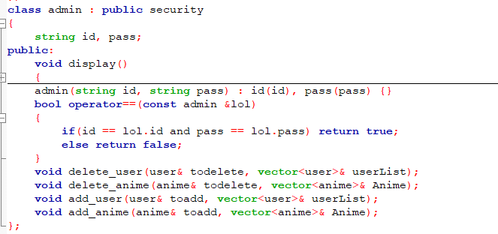

User class:

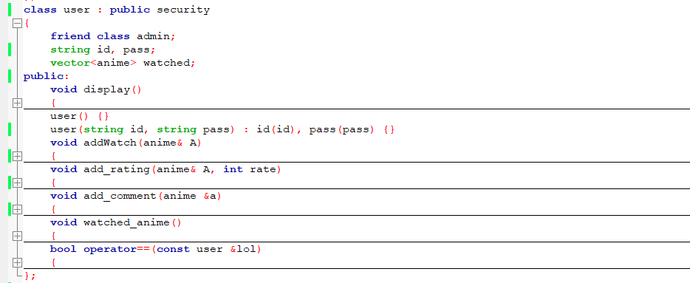

Anime class:

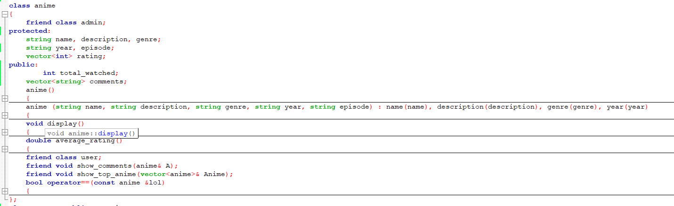

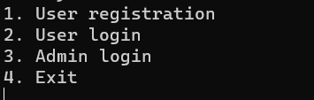

This is the first menu we get after launching the program. We get 4 options here.

For option 1 there is user registration. The code for this is:

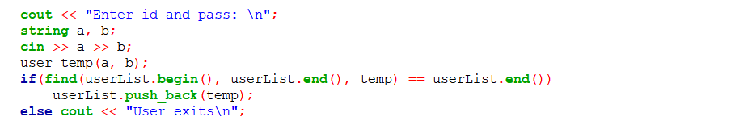

Then in user login we get to enter a new menu after successfully logging in.

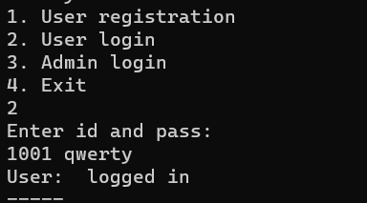

The new menu:

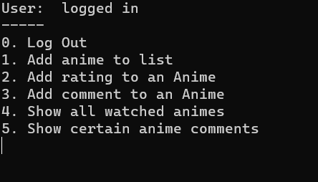

In users section I can add an anime to my watchlist:

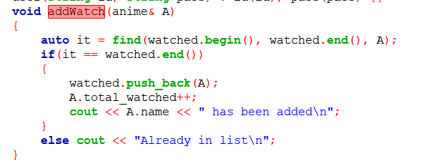

We passed a reference of an anime object here.

Same way we rated an anime:

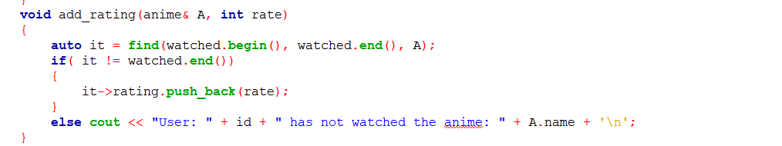

Commenting in an anime:

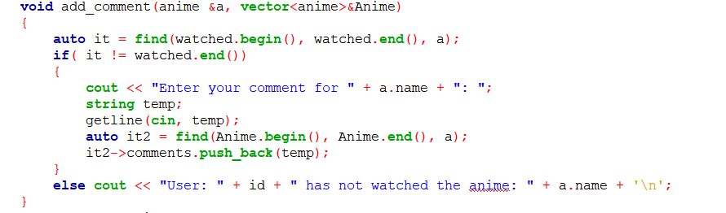

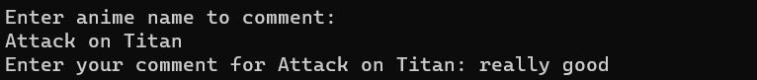

Showing all comments on a certain anime:

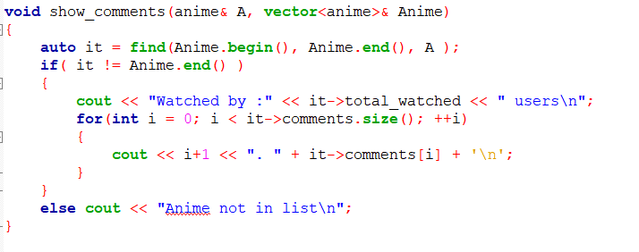

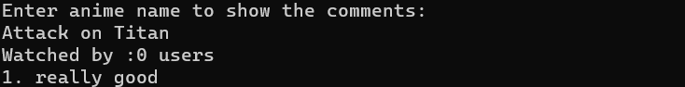

The function show_comments is friend function of anime class.

Showing all the watched animes of a user

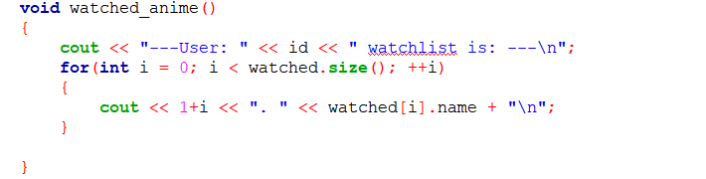

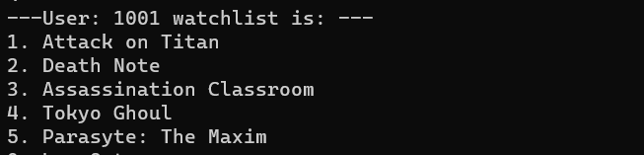

Usage of operator overloading:

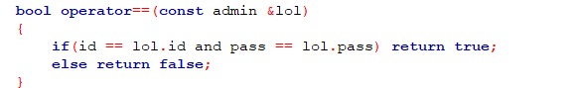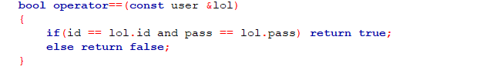

While implementing the find function I stumbled across an error where I understood that I needed to overload the == operator.

**The Admin Menu:**

**Adding and deleting an anime:**

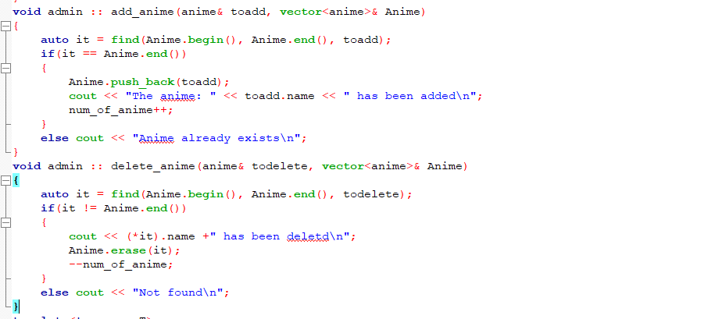

All of this became very easy by using iterators and some functions from the algorithm header file.

**Adding and deleting a user:**

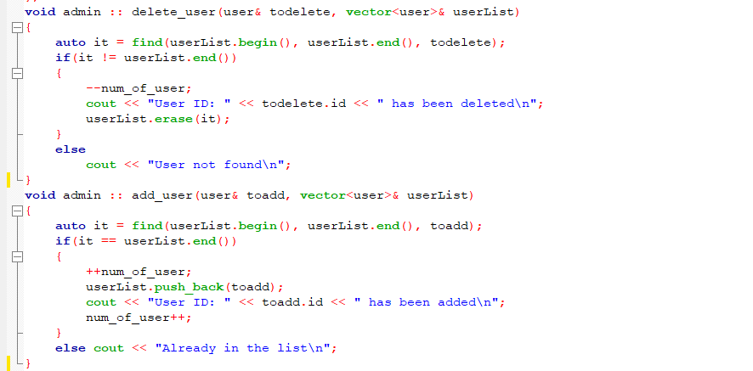

A small function to use templates:

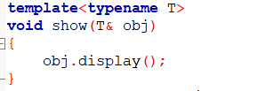

I later used this to write the output in files

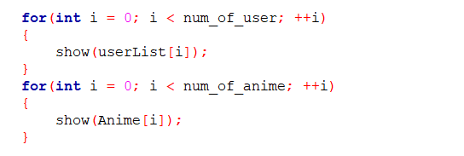 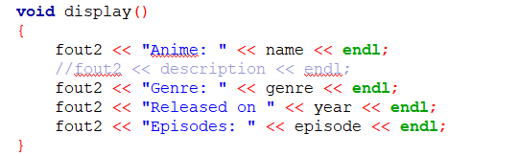

An abstract class security being inherited by user and admin

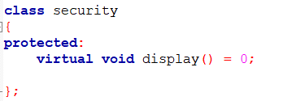

 

Reading from files:

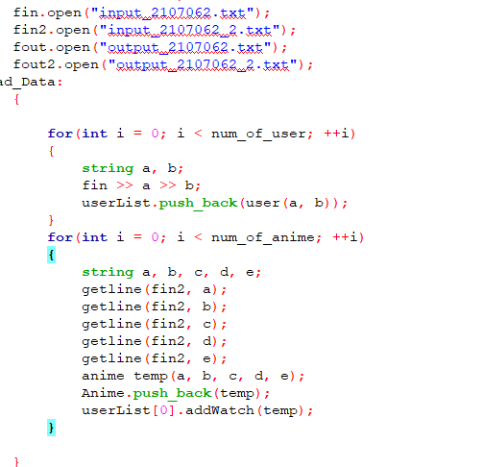

**Discussion:**

This anime management system is not the complete of MyAnimelist.net but i have tried to implement some basic functions in this. I used all the basic concepts of Object Oriented Programming in this project. Inheritance, polymorphism, encapsulation, reading/writing from file, templates, standard template library etc. While making the project I had to debug it for a lot of time, which made me realize how hard and stressing it is to really build something. Doing this has added some experience to my coding life. I enjoyed it even though it was stressful.