Latihan 10
Nama: Muhammad Danish Athaurrahman
Kelas: TI – 1C

1. a.
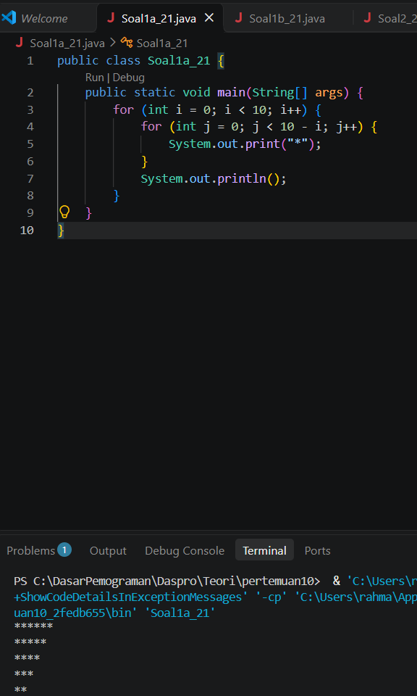
for i = 0 to 9
for j = 0 to (10 - i) - 1
print "*"
end for
println
end for
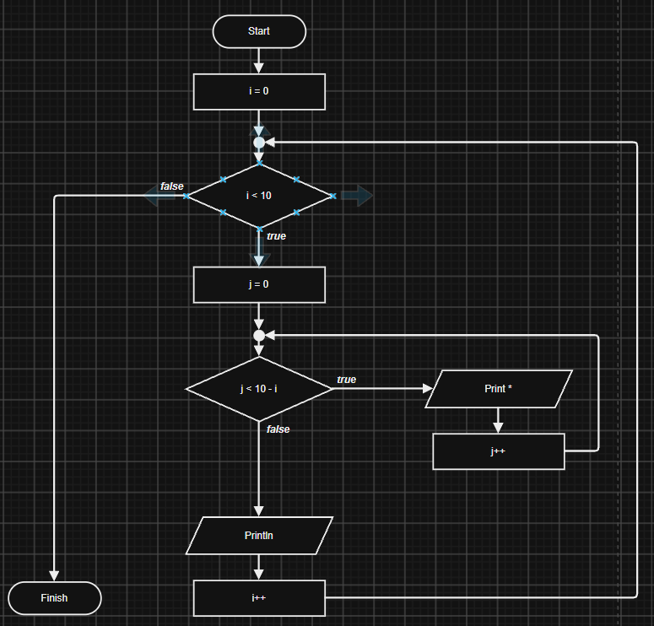

1.b.
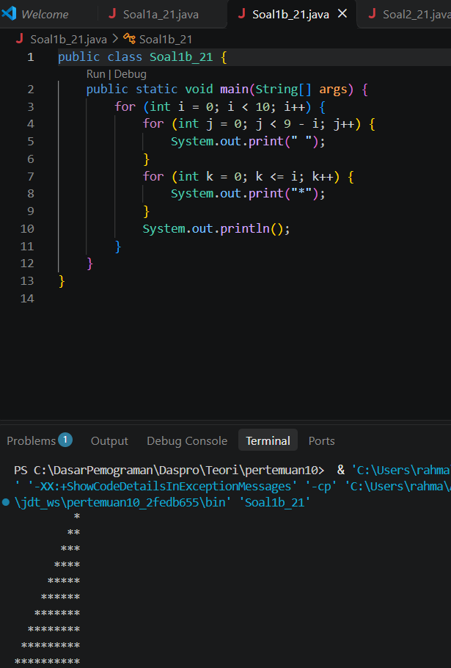
for i = 0 to 9
for j = 0 to (9 - i) - 1
print " "
end for
for k = 0 to i
print "*"
end for
println
end for
2.
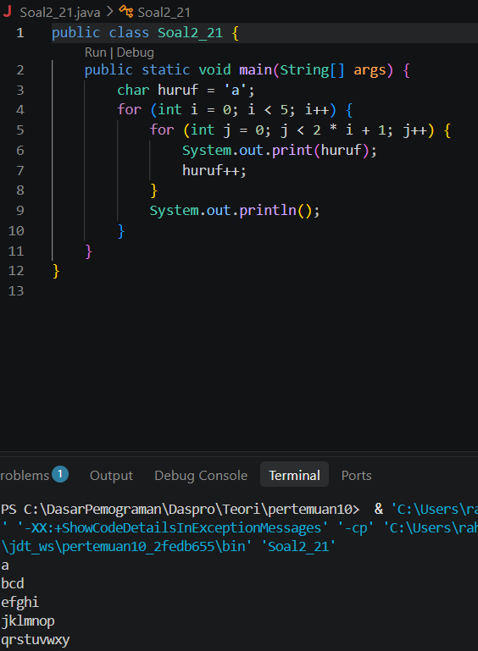
huruf = 'a'
for i = 0 to 4
for j = 0 to (2 * i)
print huruf
huruf = huruf + 1
end for
println
end for
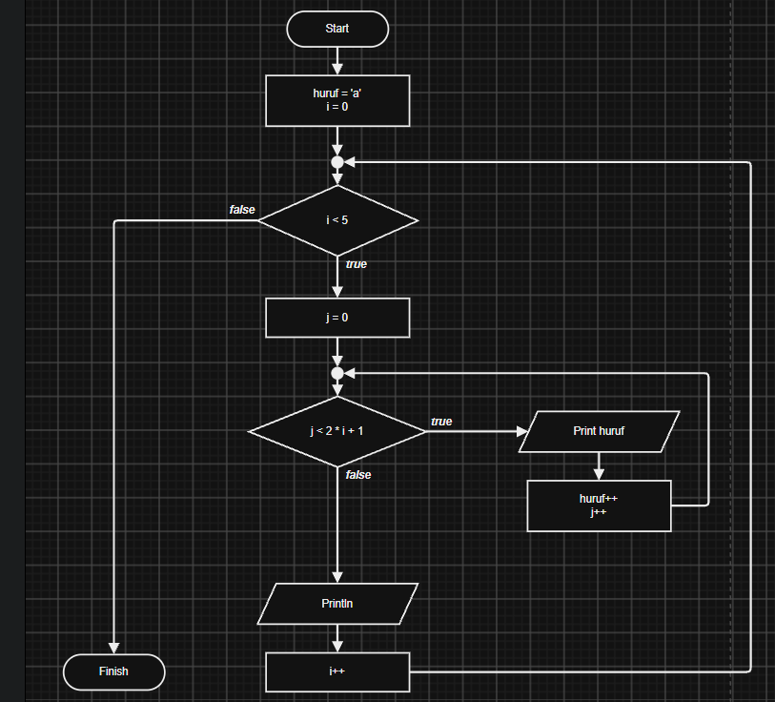

3.
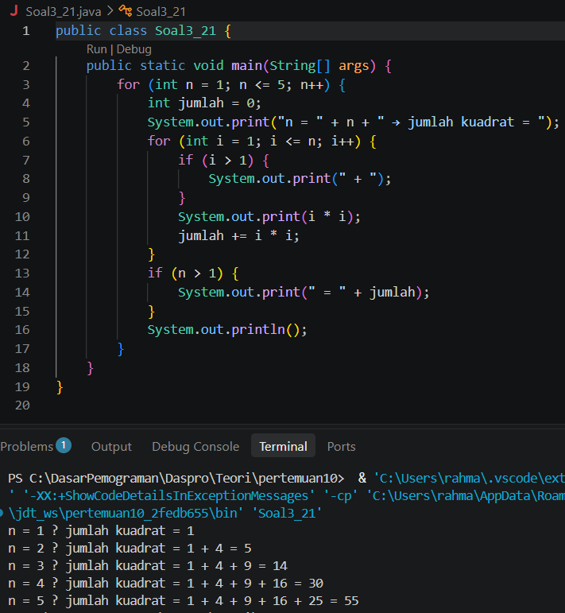
for n = 1 to 5
jumlah = 0
print "n = " + n + " → jumlah kuadrat = "
for i = 1 to n
if i > 1 then
print " + "
end if
print i * i
jumlah = jumlah + (i * i)
end for
if n > 1 then
print " = " + jumlah
end if
println
end for
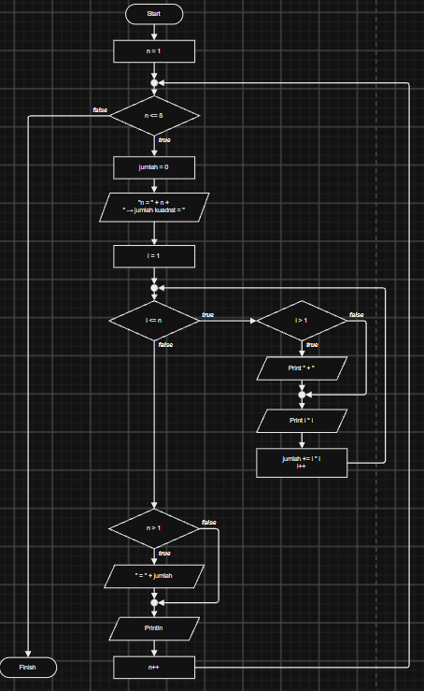

4.
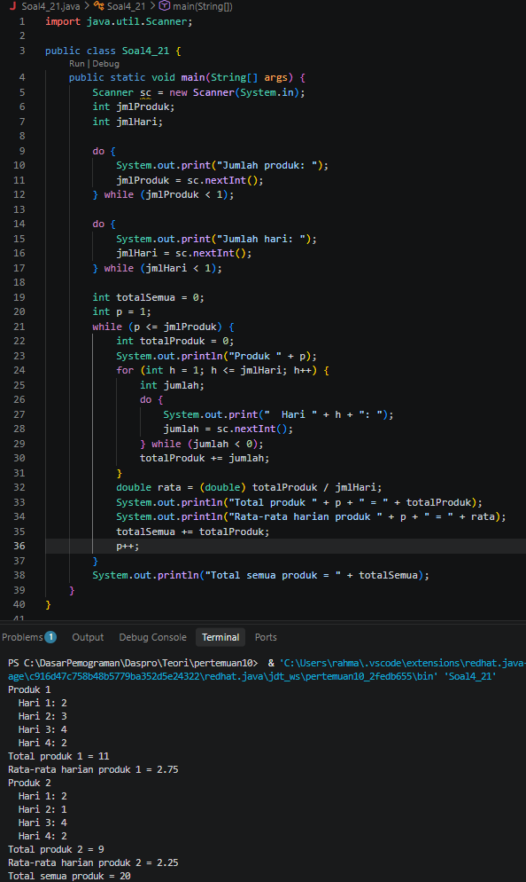
do
input jmlProduk
while jmlProduk < 1

do
input jmlHari
while jmlHari < 1

totalSemua = 0
p = 1
while p <= jmlProduk
totalProduk = 0
for h = 1 to jmlHari
do
input jumlah
while jumlah < 0
totalProduk = totalProduk + jumlah
end for
rata = totalProduk / jmlHari // tipe real/desimal
output p, totalProduk, rata
totalSemua = totalSemua + totalProduk
p = p + 1
end while
output totalSemua
