**CSE221 - ALGORITHMS**

**LAB05 : KRUSKAL'S ALGORITHM**

**Submission Due: 16th Nov, 2016**

**Task 1**

**Implement Kruskal's Algorithm to find MST for any given weighted graph.**

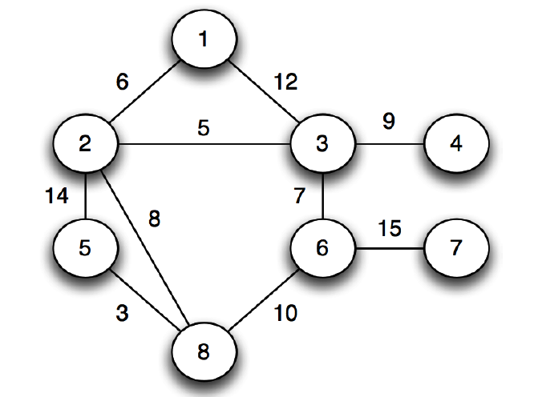

**Sample Graph for Input**

**MST for given Input Sample Graph**

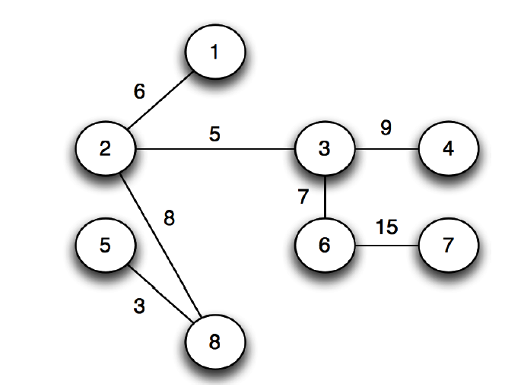

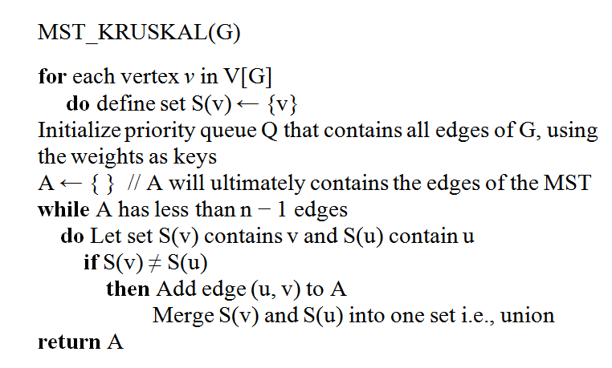

**Pseudo-code for Kruskal's Algorithm**