Amago: A Cloud-Based Produce Market for Independent Farmers, Grocers and Retailers

Abir Rahman, Ishfaq Zaman, Jawad Aziz Khan, Dr. Mohammad Monirujjaman Khan
Department of Electrical and Computer Engineering
North South University
Dhaka, Bangladesh
abir.rahman1995@gmail.com, uzushin101@gmail.com, jawad.aziz.khan.jak@gmail.com

Abstract—Bangladesh suffers from fluctuating prices of produce due to several factors, such as transport costs, seasonal supply demand changes, forced price inflation by stocking goods when demand is high and many more. Each of these factors is a unique problem but some of the solutions to these problems are data driven. Amago is a digital produce market platform that aims to eliminate inefficient, unfair and unprofitable segments of the country’s existing pipeline of the agricultural trade. The optimization of calculated minimal waste crop yield is a data problem where supply and demand data should be leveraged for prediction that our proposed system could potentially solve. Another point of inflection where profits are unfairly lower are for the farmers when sold to the unregulated middle men. Thus the Amago platform has been proposed as a better solution for a digital future.
Keywords—farming, agriculture, market, economy, farmer, retailer, data, produce, harvest, crop, yield, grocer

Introduction
In this paper, we propose an efficient, semi-automated produce warehousing platform that will quickly accumulate produce directly from the farmers based on market demand and ship them to urban retail grocery stores.
Farmers will post a sell request through an android application. Our system will process these requests and accumulate the produce until reaching maximum storage capacity. Retailers will be able to order through a online web interface, once an order is received it will be directly shipped to their specified store/outlet. The optimisation objective of the platform is to minimise the time the produce spends inside the warehouse.

Previous Work
Currently there exists no such solution in the market. Studies show that there are several challenges that have affected the agricultural industry over the years, this includes climate change, inefficient use of water and fertilizers, pests, lack of quality seeds, unfair pricing and insufficient investment in research [1]. There are multiple emerging agro-tech startups that are planning to tackle these challenges.

iFarmer
"ifarmer.asia" [2] is a Bangladesh based startup that is providing an investment platform for farmers. Farmers can sign up to work for designated farms. These farms are then advertised for sponsorship by the platform. The sponsor and farmer share the profit from the farm giving a commission to the platform.

Impact Terra
"Impact Terra" [3], a Myanmar Based startup, is designing an application to help smallholder farmers by providing real-time recommendation of leading agricultural information. Their digital service "Golden Paddy" consist of a web/android application and a Facebook page. Aiming to be an effective tool for efficient farming.

ACI Fosholi
On July 2019, ACI launched ‘Fosholi’ an android app which aims to create an agricultural platform in Bangladesh. It promises to enable 15 million farming families to access high quality agricultural data and services from the app. Fosholi offers intelligent information and advisory services to local crop farmers for free. Fosholi will help farmers by providing information on crop suitability, modern agronomic technology and practice, pest and disease alerts and weather forecasts. Thus, it will improve farmers’ decision making and farming productivity and ensure the overarching national goal of sustainable food and nutrition security.

Plantix
"Plantix" [4] is an Android based farming assistant tool. It provides crop health checking through the use of computer vision, connects farmers to scientists, experienced farmers and plant experts.

Working Procedure
Our project "Amago" aims to output an online service coupled with an app and a web client that will digitally connect the aforementioned users in a produce marketplace, similar to modern e-commerce services.
The project consists of the following key hurdles:
- Segment the Client Types
- Android App for Produce
- Web Interface for Retail
- Database Storage
- Introduce to IRL users
- Leverage Data for prediction models

For the first stretch of our project, we have accomplished planning and setting up the database, its schema, started building a prototype Android app with Bangla support and a website frontend that uses the application layer API.
We've begun working on our backend database running on PostgreSQL running on an online cloud hosting platform called Heroku. The database has been initialized with relevant dummy data to test queries and API calls. We have also used Node.js to connect with the Heroku database and written API to handle HTTP requests and responses between the client and the server.
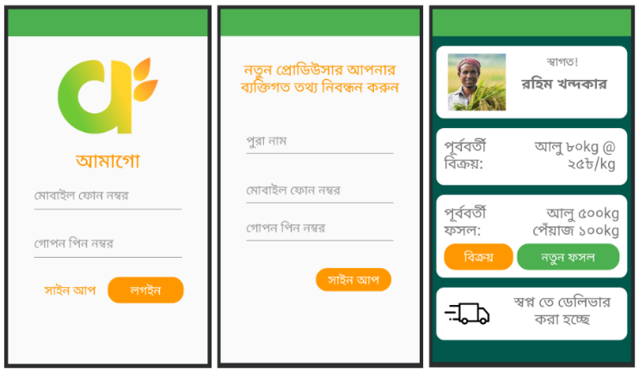
End-users such as farmers will use the Android app. They will login simply with their phone number and PIN, curate harvests and post them onto the app. The app even allows users to select between Bangla and English as their interface language, to maintain user-friendliness. The designs of the app can be seen below:
- Screenshots from the Android app.
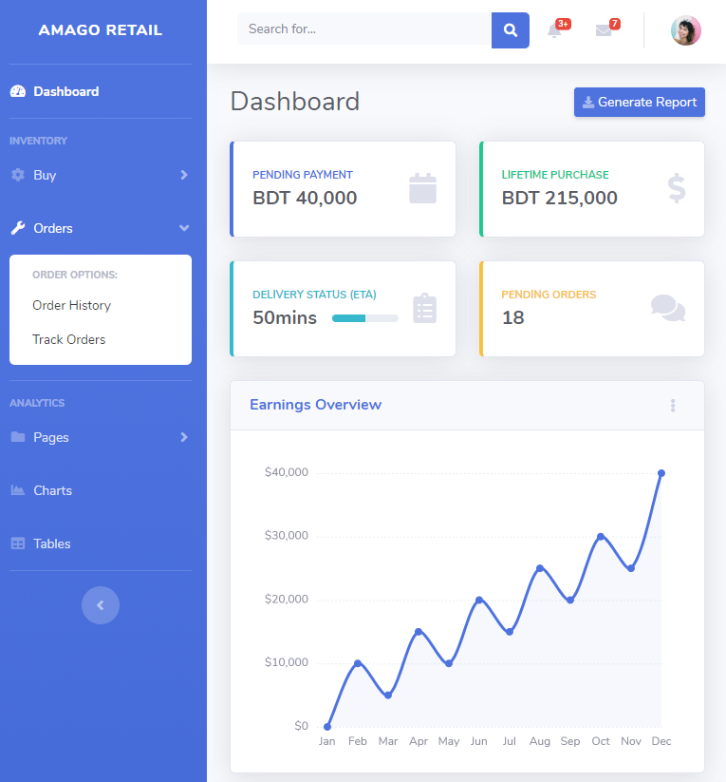
For client-side retailers, we have started work on a web frontend where users can login, register and view the main dashboard where they can track their store's orders and other information. Below is a screenshot of the website:
- Screenshots from the Android app.

System Architecture

Database and Backend
The proposed system will operate using a PostgreSQL Relational Database System. The database will log user account details, transaction requests, inventory and geolocation data. The backend will be managed using a Node framework called ExpressJS and queries will be managed by the Sequelize framework. The robust ExpressJS framework is used to create APIs that is used for communicating with the server through an Android app/Web interface. Whereas Sequelize is a database bridging manager that handles queries written in Javascript then dynamically and efficiently translates it for the PostgreSQL hosted database.

Retail Web
Our retail clients will be provided with a web interface. The web interface will be a dynamic website designed using HTML, CSS and JavaScript. The clients will be able to place orders for produce based on their needs. Below is a very simple diagram of our system:
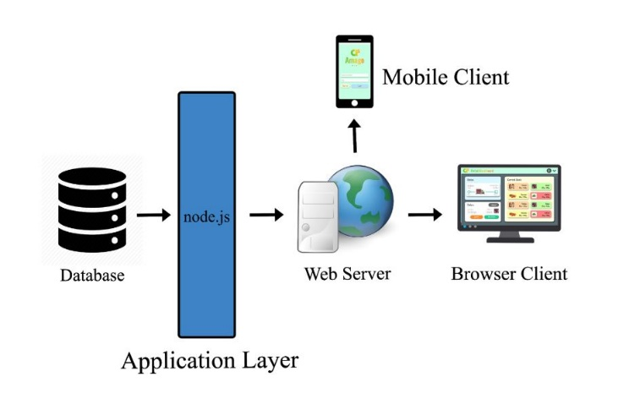
- Overall System Architecture.

Android App
The Android app, its API frameworks and the UX will follow Google's "Material” design principles. Standard software patterns and Object Oriented design was considered during the development of the app. It was done in a Linux Android Studio environment and tested on a Virtual Device running Android 5.0. The app was laid out such that non tech savvy farmers will be able to use it based on its easy operations and simple atomic functions.
Another significant way farmers can better use the app with minimum difficulty is by making the entire interfacce of the app fully in Bangla. This is done with a dynamic locale management system and is maintained by cross translating every possible string used in the interface in a refernce resource table as seen below:
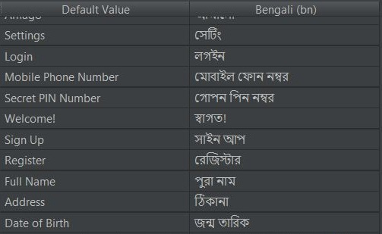
- Screenshot of Translation table.
The UI surrounding the text is designed with ‘user look flow’ in mind and buttons given large welcoming shapes and colors. Text is displayed at a highly readable 24dp and colors are contrastive as they are set up in a triadic pairing.
Farmers’ login credentials are sent to the server API via the Retrofit framework. Retrofit is a high level third party Android framework dependency that makes sending and processing HTTP Requests vastly convenient, concise and streamlined. This is done by handling all GET and POST operations like regular functions from within Android and passed to the Retrofit Interface class to run. Retrofit functions need to be declared in the Interface class along with it’s required fields. For example, for a ‘login’ POST request the only fields needed would be the phone number and the PIN. The interface function declaration looks something like:
@FormUrlEncoded
@POST("api/auth/login")
Call<ResponseBody> Login(
@Field("phone") String phonenumber,
@Field("password") String pinnumber
);

After declaration of the interface it is only a matter of calling the function, sending the necessary parameters and parsing any responses sent from the server. The return type of the functions are of ‘ResponseBody’ type which can be parsed as a JSON.
Sell requests and Harvest posts through our app are displayed on the main home page in a vertical linear view, with each operation and item segmented as a card. Each operation reloads the home page and calls the server for an updated list of harvests and sell requests. Sell requests are coupled with a status integer denoting the stage of the harvest and the correspoding card is changed to reflect it. For example when a harvest is accepted for delivery, the card can display an icon of a truck, the recipient’s name and location.

Results and Discussion
The last four months have been used to mostly develop the knowledge base to attempt a project like this. Market research and choosing the right technologies for the job was a crucial part of the time spent. Initially we had spent most of our hours going through tutorials and documentations of Node.js, PostgreSQL and Android Studio development.
We found that using Node.js as our primary application server technology would triumph over using raw PHP as it provides much higher scalability due to its asynchronous network command execution. This enables it to handle much higher user traffic compared to PHP.
We created an API based server side application that would make it easy for future expansion and upgrades, also making it easy to develop. Our initial strides were to make sure future development is smooth. Planning took a major portion of the project timeline because of the extensive scale of the project.
Results of this planning mostly include an in-progress Android application and backend services. We mostly focused on building the backend services to make sure that they were as dynamic as possible to help ease the way of development further down the line.

Future Plan
We plan on leveraging the large data that the system will amass if users join the platform. We plan to apply machine learning to make sensible understanding of all that data. We also plan to introduce new features such as farmer support and automated warehouse management tools. Computer vision models can also be used to help farmers identify crop health and other useful info, similar to "plantix".

Conclusion

In conclusion, the first phase of our project has forced us to take up new and exciting technology, that we plan to fully take advantage of. Development went along as planned, with some unavoidable and unfavorable hurdles.

Acknowledgment
Our special and humble thanks goes to our supervisor, Dr. Mohammad Monirujjaman Khan, for his intense support throughout the several months long duration of the project. We would also like to thank Shabbir Khan, Koushik Roy and Nur Islam for their friendly support.

References
- Mohammad H. Mondal, “Challenges And Opportunities Of Sustainable Crop Production In Bangladesh.” Eighth Biennial Agronomy Convention. Bangladesh Society Of Agronomy, 2010.
- iFarmer.Asia. https://ifarmer.asia/
- Impact Terra. https://www.impactterra.com/
- Plantix. https://plantix.net/en

