London housing: Unlawful renting of short-term lets on the rise - BBC News
More than 50% of STR in London exceeded the 90 day limit. Influences local communities in terms of fly tipping and noise complaints.
A government spokesman said: "We will introduce a short-term let registration scheme to reap the benefits of a thriving tourist economy while protecting the spirit of our communities." Another government spokesperson has commented that concentration of STR lets drive up housing costs. Thus, its plausible that in the future new regulations will be introduced to address this concern.
According to central London Forward's report, In 2015, there were fewer than 30,000 short-term lets in London, which more than doubled throughout 2016 to 60,000, peaking at over 100,000 in 2019.
The numbers of short-term lets then "fell dramatically" in 2020 at the height of the Covid-19 pandemic, before making a "steady recovery," the report added.
Unpacking Key London Short-Term Rental Data for 2024
The supply growth of listings since 2023 has outgrown the demand growth, which is still recovering from the pandemic (demand in 2024 was 17% lower than the demand in 2019)- This highlights the importance of choosing the best investment as competition is fierce. When supply is higher than demand, occupancy rate decreases.

Airbnb ADR: What It Is & How to Increase It
Useful metrics that can be used to compare houses. ADR is the Average Daily Rate (average price you charge per night):
- Revenue Per Available Room (RevPAR) takes the concept a step further by considering both the average daily rate and the occupancy rate. It's calculated by multiplying ADR by the occupancy rate or dividing total revenue by the total number of available rooms. This gives a more comprehensive view of a property’s financial performance, blending how often rooms are filled with how much is made from them. Unlike ADR, which looks purely at revenue from booked nights, RevPAR tells you how well you're utilizing your total available inventory.
- Capitalization rate: The cap rate is a metric for evaluating the return on investment of a property, showing how it compares in profitability to others over the long term. Unlike ADR and RevPAR, which focus on short-term income and pricing, the cap rate assesses overall investment potential and risk by indicating the potential yield of a property based on its net operating income relative to its market value. This makes it essential for understanding the broader financial perspective of STR investments.
Instead of capitalization rate, we can find the ROI via yearly revenue and the cost to purchase the property. Could also look at ROA and how it fluctuates with time (since the asset value of the property will increase over time)

Explore Short Term Rental Trends in London 2025 - City Relay
The introduction of the renters right bill, which although primarily effects the long term rental sector may affect on the overall market and demand dynamics between short and long term rentals.
Over the past three years, there has been a 21% increase in rental prices over the past three years, whereas house prices have only increased by 4% in the same period. This stat is for the overall country.
Market trends supposedly* indicate that rentals that offer unique experiences enjoy higher demands- this may include properties with nicer views, closer to events etc. *skeptical as it references a blog page that speaks about global trends as opposed to trends in London.
Luxury amenities is a strong factor in attracting renters particularly in the luxury market. Theres also an increase in business travellers- so rooms with a home office may be a good consideration.

Short-Term Rental Licensing UK (2025) | Council Rules, Control Zones & Compliance Guide — Stayful
All properties have to comply with fire safety rules, gas and electrical safety certificates, Noise management and neighbour-friendly practices, Guest identity & record-keeping, planning & building permission, Public liability / commercial-standard insurance. These are mandatory requirements for licencing
Regulatory changes such as the 90-day limit on short term let were introduced in 2015 to address: housing availability, local rental affordability, neighbourhood infrastructure and community concerns (noise levels, etc). Operators who wish to rent out for more than 90 days a year have to seek planning permission from their local authority.
Zone 1 areas such as Westminster, Camden, Kensington & Chelsea, although the areas with the greatest rent prices, require planning consent for serviced accommodation / commercial short lets. Unlicenced operators may risk a fine upto £30k and delisting- councils are now beginning to tighten on this by using data from booking platforms and tax agencies.
An opportunity from this regulatory change is that compliant and professional operators will thrive* as the changes will lead to listing supply to shrink. * can see this taking hold already as 1% of owners own 21+ properties- yet this same 1% own 24% of all properties listed.
Planning permission documentation can be prepared via the help of consultant companies such as stayful.co.uk or ethicalplanning.co.uk.
CBP-8395.pdf - house of commons research briefing the growth of STRs
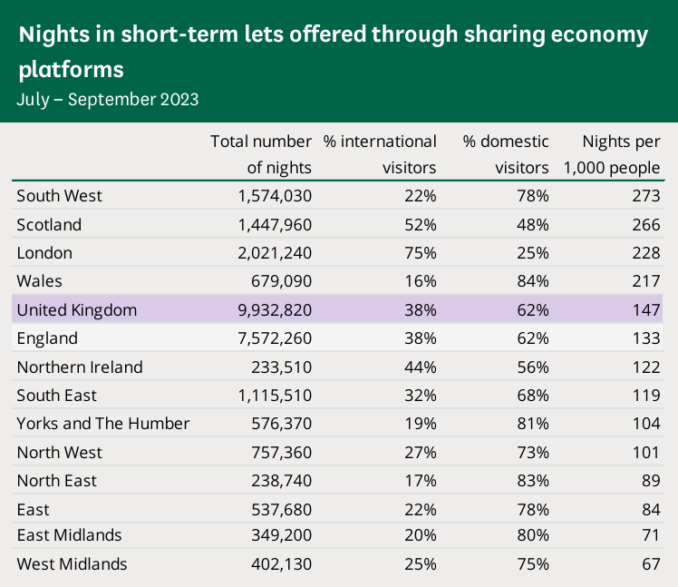
The table above shows that London constitutes 20.35% of number of nights spent across all STL platforms. Moreover, the proportion of international visitors was 75%, double that of the average (38%).

PowerPoint Presentation
67% of STLs (Short Term Listings) were in ‘Central London Forward member boroughs’ (strategic partnership of London boroughs that constitute central London. Aim to drive forward economic growth and inclusion). Could construct heat map to demonstrate this..

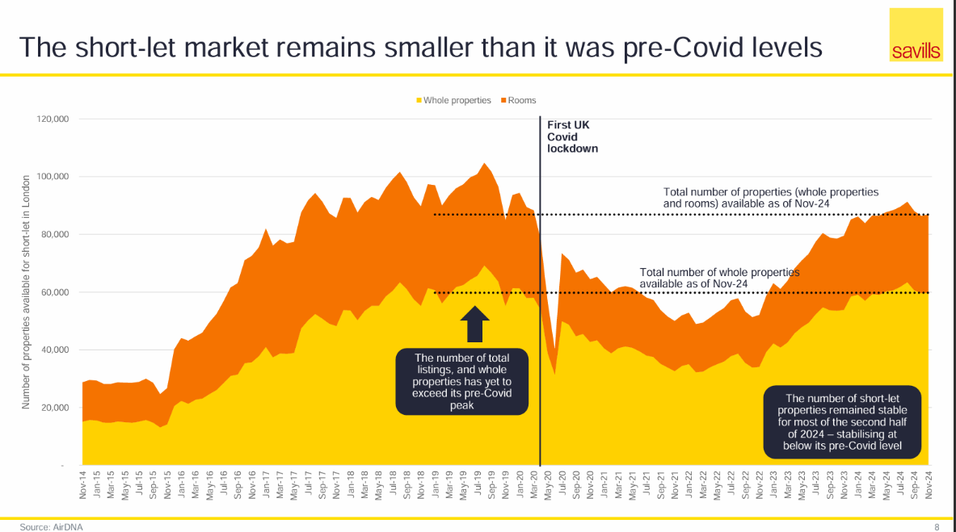

Taxes
Responsible hosting in the United Kingdom - Airbnb Help Centre
Earnings from Airbnb are taxable income, meaning owner may be charged income tax or corporate tax if operating as a company.
If renting out a property for 140 or more days, owner is subject to business rates as it deemed to be a ‘self catering property’.
If you earn over £85k, you are charged value added tax at a rate of 20%.
If renting out a room, can take advantage of the rent a room tax relief scheme which allows you to claim £7.5k tax free allowance.

Renting out your property: Paying tax and National Insurance - GOV.UK
The first £1,000 of your income from property rental is tax-free. This however cant be claimed with the rent a room tax scheme on the same income.

If operating as a company: You or your company must pay tax on the profit you make from renting out the property, after deductions for ‘allowable expenses’.
Allowable expenses are things you need to spend money on in the day-to-day running of the property, like:
- letting agents’ fees
- legal fees for lets of a year or less, or for renewing a lease for less than 50 years
- accountants’ fees
- buildings and contents insurance
- maintenance and repairs to the property (but not improvements)
- utility bills, like gas, water and electricity
- rent, ground rent, service charges
- Council Tax
- services you pay for, like cleaning or gardening
- other direct costs of letting the property, like phone calls, stationery and advertising

Other fees
Airbnb Commission in London: What Percentage Does Airbnb Take?
Host service fee, which is roughly 3% of the booking subtotal.

