Project Documentation

**Project Title**: **Cookbook**: Your Virtual Kitchen Assistant

# Introduction

* + **Project Title:** **Cookbook**
  + **Team Leader:**
  + AYUSH NAVNATH GAIKWAD
  + **Team Members:**
  + - ABDUL RAHMAN KHAN. Y
  + - AJAY.N
  + - ARAVIND KUMAR. A

# Project Overview

Purpose: **Cookbook** is a web application designed to revolutionize the way users discover, organize, and create recipes. It caters to beginners, cooking enthusiasts, and professional chefs by providing an interactive and collaborative platform.

Features:

* + Dynamic recipe search and filtering
  + Recipe organization and personal collections
  + User-friendly interface with engaging design
  + Community-driven sharing and collaboration
  + Personalized recommendations based on user preferences

# Architecture

* + Frontend: React.js with Tailwind CSS
  + Backend: Node.js with Express.js managing APIs and business logic
  + Database: MongoDB for user data, recipes, and community interactions

# Setup Instructions

* + Prerequisites: Node.js, MongoDB, Git, React.js, Express.js, Visual Studio Code
  + Installation Steps:

Clone the repository:

git clone <repository_url>

Frontend setup:

cd client **npm** install Backend setup:

cd ../server **npm** install

# Folder Structure

**Cookbook/ ■-- client/ # React frontend ■ ■■■ components/ ■ ■■■ pages/ ■**

■■■ assets/ ■ ■-- server/ # Node.js backend ■ ■■■ routes/ ■ ■■■

models/ ■ ■■■ controllers/ ■ ■■■ middleware/ ■ ■■■ README.md

# Running the Application

Frontend:

cd client **npm** start Backend:

cd server **npm** start

Access: Visit [http://localhost:3000](http://localhost:3000/)

# API Documentation

* + User: /Api/user/register, /Api/user/login
  + Recipes: /Api/recipes/ (fetch all), /Api/recipes/create, /Api/recipes/:id
  + Community: /Api/community/share, /Api/community/feed

# Authentication

JWT-based authentication for secure login. Middleware protects private routes.

# User Interface

* + Landing Page
  + Recipe Discovery Page
  + Personal Cookbook (saved recipes)
  + Community Sharing & Collaboration
  + Admin Panel (optional)

# Testing

Manual testing during development. Tools: Postman, Chrome DevTools

# Screenshots

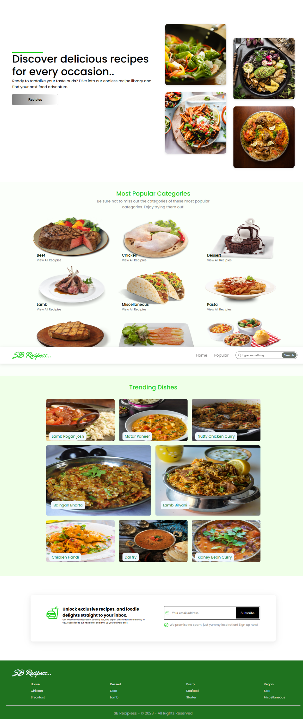

# Known Issues

* Limited recipe database (only a small set of recipes available right now).
* No image upload feature for custom recipes.
* Search results may not always be accurate with partial keywords.
* No offline mode (requires internet connection).
* Mobile responsiveness needs improvement.
* Admin panel features are still basic.

# 13.Future Enhancements

* AI-powered recipe suggestions
* Integration with smart kitchen devices
* Meal planning and grocery list generation
* Multi-language support