Abdul Rahman. M. B.
Senior Operations Leader | 28+ years Experience | Driving Business Continuity, Cost Optimization & Scalable Growth | Infrastructure Excellence | Digital Transformation | Workspace & Admin Leadership | Scaling Teams, Processes & Delivery
Chennai, India 📧 Email: rahmanchn@yahoo.com | 📞 Phone: +91 98407 04827
Linkedin: linkedin.com/in/abdul-rahman-m-b-b81891274/

Executive Summary
Dynamic professional with 28+ years of experience spanning Administration, Security Operations, Procurement, and Travel Desk management. Proven track record in streamlining operations, optimizing resources, and ensuring organizational safety and compliance. Adept at building efficient processes, managing cross-functional teams, and delivering cost-effective solutions. Known for reliability, operational excellence, and strong stakeholder coordination.
Industries: IT, ITES, Foutune 500, Startup, Midsize.
Core Competencies
- Seasoned professional with 25+ years of experience across Administration, Security, Procurement, and Travel Desk operations.
- Strong expertise in Digital Transformation, driving automation and process optimization for enhanced operational efficiency.
- Well-versed in ISO 27001 standards with hands-on experience supporting security compliance and risk management initiatives.
- Proven ability to implement Procurement Automation solutions that reduce cost, improve transparency, and streamline vendor management.
- Committed to ESG principles, ensuring sustainable and responsible business practices across operational functions.
- Excellent Stakeholder Management, collaborating effectively with leadership, vendors, and cross-functional teams to achieve strategic outcomes.
Key Achievements
- Successfully led the end-to-end setup of new corporate offices on multiple occasions ranging from 11k to 60k sqft, completing the project ahead of schedules by 15% and within approved budgets while ensuring seamless operational readiness.
- Spearheaded automation of key administrative and procurement processes, reducing manual workload by 40% and improving process turnaround time by 70% including Purchase order management system, Invoice management system, Petty cash management system, Cost capture MIS, Capex online, Visitor management.
- Implemented strategic cost-optimization initiatives across travel, procurement, and facility operations, achieving an annual cost reduction of 20% without compromising service quality or compliance.
Professional Experience
Eleviant Technologies Pvt & CTG Pvt Ltd
Role: Director Integrations
October 2021 – Present
- Official Director for a group Company – CTG Information Technology Services Pvt Ltd
- Signing authority for Employees Gratuity Fund
- Head Operations Facilities & Infrastructure
- Head Procurement including IT procurement & Travel Desk
- CSR – Improvement of Schools and Parks
- ESG – Carbon Tooling – Envizi (IBM Platform)
From Jan 2026 CTG became Cegeka.com
Designation: Director Site & Facilities, Procurement & Travel Desk
Role: remains the same.

Impiger Technologies Pvt Ltd
April 2007 – September 2021
- Head Infrastructure and Facilities
- Lead ISO 27001 implementation for physical security
- Spearheaded process automation initiatives
- Handled office expansions and relocations
- Managed Customer Support Operations for Voice Services & Auto Dialers, Streamlined and documented the processes and ensured penalty free operations

ADDITIONAL TECHNICAL ROLE
Customer Support
- IVS – Telecom Voice Services
Team management, Shift operations, Process formulation and documentation, Night shift management & Logistics
Streamlined the operations to minimize penalties and fines and customer complaints
- Sales Dialers
Process formulation & documentation, team management and night shift operations & logistics
Quality Management: ISO 9k & 27k
- Coordination with internal stakeholders
- Coordination with Quality consultants
- Process documentation
- Coordinate for audits & certifications
- Certified internal Auditor
Knowledge: Worked on Quality programs and Six Sigma, TQM workshops in Verti Software.
Software Process Automation:
Played end to end PM role and also been an active user
- Expenses capture– NEFT/UPI/Cash – Budget forecast
- Credit card management
- Purchase order management
- Invoice management
- Deliver Challan applications
- Capex online
- Workspace management – seating
- Petty cash online
- Repeated this whole exercise 3 times: 1) Sharepoint 2) Joget 3) Java in 3 different Companies.
Social Media Marketing:
- Was the earliest to explore Twitter and generated lots of leads for software development projects
- Provided data Analytics
- Supported the S&M team for events
TN Sand & MTC
- Interior Project end to end for PD & team
- CCTV installation in quarries
- CCTV installation in Buses

Vetri Software India Pvt Ltd
June 1997 – March 2007
- Infrastructure and Administration Lead
- Oversaw facilities, Physical Security documentations and customer audits, ISO, Renovations & Maintenance, Capex Procurements & Budgetting.

Personal Achievements
- Winner of Hackathon Awards
  - Hackthon Award for building Travel Management Software ApplicationHackthon Award for building Travel Management Software Application
  - Issued by Impiger Technologies Pvt Ltd · Jan 2016, Issued by Impiger Technologies Pvt Ltd · Jan 2016
  - This was a 2 days Hackathon (closed doors) where I lead a team of 6 with developers & designers and collaboratively developed this Travel Management Software Application - within 40 HRS.
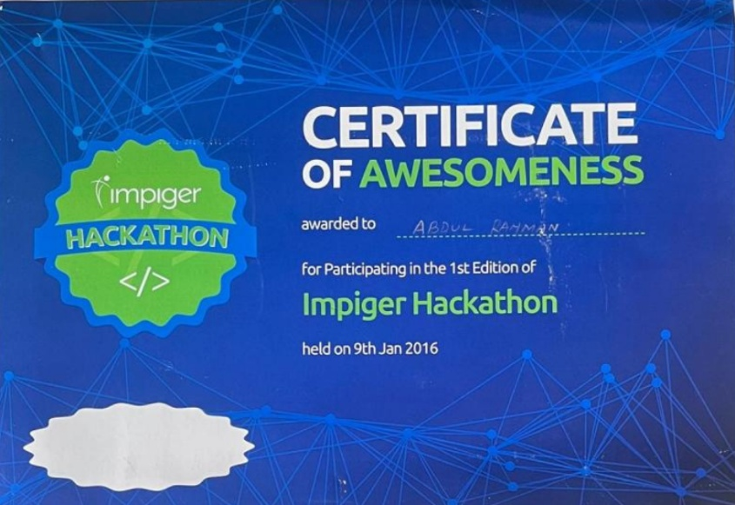
  - Won online content Hackathon conducted by US Team – 1000 USD
Extra Mile Award for Information Security Extra Mile Award for Information Security
Issued by Vetri Software India Pvt Ltd · Mar 2006Issued by Vetri Software India Pvt Ltd · Mar 2006

  - Vetri acquired by Lason. Introduced Lason Security Policies stringent than ISMS 27k
I was instrumental in documentation of policies, implementation, facing internal and customer audits.
Used to attend all leadership team meetings in place of my boss who used to nominate me on his place
  - Was a 2 years effort gaining tons of experience
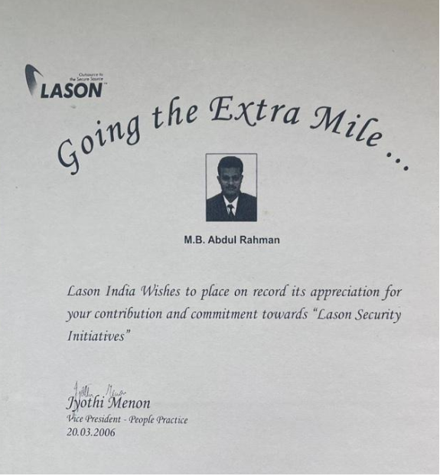

- Recognized for outstanding Time Management & Decision-Making skills
- Effectively utilized CTG online learning platform and completed 70+courses for personal development which includes Administrative, Customer service and AI

Education:
- Masters in Business Administration-M.B.A. from Alagappa University, completed in Sep’ 2006
- M. A. Personnel Management & Industrial Relations from Alaggppa University, completed in May 2004
- M. A. Public Administration from Annamalai University, completed in May 2002.

Technical Skills:
