Simple Pendulum
Faizur Rahman
Department of Chemical Engineering
BIT Sindri
6th Semester | Batch 2023–27 | Registration No. 23030420034
Project Modelling and Simulation Lab
Instructor: Prof. Ch V Raghunath
Email: faizurr464@gmail.com
GitHub: https://github.com/rahmanfaizur/simple-pendulum
1 Introduction
A simple pendulum is an ideal case of a swinging mass: we take a point mass m hanging from a light, inextensible string (or thin rod) of length L (Figure 1). The angle θ is measured from the downward vertical, so θ = 0 is the resting position. If the bob is displaced and released, it swings back and forth about this position.
Two forces act on the bob — its weight mg and the tension T in the string. It helps to resolve these along the string (radial, r̂) and along the arc of motion (tangential, θ̂). Because the string length is fixed, the radial part of gravity is balanced by tension (Fr = −T) and does not change L. Only the tangential component drives the motion:
Fθ = −mg sin θ (1)
Applying Newton’s second law along the path, with tangential acceleration a = L θ̈, gives
a = L θ̈ θ̂ (2)
and therefore the governing equation
L θ̈ = −g sin θ (3)
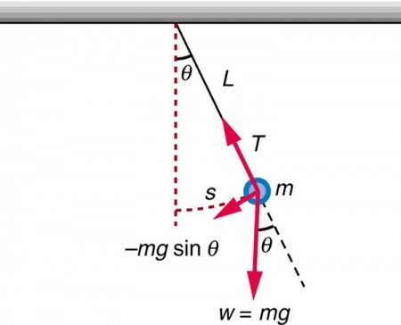
Figure 1: Simple pendulum of mass m at angle θ from the vertical, showing tension T, weight mg, and the restoring component −mg sin θ.
2 Analytical Approximation
Eq. (3) is nonlinear because of sin θ, so a closed-form solution is not elementary. When the swing is small (θ ≪ 1 radian), sin θ ≈ θ and the equation simplifies to
L θ̈ ≈ −g θ (4)
with solution (released from rest at θ = θ₀)
θ = θ₀ cos(ω t) (5)
Here ω = √(g/L) is the angular frequency. The motion is simple harmonic and the period is T = 2π/ω = 2π √(L/g), which does not depend on the amplitude in this limit.
3 Numerical Solution
For larger angles we integrate Eq. (3) on the computer. First rewrite it as two first-order equations by setting ω = θ̇ (here ω is angular velocity, not the frequency above):
dω = −(g/L) sin θ dt (6)
dθ = ω dt (7)
Differentials are replaced by small steps Δt (forward Euler). Starting from θ(0) = θ₀ and ω(0) = 0, we update θ and ω at each step. After n steps the time is t = n Δt. A smaller Δt gives a more accurate trajectory.
4 Sample Problem
Take a 40 kg steel bob (radius about 10 cm) on a 25 m wire — a large laboratory-scale pendulum. For small swings the expected period is T = 2π √(L/g) ≈ 10 s (with g = 9.81 m/s² we get T = 10.030 s). In the simulation below we release it from rest at two starting angles, 15° and 60°, and compare with the small-angle formula.
5 Python Implementation
import numpy as np
import matplotlib.pyplot as plt

plt.style.use('bmh')
figsize = (12, 5)
dpi = 150 # resolution in dots per inch
g = 9.81 # m/s^2
L = 25 # m
m = 40 # kg

def analytical_approximation(t, theta0):
return theta0 * np.cos(t * (g / L) ** 0.5)

def RHS(theta, w, dt):
"""Return the right-hand side of the ODE describing a simple pendulum."""
dw = -np.sin(theta) * dt * g / L
dtheta = w * dt
return dw, dtheta

def integrate_one_step(theta, w, dt):
"""Performs one step of integration."""
dw, dtheta = RHS(theta, w, dt)
w = w + dw
theta = theta + dtheta
return w, theta

def integrate_n_steps(theta0, w0, dt, n):
"""Performs integration for n time steps."""
theta = (n + 1) * [0]
w = (n + 1) * [0]
theta[0] = theta0
w[0] = w0
for i in range(n):
w[i + 1], theta[i + 1] = integrate_one_step(theta[i], w[i], dt)
return w, theta
Next we integrate for θ₀ = 15° and 60° over 20 s (n = 10000 steps) and overlay the analytical approximation on the same plot:
theta0_1 = np.pi / 12 # 15 degrees
theta0_2 = np.pi / 3 # 60 degrees
T = 20
n = 10000
t = np.linspace(0, T, n + 1)
dt = T / float(n)

w1, theta1 = integrate_n_steps(theta0_1, 0, dt, n)
w2, theta2 = integrate_n_steps(theta0_2, 0, dt, n)

plt.figure(figsize=figsize, dpi=dpi)
plt.title("Angular position")
plt.plot(t, theta1, "m",
label=r"$\theta_0=%.0f^\circ$" % (theta0_1 * 180 / np.pi))
plt.plot(t, analytical_approximation(t, theta0_1), "m--",
label="Approximation")
plt.plot(t, theta2, "g",
label=r"$\theta_0=%.0f^\circ$" % (theta0_2 * 180 / np.pi))
plt.plot(t, analytical_approximation(t, theta0_2), "g--",
label="Approximation")
plt.xlabel(r"$t$, [s]")
plt.ylabel(r"$\theta(t)$, [rad]")
plt.legend()
plt.show()
For 15° the numerical curve stays close to the cosine approximation. At 60° the two curves separate clearly — the small-angle assumption no longer holds. A better ODE solver would reduce numerical error further, but the main mismatch here is physical, not just the integrator.
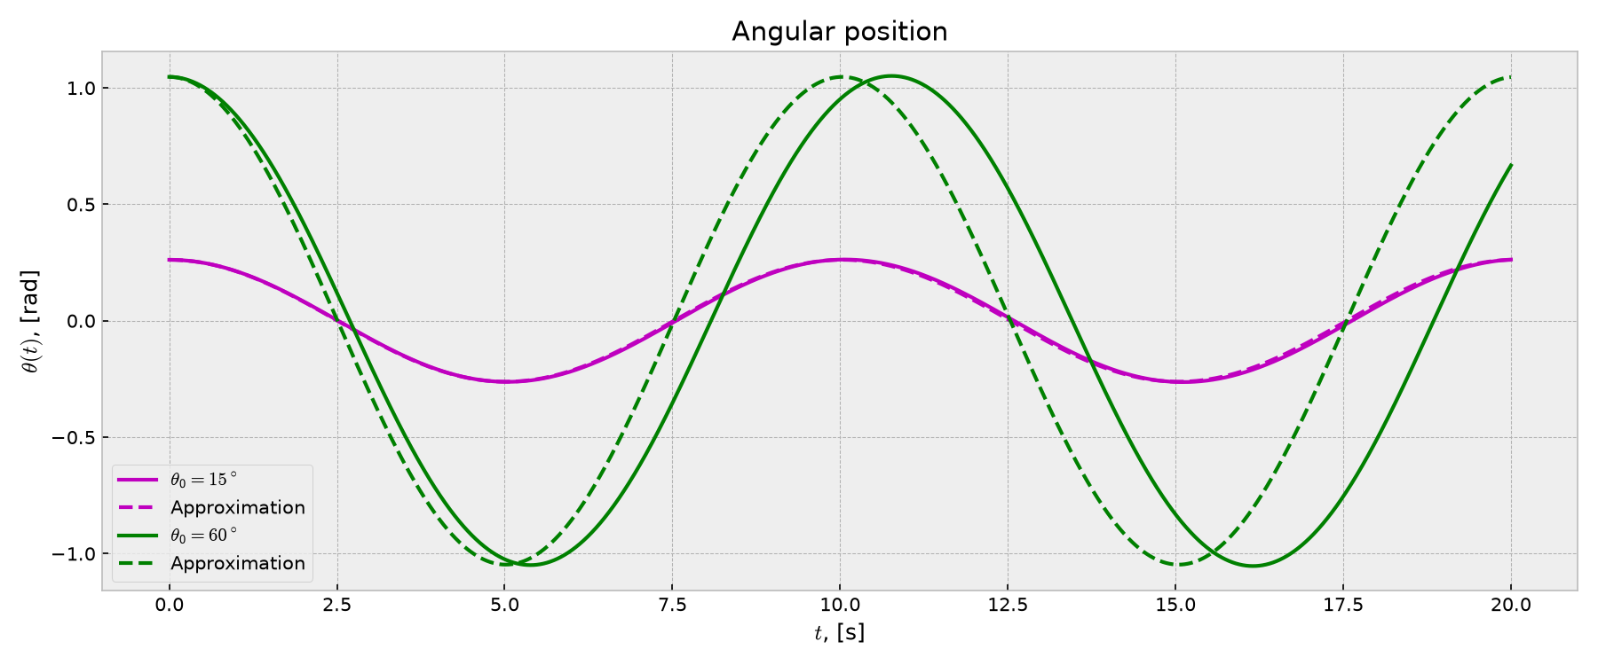
Figure 2: Angular position for θ₀ = 15° and 60° (solid) vs small-angle approximation (dashed).
6 Conservation of Energy
If there is no friction, total mechanical energy
E = U + K = mgL(1 − cos θ) + ½ m L² θ̇² (8)
should stay nearly constant. Plotting U, K and E for the 60° run is a quick check that Δt is small enough:
def compute_PE(theta):
return m * g * L * (1 - np.cos(theta)) # potential energy

def compute_KE(w):
return 0.5 * m * L**2 * np.asarray(w)**2 # kinetic energy

plt.figure(figsize=figsize, dpi=dpi)
plt.title(r"Mechanical energy, $\theta_0=%.0f^\circ$"
% (theta0_2 * 180 / np.pi))
plt.plot(t, compute_PE(theta2), label="Potential energy")
plt.plot(t, compute_KE(w2), label="Kinetic energy")
plt.plot(t, compute_PE(theta2) + compute_KE(w2), label="Total energy")
plt.xlabel(r"$t$, [s]")
plt.ylabel(r"$E$, [J]")
plt.legend(loc=1)
plt.show()

def compute_error(w, theta):
"""Computes the relative error."""
E0 = compute_PE(theta[0]) + compute_KE(w[0])
E1 = compute_PE(theta[-1]) + compute_KE(w[-1])
return np.abs((E0 - E1) / E0)

print("Relative change in E:")
print("Theta = %.0f: %.2e" % (theta0_1 * 180 / np.pi, compute_error(w1, theta1)))
print("Theta = %.0f: %.2e" % (theta0_2 * 180 / np.pi, compute_error(w2, theta2)))
Total energy barely drifts, so the chosen step size is acceptable. The relative change |E₀ − E₁|/E₀ for the two runs is:
Relative change in E:
θ = 15° : 1.56 × 10⁻²
θ = 60° : 1.33 × 10⁻²
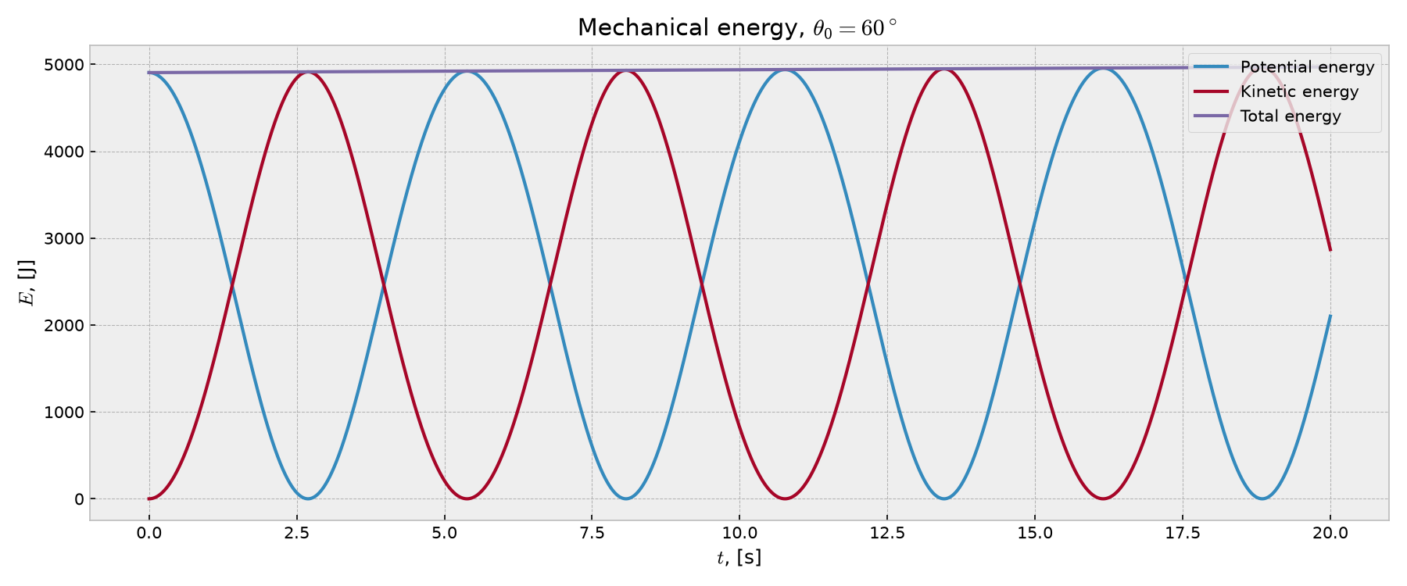
Figure 3: Potential, kinetic and total energy for θ₀ = 60°.

