Contents
Introduction 2
Data Analysis in Python 3
Data Loading and Exploration 3
Handling Data Pre-Processing & Integrity Improvement 4
Descriptive Statistical Analysis 7
Observing Data Distribution and Outlier Detection 13
Statistical Inferential Analysis with Hypothesis Testing 15
Correlation and Trend Analysis 17
Polynomial Trend Line for Yearly Global Sales 18
Forecasting Future Video Game Sales 19
Report on Exploratory Analysis of Video Game Sales 22
Summary of Approach & Key Results Interpretation 22
Limitations & Data Quality Considerations 25
Recommendations 25
Reflection on Skills & Learning 25
Environment and Setup 26
Conclusion 27
References 28

Introduction
The goal of this assignment is to perform a complete EDA process, from data loading through descriptive, inferential, correlational, and predictive analysis. At each stage, generate insights that can support decision-making for International Media Limited. The process highlights the importance of rigorous cleaning, the balance between statistical methods and business interpretation, and the limitations of working with aggregated datasets.

Data Analysis in Python

Data Loading and Exploration
The very first step in this analysis task is to load the video game sales dataset to perform the necessary analysis using Python. Since the Pandas library is a common tool for working with various data types in Python, the “read_csv()” function of Pandas is utilised to read the file as can be seen in the following Figure 1. Initial checking of the size of the data, column names, and first few rows are aimed to accomplish for understanding the structure of the dataset (McKinney, 2012).
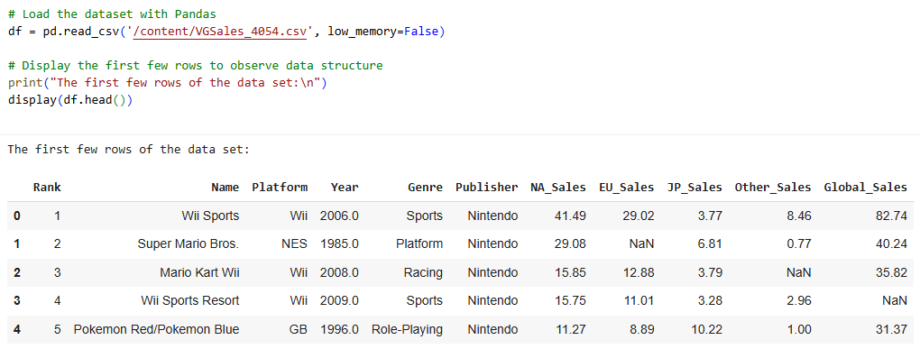
Figure 1: Data loaded and displayed on Colaboratory (Google Colab, n.d.).

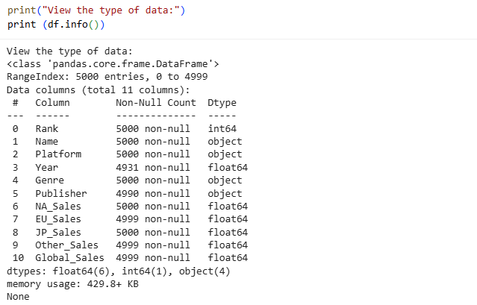
Figure 2: Columns of the dataset are printed to observe (personal collection).
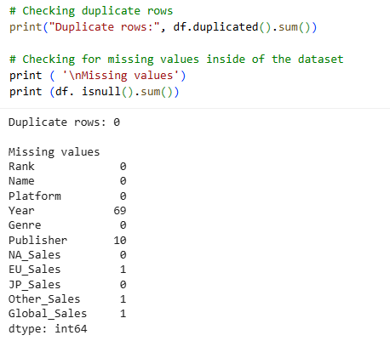
Figure 3: Duplicate rows and null value observation (personal collection).

After loading the dataset, the data types for each column have been observed, such as numbers for sales values and text for publisher names as in Figure 2. This step is very important because the wrong data type can cause errors in later analysis (VanderPlas, 2016). Missing values and duplicate rows are also checked as seen in Figure 3. As the part of the data exploration stage these checks gives an early view of possible problems and helps to plan the cleaning process (Han, Pei and Tong, 2022).

Handling Data Pre-Processing & Integrity Improvement
After carefully observing the dataset, several cleaning steps is suggested to make the data ready for analysis. As seen in the following Figure 4, white spaces in text columns need to be removed, and column names are to be standardised for avoiding errors when coding in Python. Missing values are handled by filling empty publisher names with “Unknown Publisher”. Missing regional sales figures are replaced with the mean of each region and global sales figures with the total of related regional sales. This process helps to keep the dataset complete and prevents bias caused by missing data (Han, Pei and Tong, 2022).
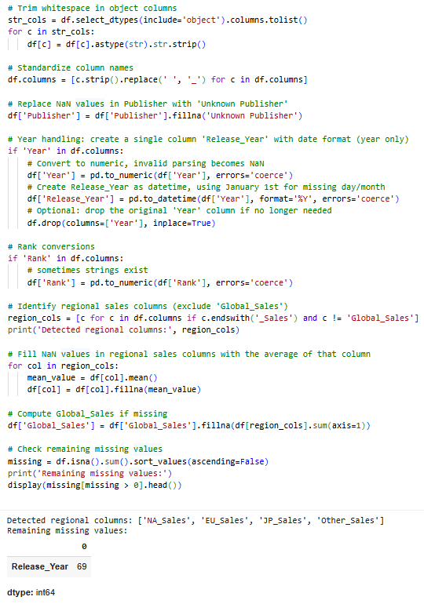
Figure 4: Applied data pre-processing techniques (personal collection).

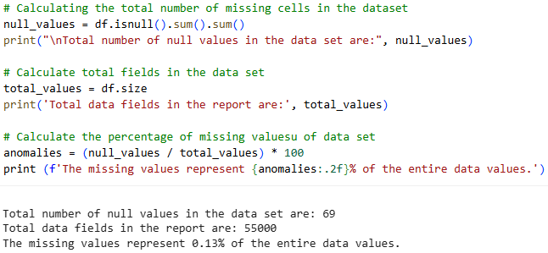
Figure 5: Calculated the proportion of missing values after data cleaning (personal collection).

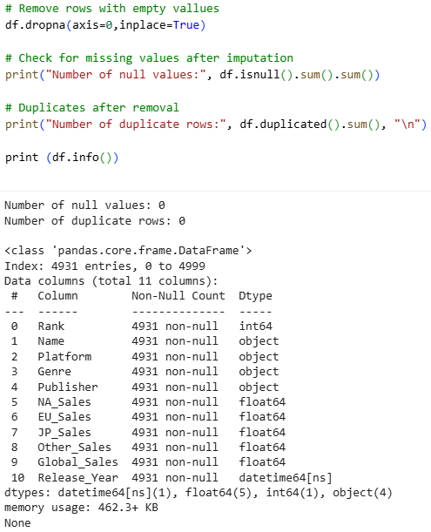
Figure 6: Removal of rows containing null values is applied (personal collection).

After performing the initial pre-processing, there are 69 missing values still exist in the “Release_Year” column which is 0.13% of the total data values as calculated in Figure 5. The total release year is 37 (from 2016- to 1980) so the mean or any random imputation for this column may affect the outcome of analysis. Since the dataset is large enough and the current missing values ​​are less than 5% also data deletion is acceptable in this case according to ApX Machine Learning (n.d.), it can be seen in Figure 6 that they were deleted instead of being imputed.

Descriptive Statistical Analysis
In order to find underlying patterns and relationships, descriptive statistics describe the data for gathering, organising, summarising, and presenting data. Central tendency and distribution measures, such as mean, range, variance, and standard deviation, are calculated with the primary goal of giving a concise and understandable summary of the data (Scott, D., 2020). All useful tools for visualising descriptive statistics have been utilised such as bar charts, line charts etc. to discover hidden insights of dataset.

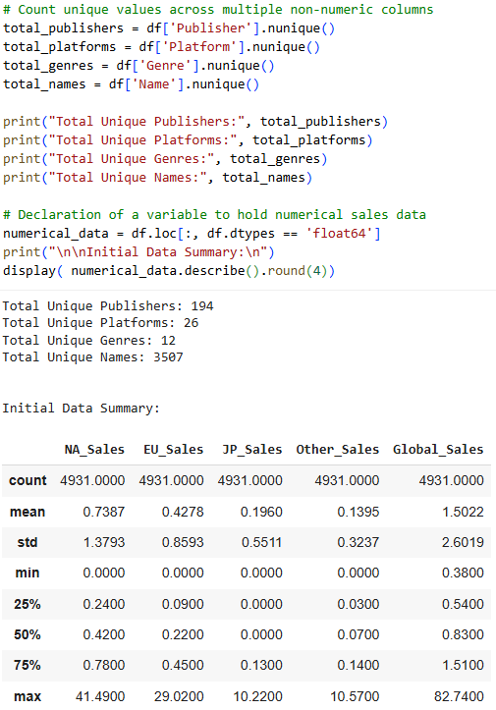
Figure 7: Overall summary statistics of video game sales dataset (personal collection).
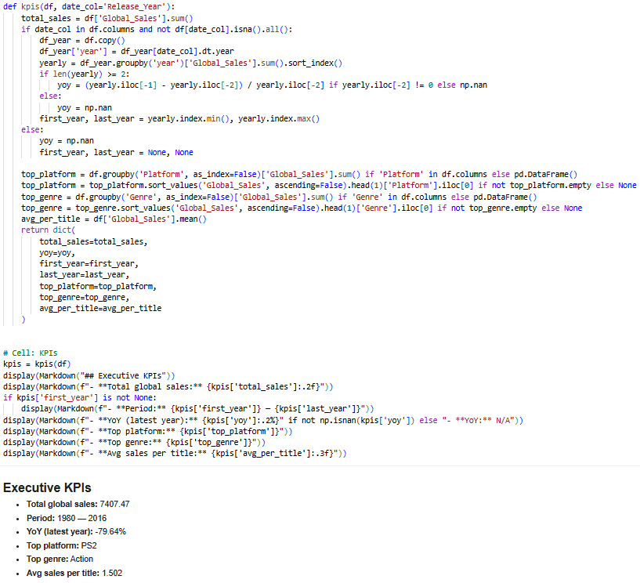
Figure 8: Calculations of executive KPIs (personal collection).
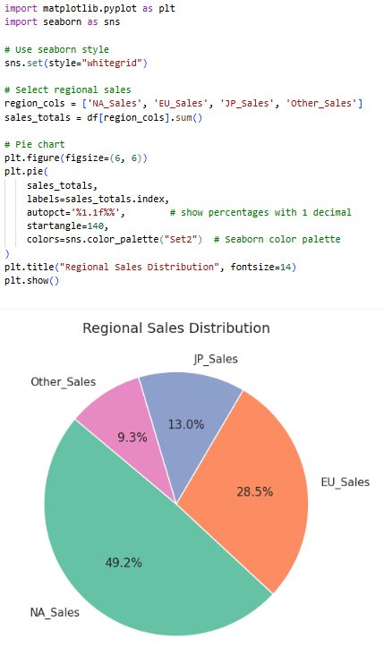
Figure 9: Pi chart for regional sales distribution (personal collection).
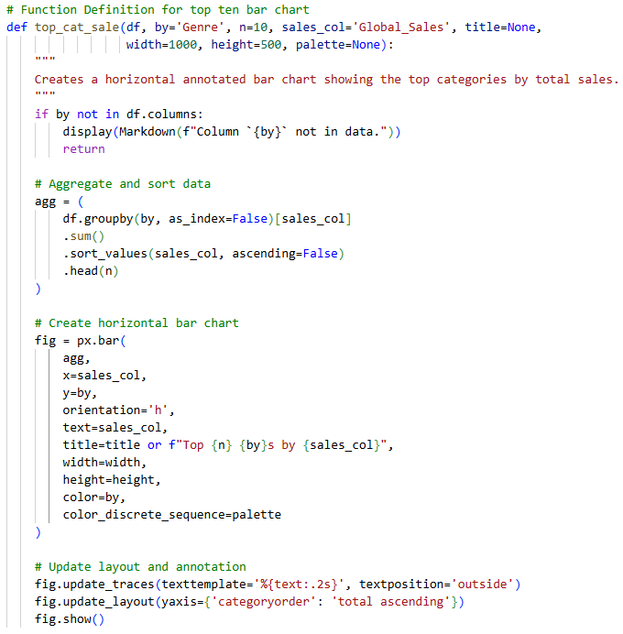
Figure 10.1: Function for bar charts (personal collection).

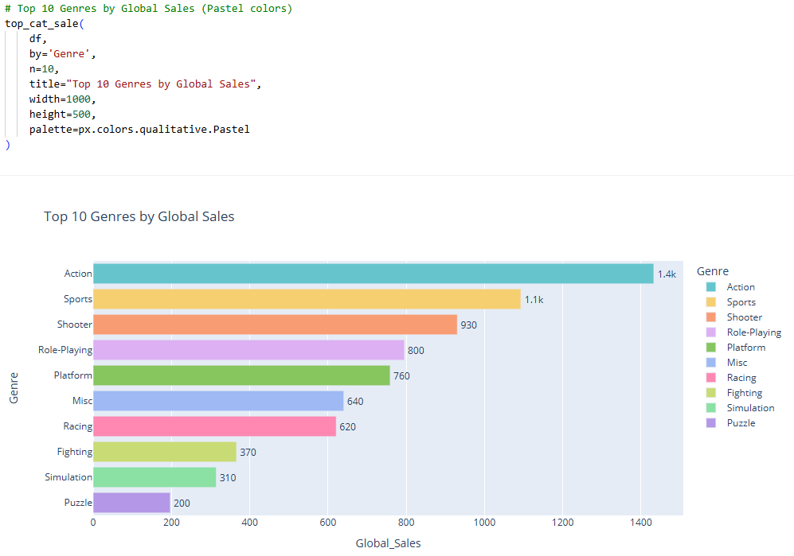
Figure 10.2: Bar chart of top 10 Genres by Global Sales (personal collection)
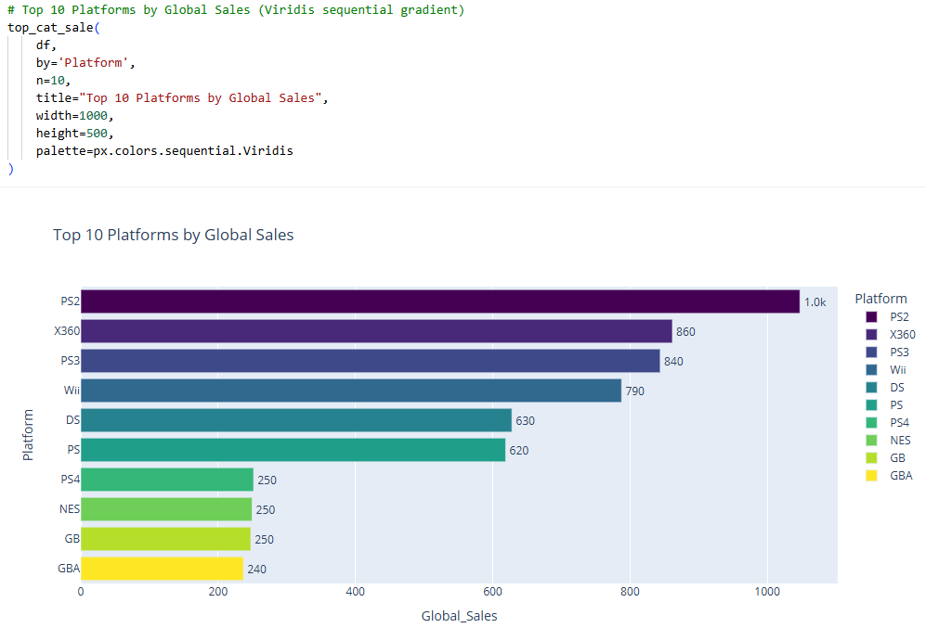
Figure 11: Bar chart of top 10 Platforms by Global Sales (personal collection).

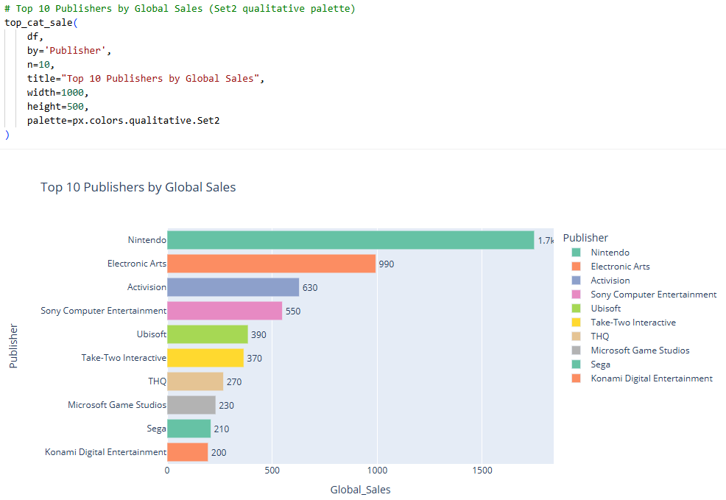
Figure 12: Bar chart of top 10 Publishers by Global Sales (personal collection).
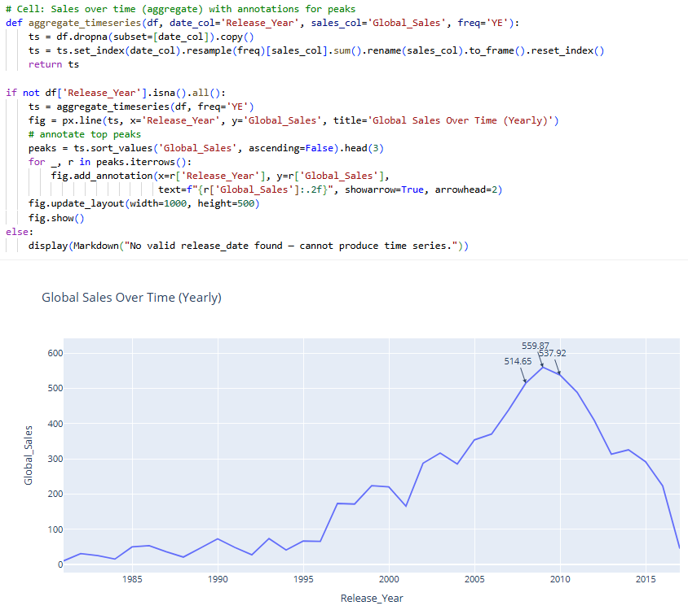
Figure 13: Line chart for Global Sales over time (personal collection).

To understand the main features of the video game sales dataset descriptive statistics analysis is accomplished. The aim was to summarise sales values and finding the clear patterns in the data. Key performance indicators (KPIs) such as total global sales, average sales per title, the most popular genre, and the best-selling platform are calculated as in Figure 8. These measures give a primary picture of how the industry performed over the dataset period (Rumsey, 2016). Central tendency, such as the mean, median and the measures of spread such as variance and standard deviation are calculated to describe sales numbers (Scott, 2020). Visual tools have also been used to support the analysis. A pie chart in Figure 9 shows how sales are divided across regions, while bar charts highlighted the top ten genres, platforms, and publishers in Figure 10, 11 and 12 accordingly. A line chart as in Figure 13 presented sales trends over time. These descriptive methods help to communicate patterns and provide the base for deeper statistical testing (Irizarry, 2019)

Observing Data Distribution and Outlier Detection
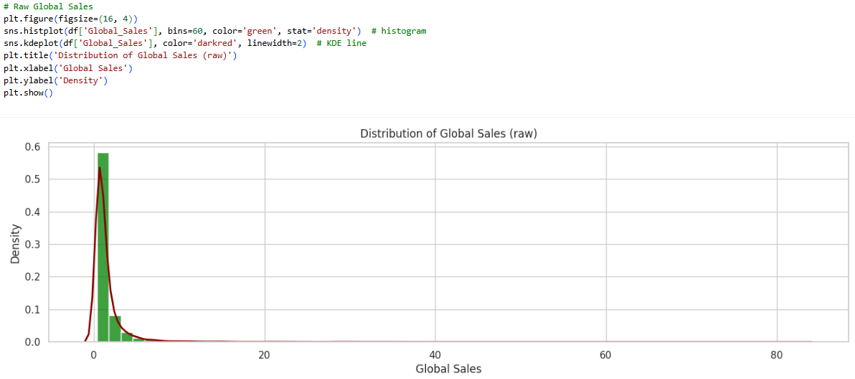
Figure 14: Histogram of Global Sales with KDE (personal collection).

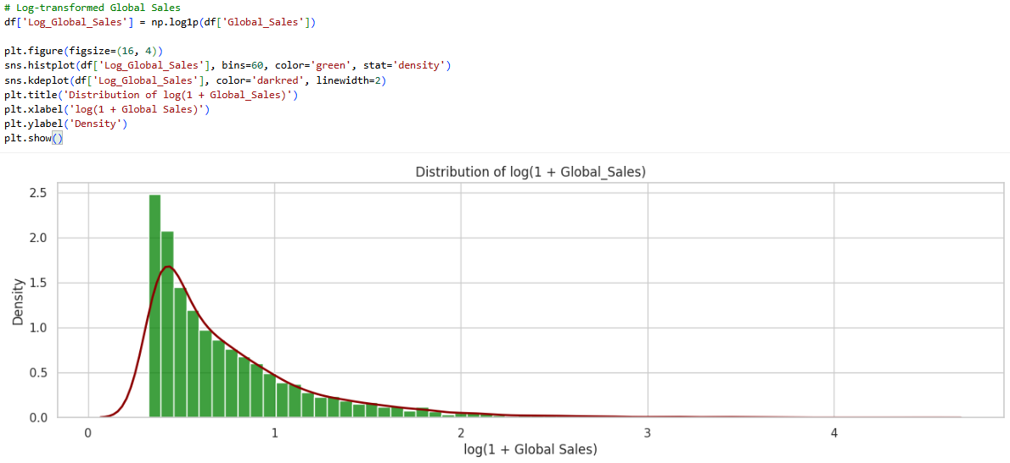
Figure 15: Histogram of log (1 + Global_Sales) (personal collection).

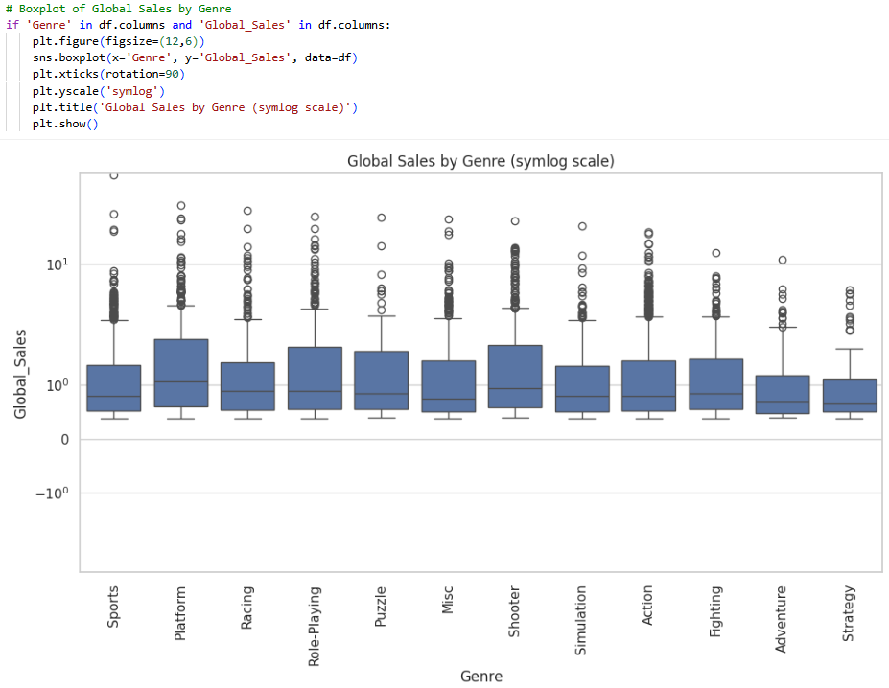
Figure 16: Boxplot of Global Sales by Genres (personal collection).

Using histograms with a density line the distribution of global sales is checked at first as in Figure 14. The results shows that sales are highly skewed, with many small values in the left and a few very large values in the right. As can be seen in Figure 15, a log transformation was used for reducing this effect and improve the visibility of the data distribution. This process made the distribution toward more normal distribution (Changyong et al., 2014). Boxplots are then created as in Figure 16 to compare sales by genre to help to see differences between groups and detect unusual data points (GeeksforGeeks, 2025). Outliers are also calculated using the z-score method as in the following Figure 17. This process measures how far each value is from the mean, outside of 3 standard deviations (Miller, 2017).

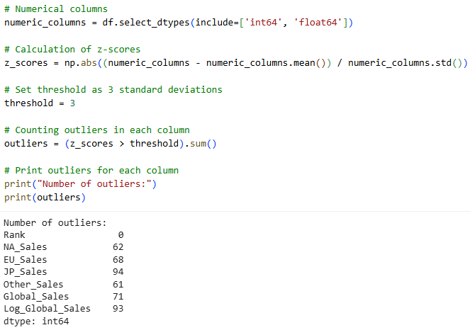
Figure 17: Calculated outliers in each numerical column (personal collection).

Figures 14 and 15 show that there are outliers with high global sales that appear on the right. Figures 16 and 17 show that there are large data points outside the interquartile range. Although there are a large number of outliers in the dataset, they are still the actual sales figures. So, we decided not to remove them for the purpose of accurate findings in the initial analysis.

Statistical Inferential Analysis with Hypothesis Testing
Inferential statistics are utilised in this data analysis project to test if the differences found in the video game sales are real or just random. A one way ANOVA test has been used to check if average global sales are different between game genres. The F-statistic and p-value are calculated for the ANOVA. If the p-value is smaller than 0.05, the null hypothesis (H₀) will be rejected, meaning at least one genre had higher sales which will stablish the alternative hypotheses (H₁).

To compare the mean sales of the top two genres a t-test has been used. For the t-test result a t-statistic and p-value are calculated which helps to decide if the two genres has statistically different sales (Field, 2024). These hypothesis tests are very important for the world scenario of data analysis because they move beyond description. By giving stronger evidence for decision making they show whether observed patterns are likely to apply to the wider population of games (Rumsey, 2016).
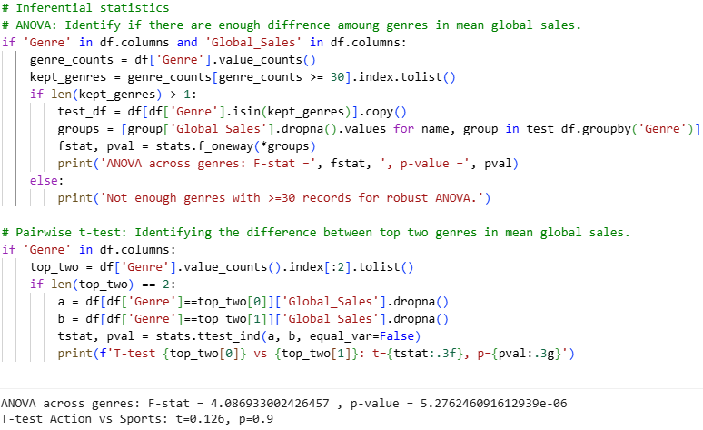
Figure 18: ANOVA across Genres and T-test statistic between top two Genres (personal collection).

From Figure 18 we can see the outcome of ANOVA across genres, the F-statistic is 4.087, which is indicating the differences in mean sales among genres. The p-value 5.276 × 10⁻⁶ is smaller than the significance level 0.05. So it provides enough evidence to reject the null hypothesis.
The outcome of the t-test between the top two genres, t-statistic 0.126, is close to zero, indicating that the average sales difference between the Action and Sports genres is negligible. The p-value of 0.9 > 0.05 is extremely high, which provides sufficient evidence to accept the null hypothesis (Kim, 2015).

Finally, for the ANOVA we found strong statistical evidence to say that the video game genres have different mean global sales. Some genres perform better than others in terms of global sales.
For the t-test we found that there is no statistically significant difference between the mean global sales of Action and Sports genres which means they perform almost equally in average global sales.

Correlation and Trend Analysis
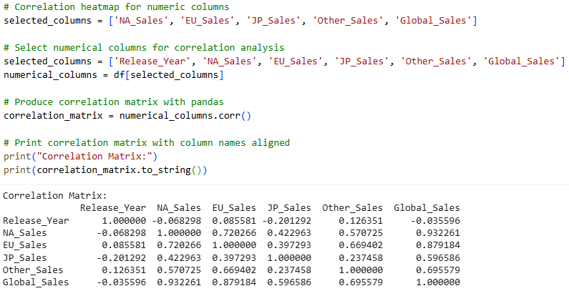
Figure 19: Correlation among numerical variables (personal collection).

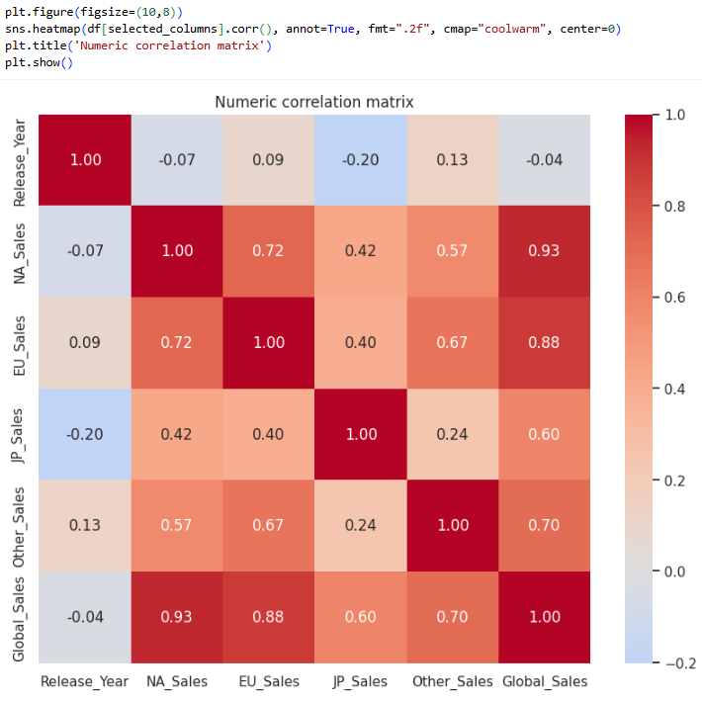
Figure 20: Heatmap showing correlation (personal collection).

Polynomial Trend Line for Yearly Global Sales

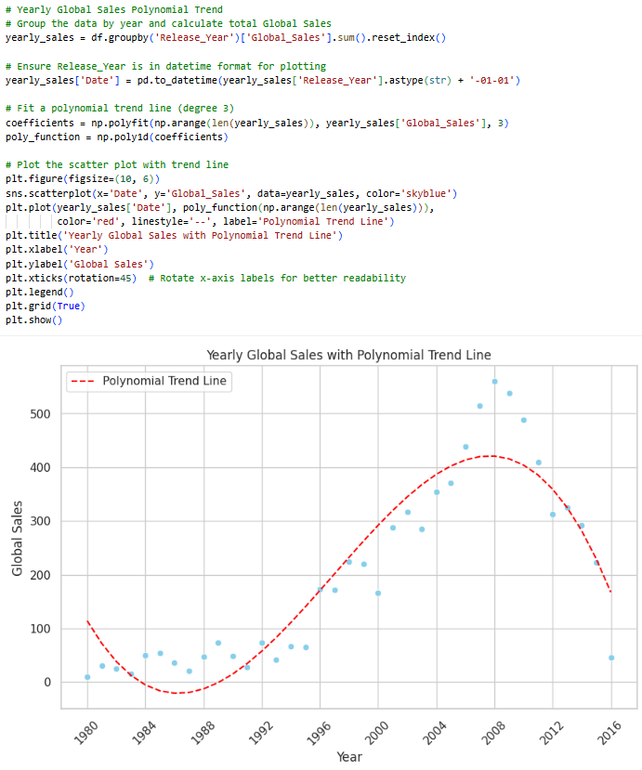
Figure 21: Scatterplot of yearly global sales over time with polynomial trend line (personal collection).

To discover the relationship among sales variables including release year the correlation analysis is used. It also checks how they move together. A correlation matrix is observed to see if regional sales such as North America and Europe are linked with global sales as in Figure 19. The heatmap on Figure 20 shows a strong positive correlation which mean higher regional sales often lead to higher global sales (Sedkaoui, 2018). After that a polynomial regression is applied to yearly sales data to find long term patterns. as seen in Figure 21, A trend line showing the relationship between global sales over time demonstrates a strong connection between these two variables, which can be represented by a polynomial line. These results provide useful insights for prediction and planning for the future business (Field, 2013; Irizarry, 2019).

Forecasting Future Video Game Sales
To estimate future video game sales, a time series forecasting approach has been used based on the yearly global sales data. The dataset covered sales from 1980 to 2016. Once the line chart for the global sales until 2016 is created, the yearly data has been converted into monthly frequency to produce chart for monthly sales forecasting.

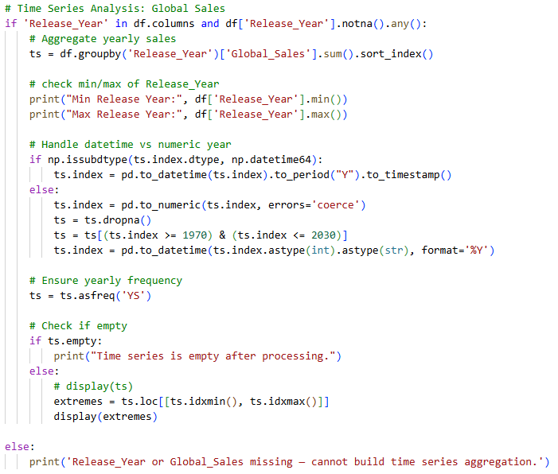
Figure 22: Code for time series analysis (personal collection).

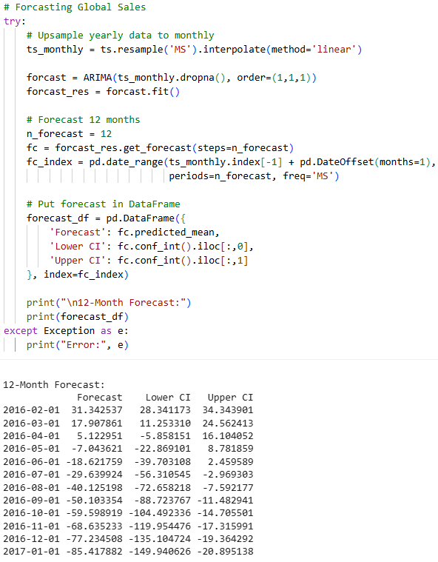
Figure 23: Global sales forecast with the lower and upper confidence interval (personal collection).
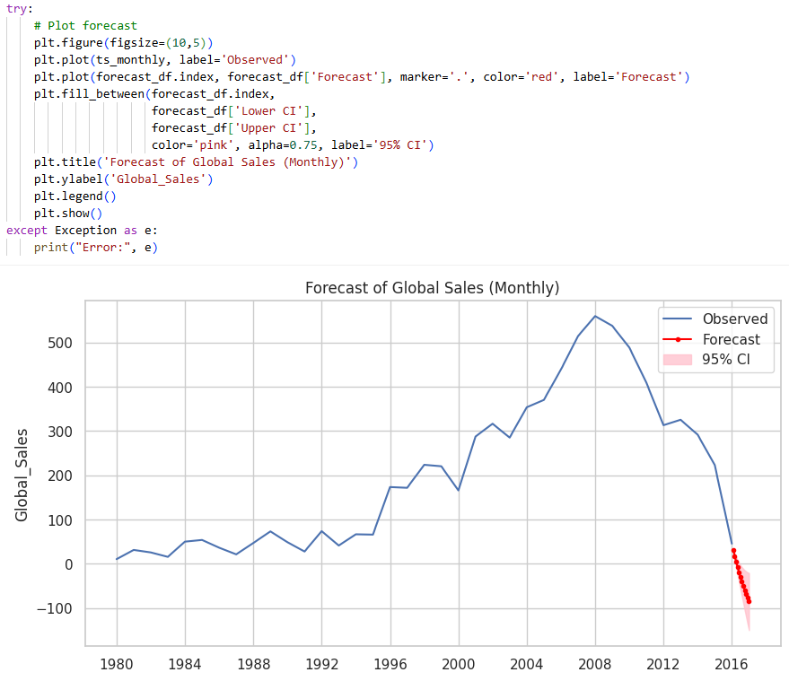
Figure 24: Global sales time series with forecast (personal collection).

Then twelve months of predicted sales values including upper and lower confidence limits are calculated to show the likely range of outcomes (Hyndman and Athanasopoulos, 2018). As can be seen in Figure 24, the results suggested a small fall in sales after the 2008 peak, followed by a steady trend in later years. The line chart of forecast displayed both the observed and predicted values with shaded confidence areas. Clear insights about potential market changes are provided by this chart and supported better planning.

Report on Exploratory Analysis of Video Game Sales
Prepared for: Analysist Manager
Author: STU98937
Date: 13/10/2025

This report presents a critical review of the exploratory data analysis (EDA) performed on the video game sales dataset of International Media Limited. This work included data loading, initial observations, cleaning and preparing the dataset, conducting descriptive and inferential statistics, identifying anomalies, applying correlation and forecasting methods, and also interpreting the results with reference to visual outputs. Understanding global sales trends, the role of genres and publishers in driving performance, and the potential use of forecasting techniques to predict future sales was the main focus.

Summary of Approach & Key Results Interpretation
Data loading & type checking:
The basis of this analysis was to load the dataset using Python. The Pandas library was used to handle the given CSV file and provide a structured dataframe. This allowed for easy inspection of rows, columns, and data types (VanderPlas, 2016). The presence of inconsistent values ​​in the year column and missing entries for the publisher was an initial challenge. The dataset needed to be cleaned before the analysis could be confirmed by identifying inconsistencies using the .info(), .duplicated(), and .isnull() commands.

Data exploration:
The dataset contains regional sales values ​​such as NA_Sales, EU_Sales, JP_Sales, and Other_Sales and also a Global_Sales field. Initial inspection revealed discrepancies where years were not formatted correctly as dates and several columns had missing values ​​that required recalculation. The importance of not assuming the accuracy of the supplied dataset is highlighted by this process.

Preprocessing & integrity improvement:
Since preprocessing was one of the most important parts of this project, several steps were taken as follows:
To ensure consistency in the dataset, column names were standardised.
Null publisher, regional sales and global sales values are imputed using proper technic​​. Although these imputations risked reducing variance, it allowed the dataset to remain complete for analysis (McKinney, 2018).
A clean Release_Year variable was created from the Year column to enable time series analysis.
Removing the 69 rows containing null values ​​and confirming that there were no duplicate rows ensured that the pattern observations were not driven by repeated or empty data.

A more reliable global_sales column was established by recalculating global sales with summing regional figures.
This process not only improved the integrity of the dataset but also demonstrated the iterative nature of the cleanup. Figure 7 of the report illustrates the consistent dataset structure and also shows the corrected Release_Year and consistent sales figures.

Descriptive EDA with KPI extraction:
Descriptive statistical analysis provided the very first insight about how the industry performed over the period into the dataset (Rumsey, 2016). Key findings, including key performance indicators (KPIs) are as follows:

Total global sales across the period from 1980 to 2016 exceeded 7407 units of money. The year 2008 is the highest revenue maker, with 559.87 units of money globally. After that period the global sales fell down successively every year until 2016 as seen in Figure 13.
Action and Sports emerged as leading contributors. More than one-third of all sales was contributed by these two genres, as seen in Figure 10.
PlayStation 2 dominated the market, followed by Xbox 360, PlayStation 3 and Wii, as seen in Figure 11.

From Figure 12 we can see that Nintendo, Electronic Arts, and Activision were the most successful publishers by achieving high cumulative sales.
In Figure 9, the pie chart showed that North America and Europe were the largest markets with 49.2% and 28.5% of total global sales respectively, while Japan had a smaller but distinct sales profile with 13%.

Distribution & outlier detection:
Exploring the distribution of global sales reveals a strongly skewed pattern as shown in Figure 7. The histograms illustrated with density curves clearly show that very few blockbusters exceeded one million due to the long-tail effect.

To reduce skewness, a log transformation was applied to create a normal-like distribution that better supported the statistical observations (Changyong et al., 2014). Utilising both boxplots and z-score methods, outlier detection was conducted as seen in Figures 16 and 17. Games such as Wii Sports appeared to be high-value outliers, representing genuine market success rather than errors.

Inferential statistical tests:
Several inferential methods were applied to understand the data insights beyond description as in Figure 18. A one-way ANOVA tested if global sales are different across genres. The F-statistic indicated significant variation, with a p-value lower than 0.05, rejecting the null hypothesis of equal means (Field, 2024). This finding suggests that in predicting sales performance, genre is a meaningful factor.

A follow-up t-test compared the top two genres, Action and Sports. The very low t value and p=0.9>0.05 indicated the two most popular genres, Action and Sports are not significantly different from each other in terms of average global sales. Figure 10 in the report visualise these group differences.

Correlation & trend analysis:
To measure the relationship between regional sales and global sales and to measure the relationship between year of release and global sales, correlation analysis techniques were applied. A correlation heatmap (Figure 20) showed strong positive relationships, especially between North American and global performance. This indicates that North American sales may serve as an early predictor of global success (Sedkaoui, 2018).

A polynomial correlation line with a scatter plot for annual global sales was also created to capture the non-linear trend of rise and fall over the decades (Box & Jenkins, 1976). The line shown in Figure 21 indicates that annual global sales increased steadily from 1980 to 2008 and then began to decline abruptly until 2016.

Forecasting:
As shown in Figure 24, the forecast declines after the peak in 2008, with sales stabilising in subsequent years. The total global sales will definitely be negative from July 2016 onwards, as confirmed by the negative upper and lower confidence intervals (Hyndman and Athanasopoulos, 2018), as shown in Figure 23. This means the video game business will be shifted to the new platform, such as e-commerce.

Limitations & Data Quality Considerations
- Missing data imputation with column averages for regional sales is realistic but can change the variance. If the missingness is significant, multiple imputation or model-based approaches are more acceptable.
- External covariates such as market events, console launches, and marketing campaigns are not included in the dataset.
- Aggregating annual data reduces seasonal resolution and can bias short-term forecasts. The best practice is to model at the highest usable frequency and ensure stationarity before forecasting.

Recommendations
Based on the analytical results of this project, I recommend:
- Implementing a robust missing data handling strategy such as multiple imputation.
- Creating a regular interactive dashboard with Power BI or Plotly Dash to explore and drill down into trends across publishers, platforms, and genres, along with KPIs and other important metrics.
- To improve forecasting, a rich dataset can include marketing spend, console release dates, major marketing campaigns, price promotions, and platform install base.
- For richer forecasts, we need to ensure higher frequencies, such as monthly or weekly data analysis.
- Implementing segment analysis by executing separate models by platform and publisher for more actionable insights.
- Implementing multiple Machine Learning models and applying appropriate model validation through back testing before relying on forecasts for decision making.

Reflection on Skills & Learning
- Programming Concepts: I learnt how to apply core programming principles through structured Python code using functions, libraries, and modular workflows.
- Data Manipulation and Analysis: I successfully cleaned, transformed, and analysed data with Pandas, NumPy, and other statistical libraries.
- Critical Evaluation: I interpreted results beyond numbers, considering limitations, outliers, and alternative approaches.
- Digital Literacy: I evaluated digital tools and explored advanced methods such as EDA and correlation and reflected on future possibilities, which increased my digital capabilities.
The project demonstrated independence of thought, strong analytical reasoning, and professional communication skills.

Environment and Setup
The data analysis was performed using the online version of Google Colab (n.d.). It provides a cloud-based environment for executing Python code and ensures easy package management and GPU acceleration. This setup allowed for interactive analysis, visualisation, and reproducible research without local installation issues.
The environment used Python 3.12.11 as the base interpreter.
The following library versions were utilised:
pandas 2.2.2, numpy 2.0.2, matplotlib 3.10.0, seaborn 0.13.2, scipy 1.16.2, statsmodels 0.14.5, scikit-learn 1.6.1, plotly 5.24.1, and IPython 7.34.0.

Conclusion
The study found a strong link between regional and global sales and clear differences in average sales by genre. Sales peaked in 2008, after which the business stabilised and then declined for several consecutive years until 2016. The findings suggest a replacement of video game platforms with e-commerce in the upcoming years.

The analysis not only answered the main questions but also identified future improvements, including high-frequency data, multivariate forecasting, and robust adaptation techniques. The reflection demonstrated significant engagement with programming tools and statistical methods which met all requirements.

References
ApX Machine Learning. (n.d.). Strategies for Missing Data: Imputation vs Deletion. Available at: https://apxml.com/courses/intro-eda-course/chapter-2-data-loading-inspection-cleaning/missing-data-strategies [Accessed: 9 October 2025].
Box, G. and Jenkins, G.M., 1976. Analysis: Forecasting and Control. San francisco.
Changyong, F.E.N.G., Hongyue, W.A.N.G., Naiji, L.U., Tian, C.H.E.N., Hua, H.E., Ying, L.U. and Xin, M.T., 2014. Log-transformation and its implications for data analysis. Shanghai archives of psychiatry, 26(2), p.105.
Field, A., 2024. Discovering statistics using IBM SPSS statistics. Sage publications limited.
GeeksforGeeks. (2025, July 12). Box Plot in Python using Matplotlib [online]. Available from: https://www.geeksforgeeks.org/box-plot-in-python-using-matplotlib/ [Accessed 10 09 2025].
Google Colab. (n.d.). Colaboratory [online]. Retrieved from https://colab.research.google.com/ [Accessed 2024].
Han, J., Pei, J. and Tong, H., 2022. Data mining: concepts and techniques. Morgan kaufmann.
Hyndman, R.J. and Athanasopoulos, G., 2018. Forecasting: principles and practice. OTexts.
Irizarry, R. A., (2019). Statistics and Prediction Algorithms Through Case Studies [online]. CRC Press. Available at: https://rafalab.dfci.harvard.edu/dsbook-part-2/ [Accessed 27 03 2024].
Kim, T.K., (2015). T test as a parametric statistic. Korean journal of anesthesiology, 68(6), p.540 [online]. Available from: https://www.ncbi.nlm.nih.gov/pmc/articles/PMC4667138/ [Accessed 24 03 2023].
McKinney, W., 2012. Python for data analysis: Data wrangling with Pandas, NumPy, and IPython. " O'Reilly Media, Inc.".
Miller. D. J. (2017). Big Data Visualization: Bring Scalability and Dynamics to Your Big Data Visualization [online]. Packt Publishing. Available from: https://links.arden.ac.uk/bvw7qn [Accessed 12 04 2024].
Rumsey, D., (2016). Statistics For Dummies [online]. 2nd edition. Wiley. Available from: https://links.arden.ac.uk/hdgx5v [Accessed 03 04 2023].
Scott, D.W., 2020. Statistics: a concise mathematical introduction for students, scientists, and engineers. John Wiley & Sons.
Sedkaoui. S., (2018). Data Analytics and Big Data [online]. Wiley. Available from: https://links.arden.ac.uk/m8qvbk [Accessed 08 03 2024].
VanderPlas, J., 2016. Python data science handbook: Essential tools for working with data. " O'Reilly Media, Inc.".

