+994 55 792 58 03

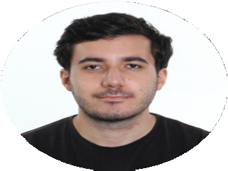

**IBRAHIM ALIYEV**

**F U L L S T A C K**

**W E B D E V E L O P M E N T**

[ibrahimaliyevv2@gmail.com](mailto:ibrahimaliyevv2@gmail.com)

Baku, Azerbaijan

# S U M M A R Y

Aspiring to be Fullstack developer. I am eager to learn and can adapt to different environments. Writing articles on Medium platform related to Fullstack Development including Git & GitHub. In 2020, I won an award "Coordinator of Year" by the Ministry of Science and Education for my social activism.

# E X P E R I E N C E

**E D U C A T I O N**

**2022 - 2024**

**AZERBAIJAN FRENCH UNIVERSITY**

**Master's degree in Data Science & Artificial Intelligence (English group)**

**2018 - 2022**

**BAKU STATE UNIVERSITY**

**Bachelor's degree in Computer Science (English group)**

## INTERNSHIP - FULLSTACK DEVELOPER

**Cubics Technology**

**2022**

Writing code for given tasks Solving problems

Website designing

Preparing pseudocode for algorithms

## CALL CENTER OPERATOR

**ASAN Call Center - 108**

**2020**

Answering the calls from citizens in ERP app Informing citizens about ASAN mobile app

Teaching volunteers the system in ASAN Call Center

# I M P O R T A N T N O T E

All my projects, live demos and GitHub repository links are located in my portfolio website which is located on the right. Also, you can view my articles on Medium in that section.

# S K I L L S

HTML CSS

JavaScript jQuery

Bootstrap, Responsive SASS/SCSS

React

ASP .NET CORE

.NET MVC

.NET WEB API

Entity framework Microsoft SQL Server

# P O R T F O L I O

## ibrahimaliyevv2.github.io

 **linkedin.com/in/ibrahimaliyevv2 github.com/ibrahimaliyevv2**

**medium.com/@ibrahimaliyevv**

