Mosheur Rahman Wolied

CSE423 Lab Assignment 1

Task 1:

| from OpenGL.GL import * from OpenGL.GLUT import * from OpenGL.GLU import *  import random import time import math  SCREEN_H = 700 SCREEN_W = 1000  rain_drop_count = 100 rain_points = [(random.randint(0,SCREEN_W),random.randint(SCREEN_H,SCREEN_H+200), random.randint(30,60))] rain_direction_vertical = 'DOWN' rain_skew = 0 rain_speed_horizontal = 2 rain_speed = [10,rain_speed_horizontal] time_interval = 1 last_rain_time = time.time() last_time_day = time.time() day = True color = 1  def change_time():  global day  day = not day  def set_day():  global day,color, last_time_day  change = False  if day:  if color < 1 and time.time() > last_time_day + 0.05:  last_time_day = time.time()  color += 0.01  change = True  else:  if color > 0 and time.time() > last_time_day + 0.05 :  last_time_day = time.time()  color -= 0.01  change = True  if color < 0:  color = 0  change = True    if change:  glClearColor(color,color,color,color)  glutPostRedisplay()   def keyboardListener(key,x,y):  if key == b'w':  print('time changed to', day)  change_time()  def specialKeyListener(key, x, y):  global rain_direction_vertical,rain_skew, day    if key==GLUT_KEY_UP:  rain_direction_vertical = 'UP'  print("Rain Direction Changed to UP")  if key== GLUT_KEY_DOWN:   rain_direction_vertical = 'DOWN'  print("Rain Direction Changed to DOWN")  if key==GLUT_KEY_LEFT and rain_skew > -50:  rain_skew -= 0.1  if key== GLUT_KEY_RIGHT and rain_skew < 50:   rain_skew += 0.1   glutPostRedisplay()  def draw_house(starting_x, starting_y,base,height,roof_height,roof_base,scale=15):  global color  # Draw the roof  glColor3f(0.1, 0.5, 0.0)  draw_triangle(starting_x, starting_y, base=roof_base,height=roof_height, hollow=True ,scale=scale, color=color)    glColor3f(0.1, 0.5, 0.0)  # Draw the house  x1,y1 = int(starting_x - (roof_base/2)) + int((roof_base-base)/2) , starting_y-roof_height  x2,y2 = x1,y1-height  x3,y3 = x2+base, y2  x4,y4 = x3, y1    draw_box(x1,y1,x2,y2,x3,y3,x4,y4,10)    # draw the door  door_height = int(height/2)  door_width = int(base/5)  door_x1 = int(x1 + (base/4) - (door_width/2))  draw_box(door_x1, y2, door_x1, y2+door_height, door_x1+door_width, y2+door_height, door_x1+door_width, y2)  draw_points(door_x1+door_width-20, y2+int(door_height/2))    #draw Window  window_height = int(base/6)  window_width = int(base/6)    window_x1 = int(x3 - (base/4) - (window_width/2))  window_y1 = y2+door_height+10  draw_box(window_x1, window_y1, window_x1, window_y1+window_height, window_x1+window_width, window_y1+window_height, window_x1+window_width, window_y1)  draw_line(window_x1+window_width/2, window_y1, window_x1+window_width/2, window_y1+window_height,2)  def add_rain_point():  global rain_drop_count,rain_points,time_interval,last_rain_time  now = time.time()  if now > last_rain_time + time_interval and len(rain_points) < rain_drop_count:  print(len(rain_points))  last_rain_time = now  rain_points.append((random.randint(0,SCREEN_W),random.randint(SCREEN_H,SCREEN_H+200), random.randint(30,60)))  def rain(speed):  global x,rain_direction_vertical, time,rain_skew, time_interval  if rain_direction_vertical == 'UP': speed[0] = -speed[0]  last_time = time.time()  if time.time() > last_time + 0.01 and time_interval > 0.3:  time_interval -= 0.5   for x,y,h in rain_points:  new_y = (y - speed[0])  new_x = x + speed[1] * (rain_skew/abs(rain_skew)) if rain_skew != 0 else x   if rain_direction_vertical == "DOWN" and new_y < SCREEN_H/1.5:  new_y = SCREEN_H   elif rain_direction_vertical == "UP" and new_y > SCREEN_H:  new_y = SCREEN_H/1.5   if new_x < 0:  new_x = SCREEN_W   elif new_x > SCREEN_W:  new_x = 0   rain_points[rain_points.index((x,y,h))] = (new_x,new_y,h)  glutPostRedisplay()     def iterate():  glViewport(0, 0, SCREEN_W, SCREEN_H)  glMatrixMode(GL_PROJECTION)  glLoadIdentity()  glOrtho(0.0, 1000, 0.0, 700, 0.0, 1.0)  glMatrixMode (GL_MODELVIEW)  glLoadIdentity()  def draw_rain(x,y,h):  global rain_skew  if rain_skew == 0:  draw_line(x,y,x,y+h,2)  else:  x2 = int(math.atan(rain_skew) * h)  draw_line(x,y,x-x2,y+h,2)  def showScreen():  global x,rain_skew, rain_drop_count,day  add_rain_point()  glClear(GL_COLOR_BUFFER_BIT | GL_DEPTH_BUFFER_BIT)   glClear(GL_COLOR_BUFFER_BIT | GL_DEPTH_BUFFER_BIT)  glMatrixMode(GL_MODELVIEW)   glLoadIdentity()  iterate()  glColor3f(0.0, 0.0, 0.0) #konokichur color set (RGB)    glMatrixMode(GL_MODELVIEW)   #call the draw methods here  glColor3f(0.0, 0.0, 1.0)  for x,y,h in rain_points:  draw_rain(x,y,h)    set_day()  draw_house(starting_x=SCREEN_W/2, starting_y=600,base=400,height=200,roof_base=500,roof_height=150, scale=10)    glutSwapBuffers()  def init():  #//clear the screen  glClearColor(1,1,1,1);  #//load the PROJECTION matrix  glMatrixMode(GL_PROJECTION)  #//initialize the matrix  glLoadIdentity()  #//give PERSPECTIVE parameters  gluPerspective(504, 1, 1, 1000.0)  # **(important)**aspect ratio that determines the field of view in the X direction (horizontally). The bigger this angle is, the more you can see of the world - but at the same time, the objects you can see will become smaller.  def draw_points(x, y):  glPointSize(5) #pixel size. by default 1 thake  glBegin(GL_POINTS)  glVertex2f(x,y) #jekhane show korbe pixel  glEnd()  def draw_line(x1,y1,x2,y2, w=5):  glLineWidth(w)  glBegin(GL_LINES)  glVertex2f(x1,y1)  glVertex2f(x2,y2)  glEnd()  def draw_box(x1,y1,x2,y2,x3,y3,x4,y4,w=5):  glLineWidth(w)  glBegin(GL_LINES)    # left  glVertex2f(x1,y1)  glVertex2f(x2,y2)    #bottom  glVertex2f(x2,y2)  glVertex2f(x3,y3)    #right  glVertex2f(x3,y3)  glVertex2f(x4,y4)    #top  glVertex2f(x4,y4)  glVertex2f(x1,y1)    glEnd()  def draw_quad(x1,y1,x2,y2,x3,y3,x4,y4):  glBegin(GL_QUADS)  glVertex2f(x1,y1)  glVertex2f(x2,y2)  glVertex2f(x3,y3)  glVertex2f(x4,y4)  glEnd()   def draw_triangle(starting_x, starting_y, base,height, hollow=False,scale=5, color=1.0):  x1,y1 = starting_x, starting_y  x2,y2 = int(x1 - (base/2)), y1 - height  x3,y3 = int(x1 + (base/2)), y1 - height  glBegin(GL_TRIANGLE_FAN)  glVertex2f(x1,y1) #left  glVertex2f(x2,y2) #top  glVertex2f(x3,y3) #right  glEnd()   if hollow:  center_y = y1 - int(height/2)  scale = 1.2  base = int(base * (1/scale) )  height = int(height * (1/scale) )  y1 = center_y + int(height/2)  x2,y2 = int(x1 - (base/2)), y1 - height  x3,y3 = int(x1 + (base/2)), y1 - height    # draw a smaller triangle inside the larger one  glColor3f(color, color, color)  glBegin(GL_TRIANGLE_FAN)    glVertex2f(x1,y1)   glVertex2f(x2,y2)   glVertex2f(x3,y3)   glEnd()   glColor3f(0.0, 0.0, 0.0)    # draw_line(x1,y1,x2,y2,scale)  # draw_line(x2,y2,x3,y3,scale)  # draw_line(x1,y1,x3,y3,scale)  def main():  glutInit()  glutInitWindowSize(1000, 700) #window size  glutInitWindowPosition(0, 0)  glutInitDisplayMode(GLUT_DEPTH | GLUT_DOUBLE | GLUT_RGB)   wind = glutCreateWindow(b"OpenGL Coding Practice") #window name  init()   glutDisplayFunc(showScreen)  glutSpecialFunc(specialKeyListener)  glutKeyboardFunc(keyboardListener)  glutIdleFunc(lambda: rain(rain_speed))   glutMainLoop()  if __name__ == '__main__':  main() |
| --- |

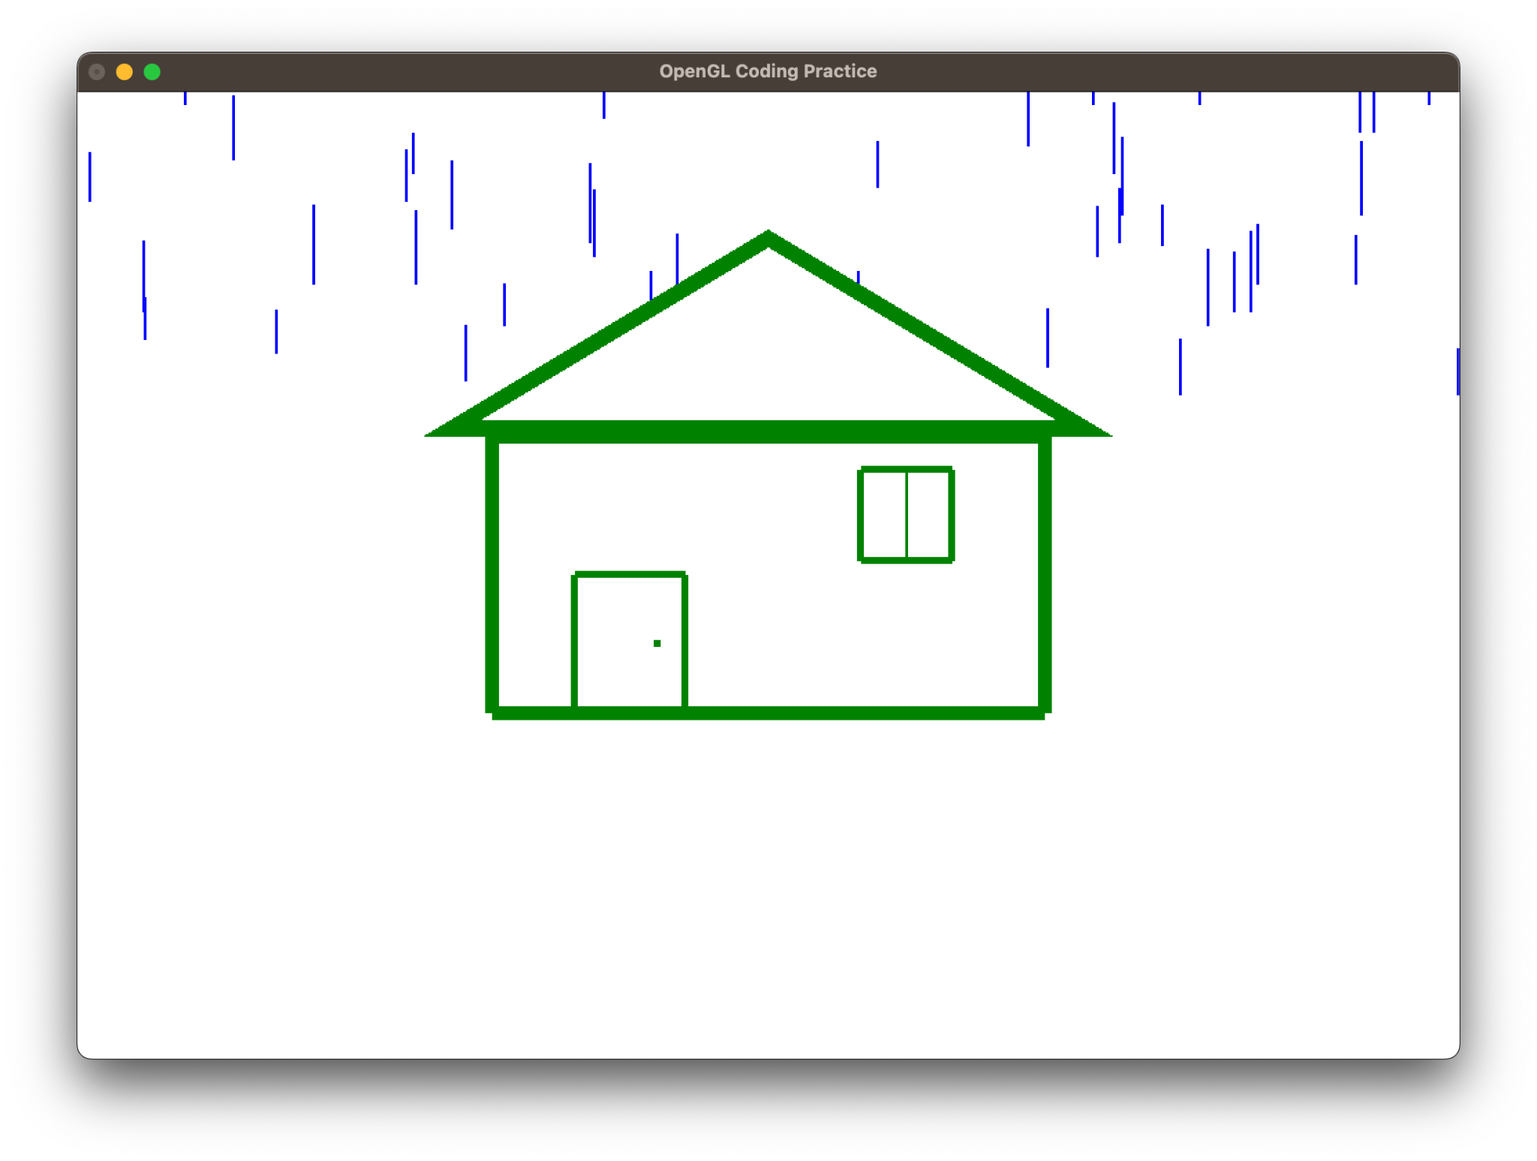

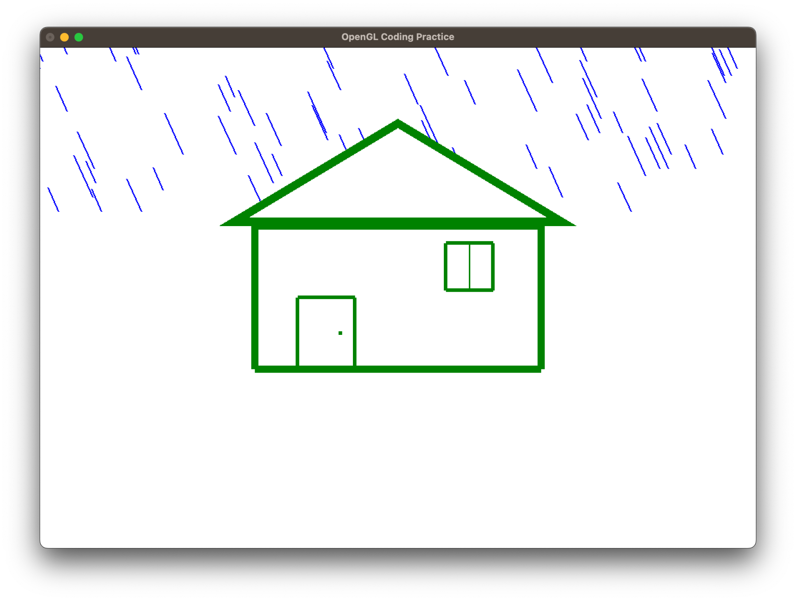

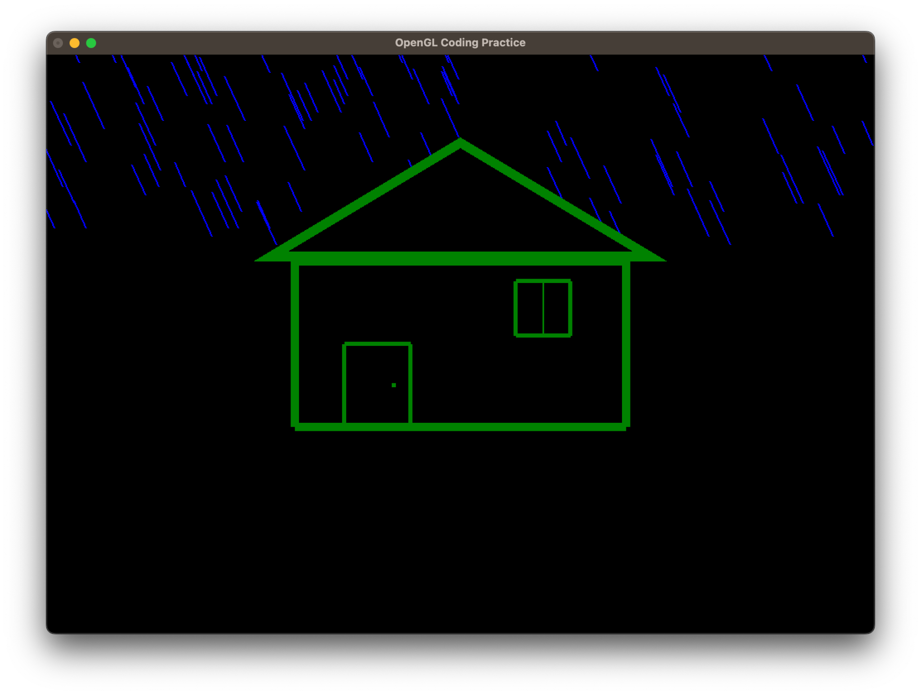Task 2:

| from OpenGL.GL import * from OpenGL.GLUT import * from OpenGL.GLU import * import random import time  # Global Variables SCREEN_W = 500 SCREEN_H = 500  points = [] colors = []  ballx = bally = 0 ball_size = 5 speed= 0.01  create_new= False bg_color = (0,0,0)  blink_duration = 1000 blinked = False last_blinked = 0  frozen = False  def convert_coordinate(x, y):  global SCREEN_W,SCREEN_H  a = x - (SCREEN_W / 2)  b = (SCREEN_H / 2) - y  return a,b  def draw_points(points,s):  glPointSize(s)  for x, y, color in points:  glBegin(GL_POINTS)  glColor3f(color[0],color[1],color[2])  glVertex2f(x,y)  glEnd()  def keyboardListener(key, x,y):  global ball_size,frozen  if key == b' ':  frozen = not frozen  glutPostRedisplay()  def specialKeyListener(key,x, y):  global speed,frozen  if key == GLUT_KEY_UP:  speed *= 2  if key == GLUT_KEY_DOWN:  speed = speed / 2  if speed < 0.05:  speed = 0.05  glutPostRedisplay()  def mouseListener(key, direction, x, y):  global points, frozen, blinked, last_blinked, colors  if key == GLUT_RIGHT_BUTTON and direction == GLUT_DOWN and frozen == False:  color = (random.uniform(0,1), random.uniform(0,1), random.uniform(0,1))  c_X,c_y = convert_coordinate(x,y)  points.append((c_X, c_y, color))   if key == GLUT_LEFT_BUTTON and direction == GLUT_DOWN and frozen == False:  blinked = not blinked  last_blinked = time.time()  for i in range(len(points)):  color = points[i][2]  colors.append(color)  points[i]= (points[i][0], points[i][1], bg_color)  def check_blink():  global points, colors, blinked, last_blinked  if time.time() > last_blinked + 1 and blinked:  blinked = not blinked  for i in range(len(points)):  color = colors[i]  points[i] =(points[i][0], points[i][1], color)  glutPostRedisplay()  def showScreen():  global ball_size  glClear(GL_COLOR_BUFFER_BIT | GL_DEPTH_BUFFER_BIT)  glClearColor(0, 0, 0, 0)  glClear(GL_COLOR_BUFFER_BIT | GL_DEPTH_BUFFER_BIT)  glMatrixMode(GL_MODELVIEW)  glLoadIdentity()  gluLookAt(0, 0, 200, 0, 0, 0, 0, 1, 0)  glMatrixMode(GL_MODELVIEW)    draw_points(points,ball_size)  check_blink()  glutSwapBuffers()  def animate():  global frozen, points, speed  if not frozen:  for ballx, bally, color in points:  new_ballx = ballx + random.choice([-10,10])*speed  new_bally = bally + random.choice([-10,10])*speed  points[points.index((ballx,bally,color))] = (new_ballx,new_bally,color)  glutPostRedisplay()  def init():  glClearColor(0, 0, 0, 0)  glMatrixMode(GL_PROJECTION)  glLoadIdentity()  gluPerspective(104, 1, 1, 1000.0)  def main():  glutInit()  glutInitWindowSize(SCREEN_W, SCREEN_H)  glutInitWindowPosition(0, 0)  glutInitDisplayMode(GLUT_DEPTH | GLUT_DOUBLE | GLUT_RGB)   wind = glutCreateWindow(b"OpenGL Coding")  init()  glutDisplayFunc(showScreen)  glutIdleFunc(animate)  glutKeyboardFunc(keyboardListener)  glutSpecialFunc(specialKeyListener)  glutMouseFunc(mouseListener)  glutMainLoop()  if __name__ == '__main__':  main() |
| --- |

