1. 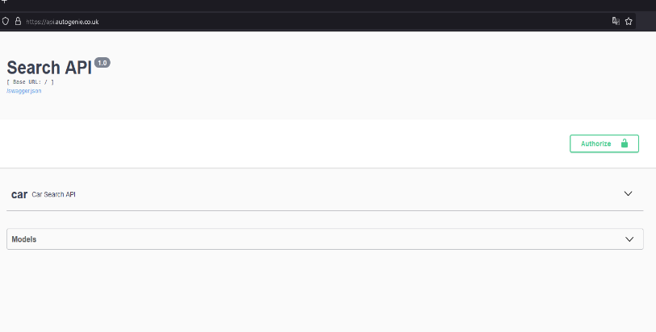Visit <https://api.autogenie.co.uk/>

1. 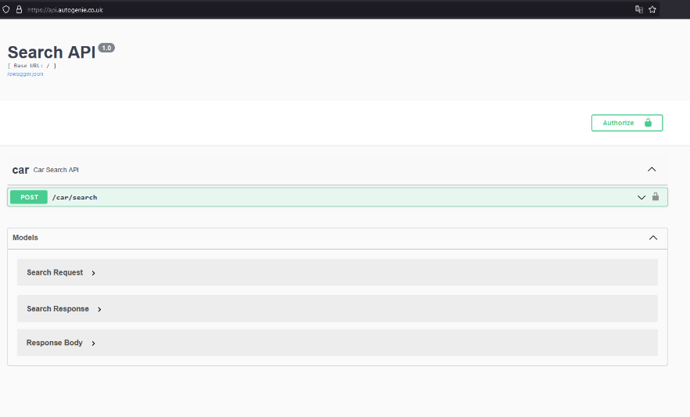To see more detail, expand the “car” and “Models”

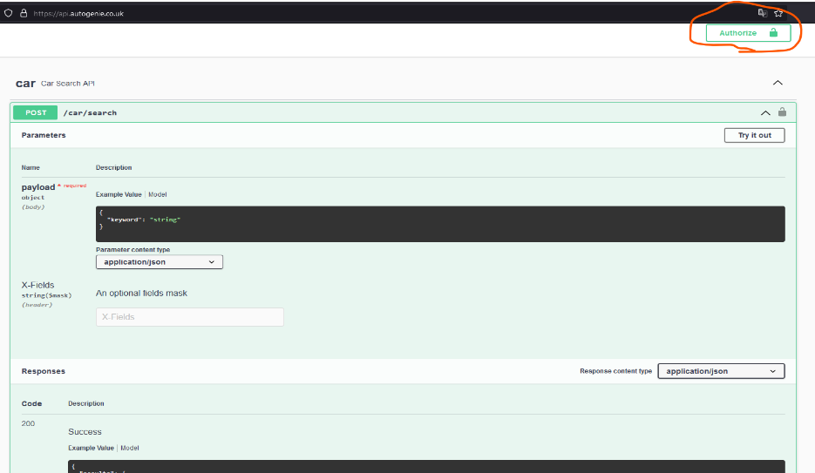

1. Click on the “Authorize” button
2. 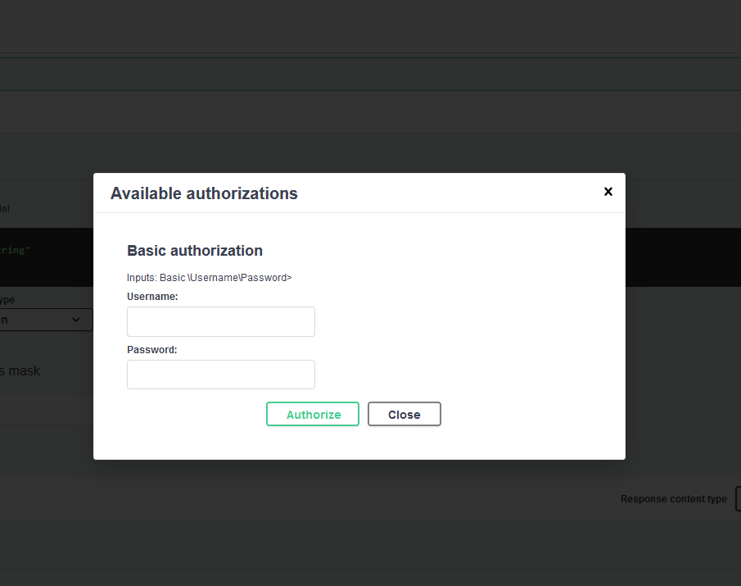A pop-up window will open to provide Username and Password. Provide valid Username and Password here. Then click on “Authorize” button below and finally click on “Close” button to close the pop-up.

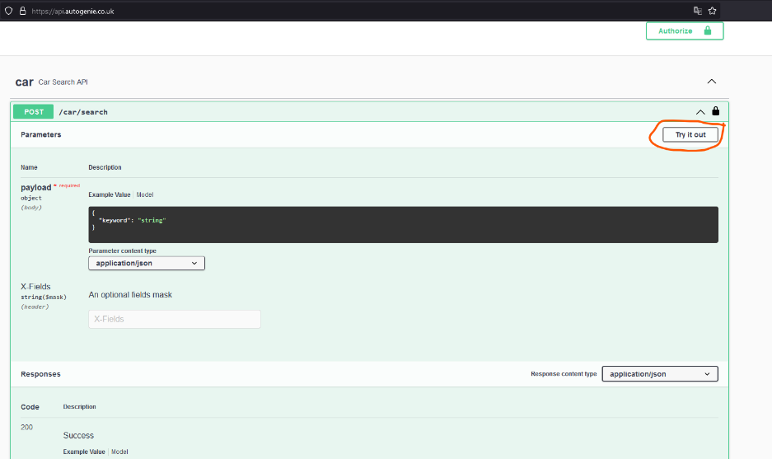

1. Then click on the “Try

it out” button at the

right.

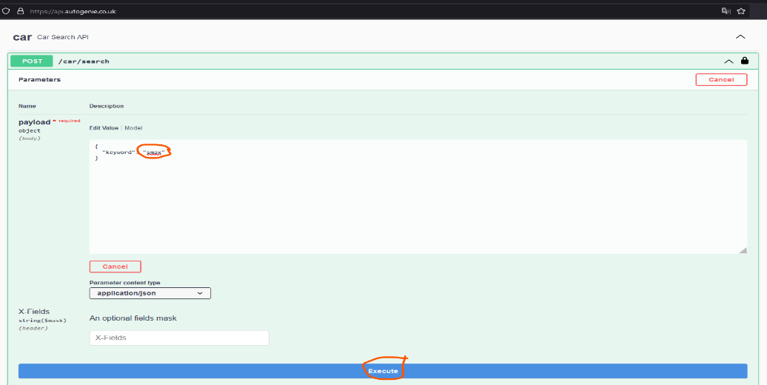

1. Write the search keyword inside the double quotes shown in the circle in the image. Then press the “Execute “ button.
2. 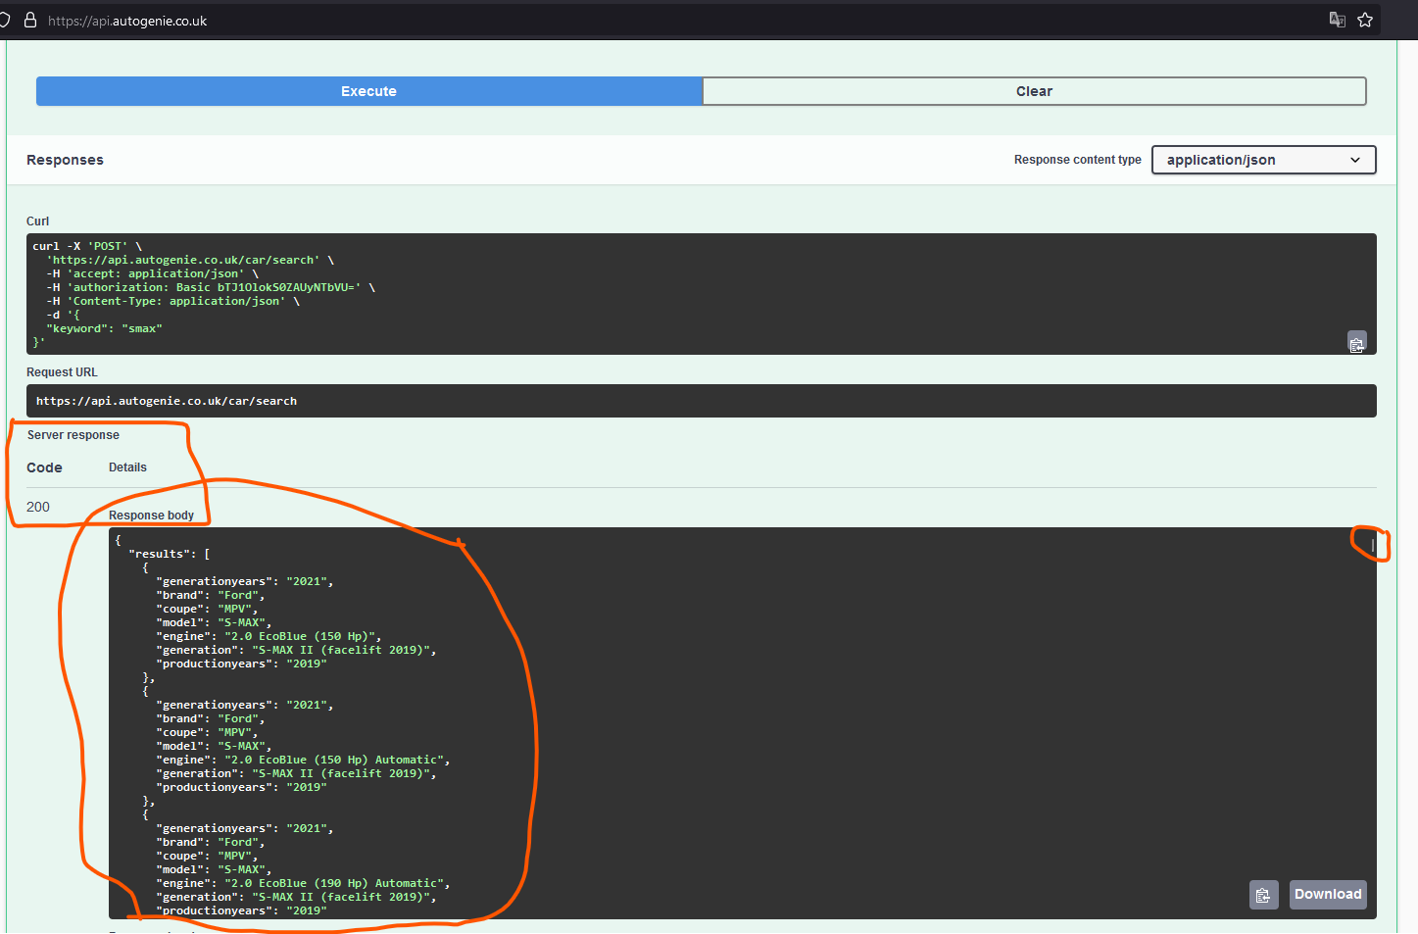Then finally you will see the result in the below. Server Response: 200 and the data in the Response Body. You can scroll down to see more results (if there any).
3. You can see the model entities to get the idea about the request and response values.

