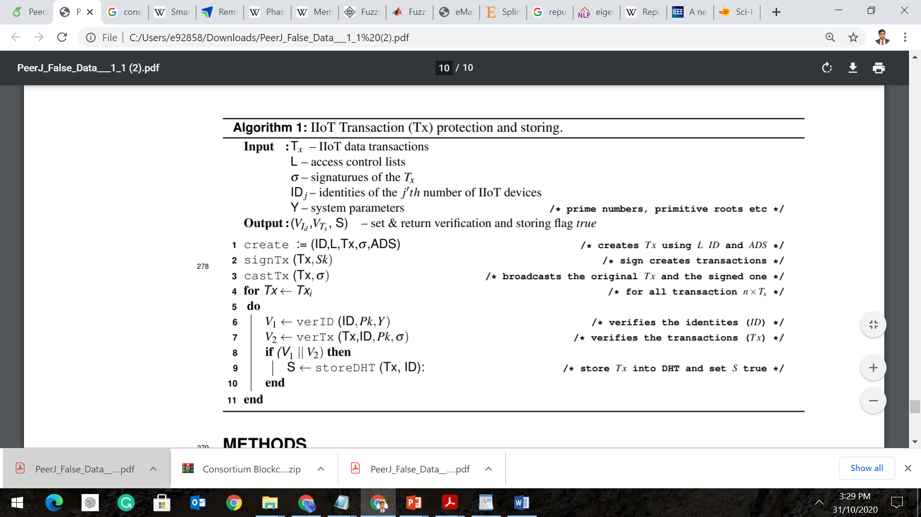

Input:

R_0 : initial reputation

ID: PMU/sensor identities

Δ δ: active power difference

ΔV : voltage amplitude variation

D: Detection level

R_t: Updated reputation at time t.

Flag: true or false

Output: (ID, D, R_t, )

Init(ID, R_0)

setStatus(ID, Δ δ, ΔV, D);

for ID 🡨 ID_i

do:

R_0 🡨 R_i

if (true)

R_t 🡨 R _0+ D/1k

updateRep(ID, R_t, D);