**TUGAS BESAR UAS APLIKASI IT II**

**rahmatsyaparudin.byethost33.com**



Disusun Oleh:

Rahmat Syaparudin

10112747

IF 17

**TEKNIK INFORMATIKA**

**UNIVERSITAS KOMPUTER INDONESIA**

**UNIKOM**

**BANDUNG**

**Index.php**

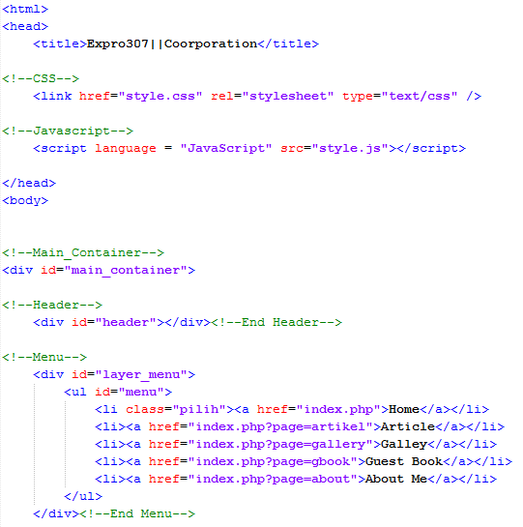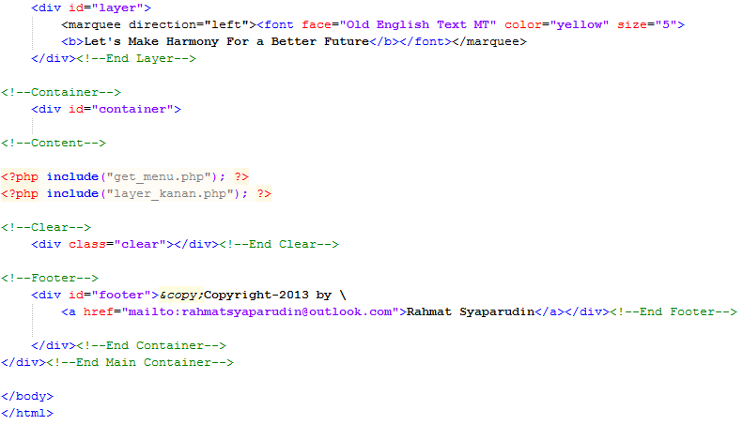

**get_menu.php**

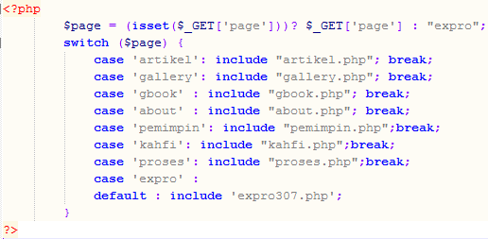

**Expro307.php**

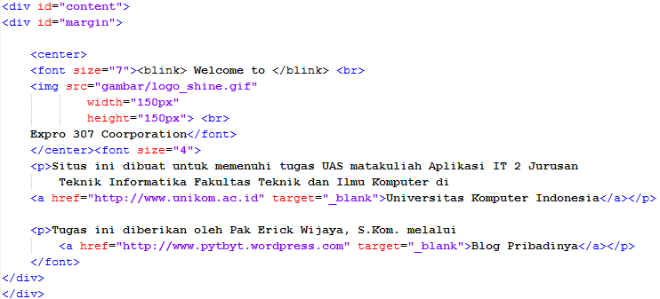

Artikel.php

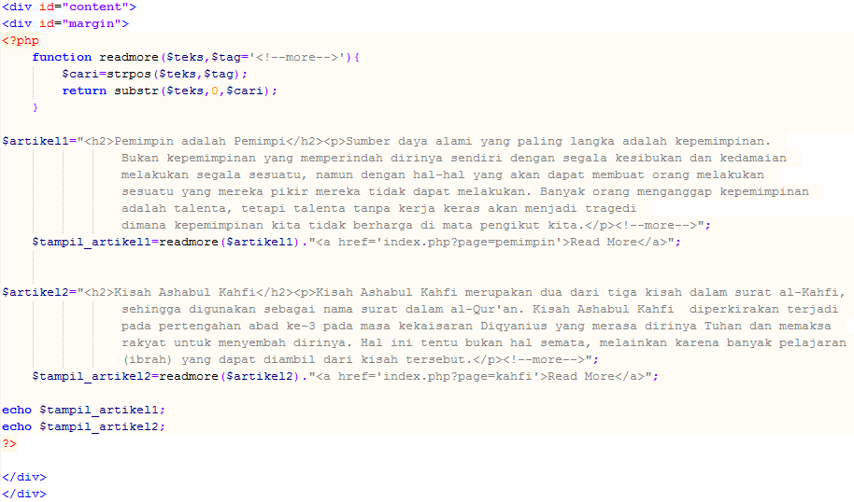

**Gallery.php**

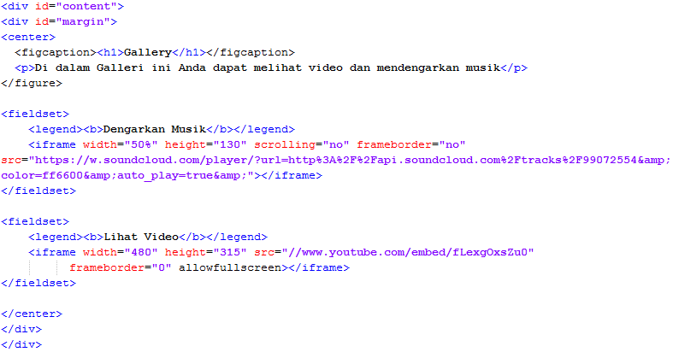

**Gbook.php (Menggunakan Tag HTML5)**

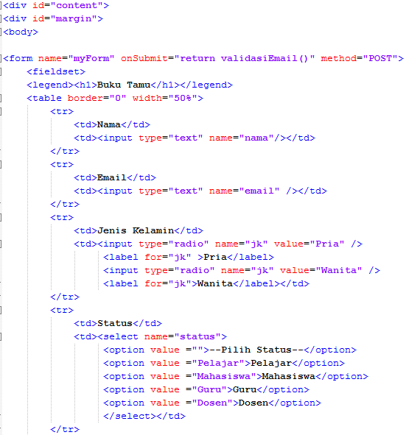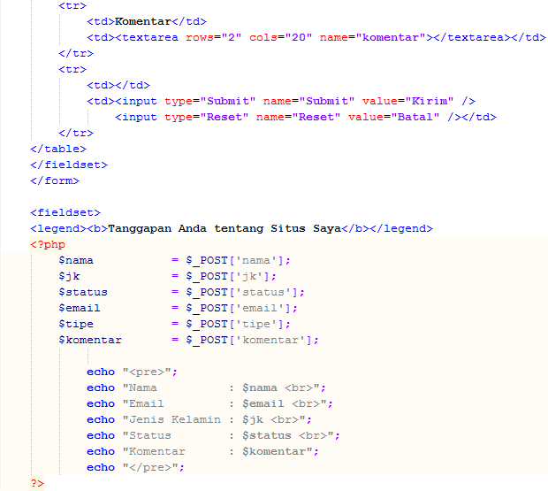

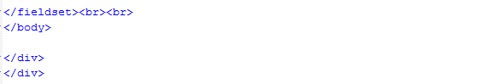

**About.php**

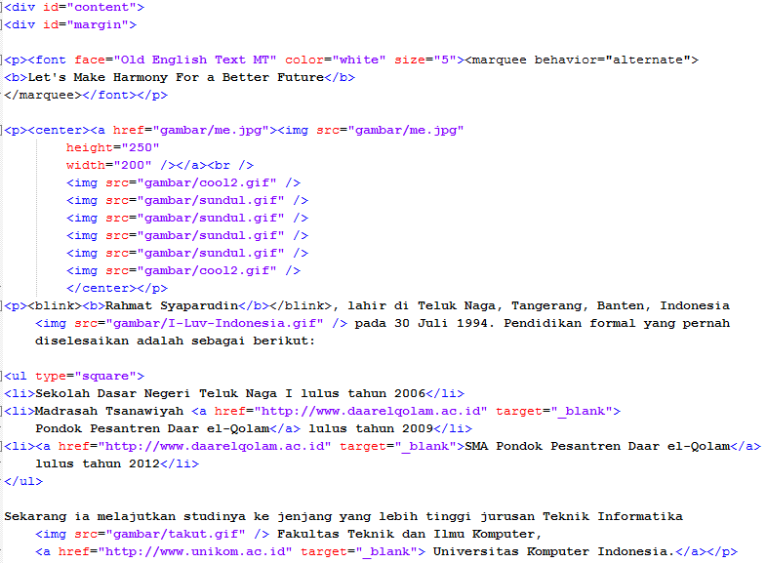

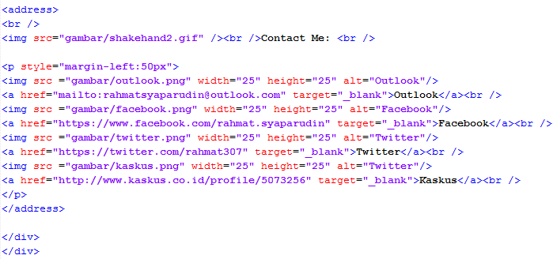

|  |  |
| --- | --- |
| **Style.css** | |
|  |  |

|  |
| --- |
| **Style.js** |
|  |

|  |
| --- |
|  |