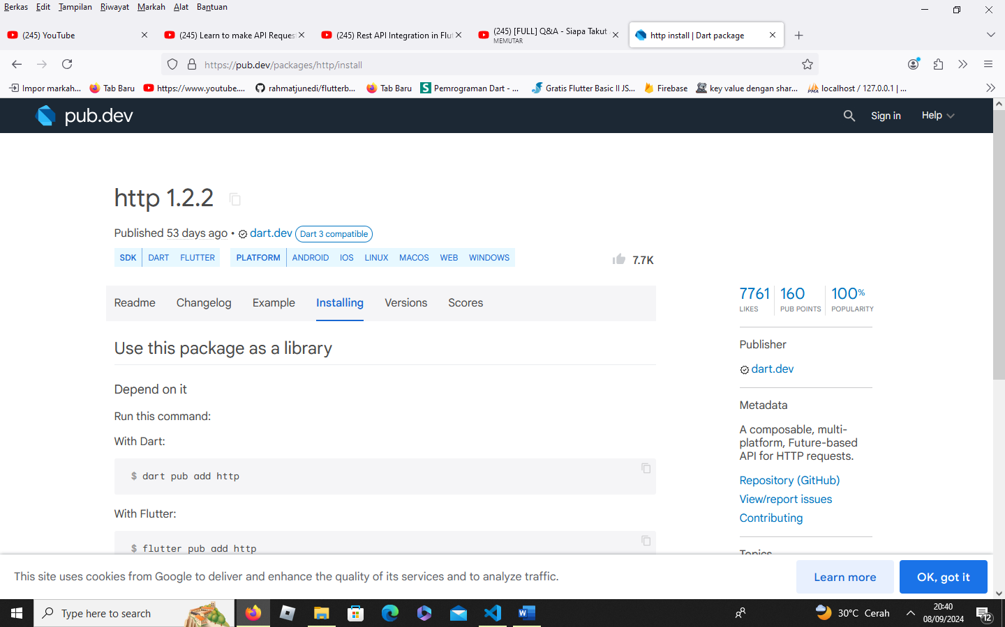

dart pub add http

fake database <https://reqres.in/>

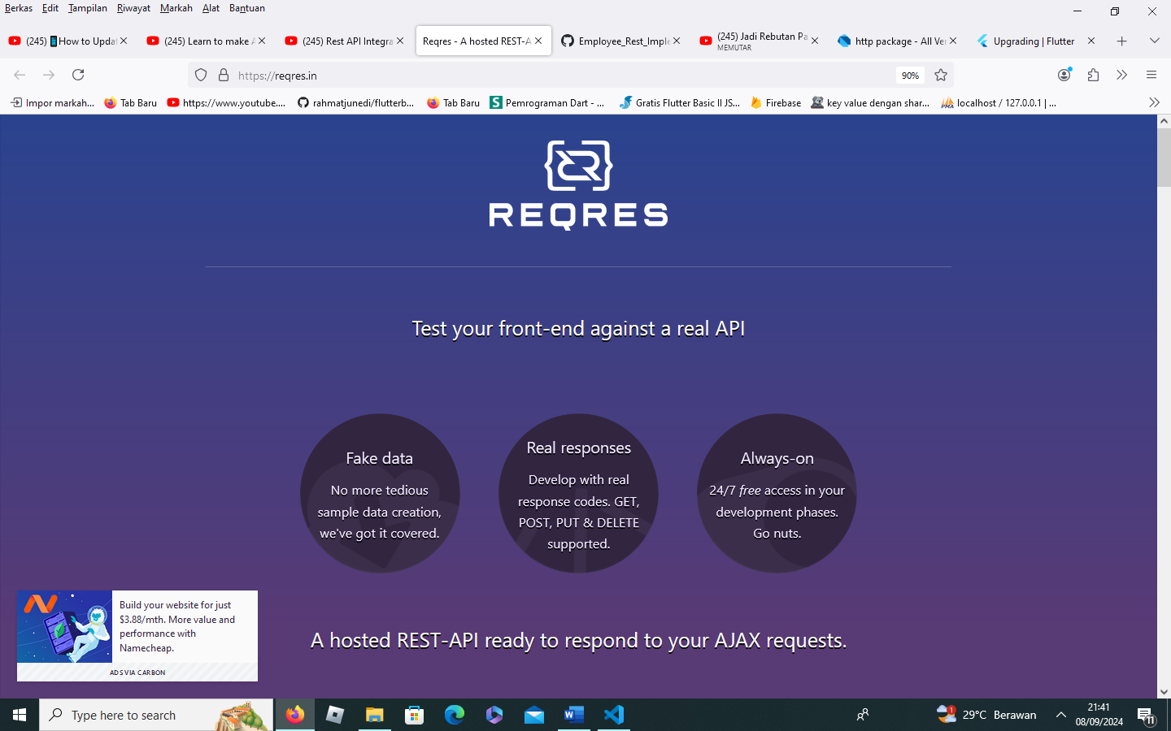

https://reqres.in/api/users?page=2

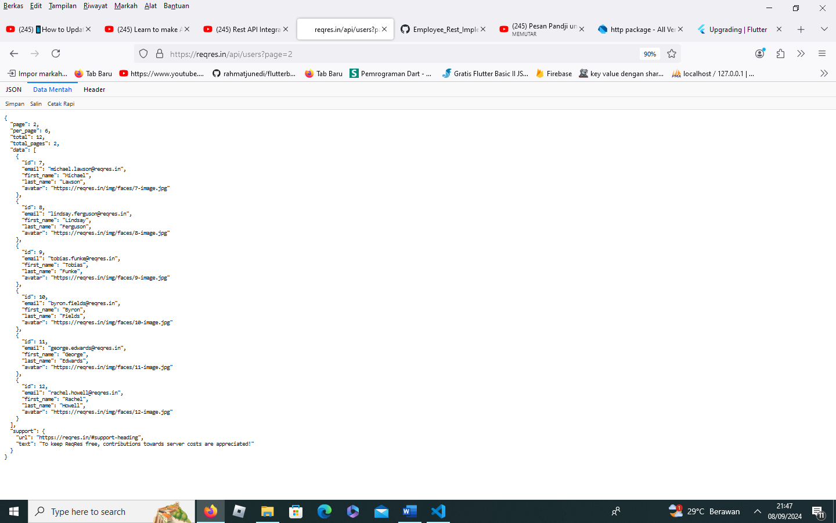

**employee.dart**

// ignore_for_file: public_member_api_docs, sort_constructors_first

class Employee {

  int? id;

  String? email;

  String? firstName;

  String? lastName;

  String? avatar;

  Employee({

    this.id,

    this.email,

    this.firstName,

    this.lastName,

    this.avatar,

  });

  Employee.fromJson(Map<String, dynamic> json) {

    id = json['id'];

    email = json['email'];

    firstName = json['first_name'];

    lastName = json['last_name'];

    avatar = json['avatar'];

  }

//  "id": 7,

//       "email": "michael.lawson@reqres.in",

//       "first_name": "Michael",

//       "last_name": "Lawson",

//       "avatar": "https://reqres.in/img/faces/7-image.jpg"

}

**employee_screen.dart**

import 'package:flutter/material.dart';

class EmployeeScreen extends StatelessWidget {

  const EmployeeScreen({super.key});

  @override

  Widget build(BuildContext context) {

    return Scaffold(

      appBar: AppBar(

        title: Text("Employee Data"),

      ),

    );

  }

}

**employee_services.dart**

import 'dart:convert';

import 'package:http/http.dart' as http;

class EmployeeServices {

  String baseUrl = "https://reqres.in/api/";

  getAllEmployeeData() async {

   try{

   }

catch (e){throw Exception(e.toString());}

  }

}

**employee_services.dart**

import 'dart:convert';

import 'package:http/http.dart' as http;

class EmployeeServices {

  String baseUrl = "https://reqres.in/api/";

  getAllEmployeeData() async {

    try {

      var response = await http.get(Uri.parse(baseUrl + "users?page=2"));

      if (response.statusCode == 200) {

        var data = response.body;

        var decodedData = jsonDecode(data);

        print(data);

      }

    } catch (e) {

      throw Exception(e.toString());

    }

  }

}

**employee_screen.dart**

import 'package:demo_api/services/employee_services.dart';

import 'package:flutter/material.dart';

class EmployeeScreen extends StatelessWidget {

  const EmployeeScreen({super.key});

  @override

  Widget build(BuildContext context) {

    return Scaffold(

      appBar: AppBar(

        title: Text("Employee Data"),

        actions: [

          IconButton(

              onPressed: () {

                EmployeeServices().getAllEmployeeData();

              },

              icon: Icon(Icons.refresh))

        ],

      ),

    );

  }

}

**main.dart**

import 'package:demo_api/screens/employee_screen.dart';

import 'package:flutter/material.dart';

void main() {

  runApp(const MyApp());

}

class MyApp extends StatelessWidget {

  const MyApp({super.key});

  @override

  Widget build(BuildContext context) {

    return MaterialApp(

        title: 'Flutter Demo',

        debugShowCheckedModeBanner: false,

        theme: ThemeData(

          colorScheme: ColorScheme.fromSeed(seedColor: Colors.deepPurple),

          useMaterial3: true,

        ),

        home: EmployeeScreen());

  }

}

class MyHomePage extends StatefulWidget {

  const MyHomePage({super.key, required this.title});

  final String title;

  @override

  State<MyHomePage> createState() => _MyHomePageState();

}

class _MyHomePageState extends State<MyHomePage> {

  int _counter = 0;

  void _incrementCounter() {

    setState(() {

      _counter++;

    });

  }

  @override

  Widget build(BuildContext context) {

    return Scaffold(

      appBar: AppBar(

        backgroundColor: Theme.of(context).colorScheme.inversePrimary,

        title: Text(widget.title),

      ),

      body: Center(

        child: Column(

          mainAxisAlignment: MainAxisAlignment.center,

          children: <Widget>[

            const Text(

              'You have pushed the button this many times:',

            ),

            Text(

              '$_counter',

              style: Theme.of(context).textTheme.headlineMedium,

            ),

          ],

        ),

      ),

      floatingActionButton: FloatingActionButton(

        onPressed: _incrementCounter,

        tooltip: 'Increment',

        child: const Icon(Icons.add),

      ),

    );

  }

}

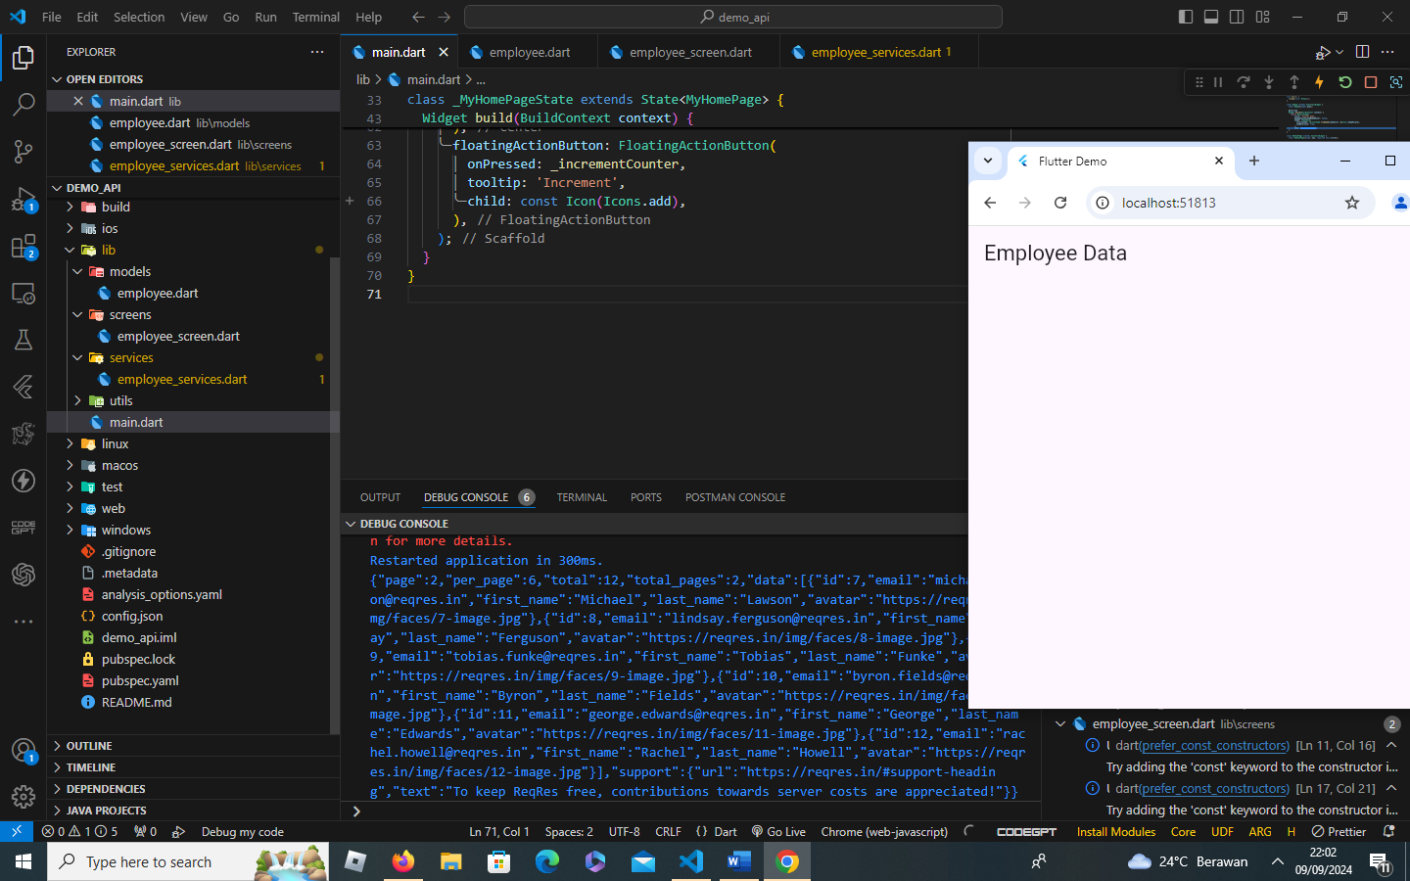

**employee_services.dart**

import 'dart:convert';

import 'package:demo_api/models/employee.dart';

import 'package:http/http.dart' as http;

class EmployeeServices {

  String baseUrl = "https://reqres.in/api/";

  getAllEmployeeData() async {

    List<Employee> allEmployees = [];

    try {

      var response = await http.get(Uri.parse(baseUrl + "users?page=2"));

      if (response.statusCode == 200) {

        var data = response.body;

        var decodedData = jsonDecode(data);

        var employees = decodedData['data'];

        print(employees);

        for (var employee in employees) {

          Employee newEmployee = Employee.fromJson(employee);

        }

        return allEmployees;

      }

    } catch (e) {

      throw Exception(e.toString());

    }

  }

}

**employee_screen.dart**

import 'package:demo_api/services/employee_services.dart';

import 'package:flutter/material.dart';

class EmployeeScreen extends StatelessWidget {

  const EmployeeScreen({super.key});

  @override

  Widget build(BuildContext context) {

    return Scaffold(

      appBar: AppBar(

        title: Text("Employee Data"),

        actions: [

          IconButton(

              onPressed: () {

                print(EmployeeServices().getAllEmployeeData());

              },

              icon: Icon(Icons.refresh))

        ],

      ),

    );

  }

}

**employee_services.dart**

import 'dart:convert';

import 'package:demo_api/models/employee.dart';

import 'package:http/http.dart' as http;

class EmployeeServices {

  String baseUrl = "https://reqres.in/api/";

  getAllEmployeeData() async {

    List<Employee> allEmployees = [];

    try {

      var response = await http.get(Uri.parse(baseUrl + "users?page=2"));

      if (response.statusCode == 200) {

        var data = response.body;

        var decodedData = jsonDecode(data);

        var employees = decodedData['data'];

        print(employees);

        for (var employee in employees) {

          Employee newEmployee = Employee.fromJson(employee);

          allEmployees.add(newEmployee);

        }

        print(allEmployees);

        return allEmployees;

      }

    } catch (e) {

      throw Exception(e.toString());

    }

  }

}

**employee_screen.dart**

import 'package:demo_api/models/employee.dart';

import 'package:demo_api/services/employee_services.dart';

import 'package:flutter/material.dart';

class EmployeeScreen extends StatelessWidget {

  const EmployeeScreen({super.key});

  @override

  Widget build(BuildContext context) {

    return Scaffold(

      appBar: AppBar(

        title: Text("Employee Data"),

        actions: [

          IconButton(

              onPressed: () {

                print(EmployeeServices().getAllEmployeeData());

              },

              icon: Icon(Icons.refresh))

        ],

      ),

      body: FutureBuilder(

          future: EmployeeServices().getAllEmployeeData(),

          builder: (context, snapshot) {

            if (snapshot.hasError) {

              return Center(

                child: Text("Error"),

              );

            }

            if (snapshot.hasData) {

              var data = snapshot.data as List<Employee>;

              return ListView.builder(

                itemCount: data.length,

                itemBuilder: (contex, index) {

                  return ListTile(

                    leading: CircleAvatar(

                      backgroundImage: NetworkImage(data[index].avatar!),

                    ),

                    title: Text(

                        "${data[index].firstName} ${data[index].lastName}"),

                    subtitle: Text(data[index].email!),

                  );

                },

              );

            } else {

              return Center(

                child: CircularProgressIndicator(),

              );

            }

            ;

          }),

    );

  }

}

